**Understanding Statements and AR in RMEx**

Before we can fully understand how the statement process works, we need to know what information is included in the statement and where it is pulled from within RMEx. We will be working and referencing the RMEx “Plain Paper” statement. A statement allows us to provide information to our client showing what accounts paid, where the payment was made, and how much of the payment is owed to the client and the agency. We can also indicate what prior balance(s) is owed to the agency, check amount included and current amount due to agency.

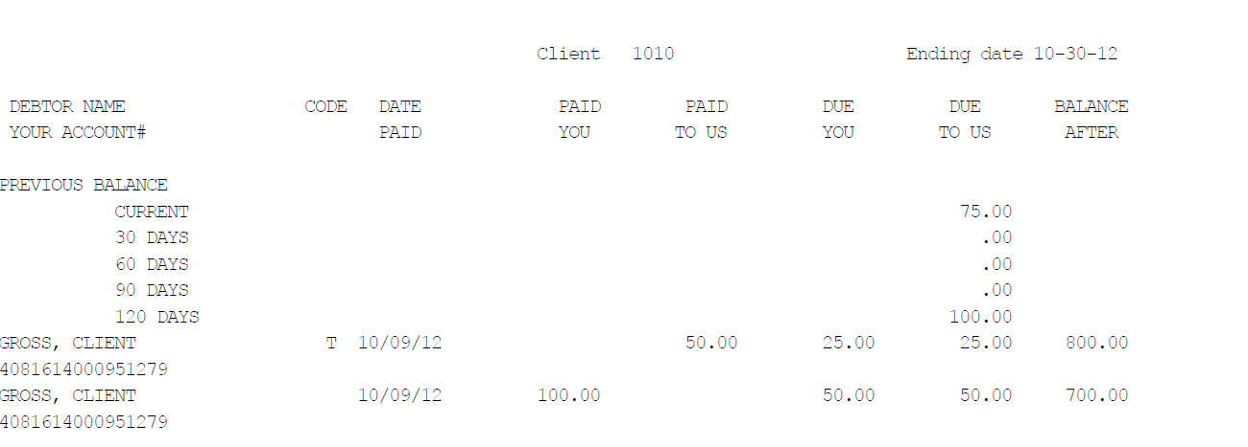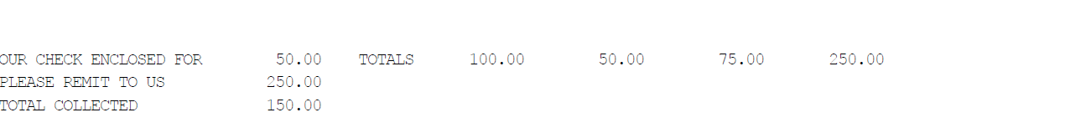

Did you know almost all the information found on a client statement is based on your client master, balance type set up and payment codes? At the client master level you decide:

* Statement or Remitting Code – user defined 1 character code and case sensitive, used to identify what statement to process. This code is use to define or separate daily, weekly and monthly client statement processing.
* Statement or Remittance type – Gross, Gross with separate NSF, Net, Net with separate NSF
* Sort Type – controls how the debtors appear and in what order the statement.
* Prior Balance – the blank or default option is to show any prior balance owed by the client to the agency, if you do NOT want the prior balance included, you will select N.
* Group Statement – allows you to create one statement based on a client group.
* Separate Directs – creates a separate statement for all payment type 11’s or payment made to your client.
* Balance Types – creates up to 3 separate statements for payments posted to the balance type specified.
* Standard Rate, Other Rate, Fee code, Commission code, and Special Rate – these fields determine the amount of money the agency is paid on the amount collected. This information is found in the due us column on the statement.

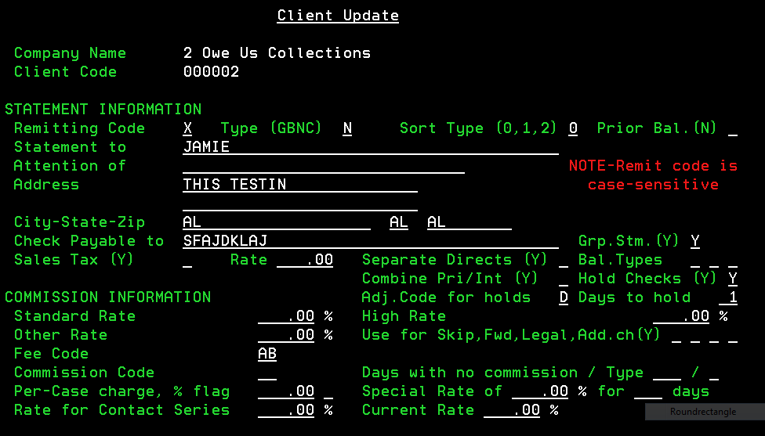

Before we can send the client a statement showing payments, we need to post some payments. Below is a sample screen print of the payment posting screen. Keep in mind only certain payment types will appear on a client’s statement. The 2 main payment types used by an agency is payment type 01 – Paid Agency and payment type 11- Paid Client. The example below shows a payment paid to the agency in the amount of $50.00, it is being applied to the “P” or Principle Balance Type.

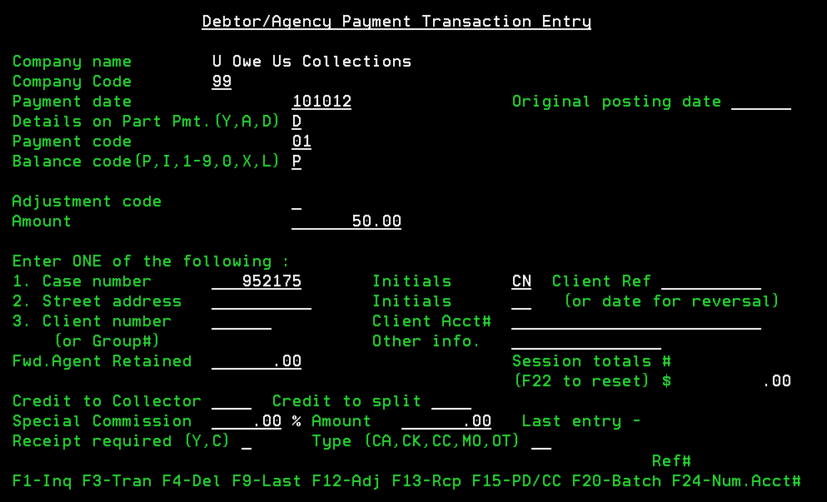

Once we have posted our payment we can run a “Payments by Client for a Period of Time” report. This report will search based on payment date range. You can also specify certain client’s to include or print leave these field blank for all clients.

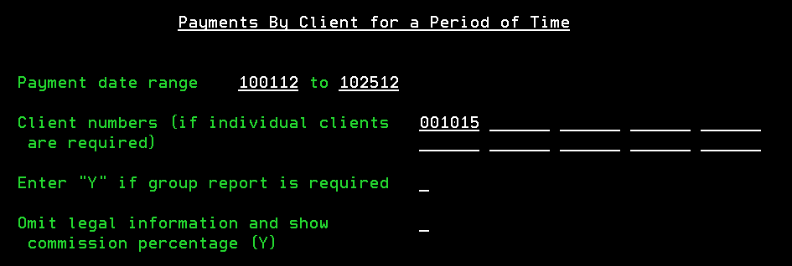

Below is the “Payments By Client” report for payment date range 10/10/12 to 10/15/12. During this period, $150.00 was paid to the agency and the agencies commission is $75.00. The next column shows us $50.00 was paid to the client and agencies commission is $25.00. There are no payments applied during this payment date range for legal accounts.

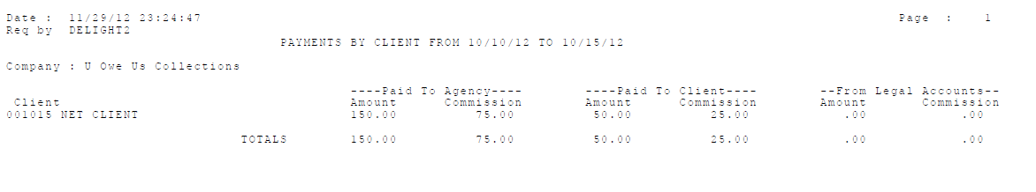

For a detailed listing of payments, you will use the “Payment Report for a Period”

This report allows you to search by payment date range and allows you select by Payment Type, Balance Codes and Adjustment codes.

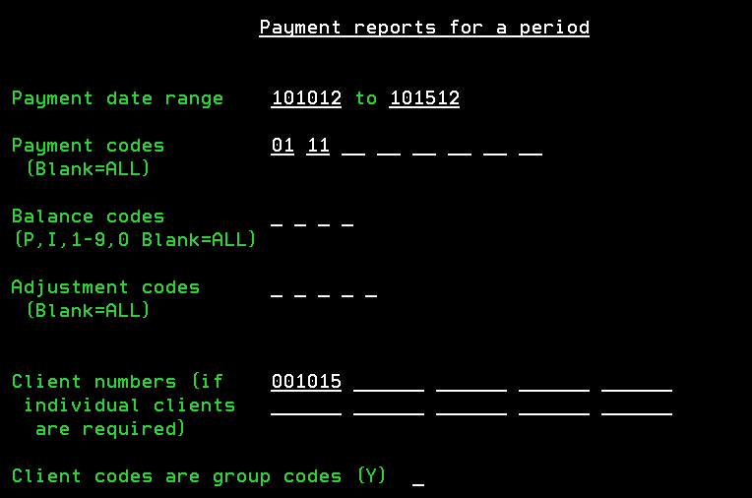

As you can see below, this report gives you an account level view of the payments posted for the selected date range.

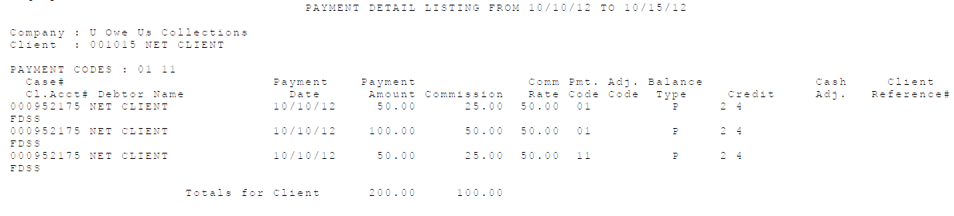

Balance Types play a big part in what appears on a statement. You must select what balance types, in system control, should appear on your client’s statements. If you do not select a balance type to appear on statements, then if a payment is made to the agency and applied to that balance type, it will not be included on the statement. However, if a payment type 11 is applied to that balance type it WILL show on your client’s statement, since you need to bill them for the payment made. This is also were you will set up any statement codes by balance type to show on your clients statements. This indicates to your client where the money was applied, primary, interest, court cost etc.

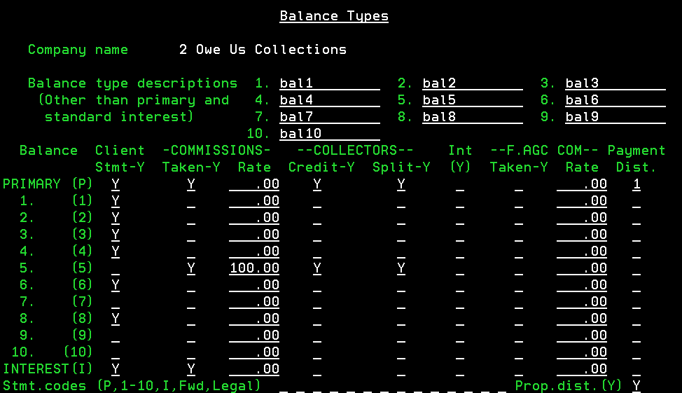

Payment Codes:

The following payment/adjustment codes appear on statements:

* 01 paid agency
* 02 forwarding agency payment
* 11 direct payment to client
* 52 AR adjustment (optional)
* 21 Agency NSF
* 31 Client NSF
* 59 Bill client and increase debtor balance
* 71 Overpayment refund client

The following payment/adjustment codes do not appear:

* Adjustments (payment codes 40-49)
* Balance types can keep transactions from appearing
* Payment code 52 may or may not
* Payment Code 72 Refund to debtor
* Payment Code 73 Overpayment adjustment
* Payment Code 90 collector commission adjustment

In this section we will review the various types of statements you can request. We will also review how those statements affect your AR.

The statement below is for a remit type of G = gross client statement. This is where you will send 100% of the money the agency collects to your client and bill them for your fees on payments made to the agency and the payments made to the client.

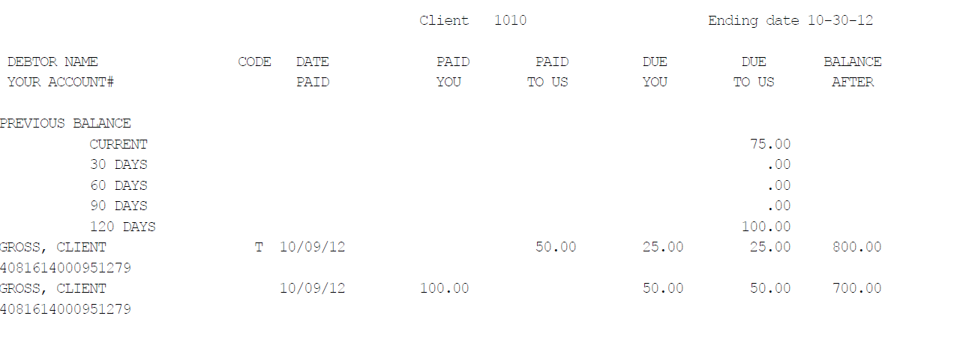

Let’s take a closer look at this statement and the information provided.

Starting from left to right of the statement, we see the following information:

* Debtor Name
* Your Account # - which appears under the debtor name
* Previous balance – indicate prior balances still owed to the agency. In this example @90days $50.00 is owed and @120 days $50.00 is outstanding.
* Code
* Date Paid – indicate the date the payment was posted by the agency
* Paid You – the amount paid directly to the client. In this example it is $100.00
* Paid To Us – the amount paid to the agency. In this example it is $50.00
* Due You – amount due the client less the commission in this example $25.00 and $50.00 is due the client.
* Due Us – amount of commission due agency. In this example $25.00 and $50.00 is due to agency
* Balance After – indicate the debtors account balance after payment was posted.

At the bottom of the statement:

* Our Check Enclosed For - in this example we are sending the client $50.00 because it is a gross client and in this case we send 100% of the money collected to the client and bill them for our fees.
* Please Remit To US - indicate the amount due for the current statement and any prior balances still owing. In this example the client owes the agency $75.00 for this statement and $100.00 for previous statements. So we are showing a total owed to agency of $175.00
* Total Collected - $150.00 this amount indicates the total amount collected by the agency and the payments made directly to the client.

Now let’s take a look at the Client AR inquiry, located on the client statement menu.

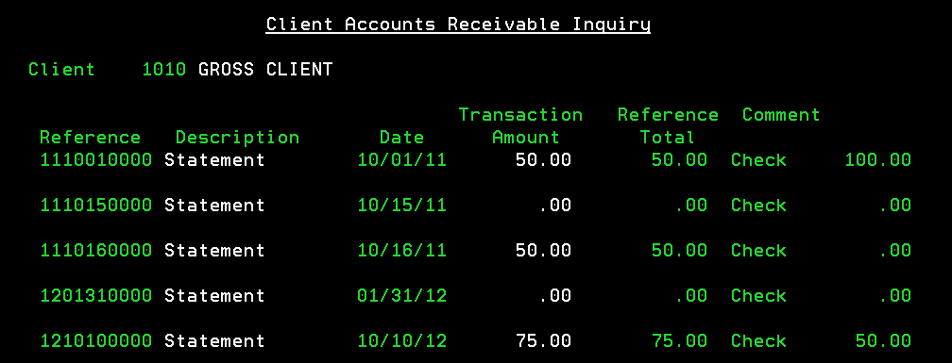

The Client Accounts Receivable Inquiry screen shows us the following information:

* Reference # - this number is printed on each statement and the first 6 digits indicate the year, month, and day the statement was run.
* Description – indicates type of AR transaction.
  + Statement – indicate a statement was created
  + Statement Credit – indicates a statement created was applied to the AR
    - Statement Credits are typically seen with Net statements and will be applied when the client has a prior balance. When the statement is processed, it will look at outstanding AR and if you are sending a check to the client and the client owes you money, we will reduce the amount sent to the client by the amount owed, if the amount collected is enough to pay off prior balance.
  + Payment – indicates a payment was made
  + Adjustment – indicates an adjustment was made to the AR
* Date – indicate the date the transaction occurred
* Transaction Amount – shows amount of transaction. For statements it indicate how much is owed to the agency.
* Reference Total – indicate the balance due for the transaction amount. So, if you post a $50.00 payment to line 1 of this AR the Transaction Amount will show $50.00 and the Reference Total will show $0.00.
* Comment – this field will show the following:
  + Check and amount – when a statement is run. If you are billing client or the in the case of a Net remit, you may see “Check 0.00” since there is no money owed to the agency.
  + Payment – if the transaction indicates a payment was applied.
  + Adjustment – if the transaction indicates an Adjustment was made the AR.
  + STM.DATE mmddyy – this indicates a statement credit was applied to the statement date indicated on the comment line.
  + Check No – indicates a statement credit. This type of statement credit needs to be looked at closely and could be an incorrect statement credit for various posting reasons. This can occur when payments applied to AR are NOT applied to the correct Reference #, thus creating a credit balance on the client AR. This can also happen, when you are running client statement other than Monthly and a client payment is applied prior to running that period’s client statement. This type of statement credit occurs on gross remit clients and you should not post any client payments until you have run the statement for that period and prior to posting any debtor transactions.

Gross Statement with Separate NSF Statement

When choosing this option, if an NSF check is received, a separate statement will be printed for the NSF transactions only. So, when selecting this option you will receive a main statement and a separate statement for NSF transactions.

AR Screen for Gross Client with Separate Statement for NSF Checks – take note of the 10/16/11 entries, this indicates that 2 statements were run on 10/16/11 and based on the reference # ending in 00 we see $75.00 was billed to the client and a check for $75.00 was sent to the client. Reference # ending in 10 shows we billed the client $50.00 for a returned or NSF check. *When dealing with Gross Statement Clients it is important to remember that if you do NOT have a separate statement for NSF payments then the $50.00 that is owed by the client will be deducted from the amount sent to the client. So in this example, if we did NOT have a separate NSF statement we would have sent the client $25.00 even though we collected $75.00.

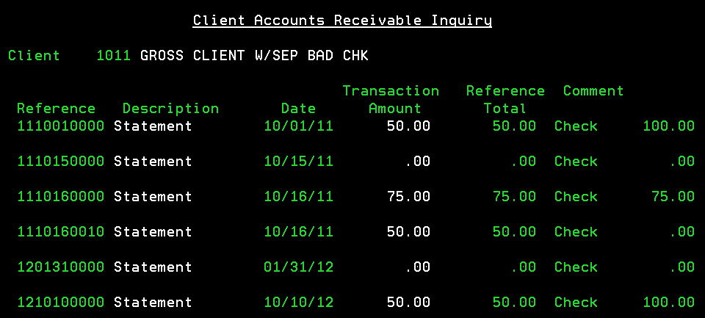

**Gross Statement with Separate Statement for Direct (payment code 11) payments:**

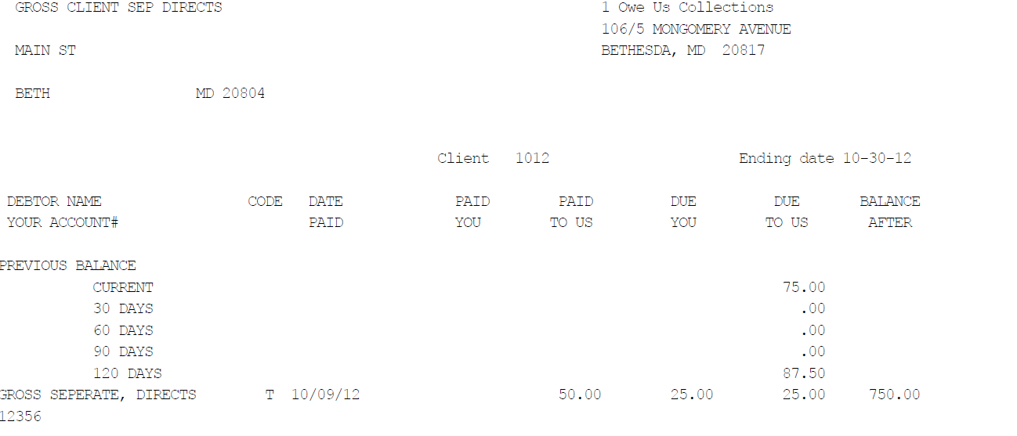

**Separate Direct Payment Statement**

In this example you will see that the amount due for direct payments is NOT included on the main statement.

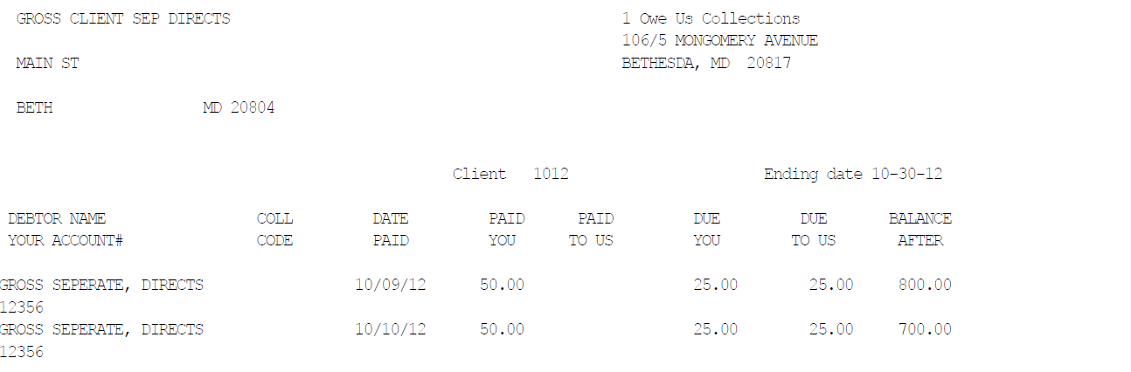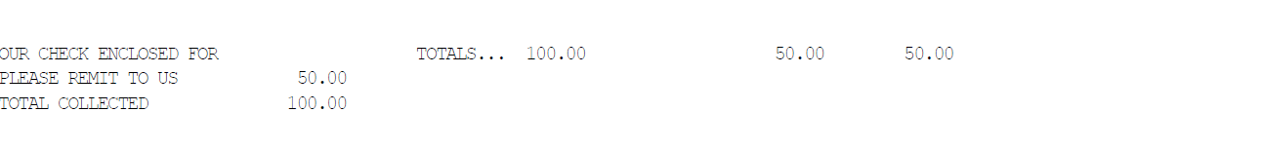

AR screen for Gross Client with Separate Statement for Direct Payments: Notice transaction date 10/10/12 for the above statements.

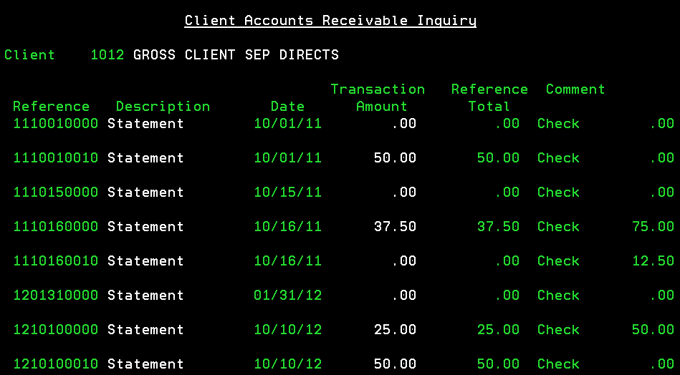

The example below show NO payment made to Main statement, but shows a direct $100.00 payment made to balance type 3 and $100.00 payment made to the agency for balance type 3. As you will notice, the first statement (Main) shows NO payments. The second statement or Direct Statement shows a $100.00 payment and the final Balance Type Statement shows a $100.00 payment. Note, since the client wants both a direct and balance type statement, when a direct payment is made to balance type 3, that payment will show up on the direct statement NOT the balance type statement. Only payment type 01 will show on the balance type statement, when is set up for separate direct statements, as shown below.



**Main Statement-**

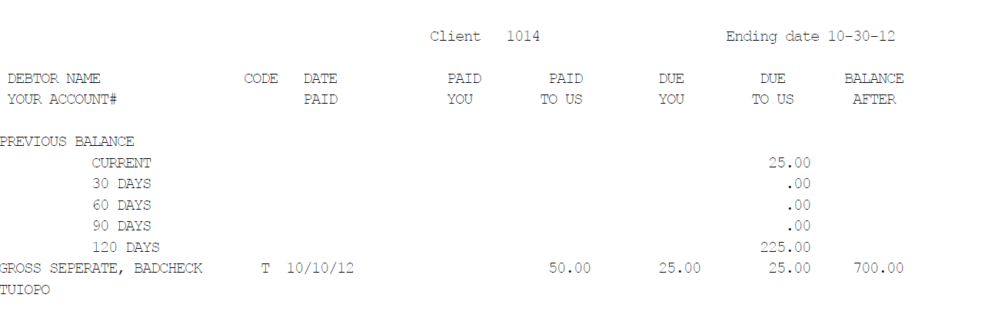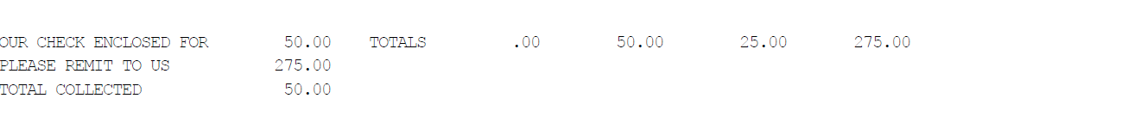

**Direct Statement-**

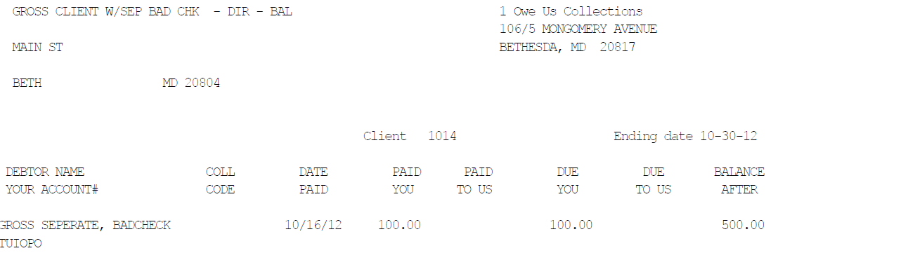

**Balance Type Statement-**

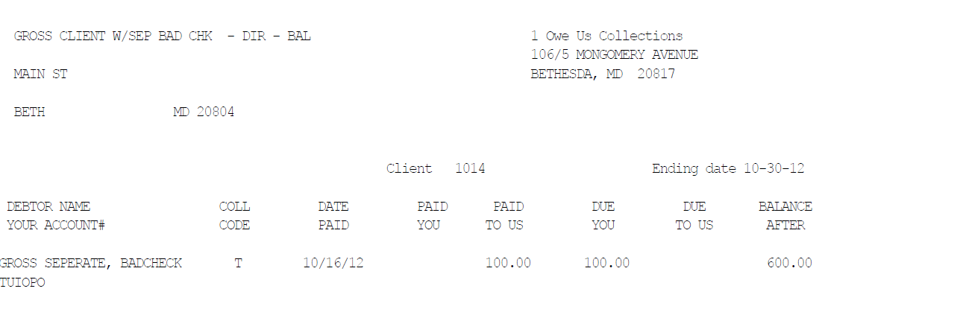

**Net Statement**

In the example below $50.00 was paid to the client and $150.00 was paid to the agency. The amount due the agency is $100.00 for this statement and $50.00 due for a prior statement. Since this is a Net statement, the agency retains the $150.00 collected and applies $100.00 to the current statement and $50.00 to the outstanding balance. This will bring the client AR to zero.

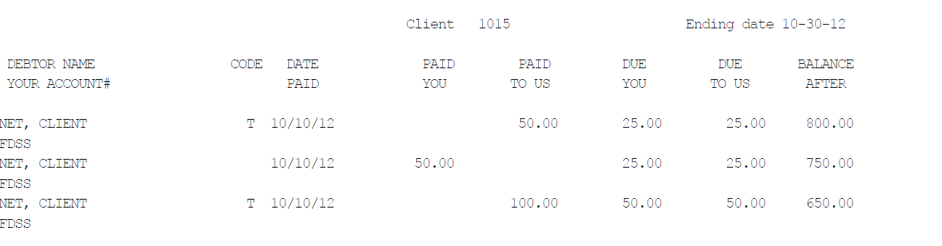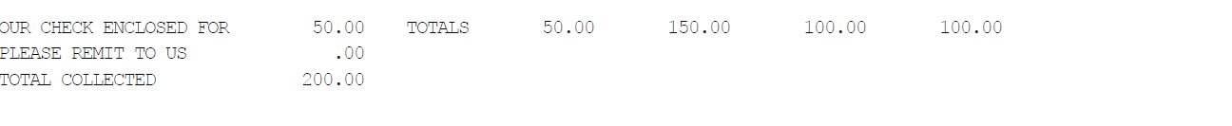

**Net Client AR**

Based on the example statement above, you can see a statement credit was applied to the 10/16/11 statement date. This came from the statement ran on 10/10/12 as indicated below. You will also see that the 10/10/12 statement transaction amount is zero, because the agency did not send a check to the client for that statement.

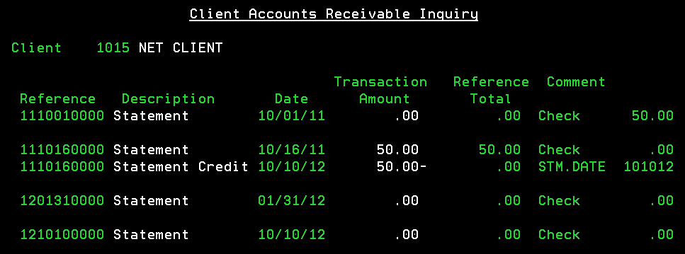

**Net Statement with Separate Direct Payment Statement**

Main Statement shows a $100.00 payment made to the agency with $50.00 to the client and $50.00 due to the agency, for the statement date ending 10/30/12. However, this is a prior balance due to the agency of $75.00. Please note, these statements are working independently of each other. As you will see, we are NOT sending the client a check, instead, we are billing the client $25.00. This amount is calculated based on the $100.00 received by the agency, less the $125.00 owed the agency.

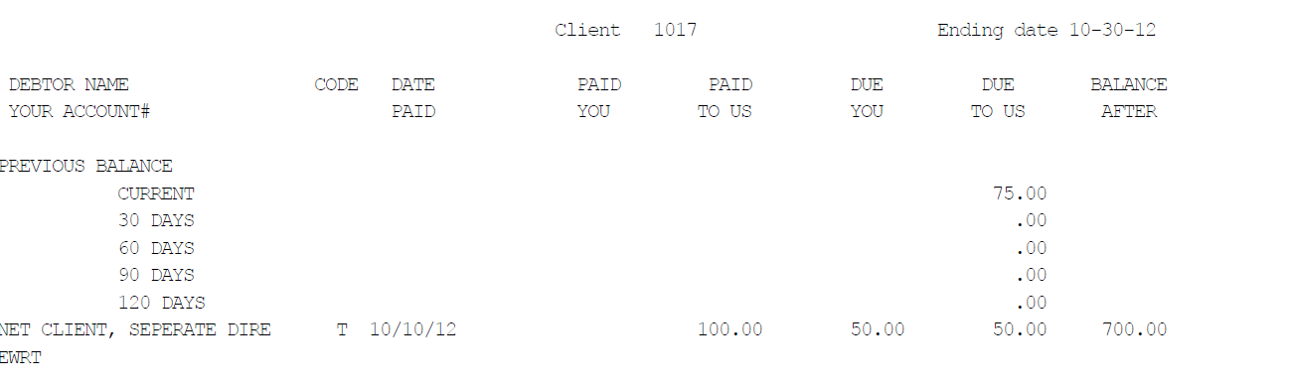

This direct statement shows $150.00 paid to the client. We are billing the client for our fees on these payments only in the amount of $75.00.

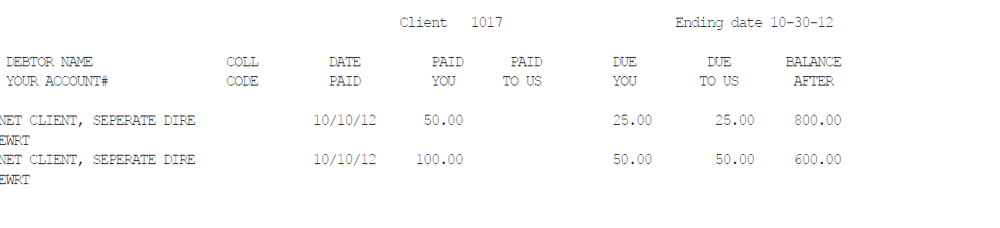

**Net Client AR with Separate Direct**

Let’s take a look at how the statement ran on 10/10/12 effected this clients AR. First we want to look at the Reference #1210100000 it tell us there is no amount owed the agency for that statement and we sent the client a check for $37.50. Next we need to look at the Statement Credit created on 10/10/12 for $12.50- with paid off the amount due in the 120 day prior balance. (see main statement above) and the final thing we need to look at is the last entry Reference# 1210100010 this the separate direct payment statement and it shows the agency billed the client for $75.00 and did not send any check.

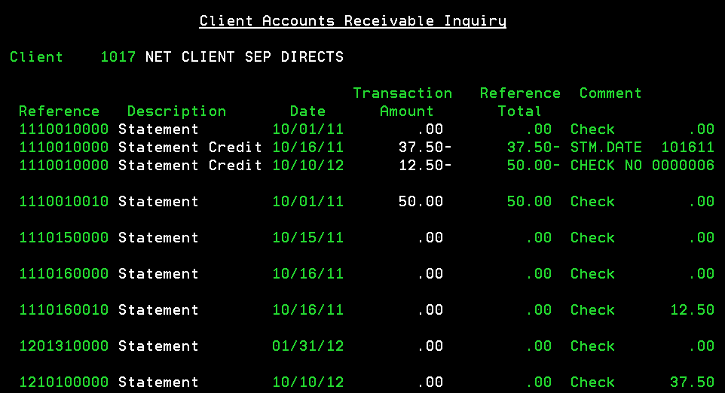

**Group Statements**

RMEx allows you set up a group statement, meaning you may have up to 100 individual clients under 1 group number and create 1 statement for all 100 clients. This is a very nice feature to have, however, we find that clients often run into problems when they take existing client, that have current AR and decide mid statement cycle to set them up for a group statement. This process should NOT be done WITHOUT careful consideration. As you will see issue with your client AR. Anytime you are dealing with statements and AR you must fully understand the out come, before proceeding.

So, what should you do if you want to change to a group statement?

Before you can change an individual client from an individual statement to a group statement or add an existing client to a group statement, you MUST do the following in the order listed below:

* Wait until the next statement process is due
* **Important - Run the statements as normal**
* **Do not make any changes or post any transactions for these clients until you have finished the steps listed below:**
* For the Client numbers that are NOT the group number Client - Adjust these Clients outstanding account receivable balances down to zero
* For the Client number that IS the group number Client - Adjust this Clients account receivables up by the amount you removed from the other Client numbers
* Go to Client master and change the field Grp.Stm.(Y) to a "Y" and make sure the group number is correct on all Clients

Now all money owed from the various clients are now located on Group Clients accounts receivables. It is important to remember, when making the client adjustments to use the proper invoice numbers

Important things to keep in mind when processing statements:

Statements can be run at any time during the month. Statements are not tied into the Month End Process, they are date driven.

It is important to remember that every time you run statements you are also updating your Client AR. RMEx provides a history of statement run dates and remit codes used for the statements created. Make sure you check that area prior to running your statements to avoid duplication. If you run your statements twice for the same date range and remit code, your Client AR will not be correct

Statement/AR FAQ

When running statements:

RULE- Don’t post any client payments until you have completed your weekly statements

RULE: Don’t post any debtor payments until all client payments have been applied

RULE: Group Statements – all clients must have the same ‘Group Code”

RULE: Per case reports MUST be run prior to statements.

Can a payment transaction appear on statement more than once?

No, once it has appeared it will not appear on another statement.

Can I rerun a statement for one client?

Yes, create unique remitting code, run a test statement, and put remit code back to original.

If the balance type 5 was posted as transaction type 11, but the client statement option is not checked. Does the system still put this on the statement anyway at 100% commission? If it does show up on the statemen**t**, wouldn’t it also show on the A/R?  
Yes, even if a balance is non-reportable it will appear on the statement if the transaction was posted as paid to client. Double check the ones that appeared on the statement to make sure they are charging the client 100%, especially since they are set up for no commission, you want to make sure you get the money back from the client.

What can I do with overpayments?

Refund to the debtor using a payment code 72, refund to the client using payment code 71 or adjust the balance to zero using payment code 73.

Why would per case/ per letter charges not appear on a client statement?

You have specified that the client is per case but you did not specify an amount. Because you ran the statements prior to running the per case report. The report must always be run prior to the statements being processed.

What happens if I transfer an account from one client to another?

The transactions posted prior to the transfer will appear on the old client statement and all futures will be applied to the new client.

Why do Per Case charges not appear on “Statement Report”?

Per Case charge appear on an “Invoice Report”

Why does my statement say “Statement Credit”?

* If you do run client statements a week later after running month-end, DO NOT post client payments to the receivables during this period. This will cause client receivable issues and statement issues regarding balances.
* If the client is a Net client and they owe you a prior balance.
* If you have a gross client with separate balance type statement and an NSF was posted to the separate balance type will create a statement credit for the amount of the NSF amount due to the agency.

What happens if a client is set up for separate directs and separate balance types. Where will that transaction appear?

If a transaction qualifies for a client direct stmt and a balance type statement, it will always appear on the client direct statement.

What happens if you run statements twice?

Receivables will be aged – If not include prior balance, will generate a statement saying owes nothing. If include prior balance it will not show. Another AR item will be created.

How do you have the rounding up of numbers?

Rounding up to the agency favor ½ penny