**Web Training, Glossary, and PDF creation**

Create the folders that will ultimately store the files on the web server

**Main folder is: “Management_Training_topic” (i.e; Management_Training_Close_Codes):** This Folder will store the Web Training Files

**Within this folder create folders called**

**“CAM-topic”**: ALL of the camtasia work files (*,camrec, *.PNG, *.wav etc). If we download this folder we can re-produce/edit any video

**“GL-topic”**: This is the Glossary web presentation / Produced vid

**“PPT-topic”:** This is the PowerPoint and the PDF created from that PowerPoint

NOTE: Do not create your file name with SPACES use underscores or dashs between words (example_Underscore.doc)

**How it looks on the web site:**

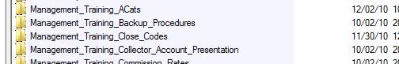

**How the inside of the folders will look:**

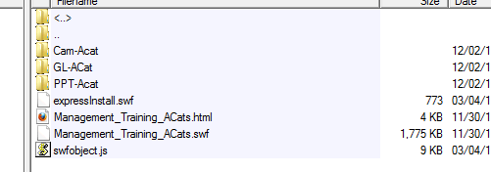

**How the links will look:**

Web Training

<http://www.quantrax.com/KB/Management_Training/Management_Training_Acats/Management_Training_Acats.html>

Glossary

<http://www.quantrax.com/kb/Management_Training/Management_Training_ACats/GL-ACat/GL-ACat.html>

PDF

<http://www.quantrax.com/kb/Management_Training/Management_Training_ACats/PPT-Acat/ACats.pdf>

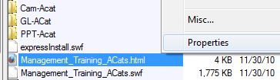

**How to find the web links:**

All web links for the Knowledgebase start with

<http://www.quantrax.com/kb>

To get the rest of the link, using CoreFTP, login and go to the directory with

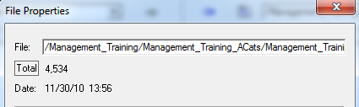

the file or video that you want to present to the user.

Right click on the file and go to its properties.

The field **“File”** in Prosperities has the rest of your link

**“/Management_Training/Management_Training_ACats/Management_Training_ACats.html”**

Adding the with the info above you get:

**http://www.quantrax.com/kb**/Management_Training/Management_Training_ACats/Management_Training_ACats.html**Web Training production – Select to Produce from Camtasia and you will be presented with these options:**

* **Select Custom, Then Next**

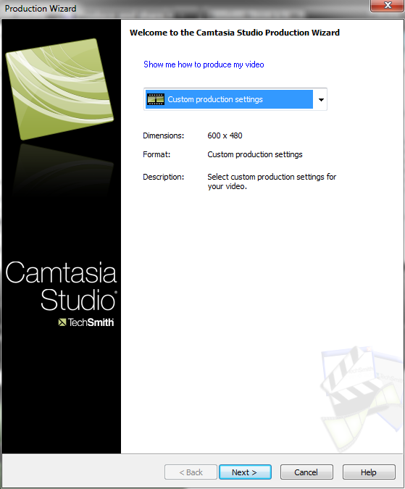

* **Select “Flash”, Then Next**

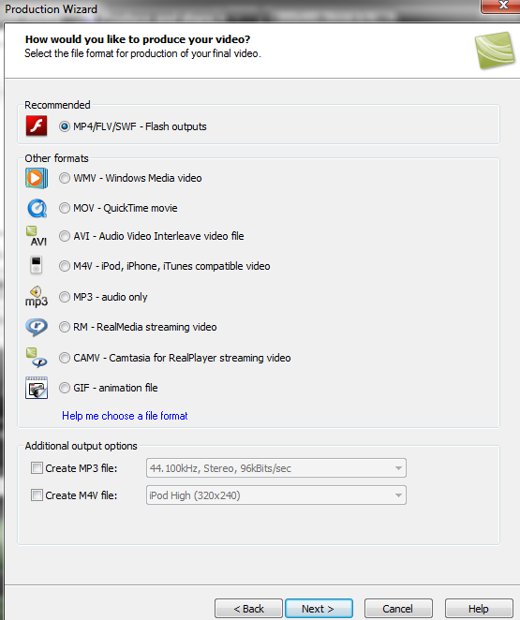

* **From the drop down box select “1024X768”**

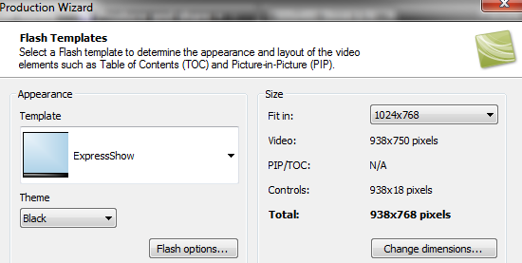

* **Select Express Show**
* **Select Flash Options**
* **Make sure you have SWF selected**
* **Select Okay and Next**

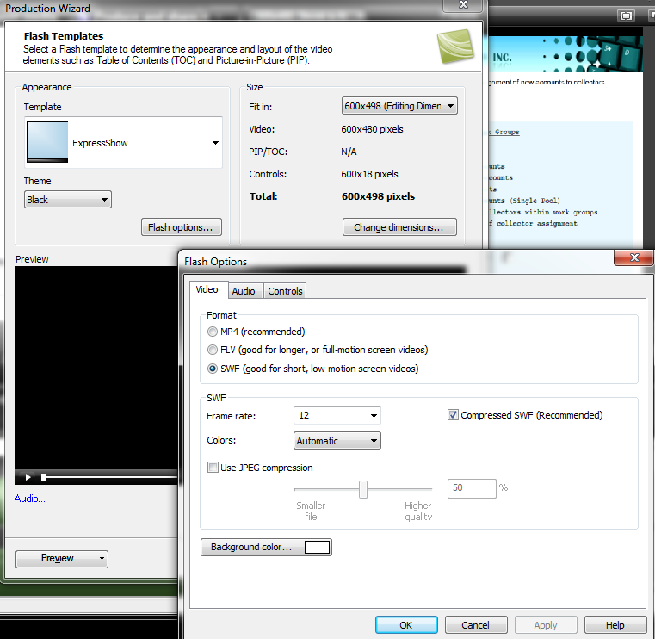

* NOTE: You can also select to preview what your produced video will look like by clicking here.
* Click Next Past this option

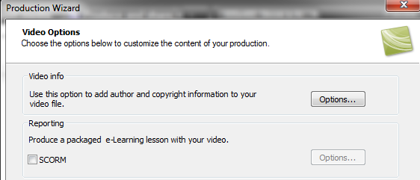

* Name your Web Presentation
* Click Finish
* Based on the size of the presentation it could take a while to create.
* Once done load to Web Site

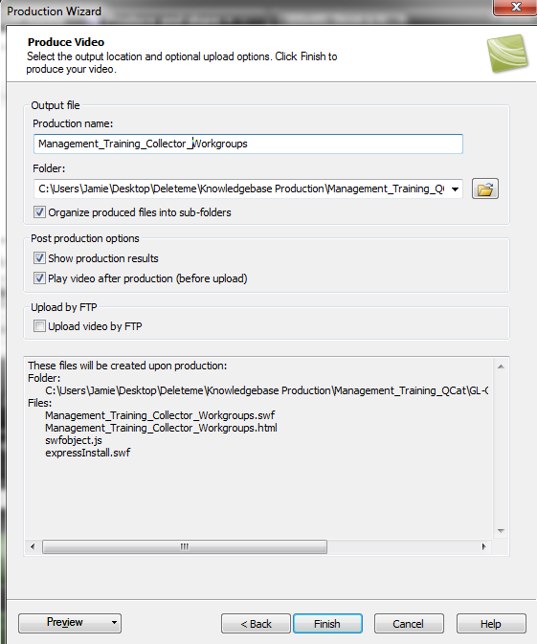

Glossary Production



This is the image that will be used for creating the glossary.

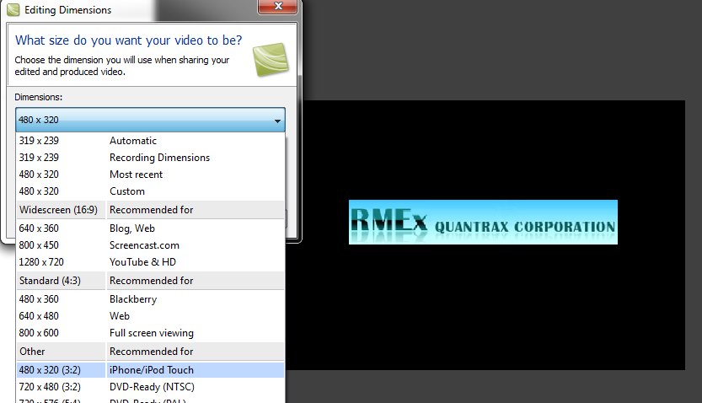

Produce at 480X320

**Converting WebEx to Camtasia videos…**

You will need to download your WebEx training session.

You will also have to install the “ARF Player” software, which will do the actual converting of your WebEx presentation.

<https://welcome.webex.com/client/wbxclient/nbr2player.msi>

After you have installed the ARF Player, you can go here for the instructions for saving the WebEx session to a WMV file. The WMV file format can then be used in Camtasia.

<http://support.webex.com/support/documentation/help/index.htm#9402.htm>

Once you have converted the file to a WMV you use our normal process for creating and publishing videos.

**WebEx to Camtasia for publishing after saving as a WMA file.**

The WebEx video may have parts of your desktop that you will not want in the finished product.

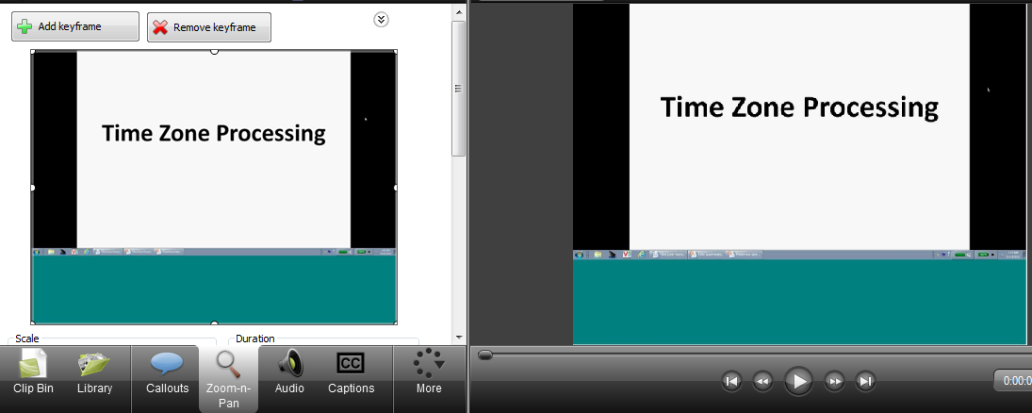

Within Camtasia there is a tab called "Zoom-N-Pan

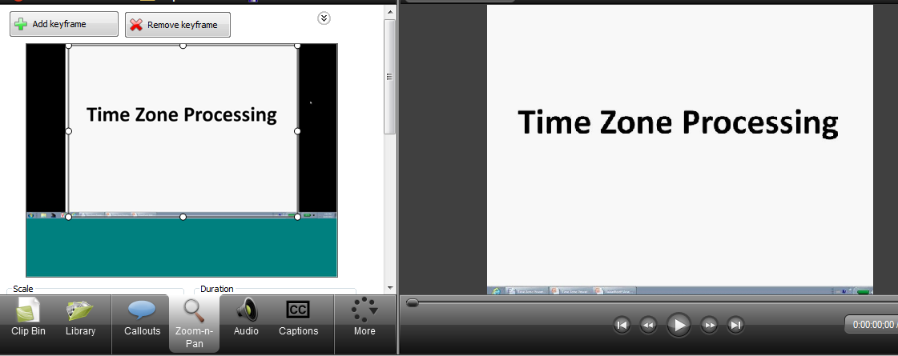

This tab will give you the ability to draw a box around your video, in essence zoom in, on the are that you want to present excluding anything outside that box.