Using the Project System for Support Team Tasks
Accessing Project System & Creating New Support Task
- Login to the AS400  - Go to the command line and type Call IQ  - From IQ Support Main Menu select 2 for Project Inquiry  - To create new project (task), from Project Search screen press F1 for New Selection | 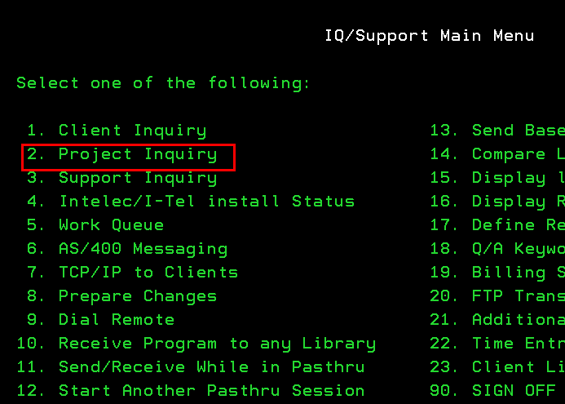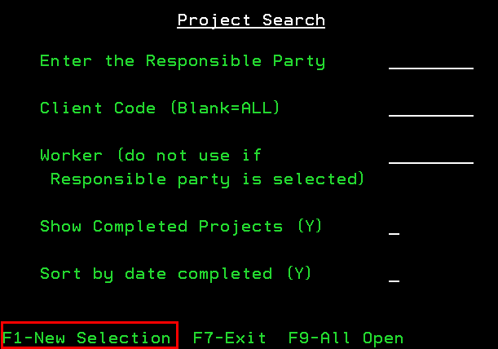
Creating NEW Support Task
- To automatically generate code, press F12 for Allocate Project Code  - Enter the following values:  - Client = QUANTRAX (unless specific for client)  - Bill Hrs: amount of hours estimated to complete the project  - Project Summary: Name the project/task  - Responsible Party: Support  - Worker: Enter your AS400 User ID (Dawnab, Patl)  - Billable: leave blank  IMPORTANT: the default is Y for billable, ensure you have correct info in this field or client maybe billed, STATUS NOTES GO TO CLIENTS  -Status: Press F6 for list (To Delete change STATUS=CANCL)  - Press F12 to Update  - Press F7 to Exit |  |  | 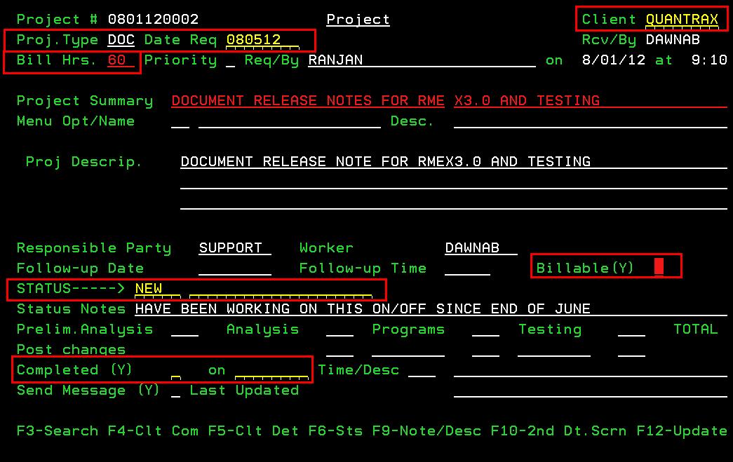
Searching for Task and Update / COMPLETE
- Go Project Search screen, to search for:  -Support tasks enter Responsible Party = Support  -Individual tasks enter Worker = AS400 User ID  NOTE: Press F8 (Minimize/Maximize) to see Project Summary  - Change STATUS as needed (press F6 for options)  - Enter Project Notes  - Enter Status Notes (IMPORTANT GOES TO CLIENT)  NOTE: Press F9 for Notes History  - Enter actual hours worked in PrelimAnalysis/Analysis/Programs/Testing  - When task is complete :  End Status = P (always use this - as per Nelson) and Completed =Y |  | 