Time Processing

**Table of Contents**

What is Time Zone processing? 3

The Allowable Calling Period 4

The Time Zone File 5

UTC 6

Time Zones and Time Zone Values 6

The DST Indicators 6

Calculating the Allowable Calling Period 7

The State Controls Table 7

Checking Valid Calling Times for an Account 9

Calculating the Allowable Calling Period for 800 Numbers 11

Calculating the ACP for All Numbers on an Account 13

Special Control Flags 14

### What is Time Zone processing?

Time zone processing ensures that when a call is launched into a particular state or province, it is at an appropriate time relative to the place being called. Every jurisdiction has an allowable calling period. This is typically from 8am to 9pm, local time, but there are significant variations that need to be taken into account.

* The complexity in time zone processing is not only related to the rules for calling each state or province (it is related to every user’s interpretation of the guidelines)

|  |  |
| --- | --- |
| **Scenario** | **Considerations** |
| A person has a home number in Maryland and carries a cell phone with a number in California  Goals:   * Make sure we do not call the person outside the guidelines    + The person may be in Maryland or California at the time the call is placed   + We know we are calling the home phone ( a fixed line in Maryland) | * Can we call at 8 AM? * Do I have to wait until 11 AM EST, when it is 8 AM in California and the debtor may have left for work? * What if the debtor forwarded their home number to their cell phone, and you would be calling at 5 AM, and calling outside the allowable calling period? * What if there are 3 home numbers for a debtor, and the least likely number happens to be the right number, but it is in a different area from the other two? * Should the third number be taken into consideration on a campaign that did not even include that number? |

* It is not about where a call originates but what matters is the time in the location that we are calling to

**Example:** Many companies outsource their call centers to locations outside the United States, the time zone logic we have in place can accommodate the following:

* + A dialer that could be outside the United States
  + Calls placed to accounts within the various territories within the U.S.

**Solution:** How does the system do this?

* + The system converts all the calling time parameters to numbers that are all based on GMT (which does not change)
  + This allows us to place a call to any part of the world, regardless of where the dialer is located

|  |  |
| --- | --- |
| **Scenario** | **How system handles the situation** |
| A company with two locations, one on the East coast and the other on the West coast.   * The East coast location is making calls, but at 10 a.m. loses one of their telephone circuits due to a technical problem * The West coast operation could make calls from their office while the problem is being resolved | * The dialer will make sure that people are only called based on the times that we are allowed to call the different destinations (system does not care where the calls originate from) * The system will take care of adjustments required for daylight savings time (DST) with accurate calculations for the few areas that do not observe DST   **NOTE:**  **RMEx:** You **must** tell the system when DST is effective and reset the option at the end of the DST period.  **I-Tel:** Handles the different calling hours that may exist in different regions, Canada is an example. |

### The Allowable Calling Period

The allowable calling period is the period between the earliest possible time to call and the latest possible time to call.

|  |  |
| --- | --- |
| **Scenario** | **How system handles the situation** |
| If as state has multiple time zones, you need to decide if you want to restrict calling to a specific period for the entire state.   * Maryland has an earliest possible start time of 08:00 and a latest possible call time of 21:00 (Both these times are expressed in EST or *local time*) * California has the same allowable calling period, expressed in Pacific Time * U.S. default calling times for a state are 8 AM to 9 PM | * This information is held on the State Controls table SC0039, in local time   **NOTE**: The *local time* on the state controls table is the time in the state where you are calling from.   * If you are in MD, the correct time for CA would be 1100 to 0000 * If you are in CA, the correct time for MD would be 0500 to 1800 * In most states, the period is 08:00 to 21:00, as expressed in local time * There are different rules for calling Canadian provinces |

### The Time Zone File

The Time Zone File is information that defines the time zone that each phone number, state or zip code is associated with.

This area is complex, because all areas within a single state do not fall into the same time zone. All states do not follow DST, and some areas within a state may choose to have different rules. Where are these rules available?

* Quantrax uses data provided by ***Melissa Data***, a company specializing in time zone processing.
* The company provides an initial master file and then regular (quarterly) updates thereafter.
* Clients need to contract with Melissa Data to receive this file regularly
  + The file, named SCITLTZ on RMEx, contains area codes and exchanges (the first seven digits of the ten digit number)
  + The state where those area code/exchanges are located
  + The zip codes where those area code/exchanges are located
  + A *time zon*e value
  + A DST (Daylight Savings Time) indicator

**NOTE:** ***Melissa Data*** does not provide the DST flag. This must be entered whenever new area code/exchange   
 combinations are loaded to SCITLTZ.   
  
The Time Zone Table (the Melissa Data file)

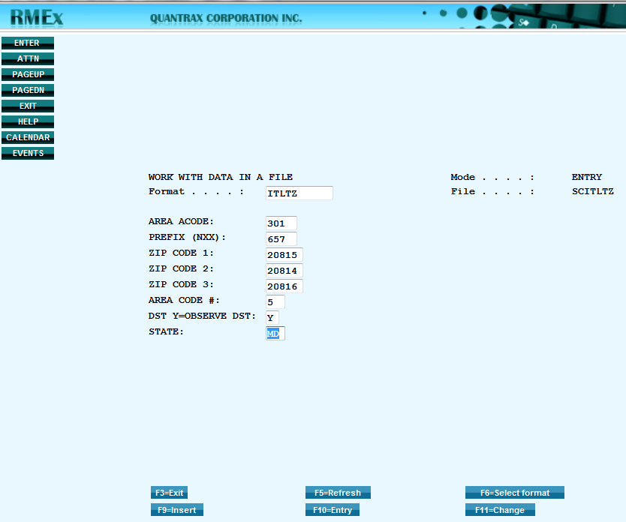

The area code value is used to calculate the allowable calling period for a specific number. This is ‘TZO’ or time zone offset.

Where there is no entry on the time zone file for a particular area code/exchange combination, the default value of 2pm to 5pm (Eastern Time) is used. This will occur when a new area code or exchange is added to the grid, and the ***Melissa Data*** file is not updated on a timely basis. Therefore, predictive dialing campaigns that include a number that cannot be accurately located as described above, the allowable calling period for the account will be 2pm to 5pm. If an agent attempts to launch a call (while in preview or power dialing) to a number that cannot be accurately located as described above, the call will be prohibited outside the period 2pm to 5pm (Eastern Time).

### UTC

UTC stands for Universal Time Coordinated. It is equivalent to GMT (Greenwich Mean Time). By comparing local times to UTC, we can ensure that we never call an account ‘out-of-time-zone’.

### Time Zones and Time Zone Values

Time zones are expressed in terms of the difference between local time and UTC (the UTC offset). If it is noon in Maryland, it is 5pm in Greenwich (near London, UK), so the UTC offset will be 5.

|  |  |
| --- | --- |
| **Time Zone** | **UTC Offset** |
| 1. Atlantic Time | 4 |
| 1. Eastern Time | 5 |
| 1. Central Time | 6 |
| 1. Mountain Time | 7 |
| 1. Pacific Time | 8 |

### The DST Indicators

There are two DST indicators. There is one for the phone number being called, and one for the location of the dialer server.

* We determine the value of the DST indicator for the phone number being called from the time zone file   
  (For a phone number in Maryland, this value will be ‘Y’)
* We determine the value of the DST indicator for the dialer server by looking at the Dialer Control File on RMEx. If this indicator is set to ‘Y’, then the time on the dialer Server will take into account the fact that the local area is observing DST

### Calculating the Allowable Calling Period

In order to be able to process accounts from different time zones within the same campaign, we convert all allowable calling periods to UTC format, expressed as a decimal. These values are stored in the QIPHT1 and QIPHT2 fields on the SCCQUE and TQ files.

To calculate the allowable calling start times and end times, we use the following equation:

**(AST+TZO-DST) / 24**

|  |  |
| --- | --- |
| **AST** | * The allowable start time in local time, in hours. * This is 8am for all states   + Maryland would be ‘0800’ |
| **TZO** | * The time zone offset (hours behind UTC or GMT) for the area code/exchange combination being called, from the time zone file   + For 301 657 2084, this value would be ‘5’ |
| **DST** | * DST is equal to ‘1’ if the DST flag for the area code/exchange combination is equal to ‘Y’ AND the DST flag on the Dialer Control File on RMEx is equal to ‘Y’ * If either flag is blank, then DST is equal to zero |
| **24** | * The number of hours in a day |

**Example**: For **301 657 2084,** the calculation would be: **(08+5-1) / 24 = 0.5**

So the value in the **QIPHT1** field would be **0.50000**

**NOTE**: In this example, DST is being observed.

To calculate the end time, we use the default time of 9pm for all states.

Maryland would **be ‘21’**

For **301 657 2084**, the calculation would be: **(21+5-1) / 24 = 1.04166**.

So the value in the **QIPHT2** field would be **1.04166**

### The State Controls Table

In addition to controls over the number being called, there are also controls based on the state in the consumer’s address.

In order to implement these controls, the **No working before** and **after** fields **must** to contain appropriate values and the ‘Use time for Dialer Campaigns’ field must be set to **Y**

If the option ‘Use Time for dialer campaigns’ is set to ‘**Y**’, then the allowable calling times from the state controls record (**No working before** or **after**) are factored into the calculation of the allowable calling period.

**NOTE**: For states with multiple time zones, such as Florida or Texas, you should use the most restrictive period.

**Example**: You should have the **No working before** time for Florida set to ’0900’ and the ‘after’ time set to ‘2100’. This will ensure that when we launch a call to Florida, we do not call before 9am, just in case the consumer is located in the panhandle.

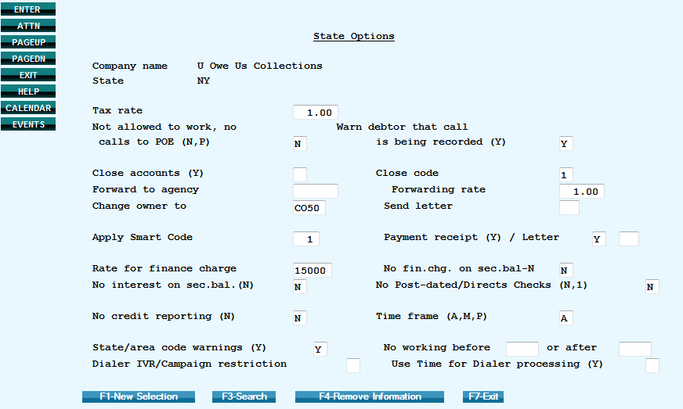

### Checking Valid Calling Times for an Account

There is a facility to verify that the calculated allowable calling period is correct. There is a menu option located on the **I-Tel Management Options** menu that will display the *ACP* in both *UTC* and in 24-hour format.

**NOTE**: Minutes are expressed in decimal (13.5 is equal to thirteen and a half hours and is therefore 13:30)

The following screenshots depict the steps to verify calling times:

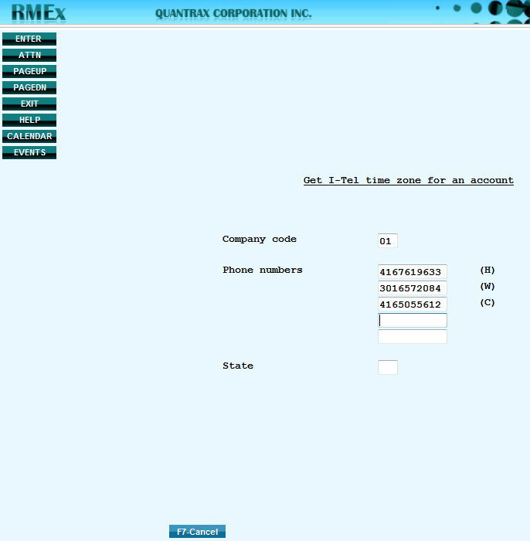

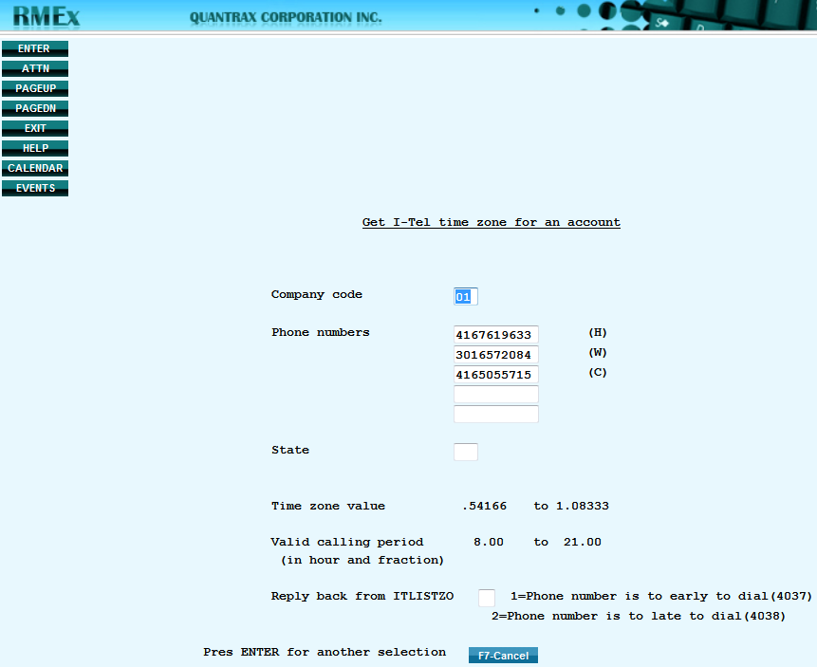

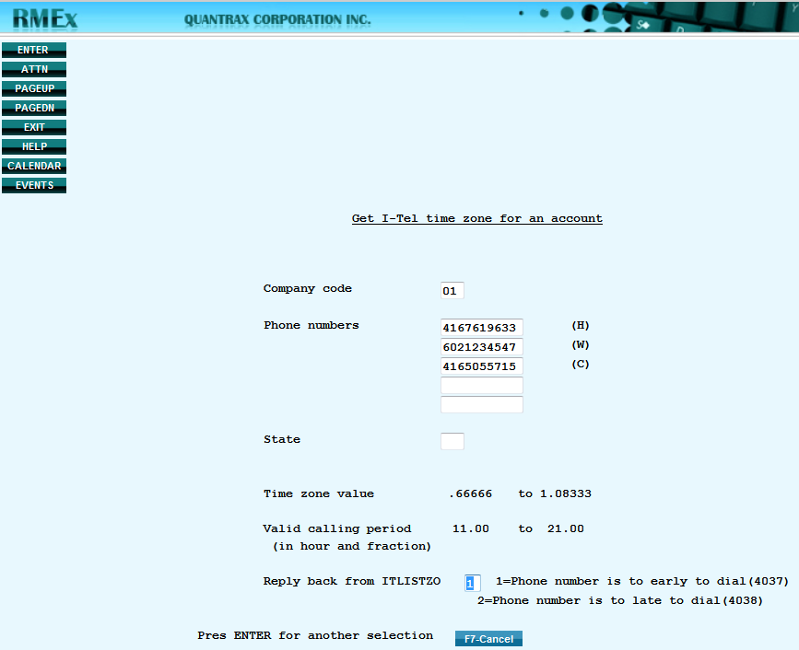

### Calculating the Allowable Calling Period for 800 Numbers

If an account has an 800 number in one of the three fields on the main account screen, the system looks at the ‘**Use of 800 numbers for time zone**’ field on the Dialer Control file. The default value is **‘ ‘** (**blank**).

If this option is selected, the system will set the allowable calling period to 2pm to 5pm (Eastern Time). This will ensure that an 800 number which may be in Hawaii is not called too early. If option ‘**N**’ is selected, the calculation of the allowable calling period will not take into account the 800 number: it will be calculated only on the other numbers on the account and the state code.

**Example #1**: An account with:

* + - * a state code of MD
      * a home number of 301 657 2084
      * a work number of 800 123 4567
      * will have an allowable calling period of 8am to 9pm

If option ‘**A**’ is selected, the calculation of the allowable calling period will not take into account the 800 number, even if the 800 number is the only number on the account: it will be calculated only on the state code.

**Example #2:** An account with:

* a state code of MD
* work number of 800 123 4567
* will have an allowable calling period of 8am to 9pm

**NOTE**: The term ‘800’ number includes all toll-free numbers such as 866, 877, 888 etc.

Where there is no entry for a particular area code/exchange combination, the default value of 2pm to 5pm (Eastern Time) is used. This will occur when a new area code or exchange is added to the grid, and the ***Melissa Data*** file is not updated on a timely basis.

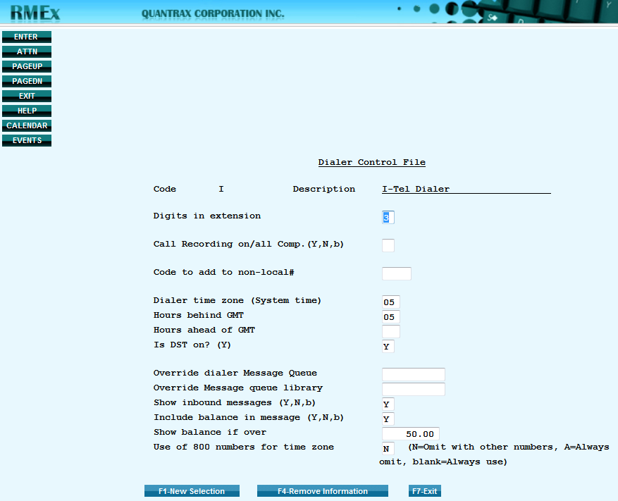

### Calculating the ACP for All Numbers on an Account

The **Allowable Calling Period** (**ACP**) is based on the three telephone numbers on the main account screen, plus the state controls table.

The **ACP** for each number is calculated based on the values in the time zone file. If any of those three numbers is in a state different from the state in the address, the **ACP** for the state (from the state controls table) is also factored into the calculation. The system will take the latest start time and the earliest end time of all the four factors. These times become the **ACP** for the account.

There is a further feature that applies a more rigorous standard, and this can be turned on or off by a flag. This flag is the field **OPF008** in file **SCSYSOP2**. The default value **is ‘ ‘** (**blank**) - the system will calculate the **ACP** as described in the above paragraph.

**NOTE**: The phone codes table must be set up correctly for this feature to operate

* If the value is ‘**A**’, the **ACP** will be calculated based on every number associated with the account
* The **ACP** for every number on the **TAB+** file for this account will be calculated
* Only numbers with an upper case phone code will be considered (numbers with a lower case phone code have been disabled and cannot be called)
* The system will take the latest start time and the earliest end time of all the numbers associated with the account. **These times become the ACP for the account.**
* If the value is ‘**D**’, the **ACP** will be calculated based on every debtor number associated with the account
* The **ACP** for every debtor number on the **TAB+** file for this account will be calculated

**IMPORTANT NOTE**: Only numbers with an upper case phone code will be considered and the system will take the latest start time and the earliest end time of all the numbers associated with the account. **These times become the ACP for the account.**

### Special Control Flags

There are three special control fields you can use that affect the calculation of the allowable calling period. These fields are on file **SCSYSOP2** and must be changed using **DFU**. There is no menu option at present for changing the values of these controls.

| **Control** | **Description** | **Values** |
| --- | --- | --- |
| **OPF004** | TEXT('USE STATE FOR PREVIEW)  FOR PREVIEW TZ CALCS, USE STATE UNLESS ADDRESS IS BAD  THEN, USE PHONE NUMBER CALLED | The valid values for this field are ‘ ‘ **(blank)** and ‘**Y**’.  The default for this field is ‘ ‘ (**blank**).  **Blank**: The system will calculate the allowable calling period based on the telephone numbers on the account (home, work and cell from the main account screen) and the state in the consumers address. The result will be the most restrictive calling period.  ‘**Y**’: For calls launched in preview (including preview calls from within a predictive campaign), the system will permit the call if the current time is between the ‘earliest time to call’ and the ‘latest time to call’ on the state controls table, for the state in the consumer’s address. There will be no verification on the number being called.  If the ***return mail flag*** on the consumer’s account is set to ‘**Y**’, then the system will calculate the ***ACP*** for the number being called, and on no other data. |
| **OPF006** | TEXT('STATE FOR TZ - N=NO')  STATE IS NOT USED FOR TZ CALCULATIONS | The valid values for this field are **‘ ‘** (**blank**) and ‘**N**’    The *default* for this field is **‘ ‘** (**blank**)   * **Blank**: The system will calculate the allowable calling period based on the telephone numbers on the account (home, work and cell from the main account screen) and the state in the consumers address. The result will be the most restrictive calling period. * ‘**N**’: The system will not check the allowable calling times from the state controls table. The allowable calling period will be calculated based only on the phone numbers on the account. |
| **OPF007** | TEXT('FOR PREV.USE ONLY#-Y')  FOR PREVIEW: ONLY CHECK THE NUMBER BEING CALLED  DO NOT CHECK OTHER NUMBERS OR THE STATE | The valid values for this field are **‘ ‘** (**blank**) and ‘**Y**’  The *default* for this field is **‘ ‘** (**blank**)    This control field affects only preview dialing  **Blank**: The system checks the allowable calling period for all numbers on an account. If the current time falls outside the allowable calling period for any number on the account, or outside the allowable calling period for the state, the call is prohibited.  ‘**Y**’: The system will check the allowable calling period only for the number being dialed: it will not check the allowable calling period for any other numbers on the account, nor will it check the valid calling times for the state in the consumer’s address. |
| **OPF008** | TEXT('CHK ALL# FOR TZ-A,D')  FOR TZ USE ALL NUMBERS INC TAB+  A=ALL, D=DEBTOR NOS ONLY | The valid values for this field are **‘ ‘** (**blank**) ‘**A**’ and ‘**D**’  The *default* for this field is **‘ ‘** (**blank**).  **Blank**: The system will calculate the allowable calling period based on the telephone numbers on the account (home, work and cell from the main account screen) and the state in the consumers address.  ‘**A**’: The system will calculate the allowable calling period based on the telephone numbers on the account (home, work and cell from the main account screen) and the state in the consumers address AND all numbers on the TAB+ screen that have enabled (the phone code is upper-case).  ‘**D**’: The system will calculate the allowable calling period based on the telephone numbers on the account (home, work and cell from the main account screen) and the state in the consumers address AND all DEBTOR numbers on the TAB+ screen that have enabled (the phone code is upper-case). |