Error in the smart code program after transferring RMEx program changes.

Here are 2 causes for this issue::

First:
When applying program changes to RMEx, you’ll ftp the changes to a file starting with “@@” such as @@RCVF. Once you have transferred the changes, the smart code program will check to see if there are any new changes to be found in @@RCVF and apply them to the system.

One of the most important steps when transferring changes using FTP is to make sure you’re sending the files as BINARY. If you do not use the BINARY option when transferring changes, it will create an error in the Smart Code program.

Second:
Another way this can happen is if the existing @@RCVF file was deleted.
So when you FTP your changes to @@RCVF, a new @@RCV file gets created. The problem is that the new @@RCV file created by the ftp program will not be the correct record length. The proper record length for all files that start with @@ and used for receiving changes is 528.

Reviewing the Smart Code error from Work Active Job.
You’ll see the error when you do WRKACTJOB (work active job) from a command line and look for the SMARTCODE job under QBATCH

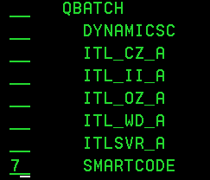

Placing a 7 next to the SMARTCODE job and hitting Enter will give a message something like this.

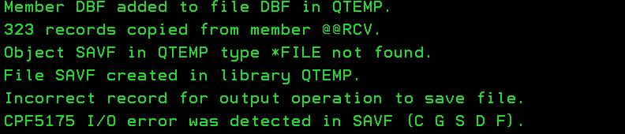

If you were to do a WRKF (work file) on @@RCVF you would see the file looking something like this.

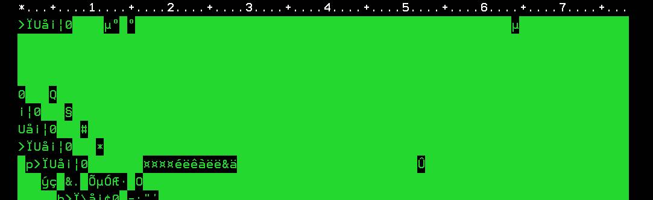

As compared to a file that was tranfered correctly, which will look like this

