|  |
| --- |
|  |
| **RMEx Secure E-Mail® Series**  **User Guide** |

**Table of Contents**

**Overview - RMEx Secure E-Mail® Series – Phase 1** 3

**Setting-Up RMEx Secure E-Mail® Series On Your System** 3

**Setting-Up Users** 4

**Uploading and Assigning Graphics/Text Files To RMEx** 4

**Setting-Up Letterheads** 8

**Setting-Up Cover Pages** 9

**Setting-Up Letters** 11

**Taking Actions Based On Consumer Interactions** 12

# 

# **Overview - RMEx Secure E-Mail® Series – Phase 1**

This feature allows our clients to send consumer letters via secure e-mail. In addition, it allows users to go beyond traditional e-mailing by providing the advantages of modern and user-friendly features of technology that will allow allowing your business to grow.

*Before* setting up RMEx Secure E-Mail Series® on your system you should have completed the following tasks:

1. Review product information [**here**](http://support.quantrax.com/KB/SecureEmailing/NewEmailingProduct_04122017Final.pdf).
2. Create your cover pages and letterheads to be used with the product. Instructions can be found via this link, [**RMEx Secure E-Mail Series® - Getting Started Guide**](http://support.quantrax.com/kb/SecureEmailing/RMExSecureEmail_GettingStartedGuide.pdf)**.**
3. Setup RMEx to e-mail letters (adding e-mail addresses, etc.); a list of Knowledgebase articles can be found [**here**](http://support.quantrax.com/KB/SecureEmailing/GeneralInstructionsToSetupLettersForEmailI%20Rmex.pdf).

**Setting-Up RMEx Secure E-Mail® Series On Your System**

Once you have completed *steps 1- 3* above, you can then start setting up RMEx Secure E-Mail Series® in your system.

**To turn on RMEx Secure E-Mail Series®:**

1. Go to on you need to **System Control Menu** > **Letter Codes**
2. Press **F7-EXIT**, to exit Letter Codes and move to the *Letter Request Options Screen*
3. Press **F7-EXIT** again to get to the *Letter Control Specifications Screen*
4. Set ***Allow emailing for letters*** to **S(ecure)**
5. Press **ENTER** to Update Information, then **F7-EXIT**

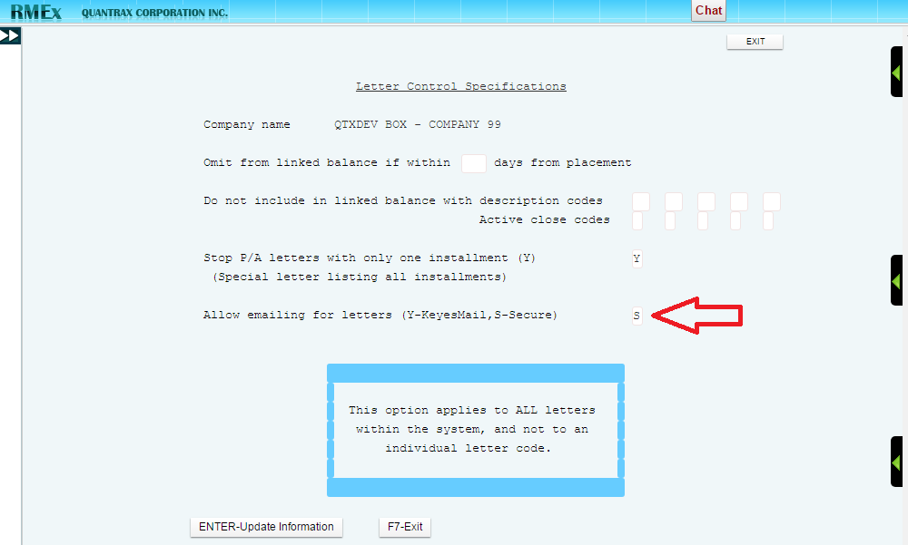

## **Setting-Up Users**

We recommend allowing only one or two employees in your organization to be able to maintain the secure e-mailing system controls. Quantrax will be adding the user profiles for this version, so please **provide Quantrax** with the users that you wish to allow changing secure e-mailing controls.

## **Uploading and Assigning Graphics/Text Files To RMEx**

Before you define your cover pages and letterheads, you need to load the graphics and text you previously designed, into RMEx.

To transfer your graphic/text files into the folder GBFLR in the IFS on your IBM I server (AS400). For those who are familiar with IBM Client access and different third party FTP interfaces, this will actually be an easy task, where you will simply need to grab and drop(or use a transfer feature) to get the file to the destination from your PC folder.

|  |  |
| --- | --- |
| **From here……** | **To here……** |

The command line method to transfer the documents through your Quantrax FTP folder is as follows:

1. From AS400 command line, type the command ***FTP RMTSYS(FTP.QUANTRAX.COM)***.
2. Provide your *user name*, press **ENTER.**
3. Provide your *password*, press **ENTER.**
4. Type command ***NAMEFMT 1.***
5. Type command ***cd EML***(Here EML is folder in the ftp site which contains your documents.).
6. Type command ***lcd /QDLS/GBFLR*** (This sets the local directory to GBFLR, where the images/documents should be transferred to).
7. Type command ***get NCP1.PNG C1.PNG***(Here NCP1.PNG is the file name in the ftp site and C1.PNG is the name we want the file to be in once transferred to GBFLR).
8. Repeat *step 7* to transfer all your files and type command ***quit*** to end your ftp session.

Once the files have been loaded into RMEx you need to assign them by doing the following;

1. Go to **System Control Menu 4**>**Secure E-Mailing**>**Maintain Standard Graphics.**
2. Type option (Opt) **1** with a two character Graphic ID to define your newly loaded graphic.

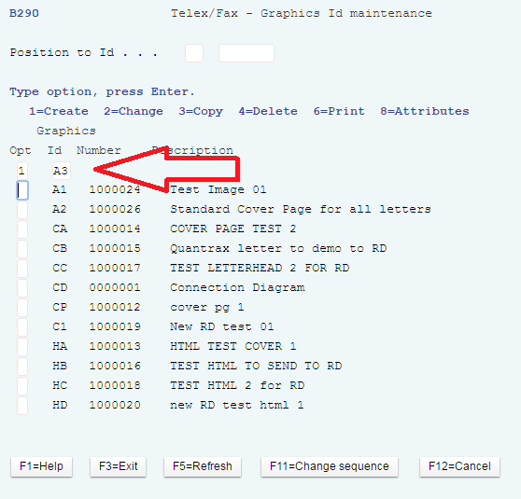

1. Type option (Opt) **2** to import your PNG/HTML graphic/document you loaded into GBFLR.

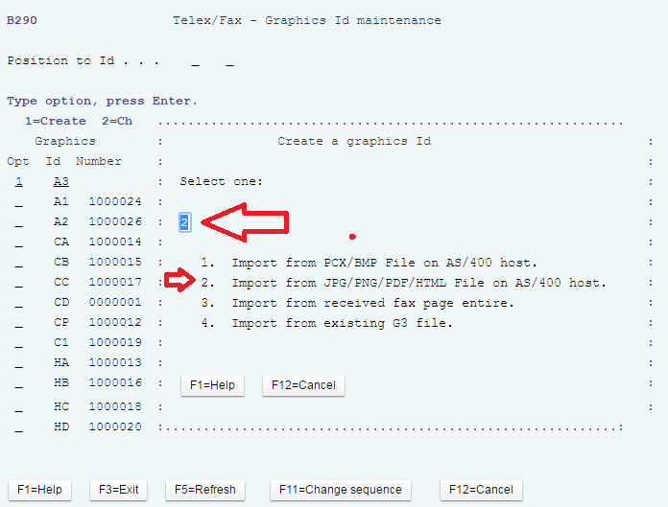

1. You need to issue the location of your uploaded document/Image in the IFS folder.

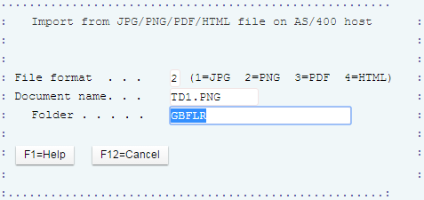

## **Setting-Up Letterheads**

You need to your graphic a description. If the loaded document/Image is to be used as a letterhead, then the ***Graphic ID*** and ***Letterhead*** options require to be changed as**1**; while everything else are kept at the default value.

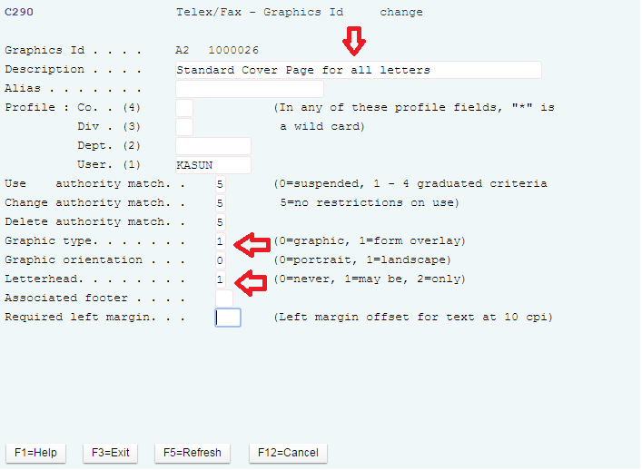

The two character ***Graphic ID*** defined above will be the letterhead code and can be assigned with letter codes directly; this will be explained later in the documentation.

## **Setting-Up Cover Pages**

If the loaded document/Image is to be used as a cover page, then only the ***Letterhead*** option requires to be changed as **1** while everything else is kept at the default value.

**NOTE**: Do not forget to give a description to your graphic.

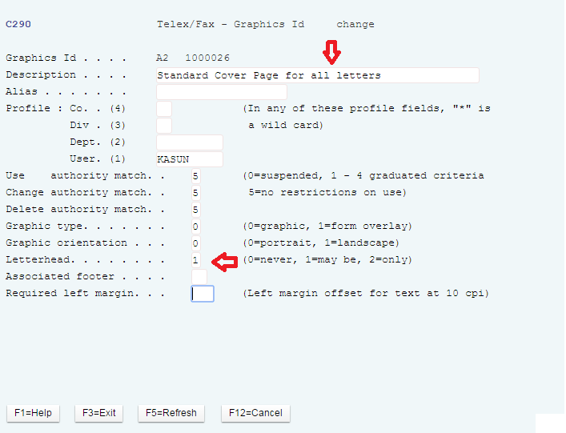

**To Assign the Uploaded Document/Image with a Cover ID**:

1. Go to **System Control Menu 4**>**Secure E-Mailing Options>Maintain cover pages.**
2. Use option **1** to create a cover sheet ID with a two character code.
3. Give a description for your cover ID and leave everything else at the default value.
4. In the next screen, you will need to decide where you want your graphic/HTML to start. Place the defined Graphic ID followed by **/** (as shown in the example below).

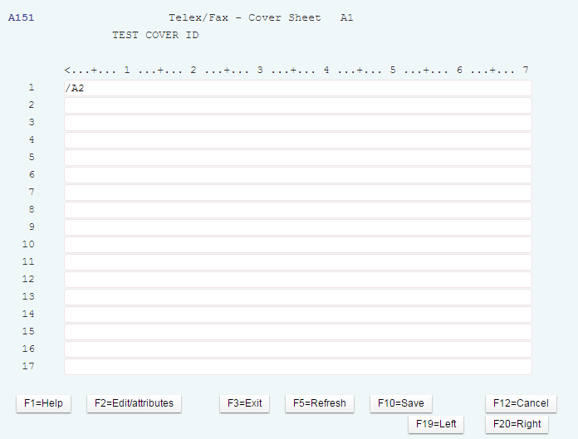

**NOTE**: We do not recommend adding text on the above setting while you use Images or HTML for your cover page. If you wish to use plain text in the cover page, then you can use the above screen to design you cover page without having to assign it with a graphic.

## **Setting-Up Letters**

1. Assign your cover page and letterheads with letters through **System Control Menu**>**Letter Codes**>Page 3 (Letter or document codes screen).

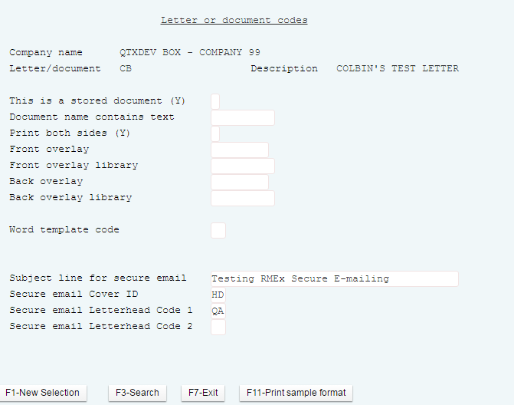

**NOTE**: When two letterheads are assigned with a letter, the first page of the letter will contain *Letterhead 01*while *Letterhead 02*will continue through the rest of the pages. The letter subject line will contain 11 digit RMEx account number (comp + case number) together with the letter code in addition to the subject that you have defined above.

Based on consumer interaction on the sent e-mail, RMEx will take action on the consumer accounts.

### **Taking Actions Based On Consumer Interactions**

The user can apply smart codes to each of the following user interactions. The assigned smart codes will get applied to the accounts interactively and automatically based on consumer interaction.

* E-mail sent
* E-mail viewed
* Attachment downloaded
* E-mail deleted

