The following are recent changes to RMEx 5.0:

February 28, 2017 – Telephony functionalities 2

February 28, 2017 – Other phone window 2

February 28, 2017 – GUI Theme 2

February 28, 2017 – DOB Search 3

February 28, 2017 – Notes 3

February 28, 2017 – Spooled files 4

February 28, 2017 – Help text 4

February 28, 2017 – Call history 4

August 04, 2017 – Follow up date 5

### February 28, 2017 – Telephony functionalities

Click on the ‘+’ icon next to the cell phone field in the account detail screen and the user will see the telephony icons which invoke functions such as pause recording, play message, transfer message etc..

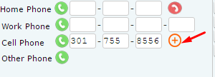

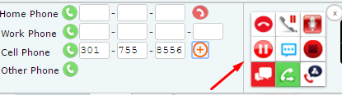

### February 28, 2017 – Other phone window

The ‘Other phone window’ (often referred to as the ‘TAB+’ window) can now be accessed by clicking on the phone icon next to the ‘Other phone’ field.

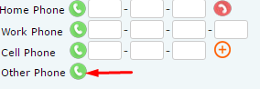

### February 28, 2017 – GUI Theme

The GUI will remember the theme that you select when you first logged into the system and when you try to log in the next time into the system it will automatically load the same theme that you had selected in your previous log in.

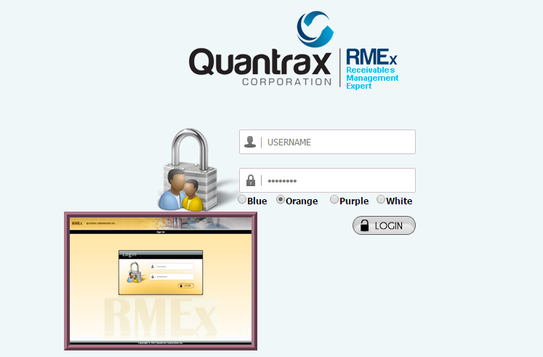

### February 28, 2017 – DOB Search

A user can now search for the consumer using Date of Birth (DOB) by inserting ‘20’ in the search type field.

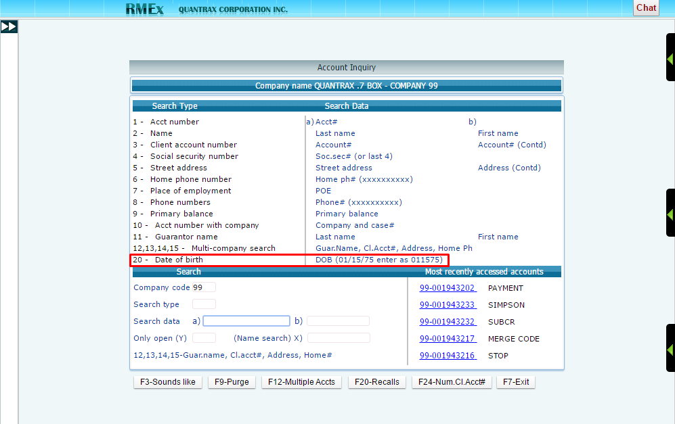

### February 28, 2017 – Notes

A user can enter notes in different colors (red, blue, yellow, pink and turquoise).

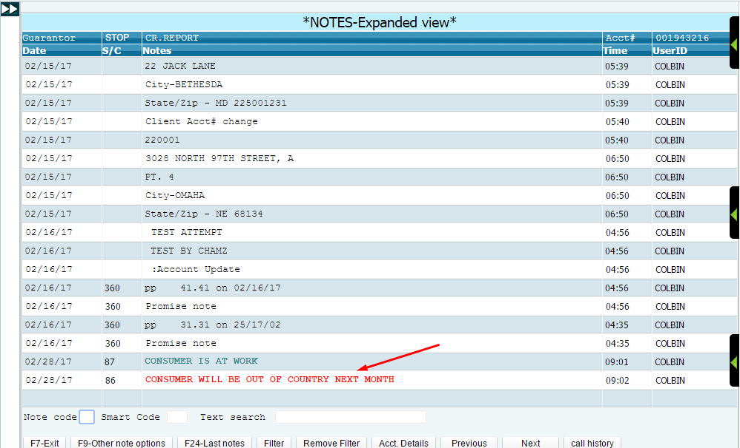

### February 28, 2017 – Spooled files

Previously, the user would have to sign off the system and sign back on through the ‘Classic view’ to access the spooled files. We have made a change and now the user can directly access the spooled files through the tree view.

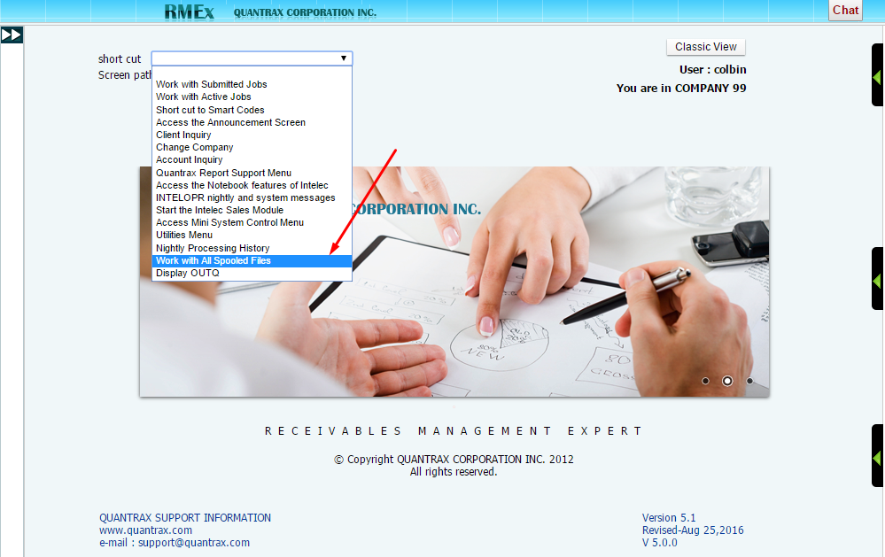

### February 28, 2017 – Help text

The help text can be accessed by hitting the ‘Alt’ + ‘F1’ keys simultaneously. Note that the help text will not be available on the protected fields.

### February 28, 2017 – Call history

The ‘call history’ option will be available in F11 notes only.

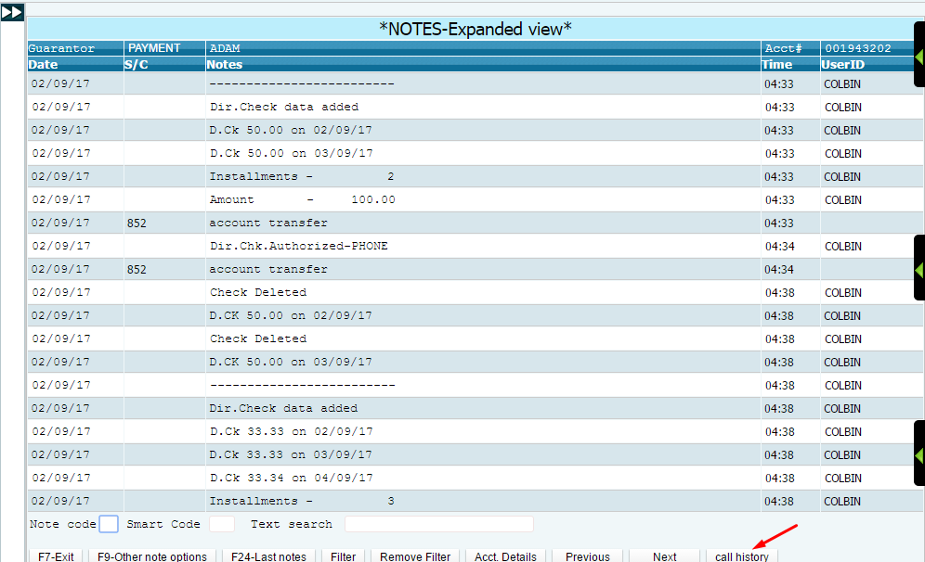

### August 04, 2017 – Follow up date

The follow up date, Time and Promise amount fields have been moved next to the ‘PD Check date’ field on the account detail screen.

