This document discusses the features and functionality of RMEx version 3.1:

Introduction – Release 3.1 Enhancements 2

Design and Navigation Changes (GUI) 2

Changing the Color Theme of RMEx 2

To Select A Color Theme: 3

Compatibility View - Unable to Login 3

Using the Tree Menu 3

Hiding the Tree Menu 4

Using the Classic View Menu 4

Accessing Custom Modification Options via the Tree Menu 5

Accessing Restricted Options 5

Using Shortcut Keys – ESC (Floating Menu) 5

Accessing the Common Options Menu 6

Warning Screens (Non-Collectors Only) 6

Collector Operation Changes 7

Searching by Place of Employment and Street Address 7

Viewing Description Codes (GUI) 8

Viewing Previous and Latest Notes (GUI) 9

Management Changes 9

Display Available Smart Codes 9

Change Primary To First Closed Active Account 10

Events (GUI) 10

Event Override Codes 10

Example of Override Codes: 14

Editable Event Notes 14

Standard Follow Up Days And Letter Code Through Events 15

Events Help Text 15

Printing Settlement Letters 15

I-Tel Updates 15

State Options for Time Zones 15

How Calling Times Are Determined When Calling A Debtor 15

Using Maximum Calls Option with Preview Calls 16

RMEx Administration Changes 16

RMEx Control Panel 16

iSeries Configuration 17

Server Configuration 17

Events Help Text 18

# Introduction – Release 3.1 Enhancements

Quantrax is proud to announce its latest release, v3.1 which provides and effective and user friendly way of managing and working accounts. The new menu navigation makes it easy for new collectors to learn the system.

The enhancements found in 3.1 are as follows:

* Design and Navigation (GUI)
  + Color Theme
  + Tree Menu
  + Shortcut Keys (Floating Menu)
  + New Warning Screens (non-collectors only)
* Collector Operations
  + Search – Place of Employment
  + Search – Address
  + Description Details for Description Codes (GUI)
  + Previous and Latest Account Notes (GUI)
* Management Changes
  + Display Available Smart Codes
  + Change Primary To First Closed Active Account
  + Events (GUI)
  + Return Mail – Recent Address Change
  + Settlement Letters
* I-Tel 3.1 Update
  + State Options for Time Zones
  + Maximum Calling Options with Preview Calls
* RMEx Administration (GUI)
  + RMEx Control Panel
  + ISeries Configuration
  + Server Configuration
  + Event Help Text

# Design and Navigation Changes (GUI)

## Changing the Color Theme of RMEx

Users have the option of selecting the color of the application screens. They can change the color to *Blue*, *Orange* or *Purple*; this is done at the login screen.

|  |  |
| --- | --- |
| **Orange Color Theme** | **Purple Color Them** |

## To Select A Color Theme:

1. On the *RMEx* *Login* screen, type your ***Username*** and ***Password***
2. Select the *color* *theme* (the default is *Blue*)
3. Click **Login**

### Compatibility View - Unable to Login

Depending on what version of Internet Explorer you are using, you may experience a problem logging in to RMEx. If you are using Internet Explorer 9; when you click **Login**, nothing happens. To resolve this problem:

1. Go to *RMEx Login Screen*
2. Before logging on, click on the **Compatibility** **View**  icon which is located in the URL address bar at the top of the screen (as seen below)
3. Try logging into RMEx

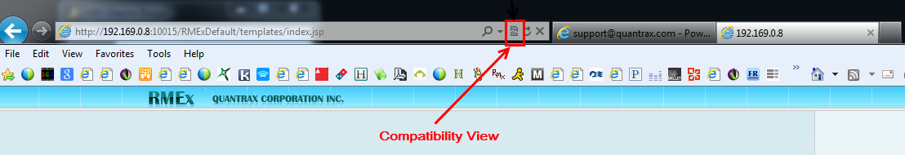

## Using the Tree Menu

RMEx 3.1 includes a new *Tree* *Menu*. This menu gives users the ability to view all the menu options at the same time from anywhere on the system, offering a convenient method for selecting options. Users can choose to hide the *Tree* menu. Experienced users still have access to the “classic view” or menu from RMEx 2.2.

**WARNING:**  Do not click on the *Tree* *Menu* until you are on the *RMEx* *Logo* (*screen shown below*) screen or you may not be able to move ahead in RMEx.

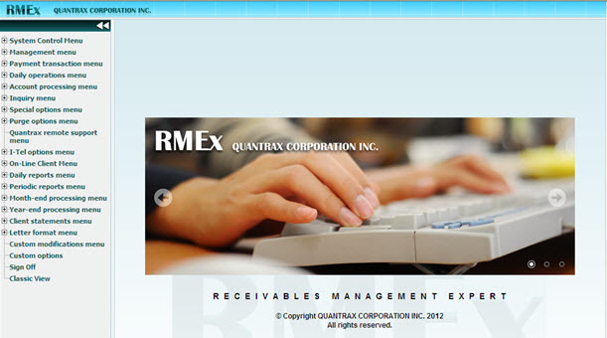

### Hiding the Tree Menu

Users can choose to *collapse* (hide) and *expand* (show) the *Tree* *Menu*. This can be done by clicking on, located in the top right-hand corner of the Tree Menu (as shown below). The works as a toggle; click once to *collapse* or *expand* the menu.

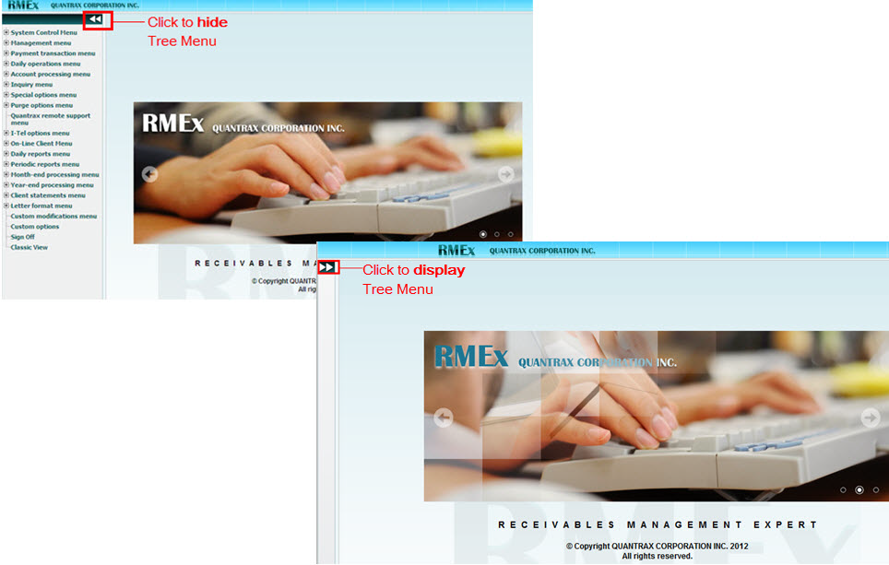

### Using the Classic View Menu

The *Classic* *View* *Menu* from previous versions of RMEx is still available.

**To Access The Classic View Menu:**

* In the *Tree* *Menu* (when on the RMEx Logo screen), *Classic View* (located at bottom of menu)

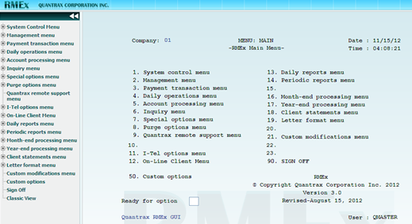

### Accessing Custom Modification Options via the Tree Menu

The *Tree* *Menu* only has options related to the RMEx base code. **Custom** **Modification** **Options** (sub menus) are not shown on the *Tree* *Menu* because it varies from client to client. To access these options, from the *Tree* Menu, click the last option *Classic* *View*.

### Accessing Restricted Options

When a user is restricted from accessing a menu option such as System Controls, the *Tree* Menu will show all menu options but when a user tries to access a restricted option, a pop-up a warning message will display.

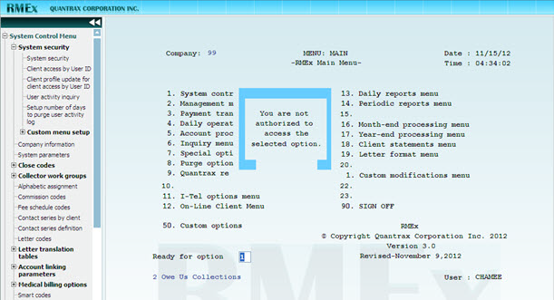

## Using Shortcut Keys – ESC (Floating Menu)

A list of available *Shortcut* *Keys* can be accessed anywhere in RMEx by pressing **ESC** for the *Floating* *Menu*. The Floating Menu displays the list of available keys that can be used to access other screens or navigate within the RMEx.

**NOTE**: The *Floating* *Menu* displays in the *Account* *Detail* screen but does not display in the *Notes* or *Description*   
*Codes* section of the screen. Always press **ESC from** the GUI page.

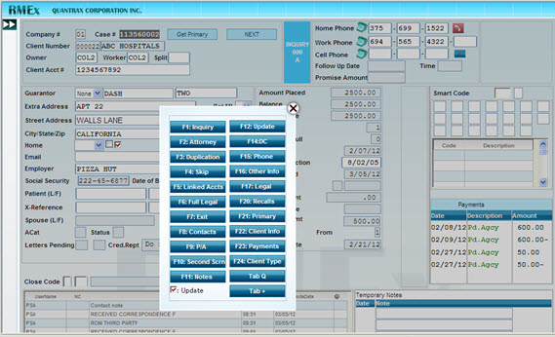

Accessing the Common Options Menu

The *Common* *Options* *Menu* can be accessed by moving your mouse over the  icon. You can also use the **Up-Arrow** key (🡹) on your keyboard. The *Common* *Options* menu includes navigational screen actions to move the user within a screen or to other screens within RMEx; provides shortcuts for the following:  
**NOTE**: This is how you access HELP. **ALT-F1** is not used for *HELP*.

|  |  |
| --- | --- |
| * ENTER * ATTN * PAGEUP * PAGEDN * EXIT * HELP * CALENDAR * EVENTS * Direct Check * Call History |  |

## Warning Screens (Non-Collectors Only)

There are two new *Warning* *Screens* that will present after login if the system detects specific issues. Both screens will only appear to users that are not set up as collectors in System Security.

1. **CHKSAVED**: Presents only if the system detects that the *Account* *Master* has not been saved within the last 4 days. **If this message appears you must have an issue with your backup**. Press **ENTER** to move forward.

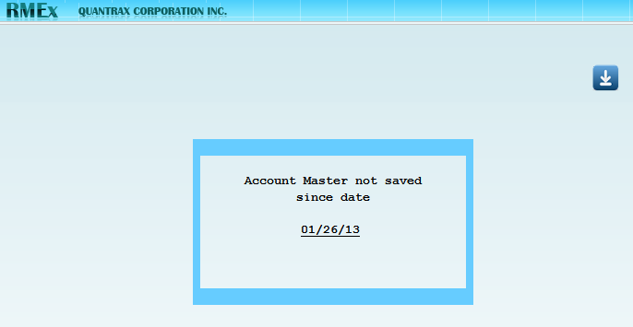

1. **CHKDISKD**: Presents only if the system detects that your **disk space is reaching a critical level of 85% or higher**. If this message appears you must take steps to begin freeing up disk space or contact your IBM partner to purchase more. Press **ENTER** to move forward.

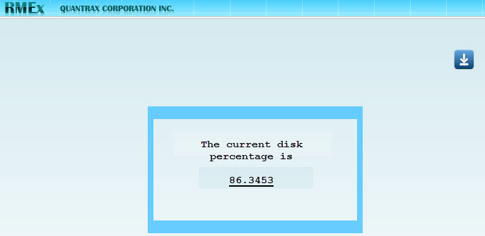

# Collector Operation Changes

## Searching by Place of Employment and Street Address

Users can search for *Place* of Employment (POE) and address searches from the debtor’s 1st detail screen. The *Address* and the *POE* fields will be highlighted.

* When *POE* is selected, a list of phone numbers for that place of employment will be presented.
* When searching by address, the *Inquiry* *Screen* and the *address* and *search* *type* fields will be populated; then press **ENTER** and you will be presented with all of the accounts that have the same address (as shown below).
* Search by the *Street Address* or *Employer* field. On the Account Detail screen, the fields will be highlighted (as shown below).

**NOTE**: If the user is restricted from changing or updating the *Street Address* or *Employer* fields, they will not be highlighted.

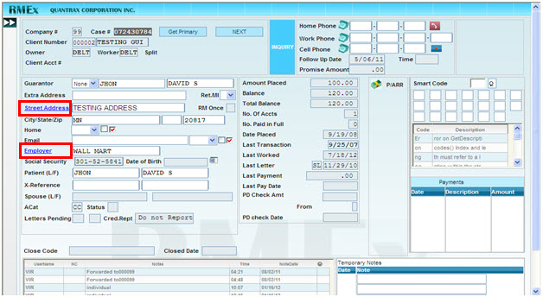

|  |  |
| --- | --- |
| **To Search by Place of Employment (POE):**   1. From *Tree* *Menu* click, **Inquiry** **Menu** > **Account** **Inquiry** 2. To Search by POE (*Employer field)*, *Search* *type*, type **07** 3. In *Search* *data*, type in **Employer name** 4. Press **ENTER** to perform search | **To Search by Street Address:**   1. From *Tree* *Menu* click, **Inquiry** **Menu** > **Account** **Inquiry** 2. To Search by Address, *Search* *type*, type **05** 3. In *Search* *data*, type in **Street Address info** 4. Press **ENTER** to perform search |

## Viewing Description Codes (GUI)

In the *Account* *Detail* screen, if the account has more than three *Description* *Codes*, use the scroll bar to view the remainder of the codes.

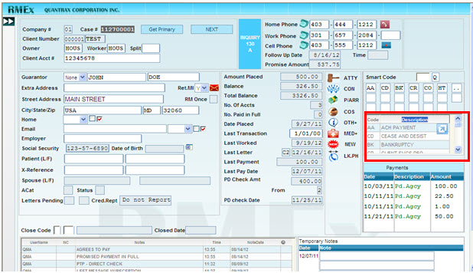

## Viewing Previous and Latest Notes (GUI)

On the *Account* *Detail* screen, users can easily browse through the *Notes* by using the **latest** (up arrow) and **previous** (down arrow) buttons to scroll up and down the *Notes*. The *Notes* section only shows five notes at a time.

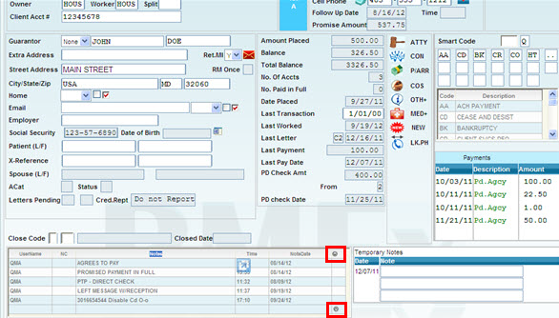

# Management Changes

## Display Available Smart Codes

The field **First unused code in each range** located in the first *Smart* *Code* screen (where you can create the code), lists your current *Smart* *Codes*. Use this feature to determine what numbers are available for new *Smart* *Codes*. The list of current *Smart* *Codes* is displayed by blocks of a hundred.

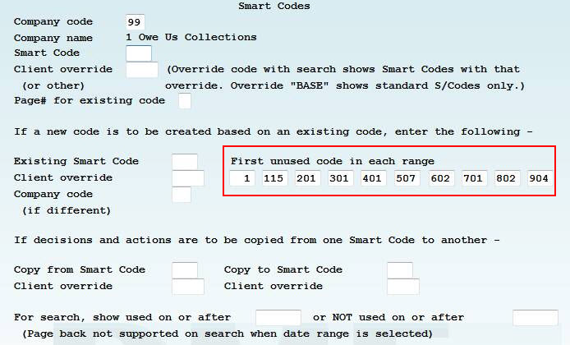

## Change Primary To First Closed Active Account

In RMEx, currently when the *primary account* is closed you can change the *primary* to the first open account. This feature would not work if all of the linked accounts were closed.

Now, when a *primary* *account* is closed, you can change the *primary* *account* to the first closed active account by typing **X** in the **Activate** field in the *Close Codes for Changing Primary Accounts screen*.

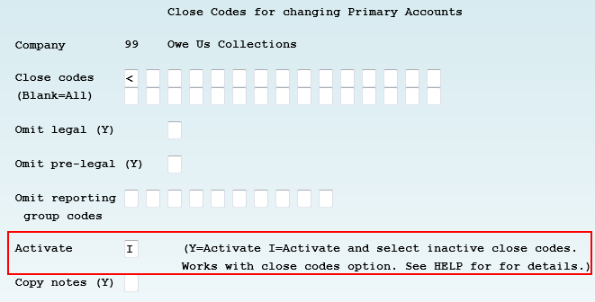

**To Change Primary To First Closed Active Account:**

1. Go to **System Control** > **Account Linking Parameters** > **Close codes for changing primary accounts**
2. In the Activate field, type **X**

## Events (GUI)

Event Overrides can be created by Client, Description Code(s) and Balance Range(s). The system has overrides for up to ten Description Codes and five Balance Ranges.

### Event Override Codes

*Events* can be setup based on a *Description* Code, Balance or the *Client* Code. The rules for priority are as follows:

* The client can define a special event override code for a specific client.
* The client can define new override codes for different balances and description codes for the above client override.
* Then when the collector tries to access an account through an event, they will be given an event/sub event list according to the matching description codes, balance and the client code.

The first step is to create your *Override* *Codes*. A code needs to be created for each scenario; one for the Client, one for each *Description* *Code* and one for each *Balance* *Range*. The second step is to create the *Override* *Code* that will be associated with your client; this is where rules are setup based on the Client, Description Code(s) and Balance Range(s). (Detailed steps to setup *Override codes* are on the next page)

**NOTE**: You **must** follow the steps in order listed below.

1. Setup events for each override code.
2. Define override rules for each client level event override.
3. Define client level event overrides.

**To Setup Events For An Override Code:**

1. Go to **System Control Menu 3** > **Dynamic Score/Events options** > **6 (to define) the Events** to have under each *Event* Over*r*ide *Code*. This will display a list of pre-defined *Event* *Override* *Codes*.

**NOTE**: To view the list of *Events* for *Event* *Override* *Code* (*6-Event*)

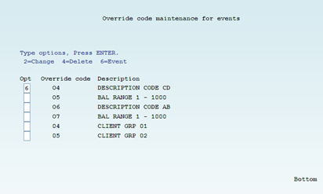

1. When the *Main* *Events* screen displays, take **option 6** again to view the sub events (if there are sub events set up under the main events).

**NOTE**: The events/ sub events can be defined for the selected *Event* *Override* *Code* via **System Control Menu 3** > **Dynamic Score/Events options** > **Option 4** (as in the original *Event* release)

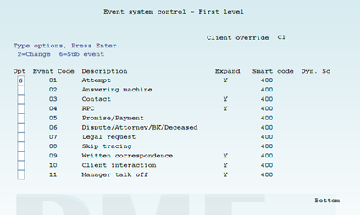

**To Setup Events For A New Event Override Code:**

1. Go **to System Control Menu 3** > **6 Events – System control setup (Overrides)**, you will presented with a list of existing *Override* *Codes*

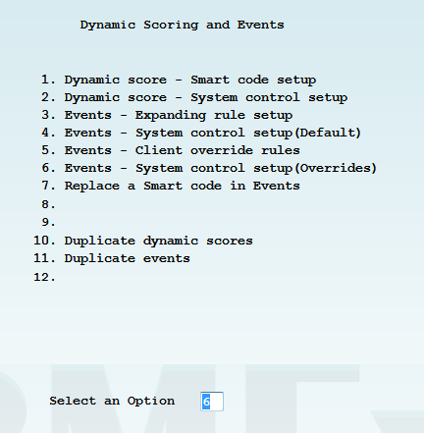 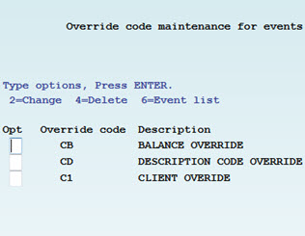

1. To create a new code, press **F6 - Add new**, and the *Override* *Code* *Maintenance* for events screen displays
2. Type in the new *Override* *Code* and the description and press **ENTER** to save your defined code

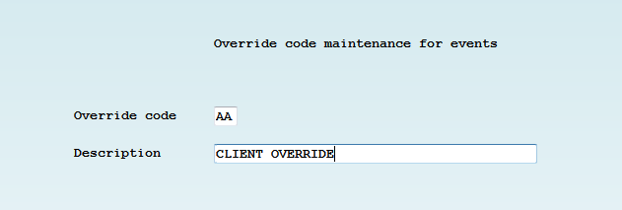

1. The following message will display, “*Do you want to copy default event list* “.

* Press **ENTER** to **confirm**, it will duplicate all the default events/sub events under the particular event override code.   
  *OR*
* Press **F7**, to **cancel** the duplicating and present the default event list from which the user can define events/ sub events as required.

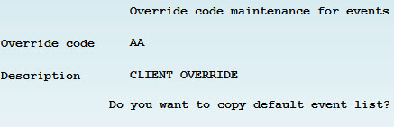

**To Setup Rules For Client Level Event Overrides:**

1. Go to **System Control Menu 3** > **Dynamic Score/Events options** > **Option 5 Events - Client override rules**. A list of pre-defined *client override codes* display.

* To create a new *client override code* press **F6 –Add new**
* To edit a pre-defined *client override code*, **type 2 (Change)** in front of the client override code to be modified

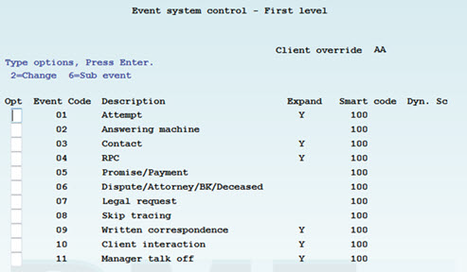

**To Setup Client Level Event Overrides:**

The final step is to tie the *Event* *Override* *code* to a *Client*.

1. *Client level event override codes* need to be setup through the *Client* *Master*, **Management Menu** > **Client Update**

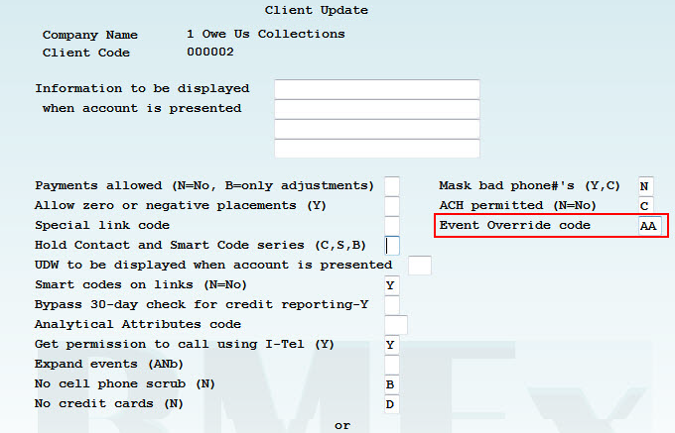

### Example of Override Codes:

| **EXAMPLE** | **WHAT TO DO** |
| --- | --- |
| Create override based ONLY on the client | 1. Use **System Control Menu 3** > **Dynamic Score/Events** > **6 Events – System control setup (Overrides)** to create an *Event Override Code* of ***AA*** and then modify your events 2. Use Option **5** and create a *Client* *Override* of ***AA*** again 3. Leave the *Description* *Code* and *Balance* *Range* option blank 4. Go to your *Client* and add *Client Override Code* ***AA*** in the field *Event override code* |
| Create override based on Client and Description Code(s) | 1. Use **System Control Menu 3** > **Dynamic Score/Events** > 6 **Events** – System control setup (Overrides) to create an *Event* *Override* *Code* of *AB* and then modify your events**.**   **NOTE**: Do the same for *Balance* *Range,*  in the *Balance* *Range* use *Events* *Override* *code* **AC**   1. Associate this to the client, by going to the client master file and add this *Client* *Override* code of ***AA***  - **Management Menu** > **Client Update** |

### Editable Event Notes

You have the ability to add up to three *Event Notes*; it is the same functionality found in older versions with the additional flexibility n to edit these notes before applying the event/sub event.

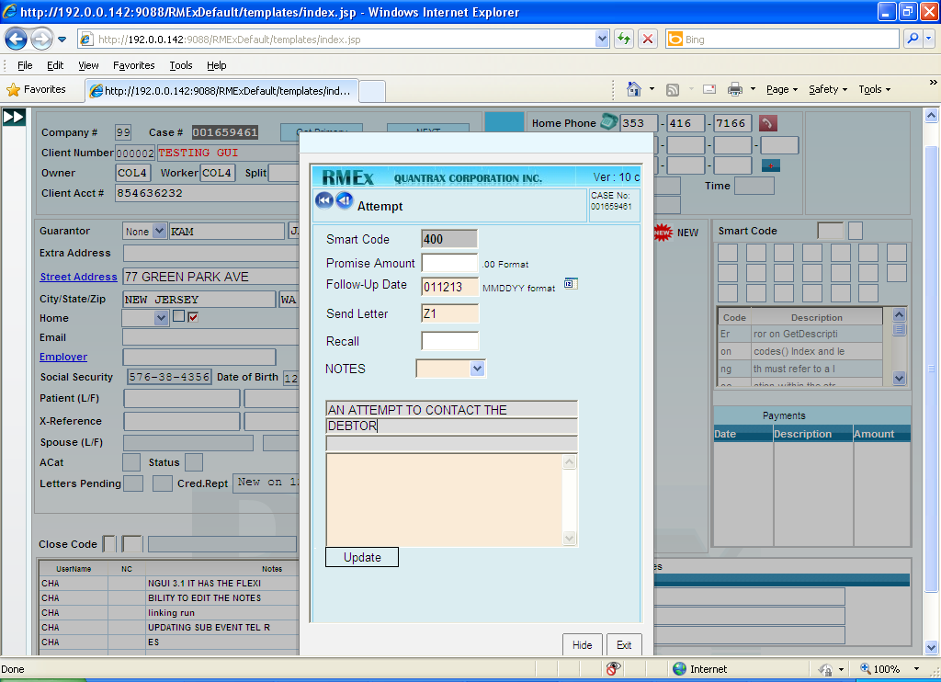

### Standard Follow Up Days And Letter Code Through Events

In Events, the standard number of follow up days and standard letter code is visible and editable. When an RMEx *smart* *code* is set up with optional follow up and letter, the standard setting will be visible to the collectors through an event/ sub event (as shown above). The user can choose to edit or to apply the standard information through the event.

### Events Help Text

Help text can be defined for each and every event and sub event using *RMEx Site Control Panel*. (See the section, *RMEx Administration Changes* for details on *the RMEx Control Panel*).

## Printing Settlement Letters

Settlement letters were not logged in letter history. The logic has changed for them to go to *letters pending* and print normally. To print a letter immediately, use **I** option to *print* *now*. This works as it did in the previous release and the letter prints immediately.

# I-Tel Updates

## State Options for Time Zones

**IMPORTANT:** I**-**Tel Dialer **c**lients must setup State Options for Time Zones. These fields must be setup for every state from the **System Control Menu (2**) > **State options**.

The option *No working before ______ or after _____* must be setup if you are using the I-Tel dialer for every state. This feature designates the times that you are allowed to call each state based on the *Time* *Zone* that **you are calling from**, and works in conjunction with the *Melissa* *Data* *Time* *Zone* file.

**EXAMPLE**:

* If you are a collection agency working from New York State:
  + Your California state options could say *No working before 1100 or after 0100*.
    - For a debtor in California that would be between 8am and 10pm.
* *Use time for dialer processing (Y) Y*.
  + Once the working times are setup, put a **Y** in **Use time for dialer processing (Y) Y** on that same page.

### How Calling Times Are Determined When Calling A Debtor

* RMEx looks at the phone number on an account (*First* *Detail* screen and *Other* *Phones*) and based on the area code and exchange, the *Time Zones* for all the numbers are determined.
* The Debtor’s address is also looked at to see what state that debtor resides in.
* The system will then review the *State* *Options* - *Before or After* settings, and compare that to the *Melissa* *Data* file (area code and exchange), and determine what is the safest time to call the debtor.

**EXAMPLE A**: Debtor’s residence state is different than state cell phone number

* Your Agency is in *New* *York* ***and***
* The debtor lives in *New* *York* ***but***
* The debtor has a work cell that is a *California* number

**Calling Times:**  (based on your setup options) could be 11am to 10pm your (New York) time.

**EXAMPLE B:** States that have more than one *Time* *Zone* (such as Florida or Arizona).

* Debtor lives in Tallahassee FL, which is Central Time Zone ***and***
* Debtor has a work cell number in Tallahassee which is Eastern Time Zone

**Calling Times**: An 8am (Eastern Time Zone) call to Debtor’s residence in Tallahassee, FL phone number results in call Debtor’s residents at 7am (Central Time Zone)

You must review your states, below is a guide, but confirm this information is current:

* Idaho and Oregon are split between the Mountain and Pacific time zones
* Kansas, Nebraska, North Dakota, South Dakota, and Texas are divided between Central and Mountain time zones
* Florida, Indiana, Michigan, Kentucky, and Tennessee are split between Eastern and Central time zones
* Alaska is divided between the Alaska time zone and the Hawaii-Aleutian time zone

## Using Maximum Calls Option with Preview Calls

We have many features to assist you in being compliant. One of them is Maximum Calls ([see RMEx 3.0 documentation](http://www.quantrax.com/kb/RMEx30/30FinalDocs/RMEx30_ReleaseNotes.pdf)), which allows you to make a certain number of calls to the debtor. When this feature was implemented, you could not make a *Preview* call **IF** the account was in a campaign that had been started. The rules have changed; you can make a *Preview* call **IF** the account is in a campaign but not if you use the *Maximum* *Calls* option.

# RMEx Administration Changes

## RMEx Control Panel

**RMEx Site Control Panel** (SCP) is used to manage the connectivity between RMEx GUI and iSeries/PC server. It acts as a centralized software component for most of the Quantrax products.

To access this feature use the following link, where *192.0.0.XXX* is the **IP** of the PC server where you have installed this console.

<http://192.0.0.XXX/SiteControlPanel/Login.aspx>

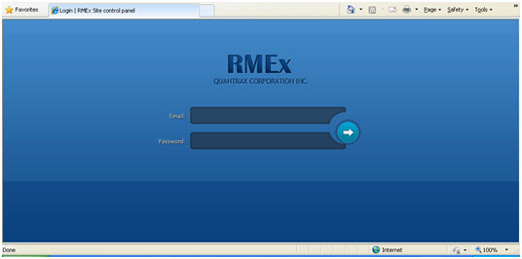

Once you log in you will be directed to *Home* screen.

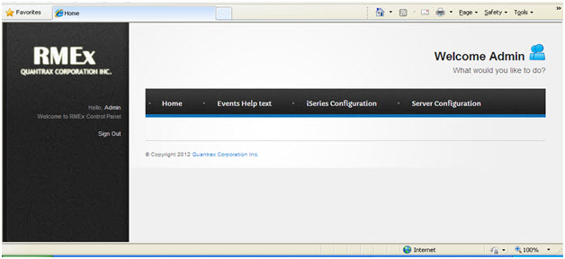

iSeries Configuration

Use the *iSeries Configuration tab* to set up the iSeries details to be used for all communication between RMEx GUI and iSeries. The set up allows up to 10 different databases for a single iSeries; thus gives Quantrax clients the ability to use multiple databases.

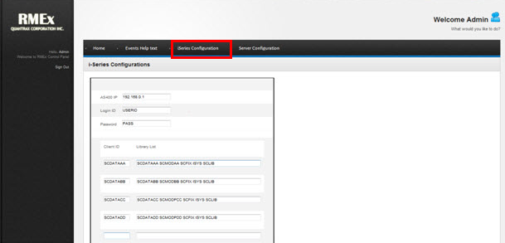

## Server Configuration

Use the *Server Configuration* option setup the PC server database settings for:

* Event Help Text
* System Dialer for Call history playback

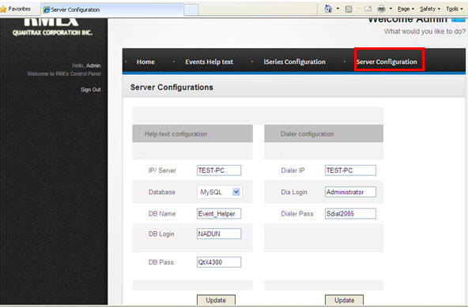

## Events Help Text

You the ability either to add or to edit the help text for each event/sub event you have already set up through the system controls for events.

**To Add Help Text for Events:**

**NOTE**: Make sure the Help Text configuration information was setup in the *Server Config*uration (previous section)

1. Login to the *RMEx Control Panel*
2. From the left-hand panel click, From the *RMEx Control Panel*, click **Event** **Root**

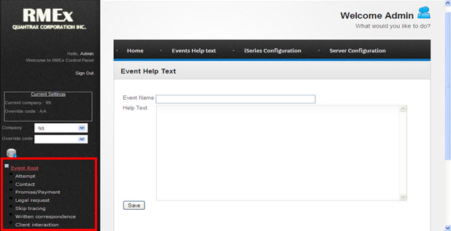

1. *Expand* the event/sub event set related to the selected *Company* and *Override* *code* combination  
   **EXAMPLE**: Event Help Text for main event **Attempt** is shown below. Help text can be defined for all events and their sub events.

