**New search type - By the social security # of patient, spouse , co-signer or multiple co-signer**

Quantrax has introduced another new feature to the ‘ Search Type ‘ options in Account Inquiry to locate an account using the social security # of patient, spouse , co-signer or multiple co-signer. To use this option you need to have the RMEx 2 environment.

**Step 1:**

Add **SCRMX21** to the library list.

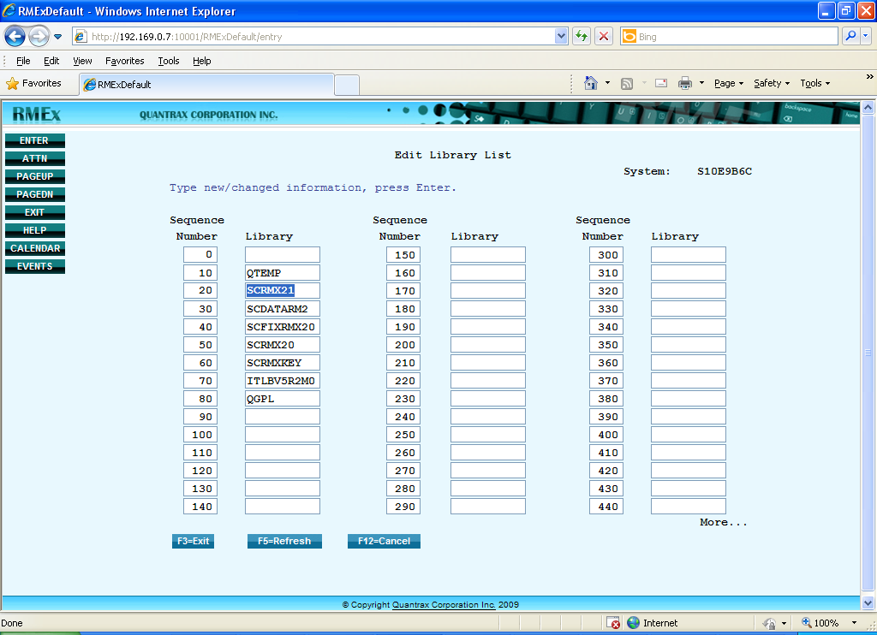

**Step 2:**

Go to the Account Inquiry screen. To search by the social security # of patient, spouse , co-signer or multiple co-signer, use ‘ Search type ‘ 04 and key in ‘X’ after the particular social security # and hit ENTER.

( **Eg. 854552450X ) – patient ss#**

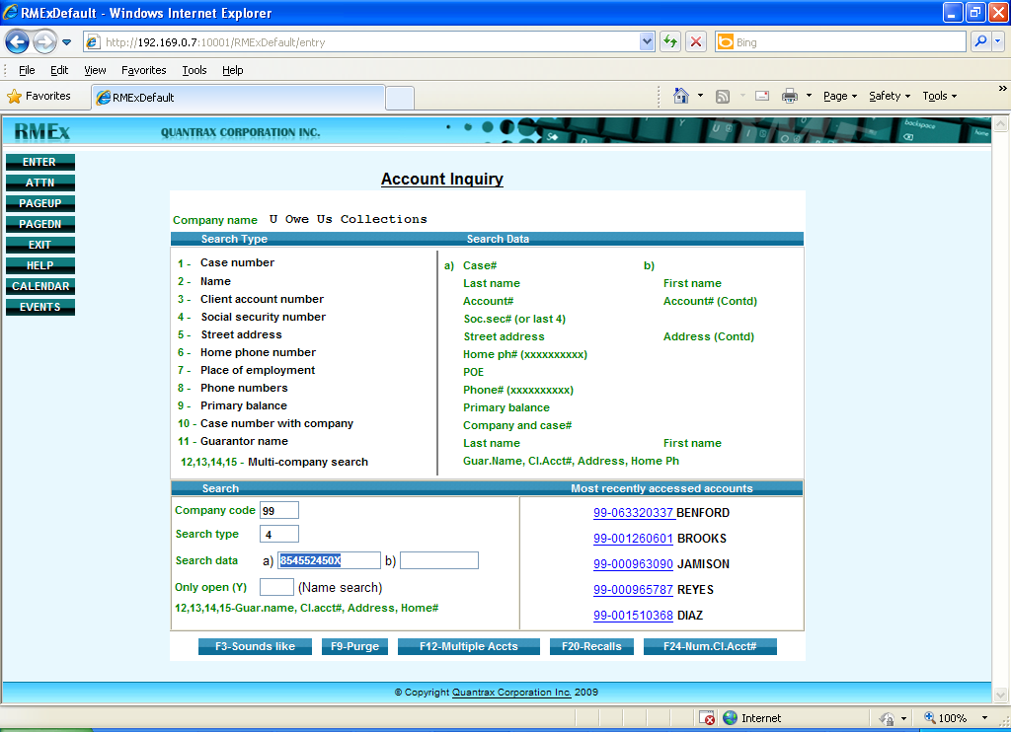

Then you will be directed to the particular account, which contains the SSN you searched for ( It could be of patient, spouse , co-signer or multiple co-signer ) as shown below.

