New selection options for the Analysis of Pending Payments
Quantrax has added two new flexible features to the ‘Analysis of Pending Payments’ option to allow the users to view a summary of the ‘total number of accounts, the total payments due and potential commission due’ for a particular date range. They are the ability to select using ‘Client codes’ and ‘if client is a group’.
You can access these feature using the following Menu Option.
RMEx Main Menu -> Opt. 3. Payment transaction menu -> Opt. 13. Payment reports for period -> Opt.10. Analysis of pending payments

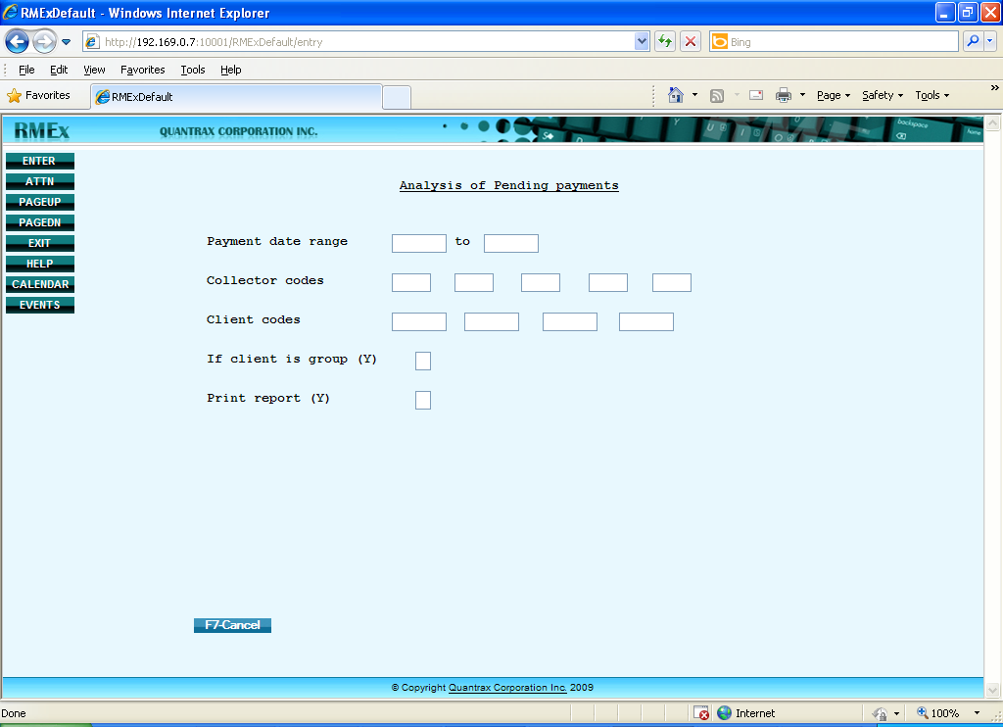

Here you will have the option of selecting the “Analysis of Pending Payments” by client codes. A total of 4 entries can be specified for a specific date range. The 'Client codes' field too is optional as the ‘Collector codes’. If you enter a client code in this field it will display only the payments due for that particular client for that given date range. (Blank equals ALL clients)
‘If client is group (Y)’ – Insert a ‘Y’ in this field if the client(s) you have selected is a group client.
After inserting the date range and the required fields; client codes (Optional) etc. and hit enter, it will display the following screens.
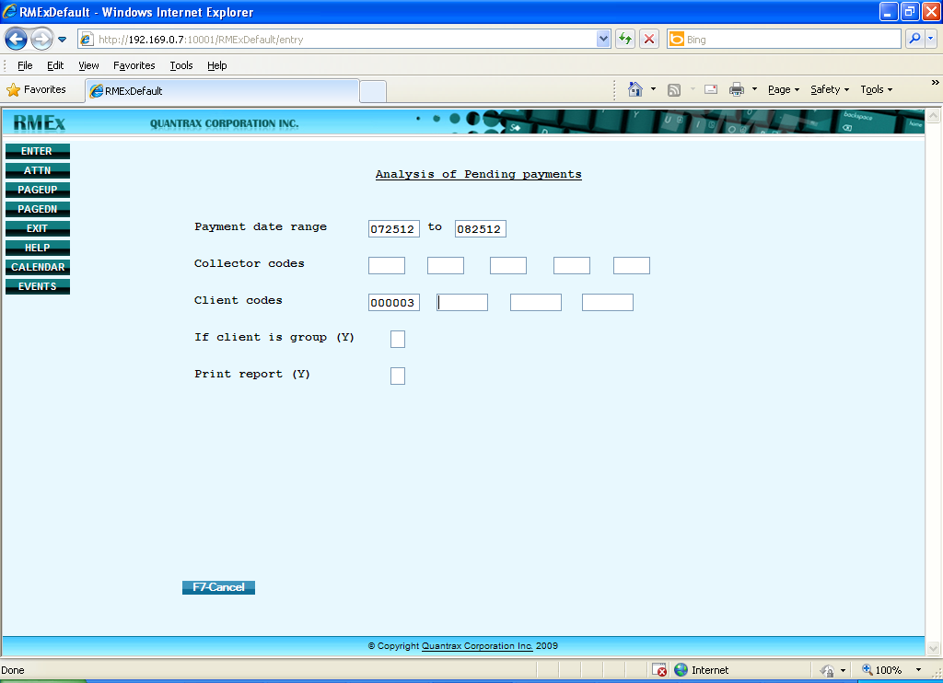
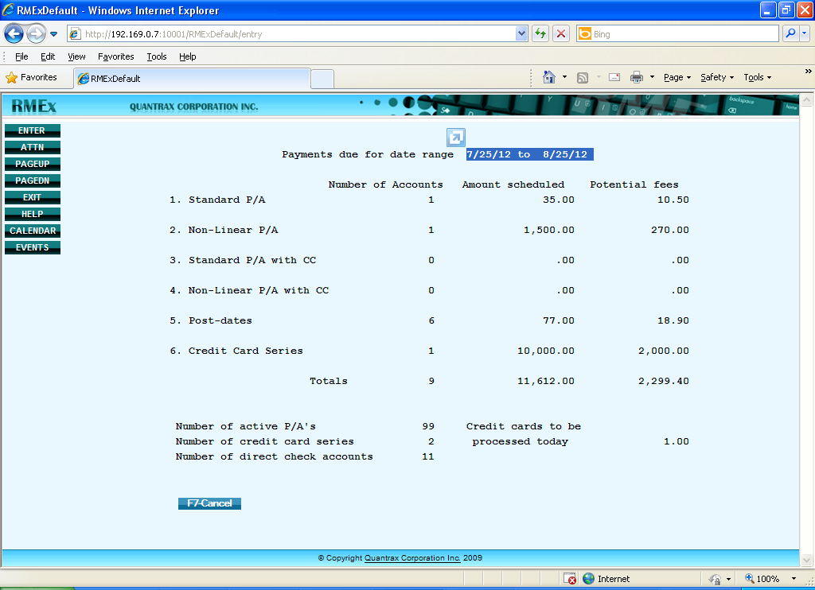
The above screen presents the summary report of 'Payments due for date range 07/25/12 to 08/25/12'.
The figures under the column 'Amount scheduled' display the total amount due from each payment type/method.
Similarly, the 'Potential fees' displays the possible commission that can be obtained from the total due amount.
Once the user has the ‘Payments Pending Report’, he/she has the liberty to compare it by viewing the detailed description of the above report through a spooled file, type the command 'wrksplf' in the command line and hit enter.
Then insert ‘5’ under ‘Opt’ field in front of the relevant report name and hit enter to view the detailed description.
