**Controlling Maximum Calls**

Controlling Maximum Calls ensures that an agent (or agents) cannot launch an excessive number of calls to any number or account. The user can turn the feature on and off by company and can set call limits by client group number. Limits can be placed on individual numbers, accounts, debtor numbers and non-debtor numbers, and home numbers, work numbers and cell numbers.

**Activating Maximum Calls Controls**

The Maximum Calls feature can be turned on and off at the company level. To do this, go to the I-Tel Options Menu and select option 6.

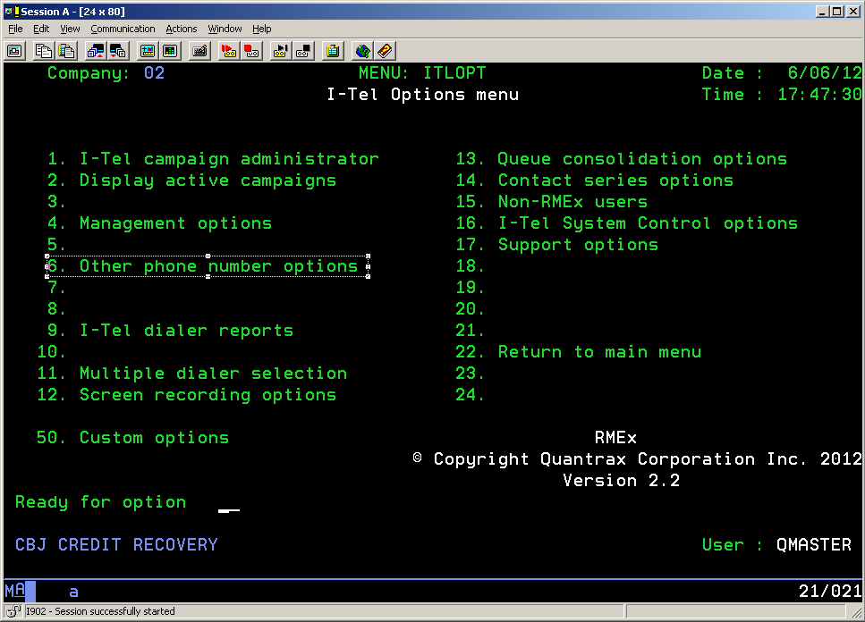

On the Other Phone Number Options Menu, select option 4:

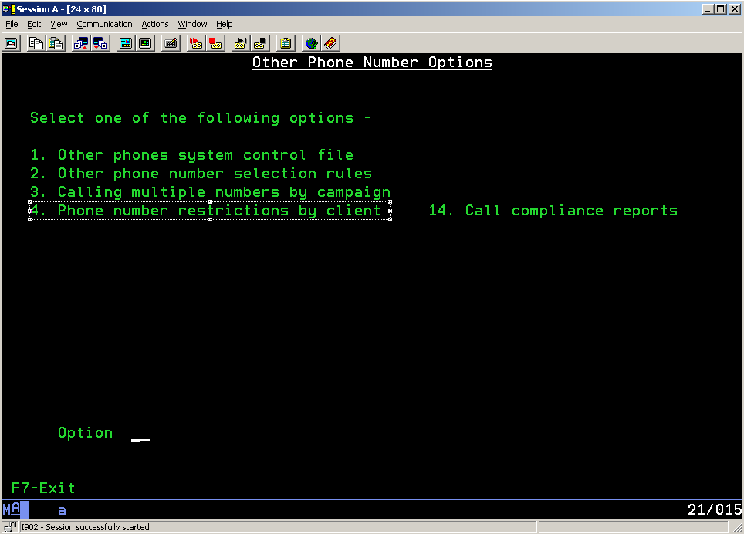

On the Phone Number Restrictions by Client Menu, select option 1:

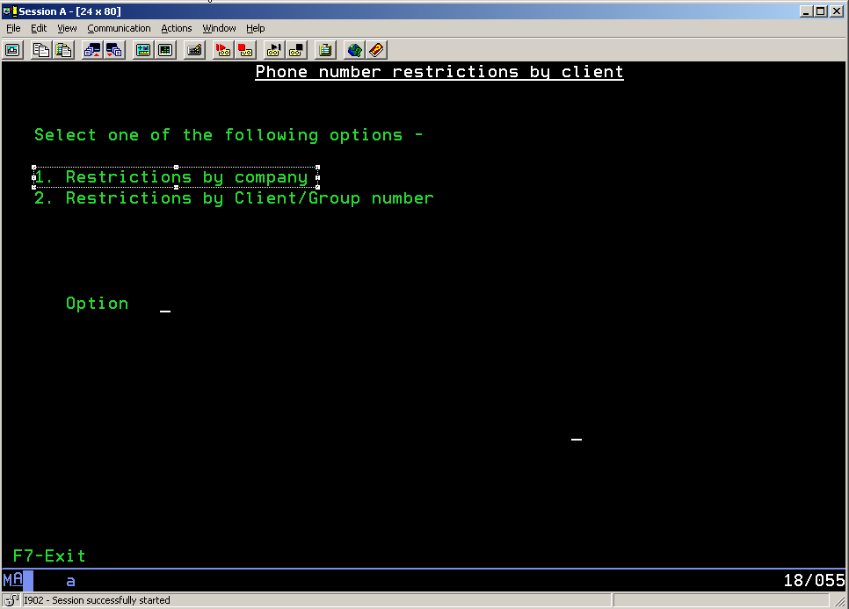

The Restrictions by Company screen will appear:

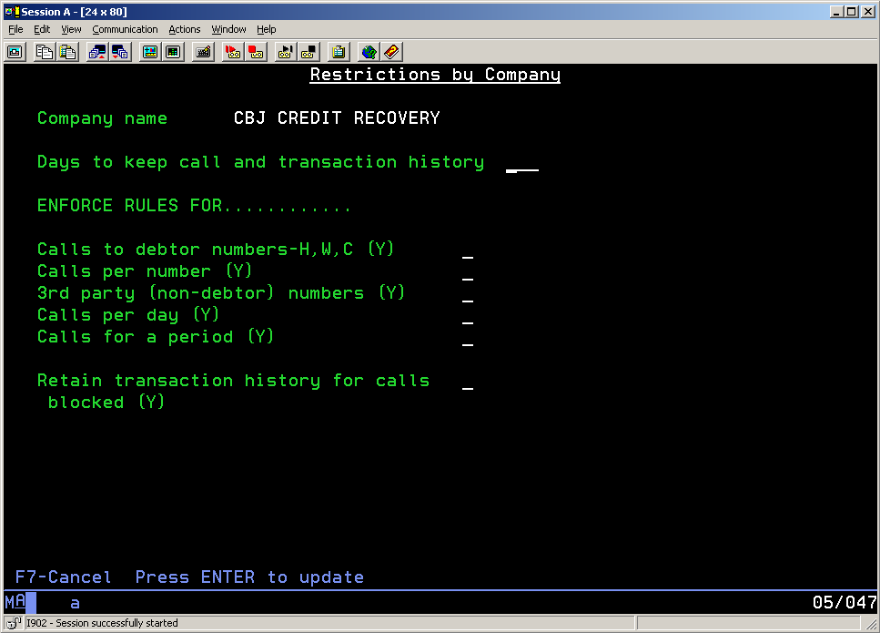

The recommended values are shown below:

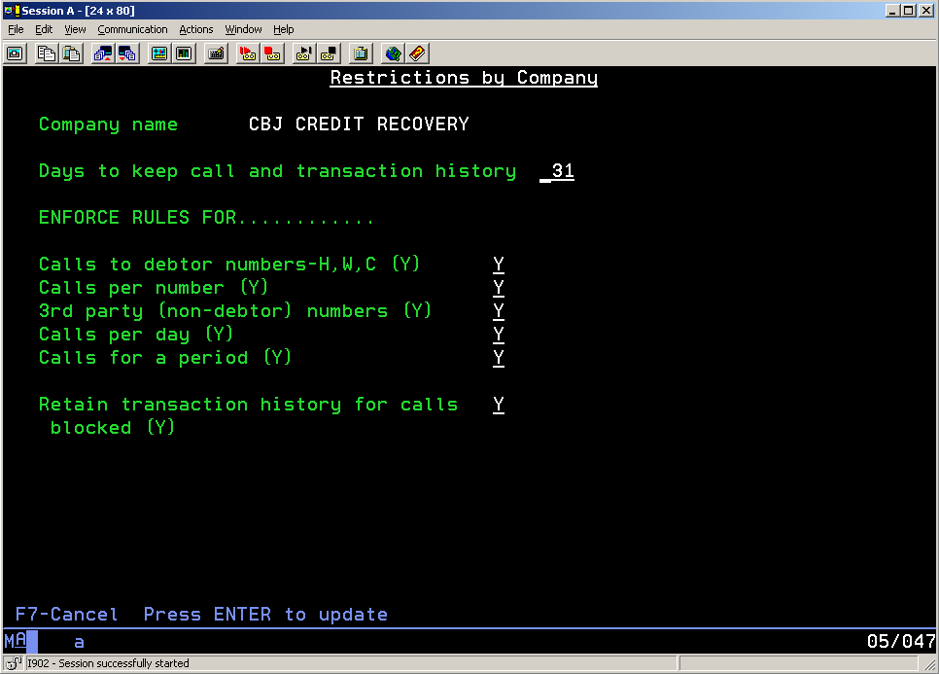

By entering values on the above screen, you will turn on Maximum Calls Processing for the company you are using. You will now need to enter the call limits for a particular client number or client group number.

**Specifying the Maximum Number of Calls**

To specify the maximum number of calls that can be launched for a particular client, select option 2 for the ‘Phone Number Restrictions by Client’ menu.

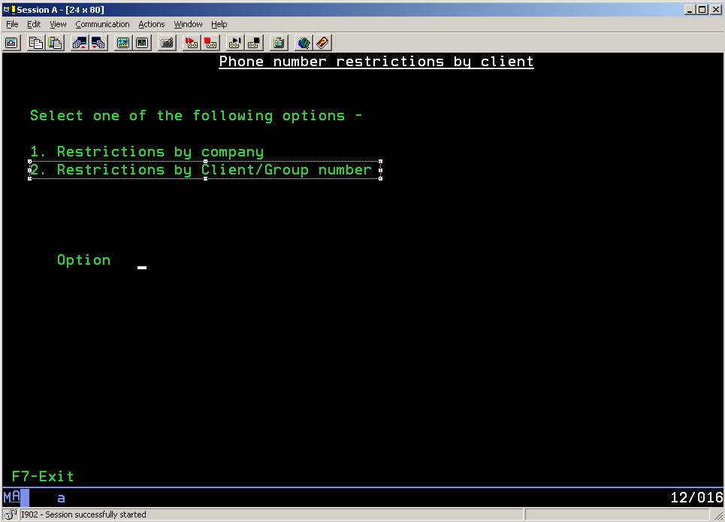

The following screen will appear, allowing you to enter a client group number or client number.

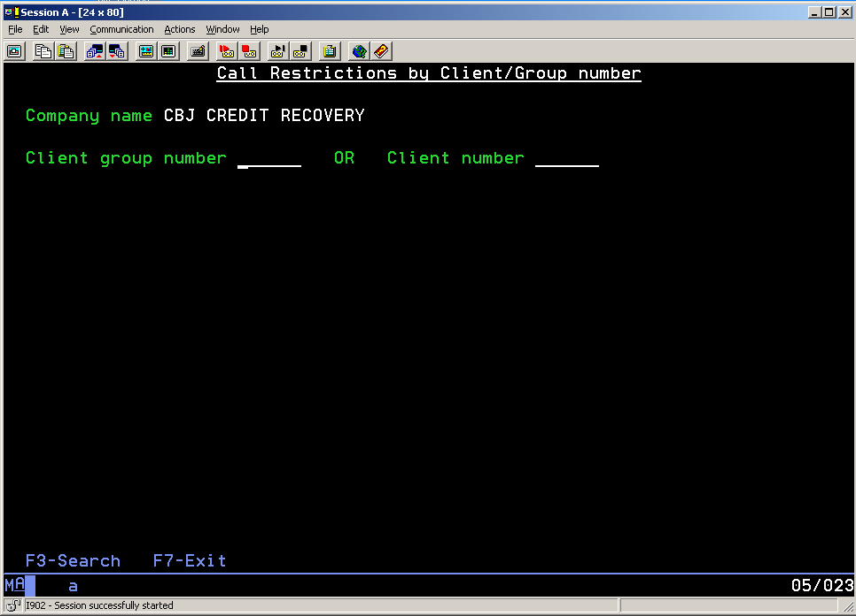

The following screen will appear, allowing you to enter the maximum number of calls for different types of numbers.

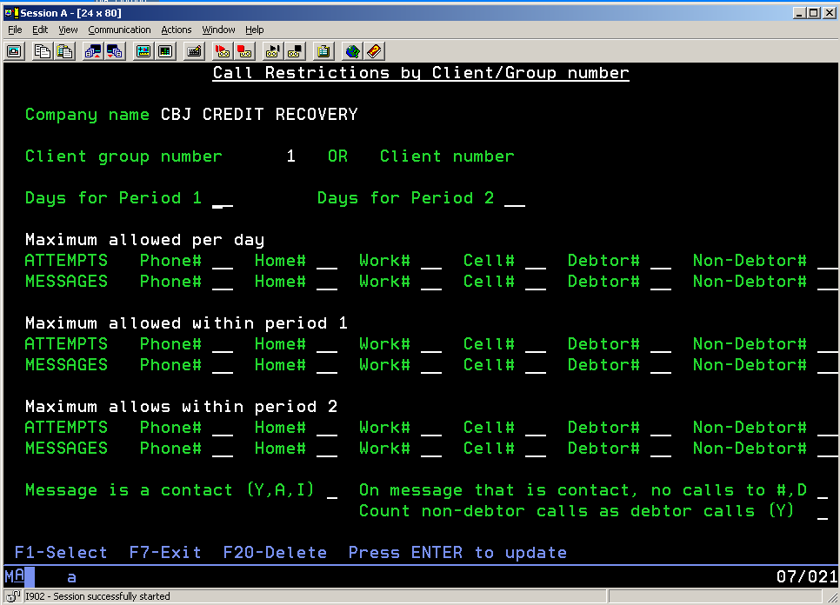

Phone# The maximum number of times a call can be launched to a single phone number

Home# The maximum number of times a call can be launched to a phone number designated as a home number

Work# The maximum number of times a call can be launched to a phone number designated as a work number

Cell# The maximum number of times a call can be launched to a phone number designated as a cell number

Debtor# The maximum number of times a call can be launched to a phone number designated as a debtor number

Non-Debtor# The maximum number of times a call can be launched to a phone number designated as a non-debtor number

A number is defined as a debtor home number if the phone number has a phone code that is marked as a ‘debtor home phone’. This parameter can be changed by taking menu option one from the Other Phone Number Options menu and selecting the relevant phone code.

In the example below, Phone code ‘H’ is marked a a ‘Debtor home phone’ by placing a ‘Y’ next to that option.

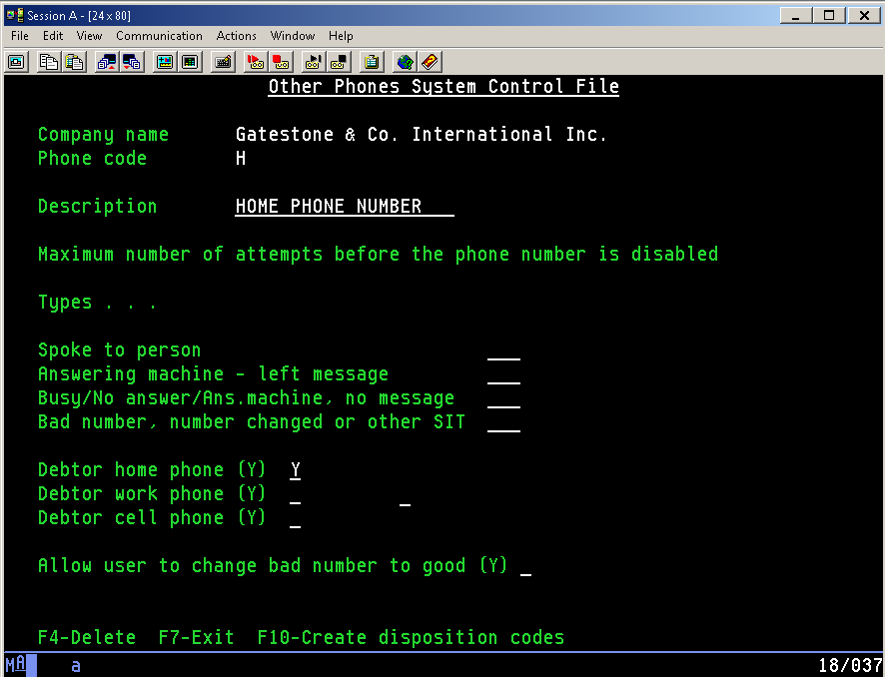

Each phone code that belongs to a debtor should be marked as a debtor home phone, work phone or cell phone. If none of these options is set to ‘Y’, then the phone code is considered to be non-debtor phone code.

The following screen has been completed and a description of each specification is below.

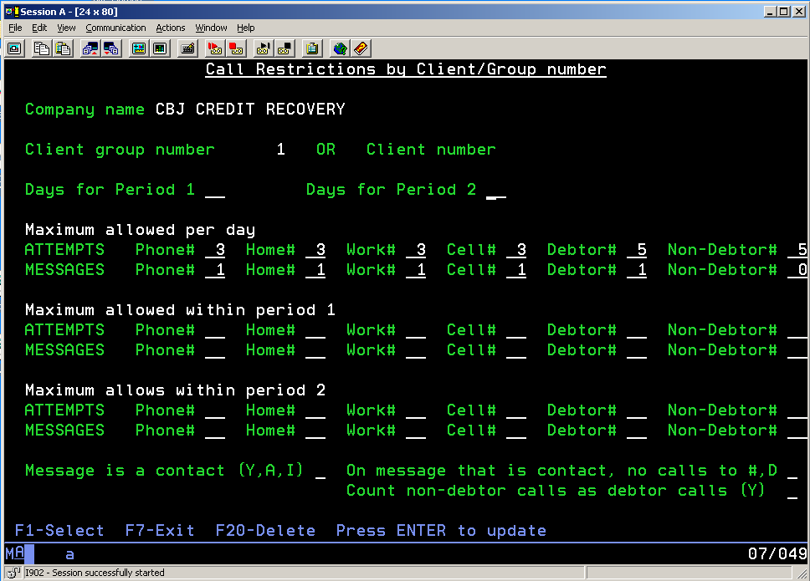

1. A maximum of three calls can be launched to a single number, even though five calls may be made to debtor numbers.
2. Three calls may be launched to a phone number with a phone code designated as a debtor home phone, provided that the maximum number of calls to a debtor is not exceeded.
3. Three calls may be launched to a phone number with a phone code designated as a debtor work phone, provided that the maximum number of calls to a debtor is not exceeded.
4. Three calls may be launched to a phone number with a phone code designated as a debtor cell phone, provided that the maximum number of calls to a debtor is not exceeded.
5. Five calls may be launched to a phone number with any phone code designated as a debtor phone, provided that the maximum number of calls to an individual phone number, or a phone type, is not exceeded.
6. Five calls may be launched to a phone number with any phone code designated as a non-debtor phone. Note that, in this example, these calls are in addition to any calls launched to debtor numbers. This is because the ‘Count non-debtor calls as debtor calls (Y)’ field at the bottom of the screen is set to blank.
7. Only one message may be left per day. The message can be left on any type of number belonging to the debtor. No messages can be left on non-debtor phone numbers.

There are three fields at the bottom of the screen:

Message is a contact (Y, A, I)

Y Any message is considered a contact

A Messages left by live agents are considered contacts

I Messages left by IVR agents are considered contacts.

This option allows the user to restrict subsequent calls to a number if the first call resulted in a contact.

On message that is a contact, no calls to #, D

If a call has been launched to a number and has resulted in a message being left, the user has the option of prohibiting subsequent calls to either that number or to any debtor number. Specify ‘#’ to prohibit subsequent calls to the number dialed or specify ‘D’ to prohibit subsequent calls to any debtor number.

Count non-debtor calls as debtor calls (Y)

If you wish to count any call on an account to be considered a ‘debtor’ call, specify ‘Y’ in this field. This will effectively limit the maximum number of calls on an account to the value specified in the ‘Debtor#’ field. The value in the ‘Non-debtor#’ field will be ignored.