**Changes in ‘ Account list for Audit ‘ – Adding a Multiple Client Range & Saving a Sub List**

The option ‘ Account list for Audit ‘ is useful to clients in many ways as it gives you the ability to select (categorize) accounts using various options, depending on the client requirement.

You can access this feature using the following Menu Option.

RMEx Main Menu -> Opt.2. Management menu -> Opt. 7. Smart Code/User audit options -> Opt. 6. Display accounts for audit

Then you will be directed to the following screen.

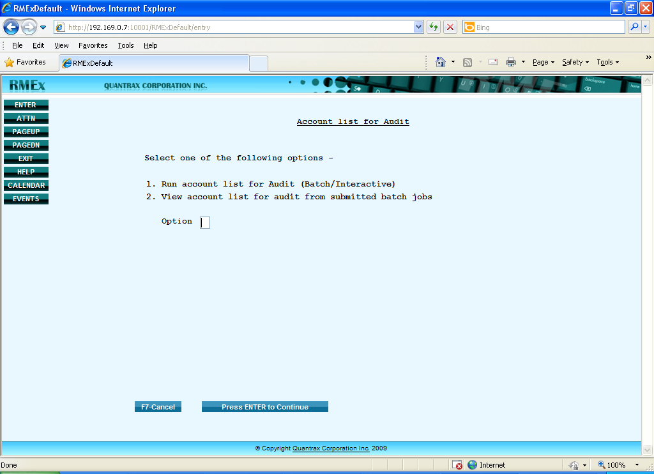

By entering ‘1’ in the ‘Option’ field and hit enter, you can go to the following screen and select the options to ‘Run Account List for Audit’.

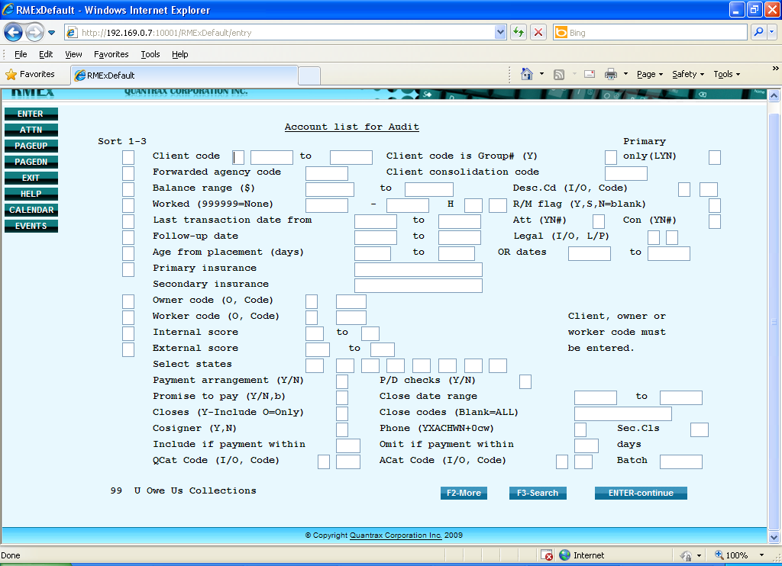

**Multiple Client Range**

In RMEx3, Account List for Audit option allows you to enter a ***multiple client range*** depending on the client requirement. To enter a multiple client range, you need to key in a ’ +’ mark in the blank next to the ‘ Client Code ‘ field as shown below and hit ENTER. Then it will display the following screens.

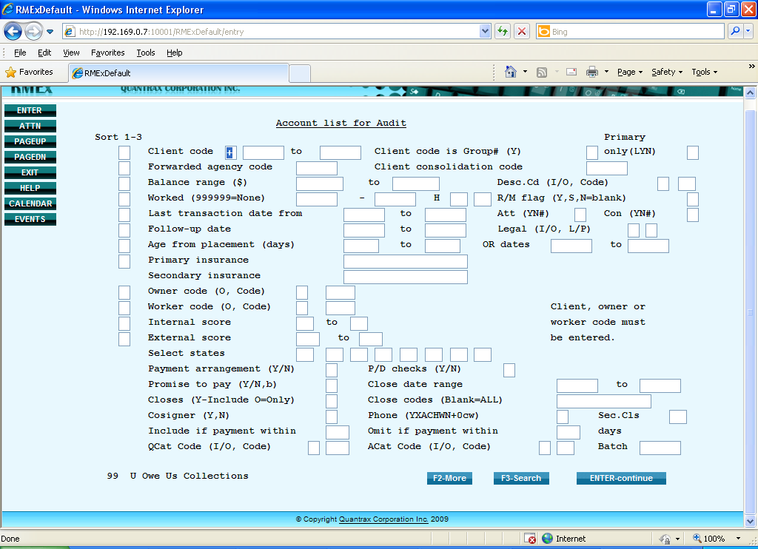

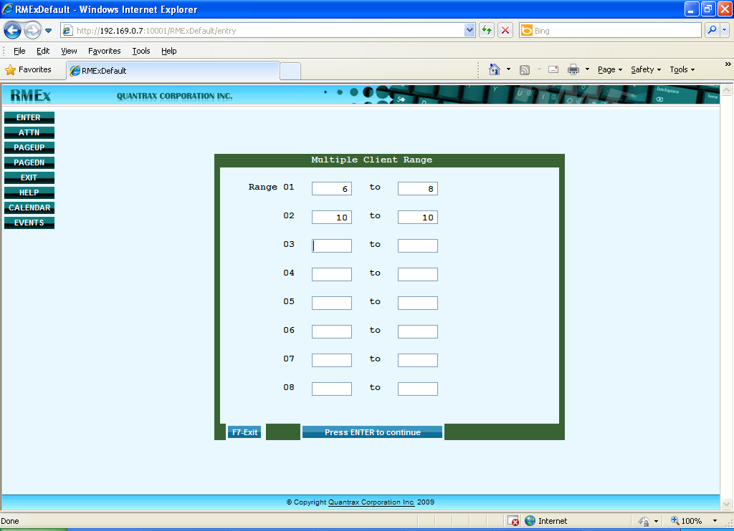

For instance, suppose that you want to audit the accounts of Clients 6,7,8 and 10. Then you just have to enter the Client Range as shown in the above example. ( 6 – 8 and 10 – 10 )

Once you enter the client range and hit enter it will direct you to the following screen where you entered a ‘ + ‘ mark, now changing it at once to a asteric ( * ) to indicate that you have entered a ‘Multiple Client Range’ under that field.

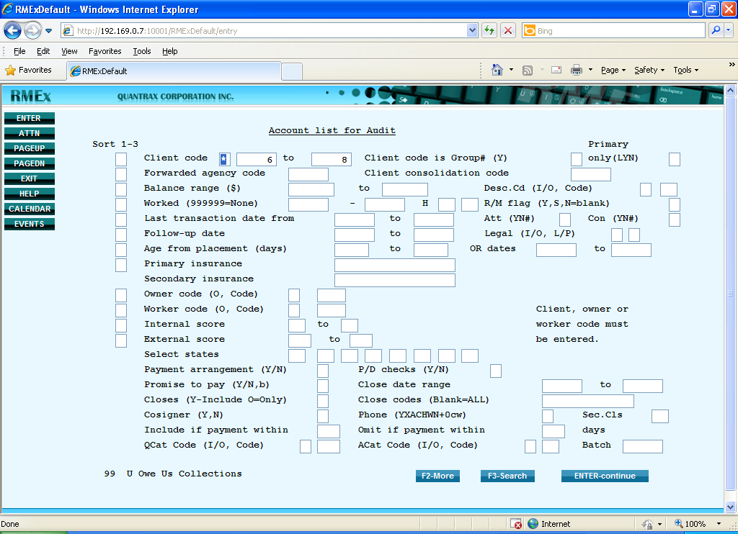

Next you can enter the details such as which type of accounts you wish to audit of those particular clients.

In the following example we are going to audit the accounts with the ‘ Balance Range ‘ of $100 to $5000 of the above mentioned clients.

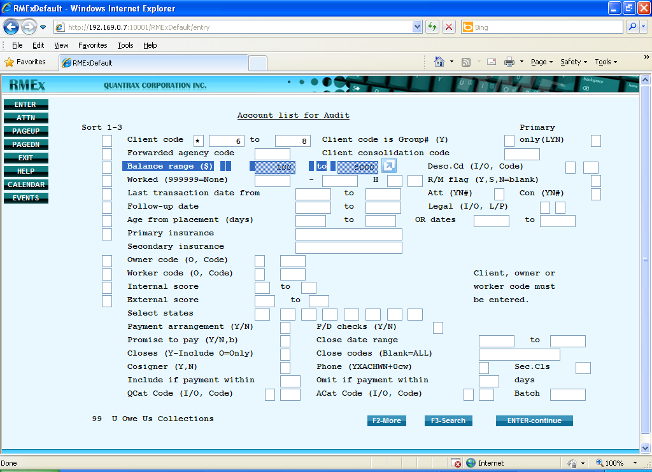

When you finish entering the necessary details and press ‘ Enter ’ to continue , you will be presented with the next screen where you can make ‘ Additional Selections ‘ or proceed by hitting enter.

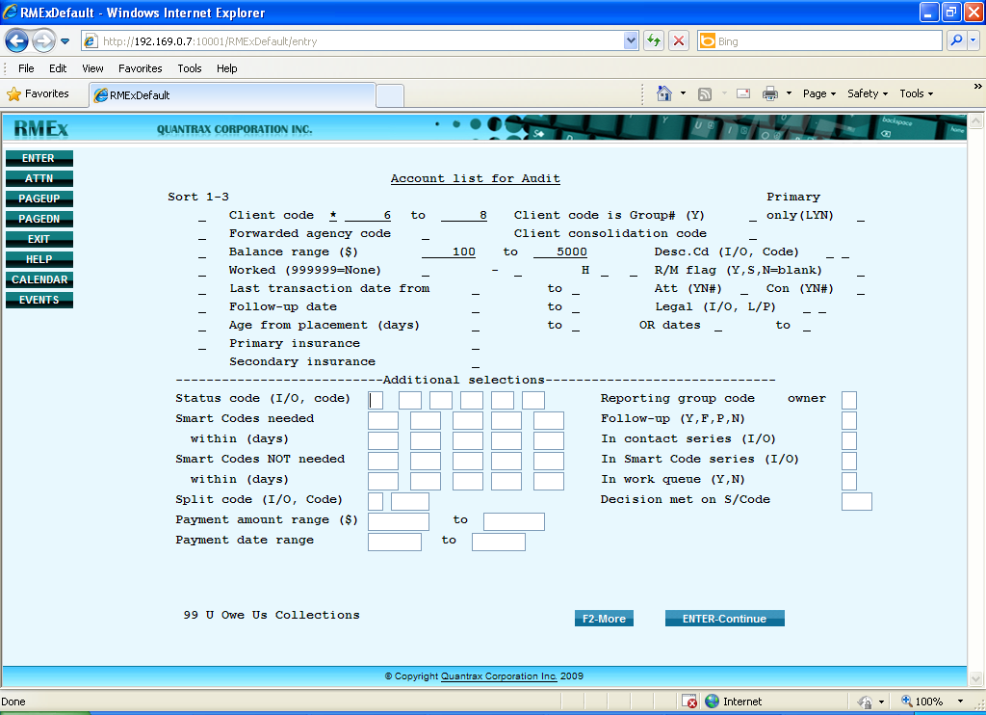

When you chose the option to proceed you can either save it as a Batch or run it interactively as shown below.

**Example 1 – Saving the Account List for Audit as a Batch.**

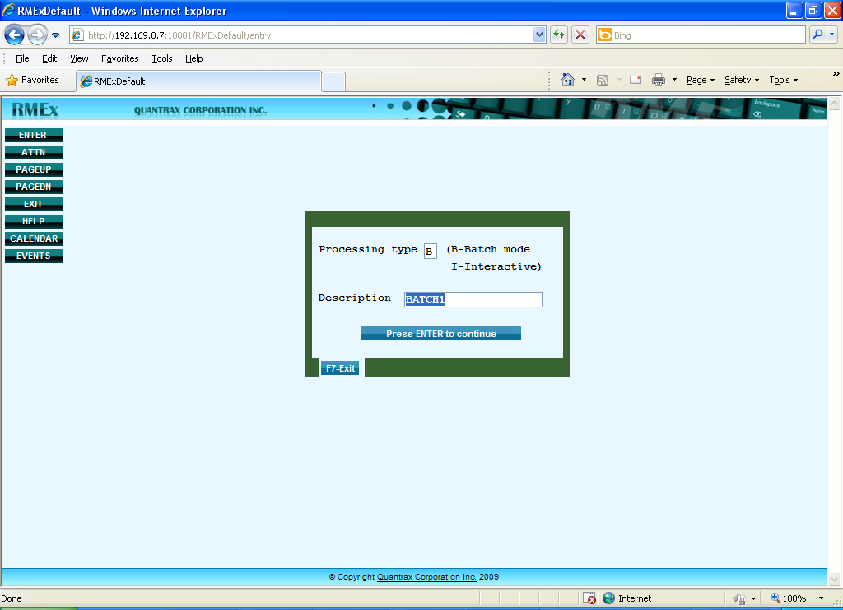

**Example 2 – Running the Account List for Audit option Interactively.**

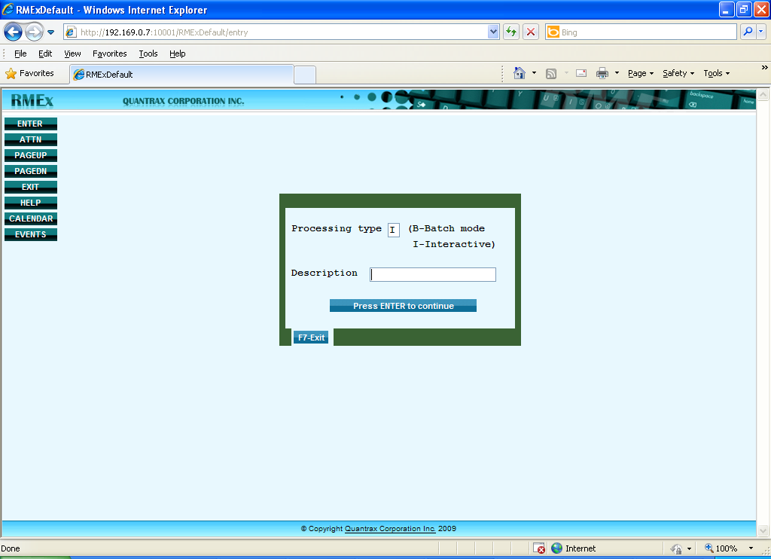

If you run it interactively you will get the following screen with the Search Results.

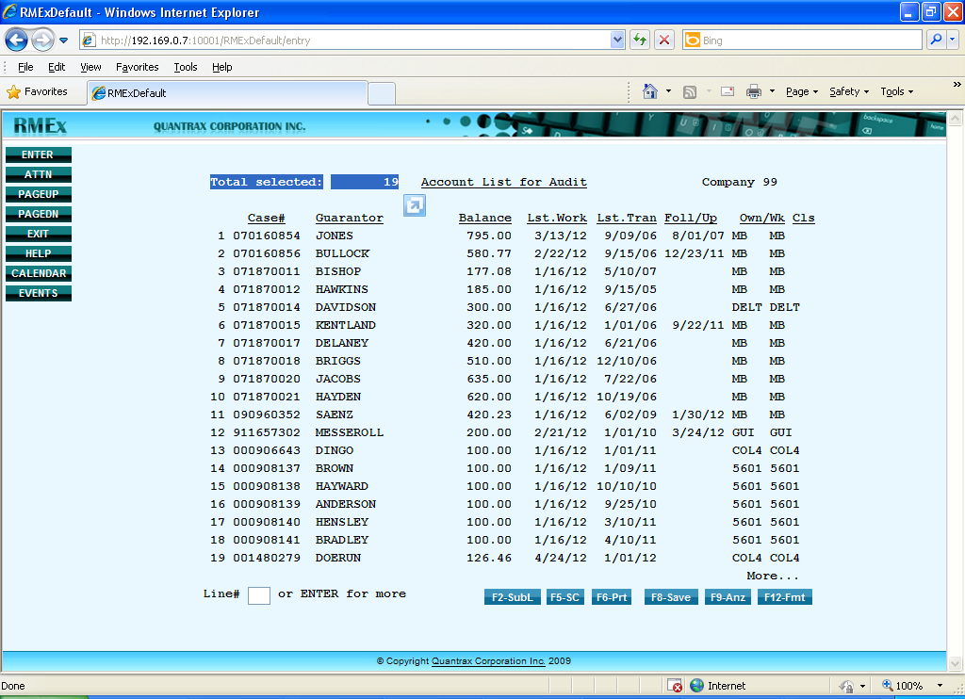

Here if you wish **to save the interactively run Audit Option, Press F8**. Then you will get the screen below and give a description as shown in the example to Save it as Audit list.

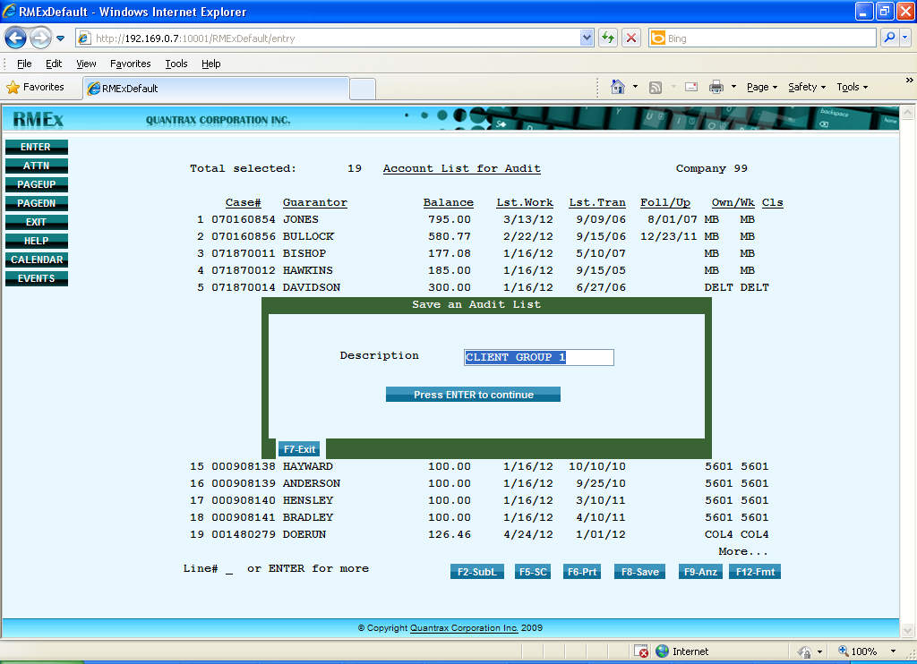

Or else if you wish to take **a sub list of** that **‘ Account List for Audit** ‘ ( one before last screen ), Press F2. Then you will be directed back to the very first screen ( as shown below )where you selected the options to run ‘ Account List for Audit ‘.

There you can select the option with which you wish to ‘ Sub list ‘. ( Refer the following screen. )

**Eg :** Whether certain phone numbers exist on the account detail screen or not.

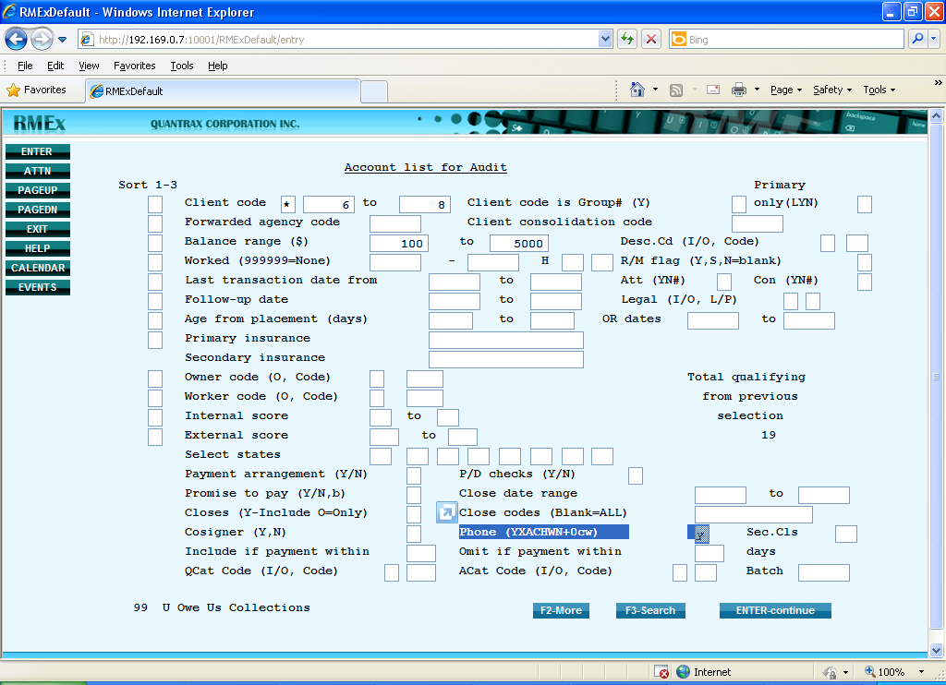

Once you select the option and press ENTER to continue , it will direct you to the following screen where you can view a Sub list of the previous Account List for Audit.

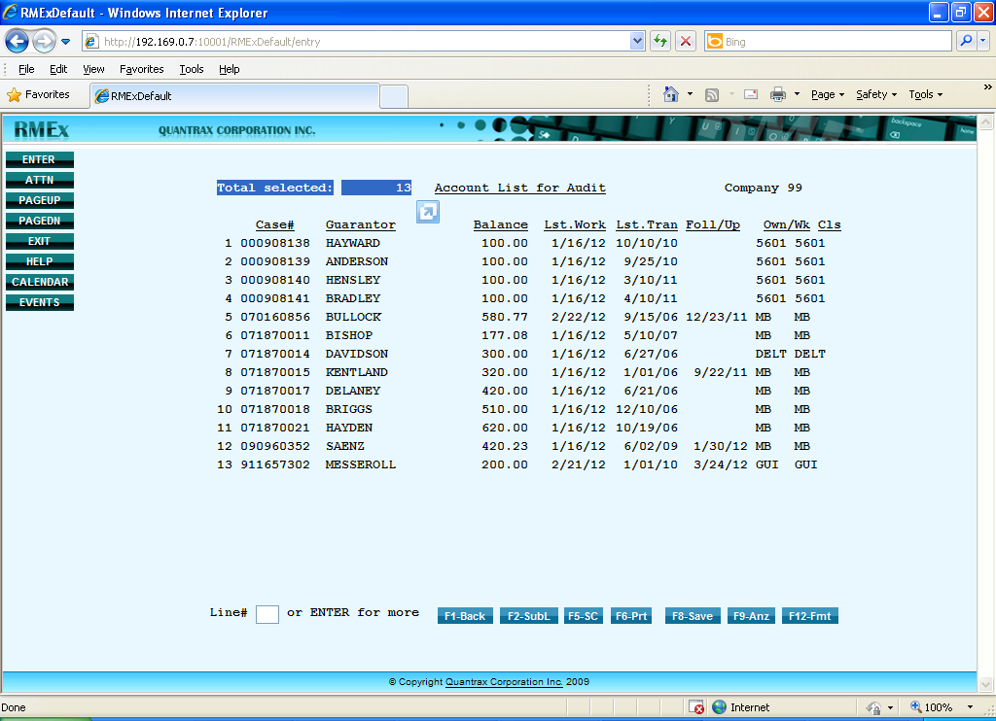

If you wish to save this Sub List, press F8 and once you get the following screen give a ‘ Description ‘ to save as shown below.

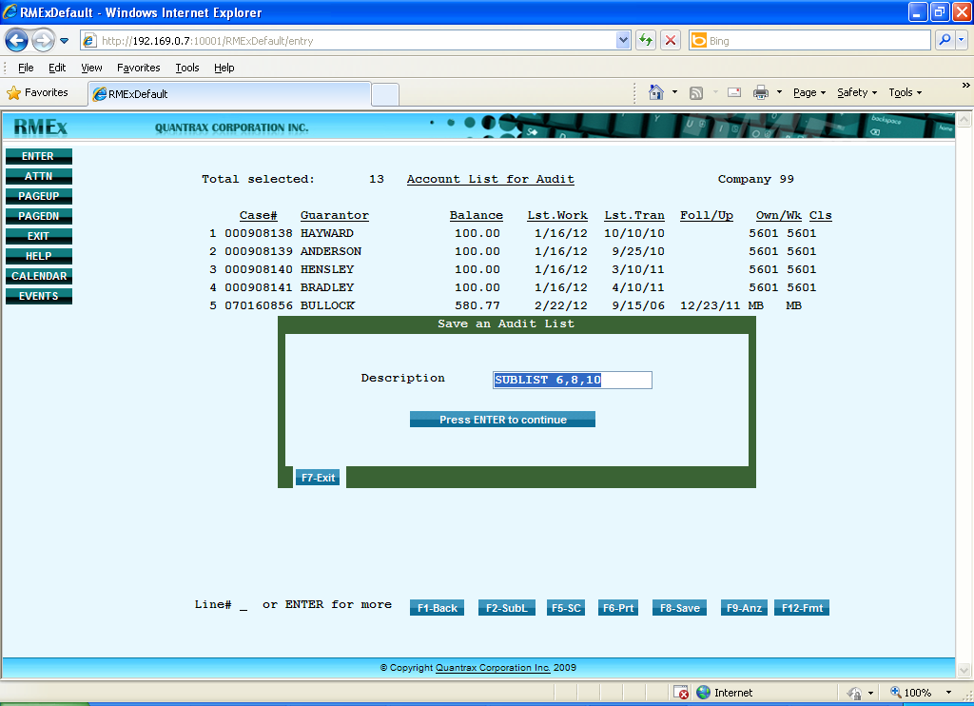

Next, to view the Sub List you saved , take option 2 from the ‘ Account List for Audit ‘ Screen.

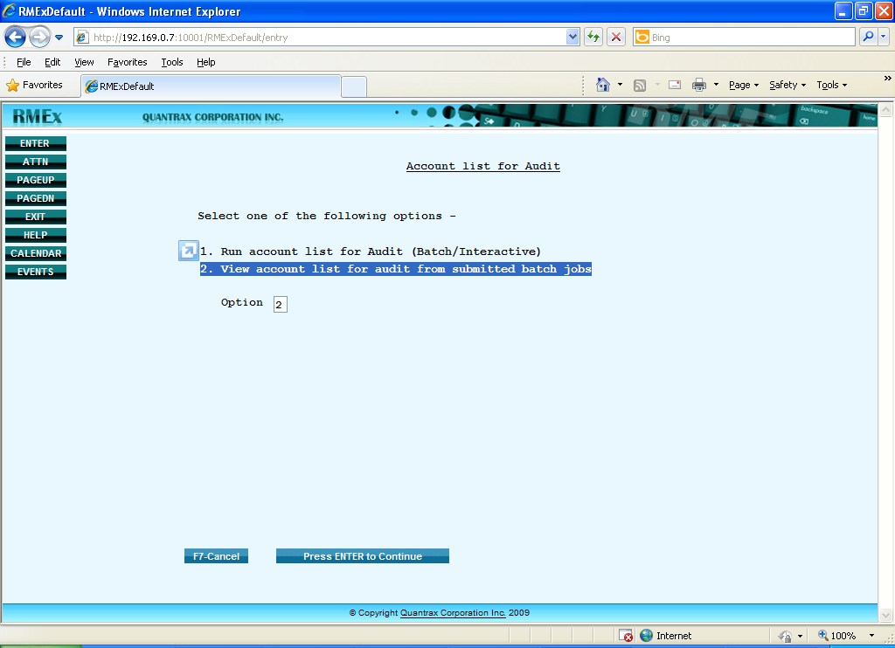

After going into the below screen , key in ‘1’ in front of the relevant name to view the details.

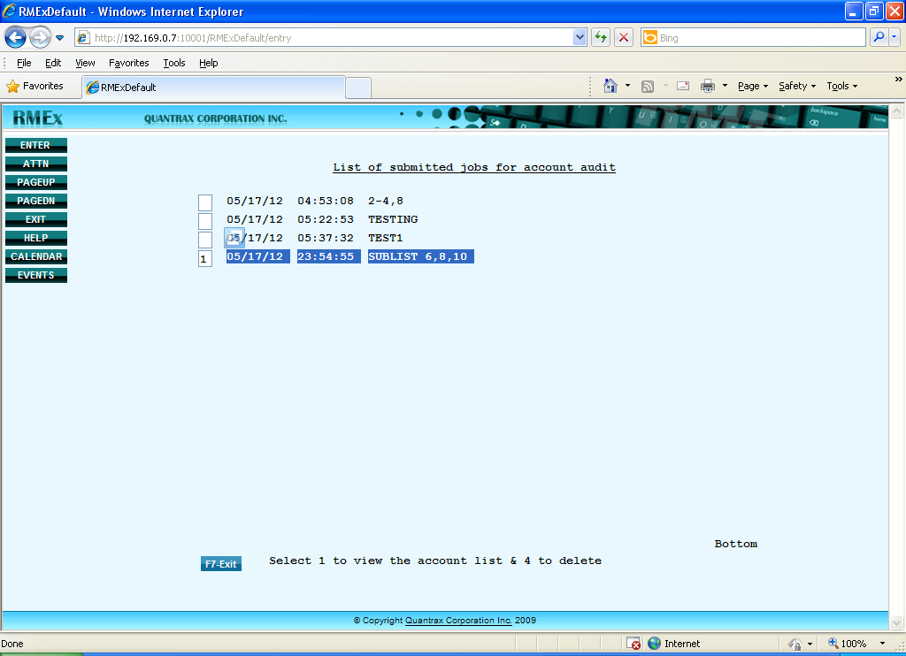

Then you will be presented with the same screen you saved earlier, as shown below.

