This document discusses the new features in RMEx Version 3.0:

Management Changes 2

Account List for Audit - Adding a Multiple Client Range & Saving a Sub List 2

To Save a Sub-list of Account List for Audit 5

Collector License by State 7

Search for Clients by Contact Series, Contact Series by Client and Smart Code Series 8

Analyzing Account Processing Queue 10

Change Company in the Payment Entry Screen 13

Multi- part Account Processing during the Nightly 13

Account Linking through Posting 15

New Selection Options for the Analysis of Pending Payments 16

Prevent Fishing in Account Inquiry Screen 18

Intelligent Call Monitoring 18

Collector Operations Changes 21

Debtor Authentication 21

Account Inquiry Search - By Phone Number 27

New Search Type - By Email Address 29

New search type - By the social security # of patient, spouse, co-signer or multiple co-signers 31

Use Court Case Numbers to Search and Analyze Accounts 32

View Balance for Linked Accounts with Different Court Case Numbers 34

Legal Screen Enhancements 35

Defendant Attorney Codes 36

Court Codes 36

County Codes 37

Judge Codes 38

Covering Attorney Codes 38

Full Legal Screen Enhancements 39

Caption Screen 39

Suit Detail Screen 40

Garnishment Screen 41

Clerical Operations Changes 41

Additional Account Processing Types 41

Compliance Changes 42

State Compliance 42

Allowable Calling Period 42

Holidays 42

Maximum Calls by State 42

The Home before Work Rule 42

I-Tel Changes 43

Campaign Merging Options 43

Controlling Maximum Calls 44

# Management Changes

## Account List for Audit - Adding a Multiple Client Range & Saving a Sub List

The option **Account List for Audit** gives you the ability to select and sort accounts using various options, depending on your requirement. Within **Account List for Audit** you can sort accounts by a range of client codes and save a subset of the audit list.

**To Add Multiple Client Range(s) to Account List for Audit:**

1. From the *RMEx Main menu*, select **Management menu** then select **Smart Code/User Audit options**
2. From *Management menu*, select Smart Code/User audit options then select Display accounts for audit

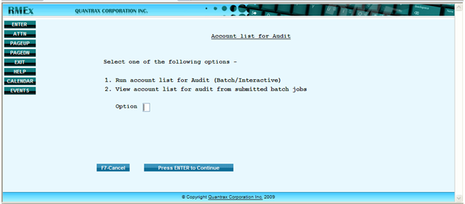

1. From *Account list for Audit* menu select Run account list for Audit (Batch/Interactive)
2. In the *Client Code* field, type **+** (plus sign) and press **Enter**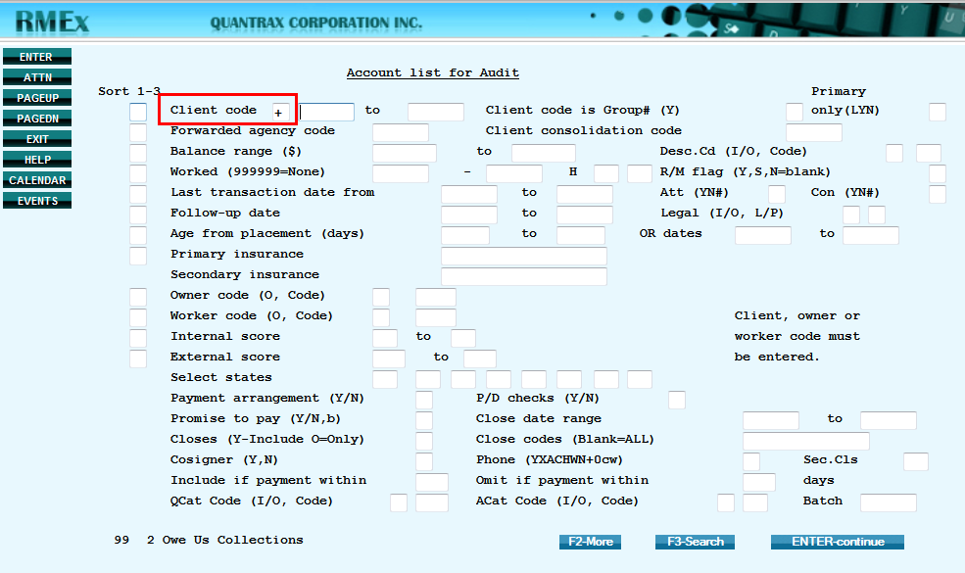
3. Type the *Client Range* and press **Enter  
     
   EXAMPLE:** To audit the accounts of Clients 6, 7, 8 and 10 enter the *Client Range* is shown below:

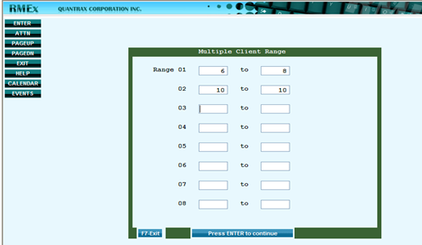

1. In the *Account List for Audit* screen, type the details for the account(s) and press **Enter** when done

***NOTE***: The *Account List for Audit* screen will now show **\*** (asterisk) where you entered **+** (plus sign) to

indicate that you have entered a *Multiple Client Range* under that field

***EXAMPLE***: To audit the accounts with the *Balance Range ($)* of 100 to 5000 is shown below:

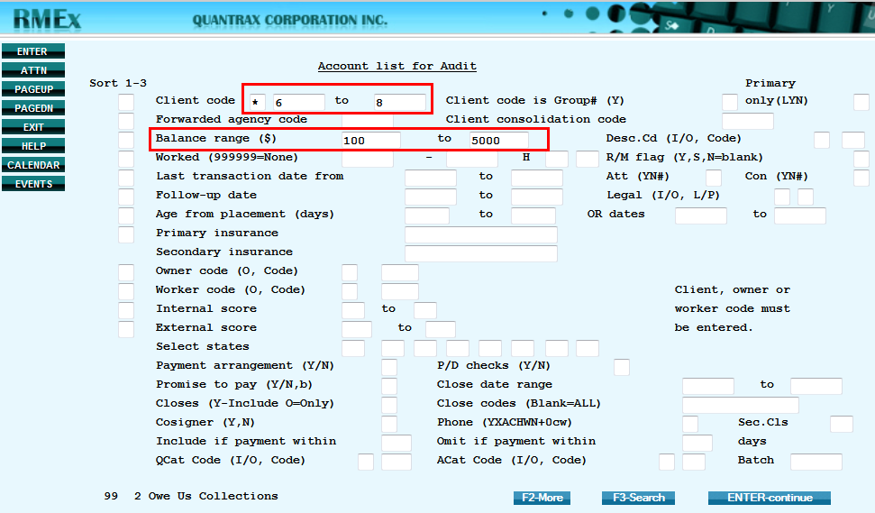

1. *The Additional Selection* screen displays; type other account details or to proceed press **Enter**

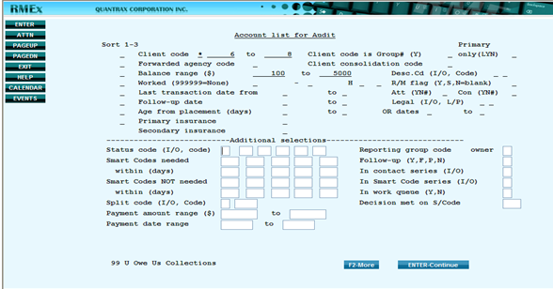

1. Choose to save it as a**Batch**or run it **Interactively**:

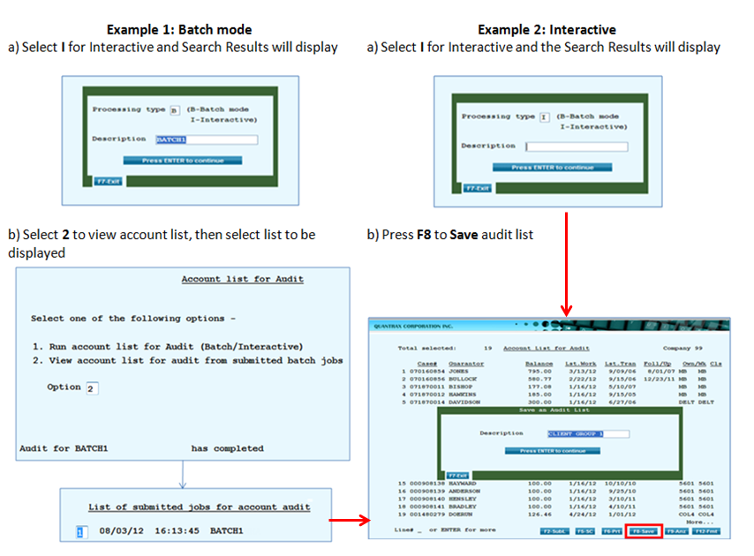

## To Save a Sub-list of Account List for Audit

1. After you have run your *Account List for Audit*, press **F2** – **SubL** to create a sub list

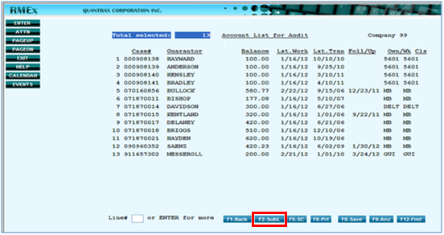

1. Select options to sort out accounts for your sub list then press **Enter**

**EXAMPLE**: Selects certain phone numbers that exist on the account detail screen

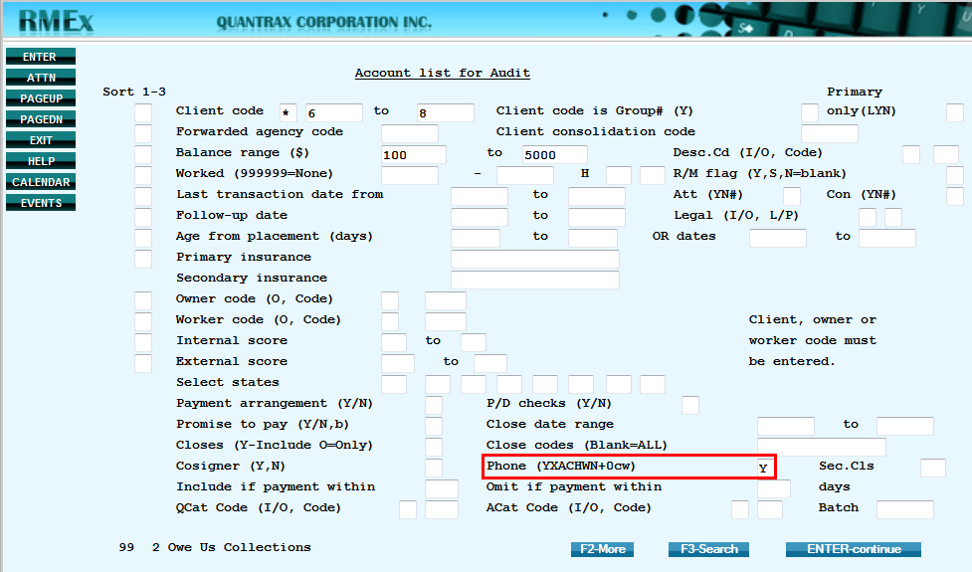

1. To Save the Sub List, press **F8** and type a *Description*

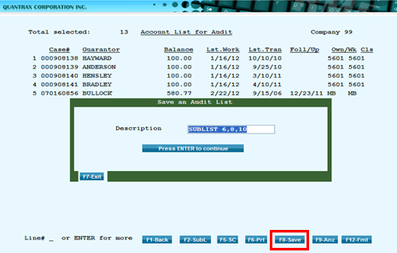

1. To view the Sub list you saved, select option **2** to view the account list submitted to batch jobs, then type **1** next to the list to be viewed

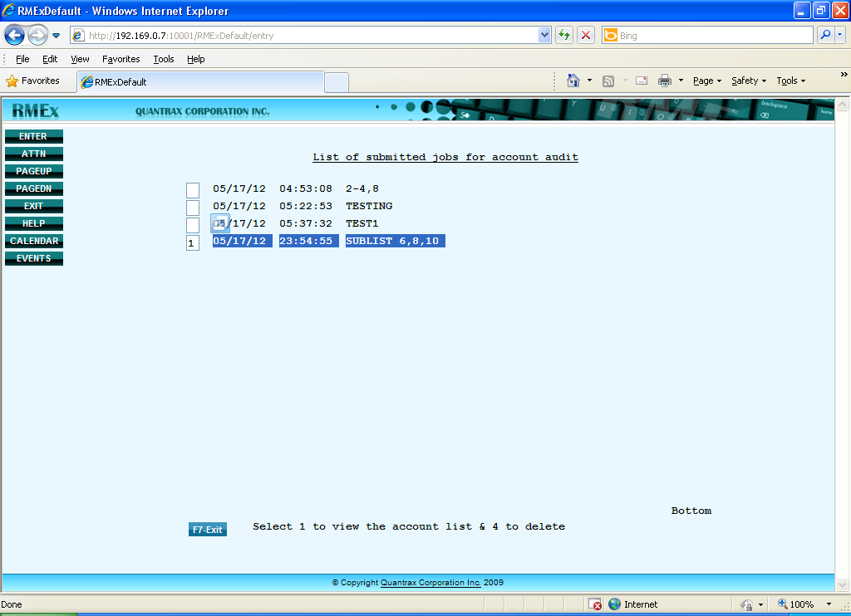

## Collector License by State

This new feature available in RMEx GUI version 3.0, allows you to permit users (Collectors) to work debtor accounts by the state. Each state has different rules, depending on state rules. The collection agency may need to have a license and some states may require the collector to be licensed for that particular state. The license can be a c*ollector license* or a *common state license*.

**NOTE**: Continue to define state controls from the **System Control menu** > **State Options**

 Click icon to listen to the importance of using *Collect License by State* and how it is different from   
 *State Controls*!

**To Setup Collector / Common State License:**

1. From the *RMEx Main Menu* select **System Control** **menu**, then select **System** **Security**

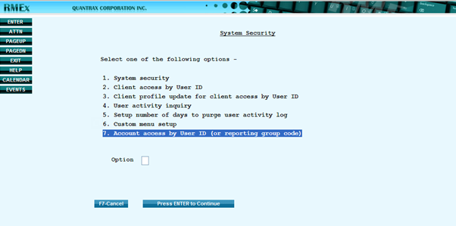

1. From the *System Security menu*, select **Account access by User ID (or reporting group code)**

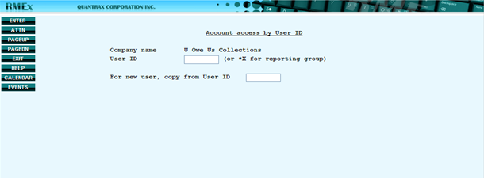

1. Enter a **User ID** or a **Reporting Group** **code**  
     
   **NOTE**: To enter a *Reporting Group*, in the User ID field type in an asterisk (*) followed by **Reporting Group code** such as *XX. Use this for Collectors have to be grouped by a *Reporting group code.*

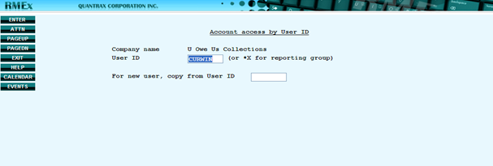

1. Enter **state** abbreviation   
     
   **NOTE**: For agencies that have a *Collector license* for several states, you can add multiple state codes under that particular *user id* (Collector). If an agency has obtained a *state license* for particular states, several Collectors (Reporting Group) can work the accounts of those states.

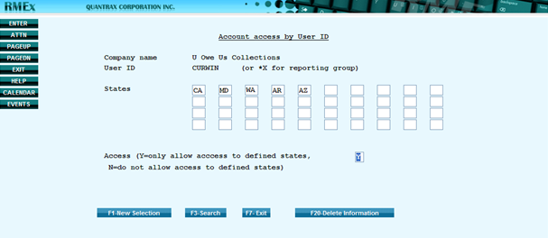

1. In the *Access* field enter **Y** (only allow access to defined states) or **N** (do not allow access to defined states), then press **Enter** to save

## Search for Clients by Contact Series, Contact Series by Client and Smart Code Series

In RMEX GUI 3.0, the *Client* *Search* *Option* has additional options to search by *Contact* *Series*, *Contact* *Series* by *Client* and *Smart* *Code* *Series*. This provides seven options in total for searching in *Client* *Inquiry*.

**To search for clients by Contact Series, Contact Series by client and Smart Code Series:**

1. From the *Main* *Menu*, select **Management menu**, then **Client** **Inquiry**
2. From the *Client* *Search* screen, press **F3** to search

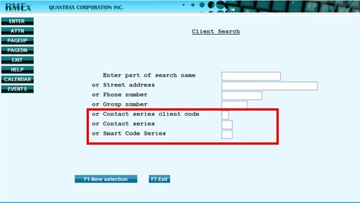

**To search for clients by Contact Series:**

1. From the *Client* *Inquiry* type in search details and press **Enter**, then type **1** in front of the client name you want to select

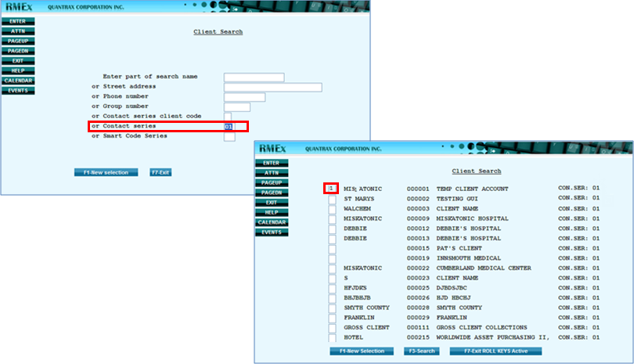

**NOTE:**  Use the same steps to search by *Contact* *series* *client* *code* and *Smart* *Code* *Series*

## Analyzing Account Processing Queue

The *Analyzing Account Processing Queue* feature allows managers to look into a queue and analyze the accounts in the queue. Use it to view the total numbers, amounts, percentages of an account queue for a collector; including the *Unit yield* for the batch, which is a very important factor in analysis.

**NOTE**: To use this option you need to have the RMEx 2 environment

 Click icon to listen to the benefits of using *Analyzing Account Processing Queue* and what you want   
 to do after you analyze a queue!

**To use Analyze Account Processing Queue:**

1. From the *RMEx Main Menu* select **Management menu**, then select **Smart Code/User audit options** and then select **Audit a user (to be worked)**
2. From the *Audit A User (Accounts to be worked)* screen, type a *User Id* and press **F10** for **Work map analysis**

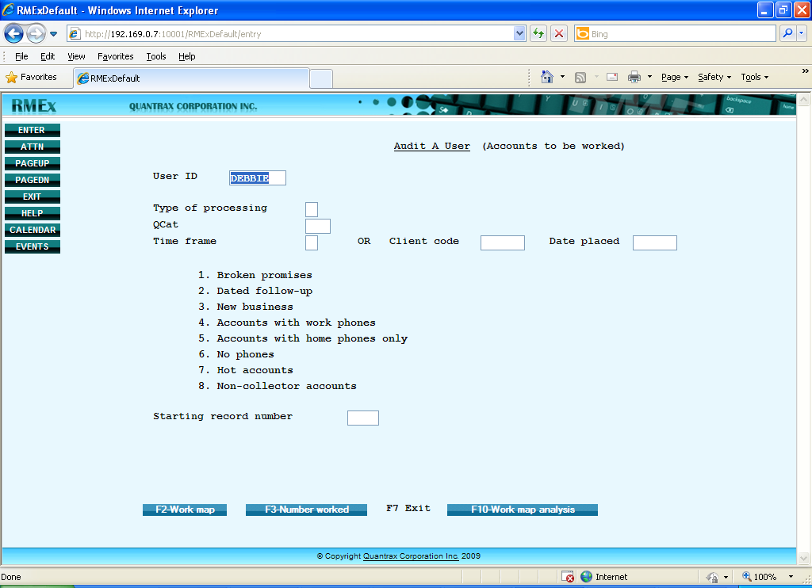

1. From the *Work Map Analysis* screen, type **1** under *Opt*. column to select the queue to be analyzed and go to the *Analyzing Account Processing Queue* screen

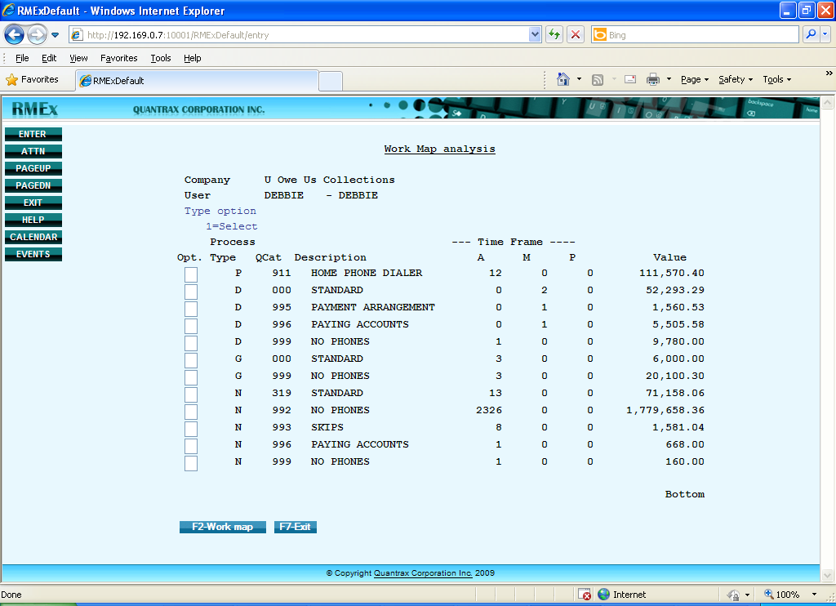

1. From the *Analyzing Account Processing Queue*, select the information for your analysis then press **Enter** to proceed

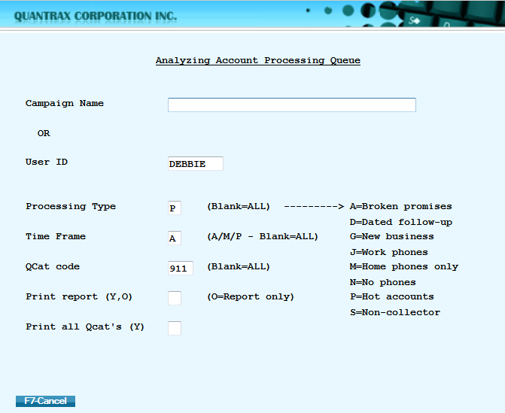

**EXAMPLE**: This is the summarized *Analysis of Account Processing Queue for User Id* = *DEBBIE*

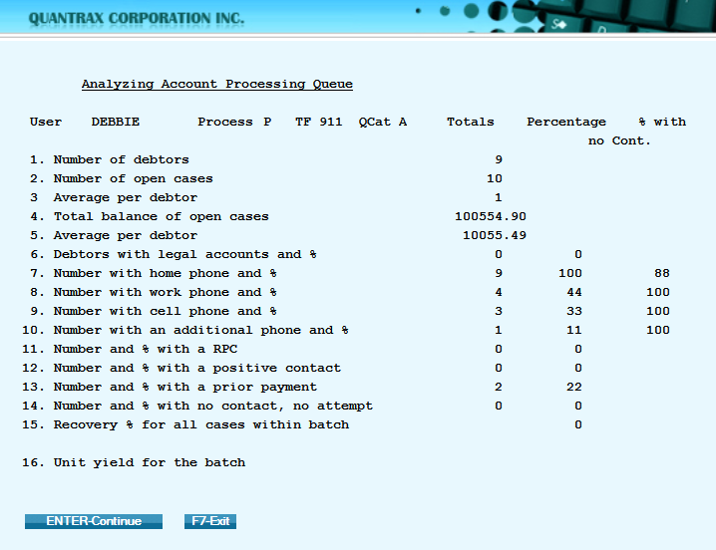

**NOTE**: The numbers in the analysis represent the following information:

* **Average per debtor** = Total Payments divided by Total Balance of Open Cases
* **Unit Yield** = Commission divided by Number of Accounts
* **Recovery %** = Total Placements divided by Total Payments.
* *Percentages* will be rounded either up or down

**EXAMPLE**: 1.1% will be displayed as 1% and 7.7% will be displayed as 8%

## Change Company in the Payment Entry Screen

In RMEx GUI version 3.0 you can change the company in the *Payment Entry Screen*.

**To change the Company in the Payment Entry Screen:**

1. From RMEx *Main Menu*, select **Payment transaction menu**
2. Select **Debtor/Agency entry**
3. Type the *Batch number*
4. Select if a receipt is required for each transactions and enter *the Number of copies*
5. Type *Company Code* to desired company (the Company Name will display)
6. Continue adding other payment data and press **Enter** to save

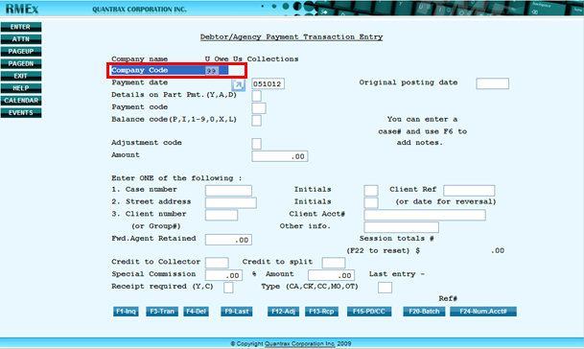

## Multi- part Account Processing during the Nightly

This significant feature speeds up the *Nightly Process* by allowing *Account Processing* to run effectively in multiple simultaneous jobs. This minimizes the time spent on completing the *Nightly* process. The system allows this process to run conveniently in 3, 4 or 5 parts according to your needs.

**To Use Multi-part Account Processing**:

***WARNING*:** It is advised to contact Quantrax before setting up the *Multi-part Account Processing* option

1. From the *RMEx Main Menu* select System control menu, then select **System Parameters**
2. From *System Parameters*, press **ENTER** for **More Information** (next screen)

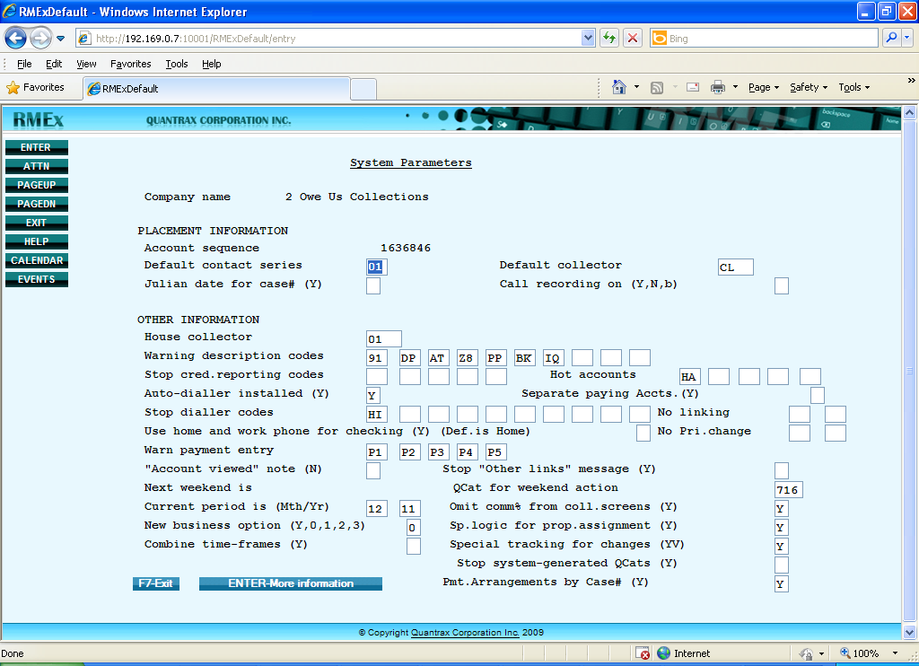

1. From the page two *System Parameters* screen, in the field **Run account processing in 3, 4, or 5 parts** type **1**, **2** or **3**



## Account Linking through Posting

This feature available in RMEx 3.0 gives you the ability to link accounts when posting accounts into the system. By allowing part of the linking process to run during day, this option enables the *Nightly Process* run faster by reducing the time taken for account linking.

 Click icon to listen to why you should use *Account Linking through Posting*!

**To Use Account Linking through Posting:**

1. From *RMEx Main Menu* select **System control menu**, then select **System Parameters**
2. From *the System Parameters* screen, press **ENTER** for **More** (**Information** next screen)

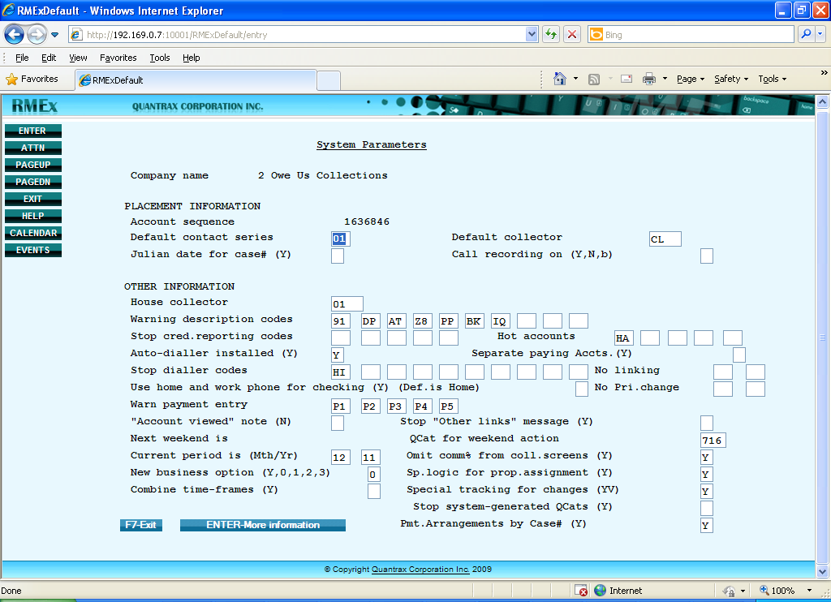

1. From the page two *System Parameters* screen, in the field **Run linking during the day (Y**), type Y to allow the system to link accounts at the time of posting

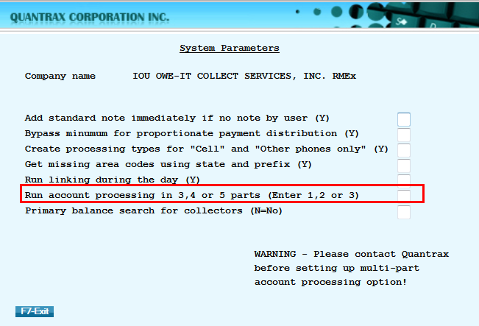

## New Selection Options for the Analysis of Pending Payments

RMEx 3.0 introduces two new features the *Analysis of Pending* *Payments* option. These new features allow users to view a summary of the *total number of accounts,* the *total payments due* and *potential commission due* for a particular date range. There is also the ability to select the data by *Client codes* and *if client is a group*.

**To access Analysis of Pending Payments:**

1. From the *RMEx Main Menu* select the **Payment transaction menu**, next select **Payment reports for period**
2. From *Payment reports* for period select **Analysis** **of pending payments**
3. From the *Analysis of Pending Payments* screen, type in a *date range*
4. Type in up to four **Collector codes** (optional)
5. Type in up to four **Client codes** (optional)

**NOTE**: If a *Client code* is entered, only the payments due for that particular client within the specified date   
 range will be shown (Blank equals ALL clients)

1. In the field *If client is group* (Y), type **Y** if the client(s) selected is a group client
2. Press **ENTER** when done

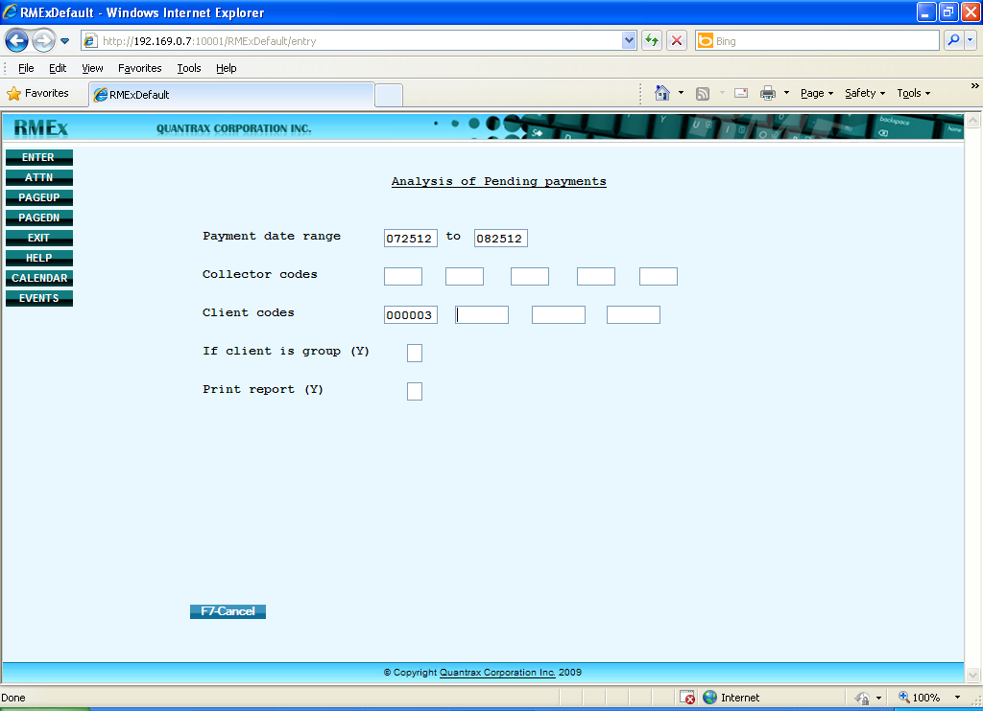

**EXAMPLE**: Below is a summary report of *Payments due for date range 07/25/12 to 08/25/12*

**NOTE**: The numbers in the analysis represent the following information:

* **Amount** **scheduled** = total amount due from each payment type/method
* **Potential** **fees** = the possible commission that can be obtained from the total due amount

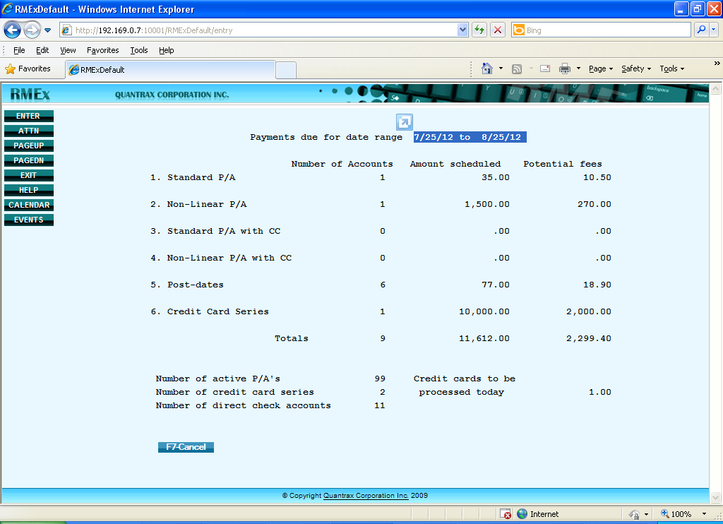

1. The Payments Pending Report can be compared viewing the detailed description through a spooled file by going to the command line and typing **wrksplf** and press **ENTER**
2. To select the report, in **Opt** type **5** in then press **ENTER** to view the detailed description

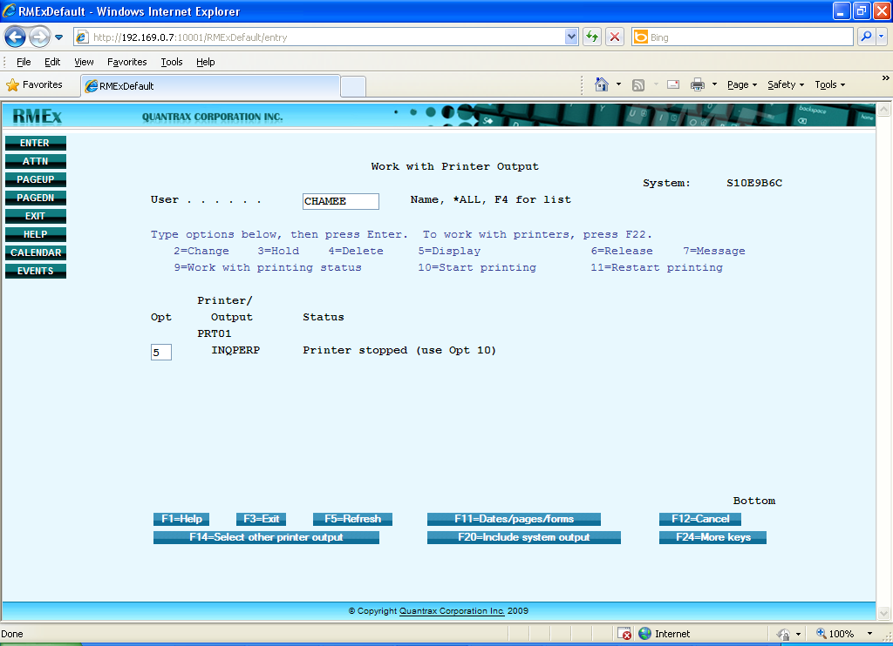

## Prevent Fishing in Account Inquiry Screen

A new security option to prevent “fishing” has been added for the *Account Inquiry > Primary balance*. It stops collectors from using this Primary balance option to fish" for high balance accounts.

To control which users are allowed to use *Account Inquiry* > *Primary balance*:

* The user must be set up as a collector
* The user cannot have a **Y** in the *close accounts field*

**NOTE**: If the user **does not** have access to use the option, they will be presented with the message: *SC-9017 This option has been disabled for you*

## Intelligent Call Monitoring

This new option allows managers to monitor calls of a group of collectors either by *Reporting Group Code* or *User IDs*, based on client and linked balance range. When the account information is displayed on the screen the collector’s extension is also shown.

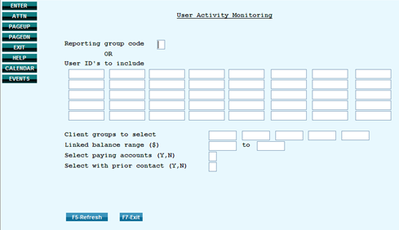

**To Run Intelligent Call Monitoring:**

1. From the *RMEx Main Menu* select
2. From the *User Activity Monitoring* screen type the *Reporting Group Code* or User IDs  
   **NOTE**: Users assigned to a *Reporting Group* can be found under Collector Set Up
3. Fill-in other necessary details such as *Client Group*, *Linked balance range* and other options on the screen

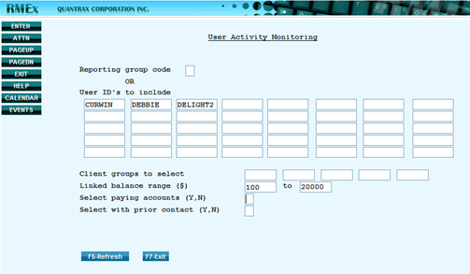

1. Press **ENTER** to display first open account for the ID(s) requested (according to the sequence that was typed into the screen)

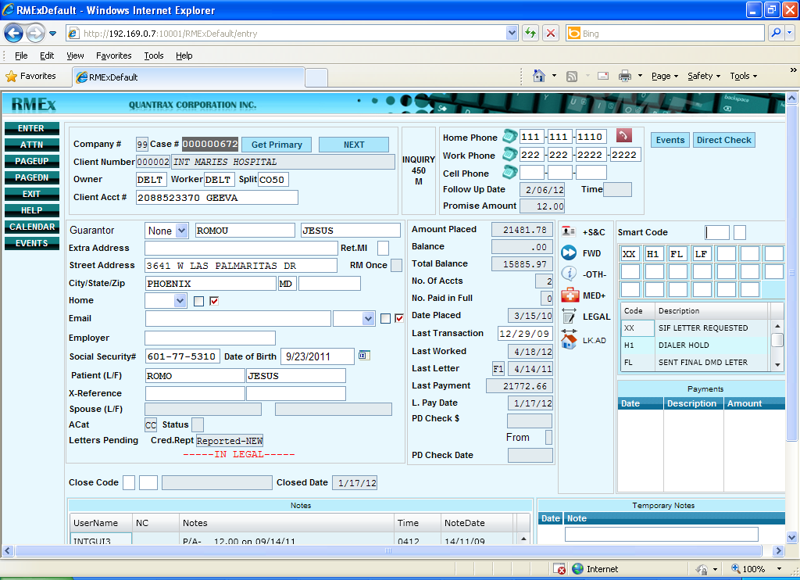

1. Press **F7** while viewing the account to listen to the call **using the dialer** as it displays the extension (press F7) on which the collector is connected.  
     
   **NOTE**: When the collector ends the call and exits the account it will search for the next open account



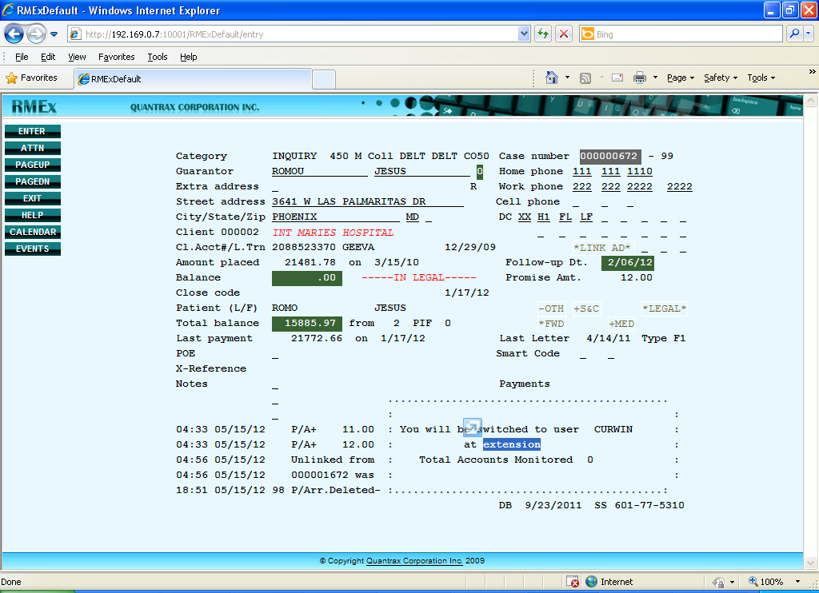

# Collector Operations Changes

## Debtor Authentication

In RMEx GUI version 3.0, the new ***Debtor Authentication*** feature reduces the risk of identity theft and fraud of the debtor’s personal information. When a collector makes calls and inquires, the receiver of the call may pretend to be the debtor and can find out their personal information. This can lead to violation issues.

***Debtor Authentication*** has up to seven options to validate the debtor’s identity. The collector must enter the correct debtor information before they are presented with the account details. Authentication options are setup on the client level. The Authentication options are as follows:

* Full SSN
* Last 4 digits of the SSN
* Full DOB
* Month and Date of the DOB
* Address
* Client account number
* Last 4 digits of the Client account number

Related authentication options are coupled into *sets*. Options in the same set are considered a single option. For example, *Full SSN* and *Last 4 of SSN* are considered one option. Enter **Y** (Need to authenticate) or **S** (Single option to authenticate).

If an option is selected with the value **S**, when that question is answered correctly the system will not need to verify other ***Debtor*** ***Authentication*** questions.

 Click icon to listen to examples of how *Debtor Authentication* works!

| **Other Authentication Options** | **Description** |
| --- | --- |
| **Non-collector bypass (Y)** | Prevents displaying the authentication screen to a non-collector enter a **Y** in this field.  **EXAMPLE**: If a **Y** is entered in this field a manager does not have to authenticate before viewing the debtor's information. |
| **Non-collector calls (N-No)** | Prevents non-collectors calling the debtor enter **N** in this field. |
| **Number of items required** | Sets the maximum number of options required to authenticate.  **EXAMPLE**: If all the six items are selected and a collector needs to authenticate only four enter **4** in this field. |
| **Bypass if authenticated within minutes** | Suspends authentication of a debtor within a certain time frame, enter the time period in minutes.  **EXAMPLE**: If 10 minutes is entered in this field and a collector authenticates the debtor at 9:00 A.M. the next time you have to authenticate the debtor will be at 9:10 A.M. This can be used if a call is disconnected or the debtor wants you to call back after 5 minutes. |
| **Maximum failed attempts allowed** | Sets the number of times a collector can fail to authenticate the debtor before attempts are suspended. |
| **S/Code if authenticated** | Configures the system to automatically apply a predefined Smart Code for authenticated accounts when presenting the account detail screen to the collector. |
| **S/Code if not authenticated** | Configures the system to automatically apply a predefined Smart Code saying “Failed to authenticate the debtor” for not authenticated accounts within the *Maximum failed attempts allowed***.** |

**To setup authentication options:**

1. From Main Menu select **System** **Control** menu , next select **System** **Security** and then select **Right party authentication options**The *Right party authentication options* screen displays
2. Press **F6** to **Add** a new client or in *Opt* column type **2** to **Edit** client information

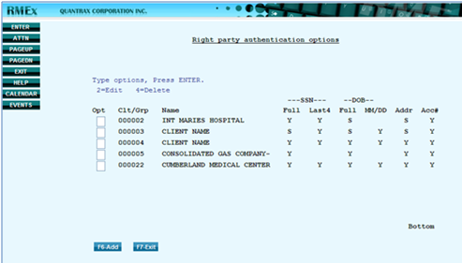

1. Add/modify the debtor authentication options, then press **ENTER** to update   
   **NOTE:**  Use **Y** (Need to authenticate) or **S** (Single option to authenticate)

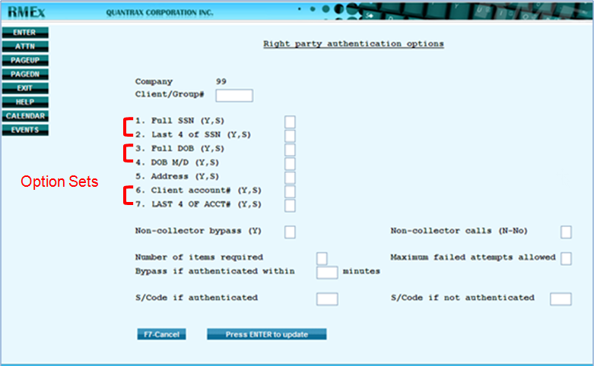

The system will automatically present the following screen to the collector to verify the debtor’s information.

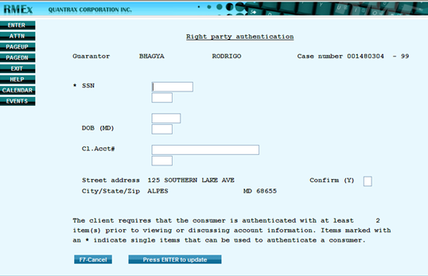

**EXAMPLE 1**: In the screen below, if the *Full SSN* is verified the system will ignore the DOB and Address options and the *Account Detail* will be presented to the collector.

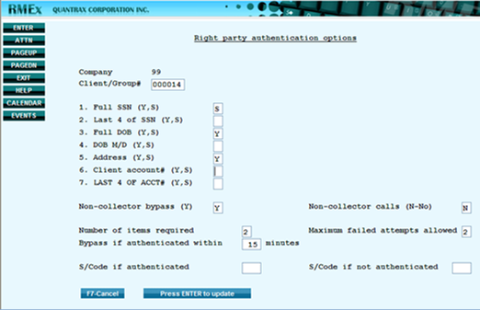

**EXAMPLE 2**: In the screen below, six options have been selected but only two options from different option sets need to be authenticated.

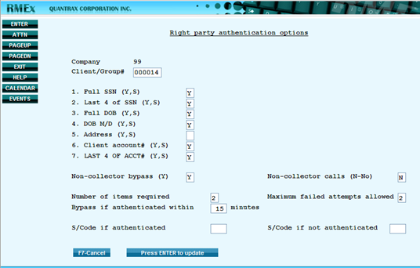

**To authenticate debtor information (collector):**

1. When collectors try to access the account (Account Inquiry screen), if Debtor Authentication is configured for client the following screen displays

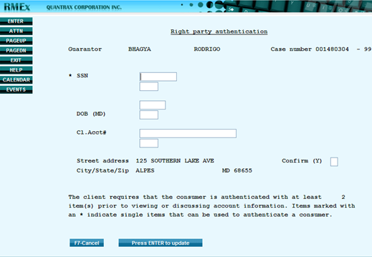

1. Verify the information with the debtor and type it in the screen then press **ENTER** to go to the *Account Detail Screen*

**NOTE**: When incorrect information details are entered, the message *Authentication failed* displays

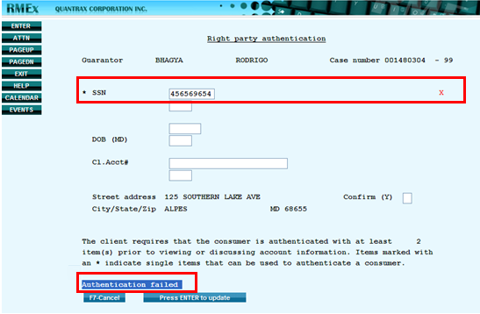

**NOTE:** When the maximum failed attempts allowed has been reached, the message *Maximum attempts for authentication* displays

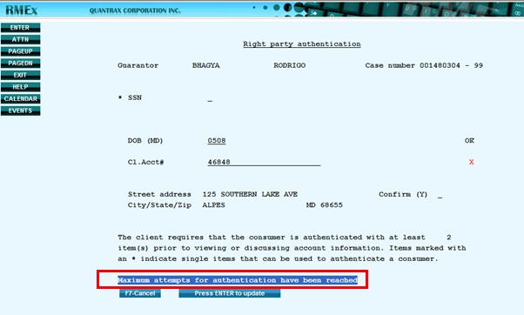

**To find out if authentication failed on an account:**

1. Check the A*udit Notes* in the *Account Detail* screen press **F11**
2. Press **F10**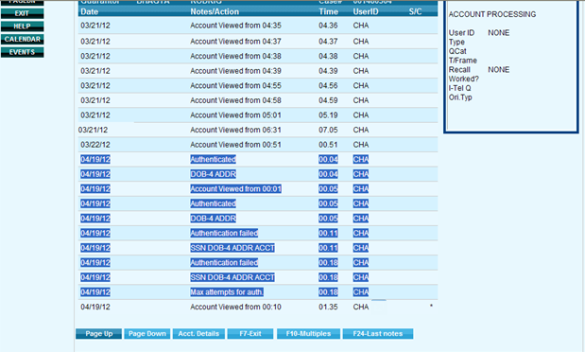

## Account Inquiry Search - By Phone Number

In RMEx GUI 3.0, from the *Account* *Inquiry* screen you can search by all phone numbers; both “good” and “bad” work and home phone numbers. In the *Inquiry* *Account* search results screen, good numbers are notated with capital letters (H for home) and bad numbers are notated with small case letters (h for home). This feature works for both work and home phone numbers.

**To search for ALL phone numbers from the Account Inquiry screen:**

1. From the *Main* *Menu*, select **Inquiry** **Menu**, select **Account** **inquiry** screen
2. For *Search* *type* enter **08** for **Phone Numbers**
3. For *Search* *data* enter the home or work **phone** **number** followed by **X** (**4656465896x)** then press **Enter**

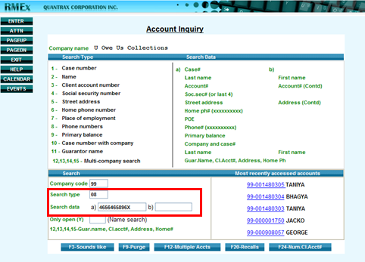

**Example 1**: If a unique phone number was entered, the *Account* *Detail* screen will display for the phone number searched, as shown below.

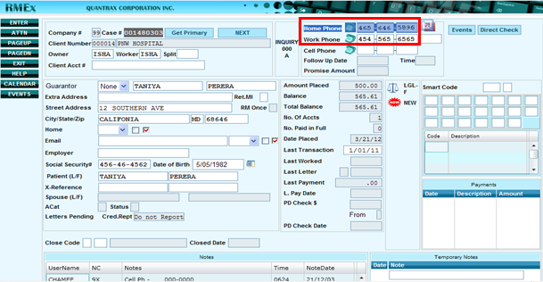

**Example 2**: If the phone number you searched for is a “bad” number), the *Account* *Inquiry* results screen displays. Select the line number to view the account.

**NOTE***: The same number may be listed in several accounts and categorized as”good” and” bad”*.   
 (1234785965**H**, 1234785965**h**)

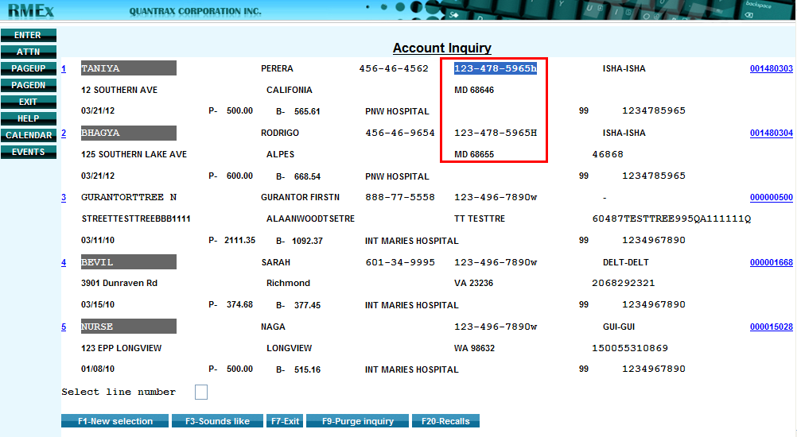

## New Search Type - By Email Address

In RMEx GUI 3.0, from the *Account* *Inquiry* screen you can search by email address.

**To search by email address from the Account Inquiry screen:**

1. From the *Main* *Menu*, select **Inquiry** **Menu**, select **Account** **inquiry** screen
2. For *Search* *type* enter **02** for **Name**
3. For *Search* *data* enter the **email address** (janedoe@gmail.com)and then press **Enter  
     
   Example 1:** Search using the “full” email address.

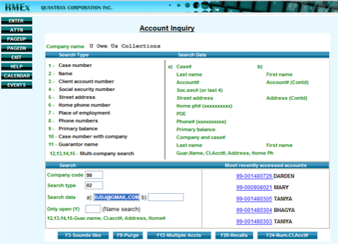

**Example 2:** Search using any part of the email address.  
**NOTE**: You must type in **@** with any part of the email address you are searching for (such as **STEVE.EL@**).

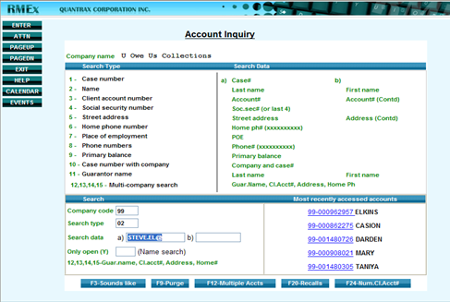

1. From the *Account* *Inquiry* results screen, click on the **line number** to view the account

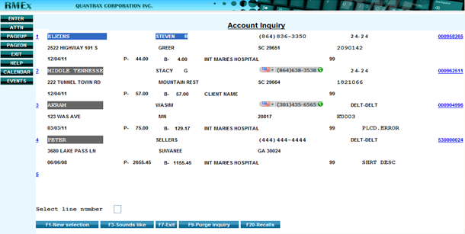

## New search type - By the social security # of patient, spouse, co-signer or multiple co-signers

In RMEx GUI 3.0, from the *Account* *Inquiry* screen you can the social security # of patient, spouse, co-signer or multiple co-signers.

To search by the social security # of patient, spouse, co-signer or multiple co-signer:

1. From the *Main* *Menu*, select **Inquiry** **Menu**, select **Account** **inquiry** screen
2. For *Search* *type* enter **04** for **Social security number**
3. For *Search* *data* enter the social security # X and press **ENTER** (**854552450X)**

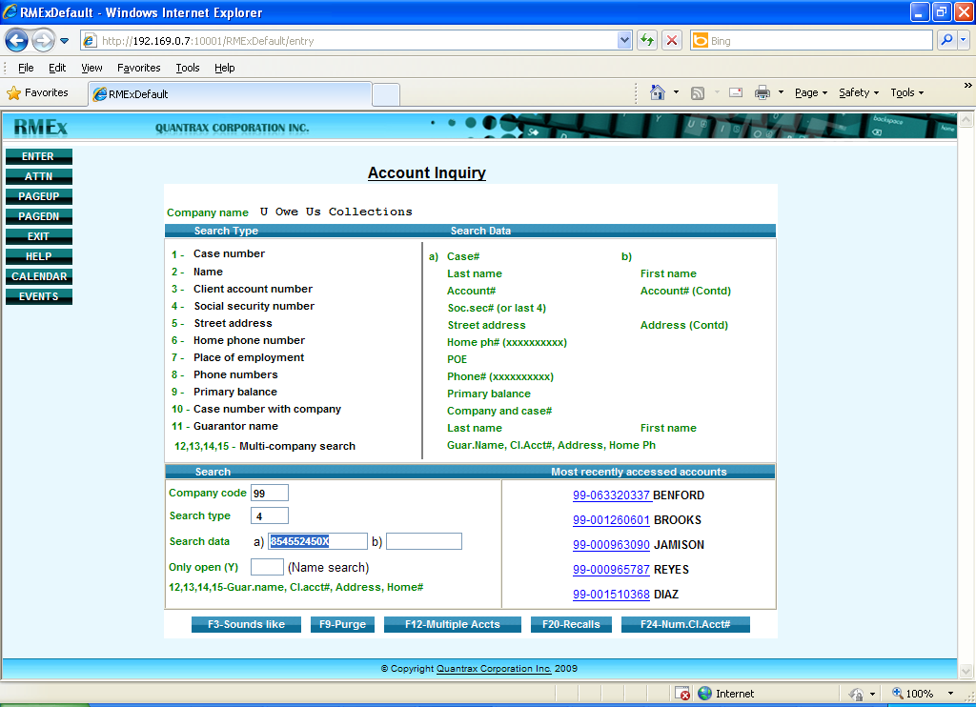

1. The account that contains the SSN you searched for will display  
   **NOTE**: It could be SSN of patient, spouse, co-signer or multiple co-signer

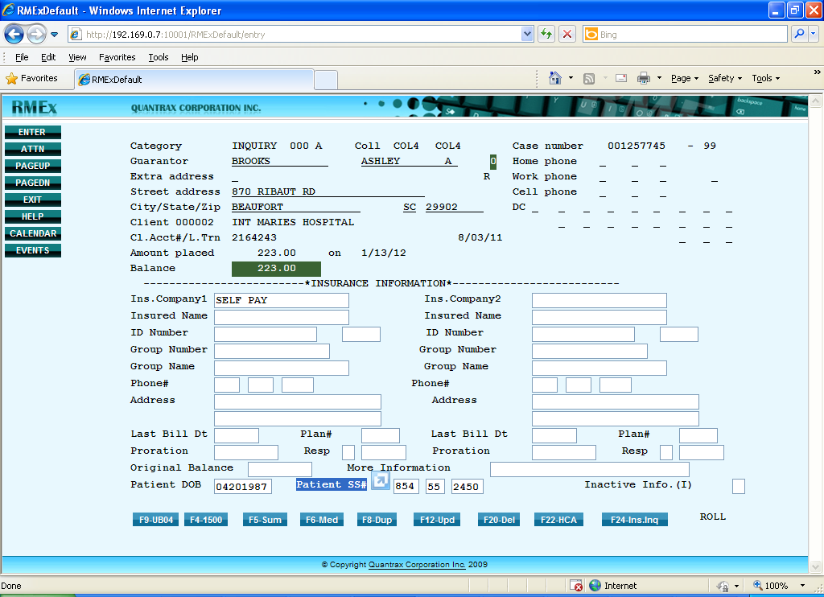

## Use Court Case Numbers to Search and Analyze Accounts

In RMEx GUI version 3.0, you can search legal accounts by court case number and analyze linked accounts’, Summary by Docket#, Balance Type, Worker Code and QCat Codes.

**To search for an account by court case number (docket number)**:

1. From the *Main* *Menu*, select **Inquiry** **Menu**, select **Account** **inquiry** screen
2. For *Search* *type* enter **01** for **Case number**
3. For *Search* *data* enter **CC** followed by **your court case number** (CC8896515100)

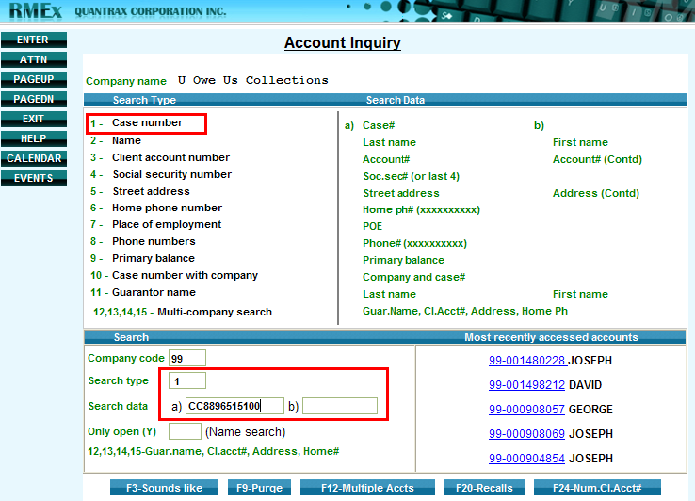

1. Press **Enter**

The account will display in the *Account* *Detail* screen if the court case number entered unique

**NOTE**: The *Account Search Result* screen will display if part of the case number was entered or if it is not a unique number. The court case numbers will display in the position that the C*lient* *Account* *Number* appears in a normal case number search.

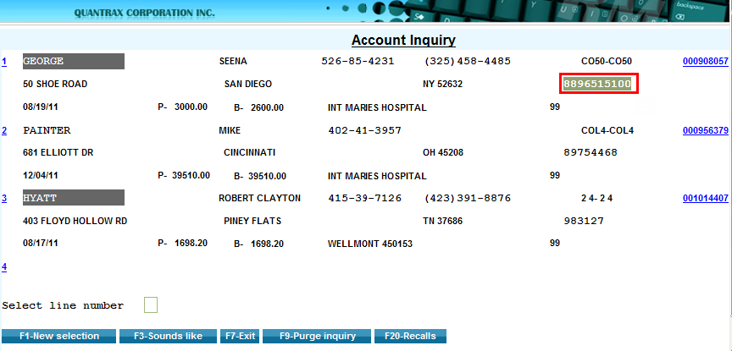

## View Balance for Linked Accounts with Different Court Case Numbers

In RMEx GUI version 3.0 you can view the total balance forlinked accounts with different court case numbers via the *Full* *Legal* screen. Totals can also be viewed by balance types, worker and QCat. The screen is similar to the options from within the linked account summary.

**To view a balance for linked accounts with different court case numbers:**

1. From the *Account* *Detail* screen, press **F6** for **Full** **Legal** screen then click **F5** for **Docket#**

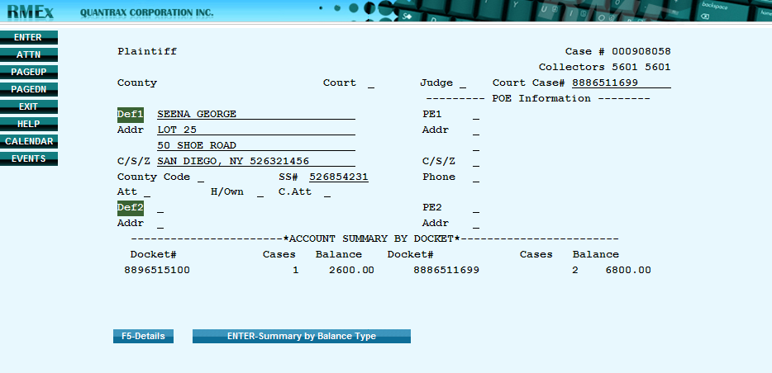

1. Press **ENTER** to view totals by *balance type*, *worker* and *QCat respectively.*

**Account summary by Balance Type**

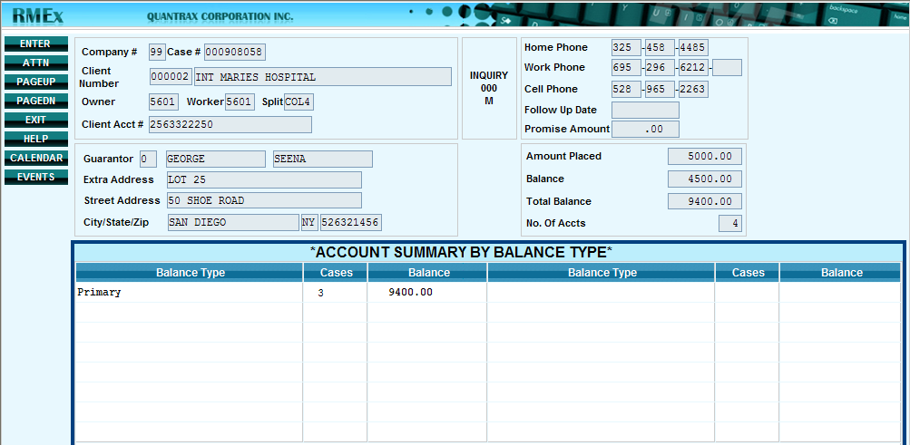

**Account summary by Worker Code**

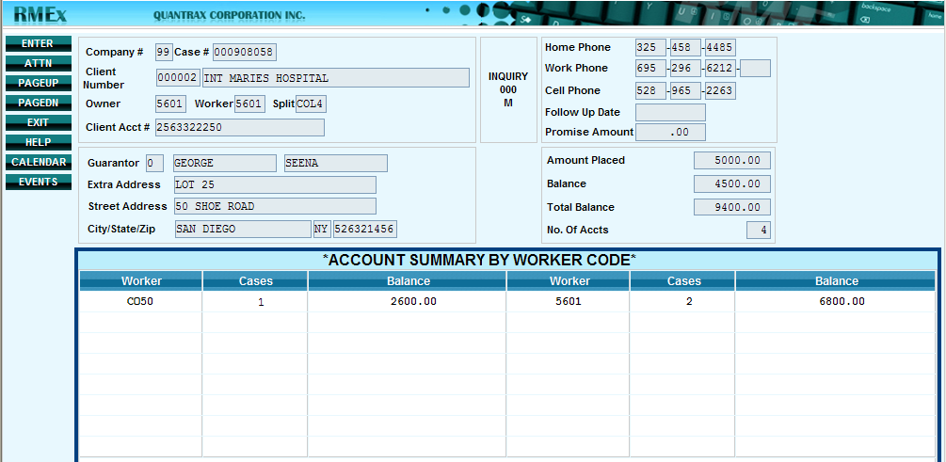

**Account summary by Qcat Codes**

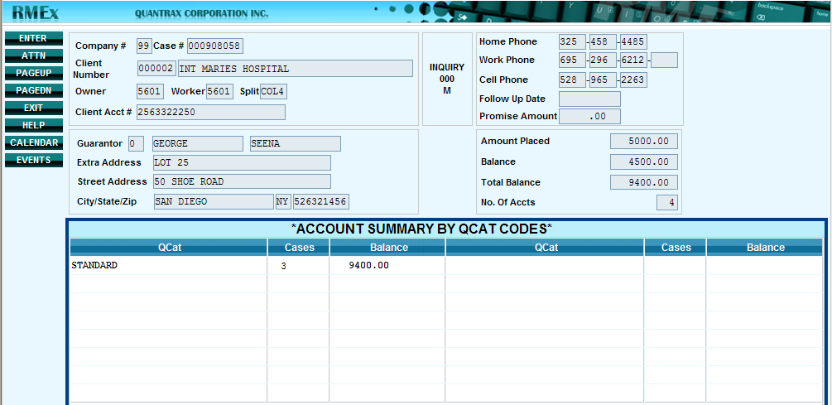

## Legal Screen Enhancements

New options have been added to the **Update Legal Master Files** menu, **Full Legal Screen** and the addition of new fields within some of the screens. The enhancements are as follows:

* Additional fields in Defendant Attorney Codes
* Additional fields in Court Codes
* Additional fields in County Codes
* New options on Legal Master Files Menu
  + Judge Codes
  + Covering Attorney Codes
* Additional screens in Full Legal Screen
  + New Caption screen
  + New Suit Detail screen
  + New Garnishment screen

### Defendant Attorney Codes

The following new fields have been added to the Defendant Attorney Codes screen:

|  |  |
| --- | --- |
| * Additional name | * Secretary name |
| * Phone | * Remarks |
| * E-Mail address |  |

**To access the Defendant Attorney Codes screen:**

1. From *Main Menu* select **Management menu** then select **Legal Files and Reports**
2. From *Legal Files and Reports*, select **Defendant Attorney Codes**
3. Type in information and press **ENTER** to save   
    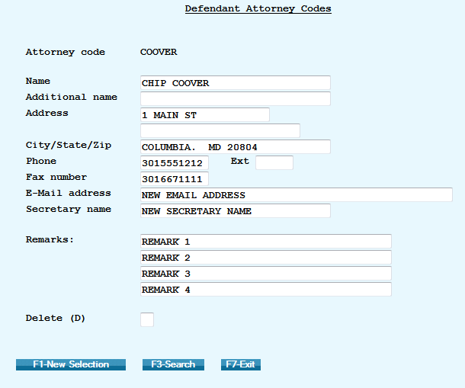

### Court Codes

The following new fields have been added to the Defendant Attorney Codes screen:

|  |
| --- |
| * Description (longer length) |
| * Courthouse Name |
| * Phone |
| * Extension |

**To access the Court Codes screen:**

1. From *Main Menu* select **Management menu** then select **Legal Files and Reports**
2. From *Legal Files and Reports*, select **Court Codes**
3. Type in information and press **ENTER** to save

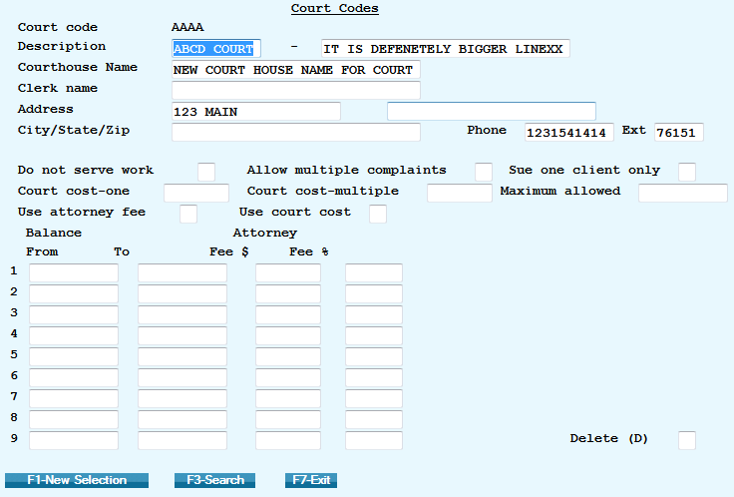

### County Codes

The following new fields have been added to the Defendant Attorney Codes screen:

|  |
| --- |
| * Second person |
| * Phone |
| * Fax |

**To access the County Codes screen:**

1. From *Main Menu* select **Management menu** then select **Legal Files and Reports**
2. From *Legal Files and Reports*, select **County Codes**
3. Type in information and press **ENTER** to save

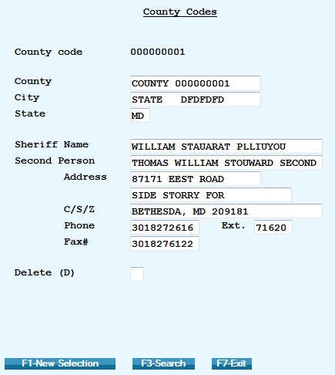

### Judge Codes

A new option is available on the **Legal Master Files Menu** called **Judge Codes**. Use the Judge **Codes** screen to enter detailed information about the judge.

**To access the Judge Codes screen:**

1. From *Main Menu* select **Management menu** then select **Legal Files and Reports**
2. From *Legal Files and Reports*, select **Judge Codes**
3. Type in information and press **ENTER** to save

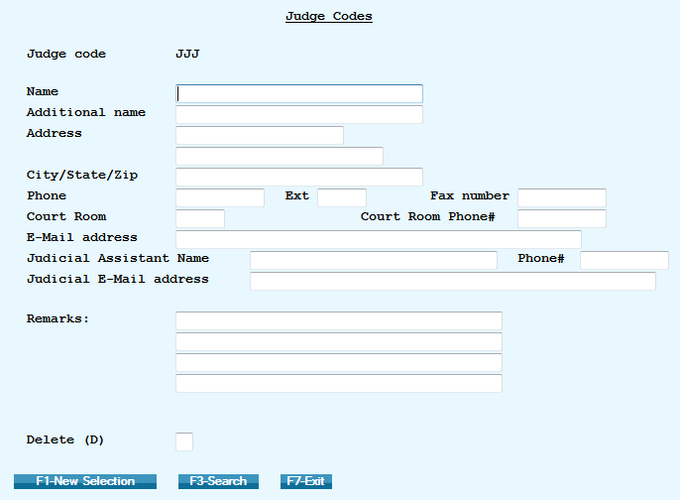

### Covering Attorney Codes

A new option is available on the Legal Master Files Menu called **Covering Attorney Codes**. Use the Covering Attorney Codes screen to enter detailed information about the covering attorney.

**To access the Covering Attorney Codes screen:**

1. From *Main Menu* select **Management menu** then select **Legal Files and Reports**
2. From *Legal Files and Reports*, select **Covering Attorney Codes**
3. Type in information and press **ENTER** to save

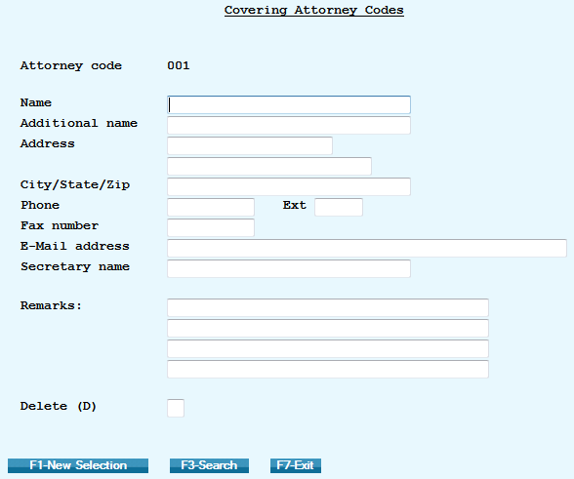

### Full Legal Screen Enhancements

Additional legal screens are available from the **Full Legal Screen** via the **Account Detail** screen. The new screens are:

* Caption Screen
* Suit Details Screen (by defendant)
* Garnishment Screen  
  **NOTE**: Only three defendants can be entered (Def1, Def2 and Def3)

There are 2 new files (one for Garnishments and for a second legal screen) stored at the defendant level (DEF1, DEF2 and DEF3)

For letters, there are a set of merge codes for data in each screen. For the Caption and Garnish screens, there are merge codes to indicate these items are for which defendant.   
Click on the icon to view the list of merge codes for the **Full** **Legal** screen enhancements [](http://www.quantrax.com/kb/Legal_Screen_Enhancements/DOC_LegalScreen/NewScreenMergeCodes.pdf)

**To view the merge codes used for letters:**

1. From *Main Menu* select **Letter Format menu** then select **Merge Codes**

### Caption Screen

Use the **Caption Screen** to notate the heading of a motion or other document filed with a court. It typically contains the names of the plaintiff(s) and the defendant(s), the name of the court, the assigned judge, and the case number.

**To access the Caption Screen:**

1. From *Main Menu* select **Inquiry menu** then select **Account Inquiry** and bring up an account **NOTE:** You can also access **Account processing****menu** then select **Account inquiry**
2. From the **Account Detail Screen** press **F6** for the **Full Legal** screen, then **F2** for the **Caption** screen
3. Type in information and press **F12** to update

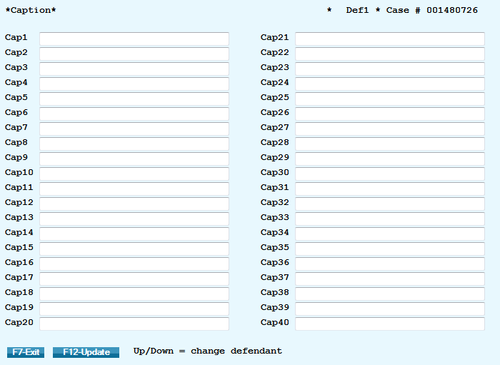

### Suit Detail Screen

Use the **Suit Detail Screen** to enter detailed information about the law suit.

**To access the Suit Detail Screen:**

1. From *RMEx* *Main Menu* select **Inquiry menu** then select **Account Inquiry** and bring up an account **NOTE:** You can also access **Account processing****menu** then select **Account inquiry**
2. From the **Account Detail Screen** press **F6** for **Full** **Legal** screen then **F8** for the **Suit Detail** screen
3. Type in information and press **F12** to update /or go to view info for next defendant

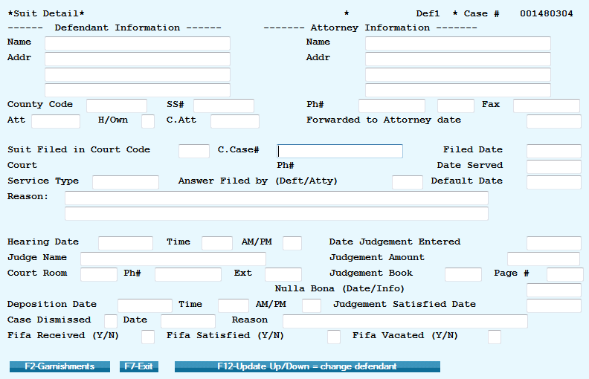

### Garnishment Screen

Use the **Garnishment Screen** to enter up to 5 garnishments for each defendant.

**To access the Garnishment Screen:**

1. From *Main Menu* select **Inquiry menu** then select **Account Inquiry** and bring up an account **NOTE:** You can also access **Account processing****menu** then select **Account inquiry**
2. From the **Account Detail Screen** press **F6** for **Full** **Legal** screen, **F8** for the **Suit Detail** screen then press **F2** for **Garnishment** screen
3. Type in information and press **F12** to update and/or go to view info for next defendant

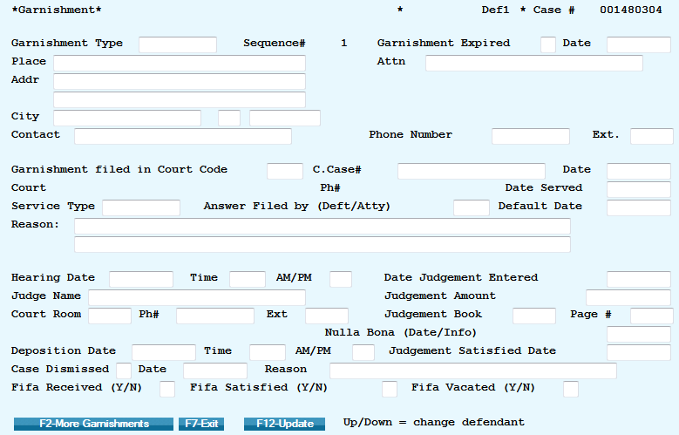

# Clerical Operations Changes

## Additional Account Processing Types

RMEx 3.0 includes two additional Account Processing Types, Cell phone numbers only and Other phone numbers only.

 Click icon to listen to examples of how to use the two new *Account Processing Types*!

**To access Account Processing Types:**

1. From the *RMEx Main Menu* select **Account Processing Menu**, then select **Display Accounts** to be worked
2. Enter the required *Type of processing* and the necessary details to access the accounts that are to be worked (as if in the previous version)

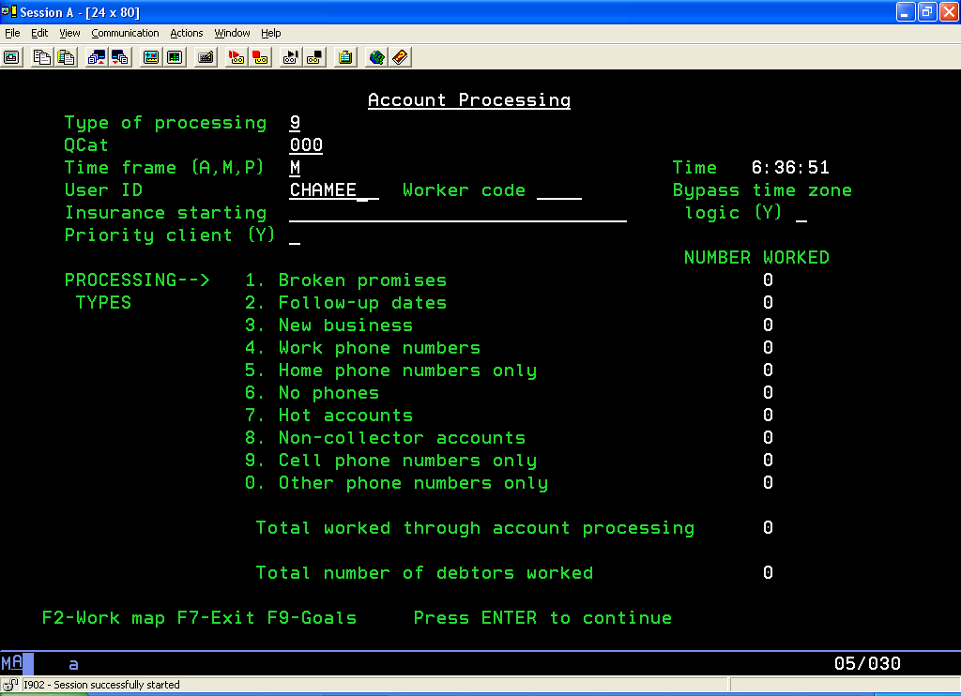

# Compliance Changes

## State Compliance

The *State Compliance* module provides users with four key controls to enforce compliance with state regulations. The controls are:

### Allowable Calling Period

Different states have different *Allowable Calling Periods* by day of the week and by type of call.  
 **EXAMPLE**: You can start calling California at 8am local time with live agents, but you cannot use virtual agents until 9am.

### Holidays

There are different rules for calling on holidays; different states and provinces have different holidays in addition to national holidays. The *State Compliance* module contains provision for specifying the holidays for each individual jurisdiction at the state or national level. The *Allowable Calling Period* for holidays is entered onto the system and RMEx will prohibit a call outside that period.

### Maximum Calls by State

Different states have different rules concerning the volume and frequency of calls to a consumer. The *State Compliance* module allows users to specify the maximum number of calls within a period.

### The Home before Work Rule

Some states have a *must call home before work* rule. An attempt to contact the consumer at home must be made in good faith prior to calling a work number. The *State Compliance* module allows users to indicate which states require this rule and prohibits a call to any work numbers for a specified number of days after a call to a home number.

# I-Tel Changes

## Campaign Merging Options

One of the newest features, *Campaign Merging Options* allows the clients to merge the campaigns automatically to reduce the burden of handling them manually. This option is designed to cover the whole area concerned with managing campaigns.

**EXAMPLE**: There are twenty campaigns with a total number of five thousand accounts and five collectors. Assuming that a collector can work a maximum of four hundred accounts per day – that results in a total of two thousand from the five collectors and leaving three thousand accounts behind. The feature can be setup to handle this situation efficient way (the field **Include if not worked for ___ days**).

 Click icon to listen to examples of situations when you should consider using *Campaign Merging*   
 Options!

**To Run Campaign Merge Options**:

1. From the *RMEx Main* menu select **I-Tel options** menu
2. Select option **Queue Consolidation** options
3. Select option **Campaign merging** options

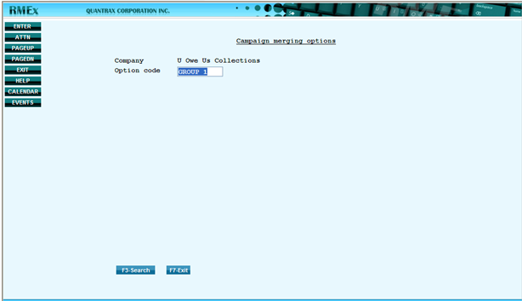

1. From the *Campaign merging options* screen, type in **Option code** and press **ENTER**
2. Type a **Description** for the *Option code*
3. Type in the **Campaigns** to be selected

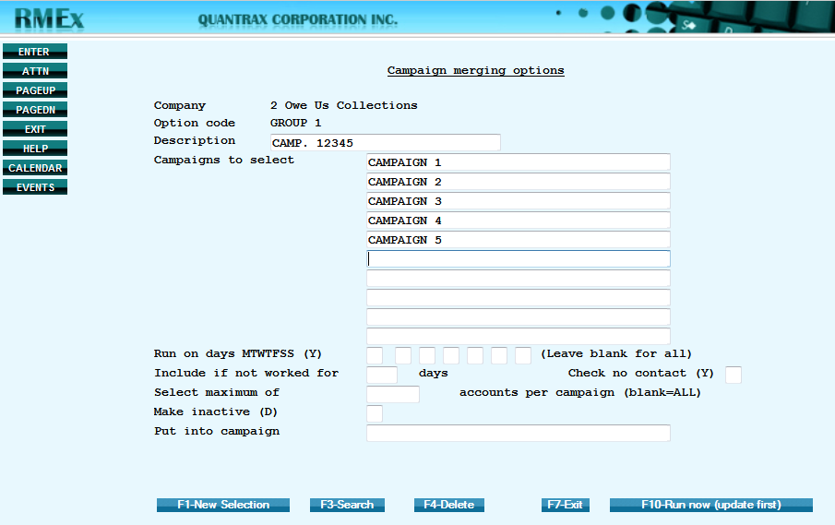

1. Set up the options:
   * **Run on days (Y) –** insert a **Y** in the relevant position to specify on which days of the week (MTWTFSS) you wish to work the accounts
   * **Include if not worked for ___ days** - giving the priority for the date last worked
   * **Check no contact (Y)** - to select the account even if it has been attempted within the number of days mentioned in the previous option, with no contact
   * **Select maximum of ________ accounts per campaign –** the maximum number of accounts that you wish to select/work from each campaign
   * **Make inactive (D) –** in case you wish to de-activate this *Option Code* you can insert a **D** in front of this option
2. When finished press **ENTER** to **Save merge options**
3. Press **F10** to **Run now (update first)** **–** To execute this merge campaign criteria interactively now

## Controlling Maximum Calls

*Controlling Maximum* Calls ensures that an agent(s) cannot launch an excessive number of calls to any number or account. The feature can be turned on and off by company and sets call limits by client group number. Limits can be placed on individual numbers, accounts, debtor numbers and non-debtor numbers, and home numbers, work numbers and cell numbers.

#### To Activate Maximum Calls Controls (Company level):

1. From the *I-Tel Options* menu select **Other phone number options**
2. From the *Other Phone Number Options menu*, select **Phone number restrictions by client**

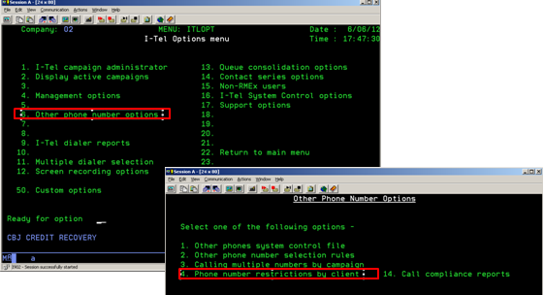

1. From the *Phone Number Restrictions by Client menu*, select **Restrictions by company**

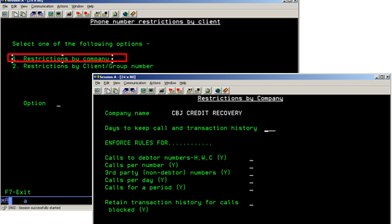

1. The **recommended** values are shown below  
   **NOTE**: Entering the values shown below turns on *Maximum Calls Processing* for the company you are using. Next you need to enter the call limits for a particular client number or client group number.

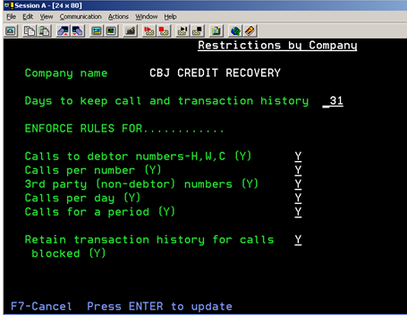

#### To Specifying the Maximum Number of Calls (by Client):

1. From *Phone Number Restrictions by Client menu*, select **Restrictions by Client/ Group number**
2. Type a client group number or client number
3. Type the maximum number of calls for different types of numbers (see table below for details)

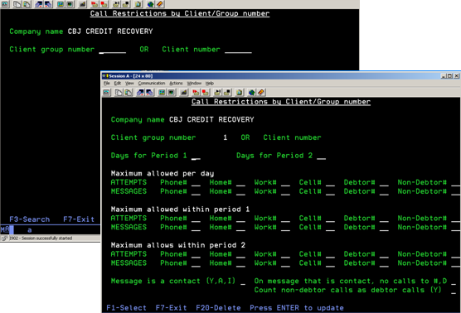

|  |  |
| --- | --- |
| **Call Restrictions by Client/Group Number** | |
| **Phone#** | The maximum number of times a call can be launched to a single phone number |
| **Home#** | maximum number of times a call can be launched to a phone number designated as a home number |
| **Work#** | The maximum number of times a call can be launched to a phone number designated as a work number |
| **Cell#** | The maximum number of times a call can be launched to a phone number designated as a cell number |
| **Debtor#** | The maximum number of times a call can be launched to a phone number designated as a debtor number |
| **Non-Debtor#** | The maximum number of times a call can be launched to a phone number designated as a non-debtor number |

**NOTE**: A number is defined as a *debtor home number* if the phone number has a phone code that is marked as a debtor home phone. This parameter can be changed from the *Other Phone Number Options* menu and selecting **Other phones system control files** then type the relevant phone code. Each phone code that belongs to a debtor should be marked as a debtor home phone, work phone or cell phone. If *none* of these options is set to **Y** then the phone code is considered to be non-debtor phone code.

**EXAMPLE**: Phone code H is marked a *Debtor home phone* by placing a **Y** next to that option

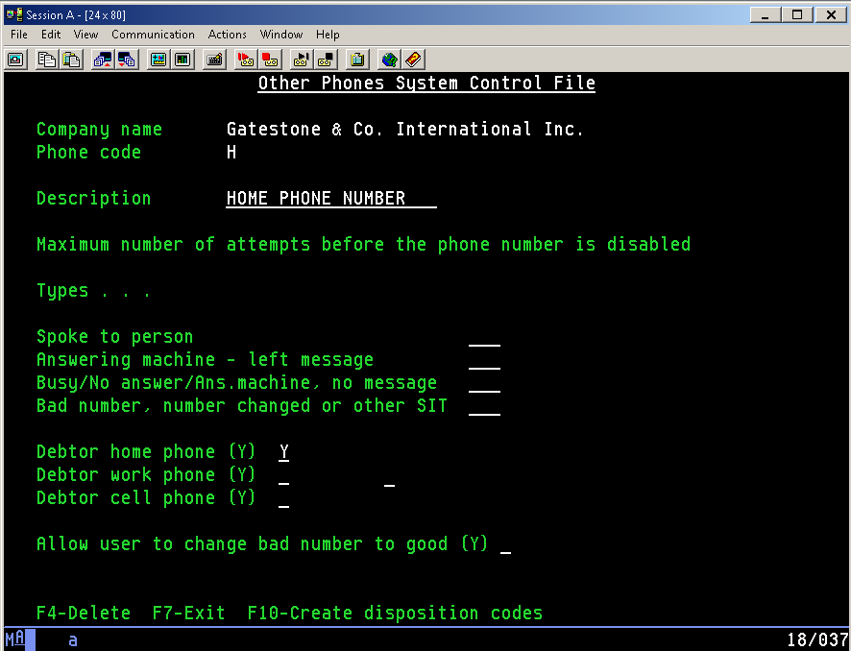

**EXAMPLE**: The following screen has been completed and a description of each specification is below

* A maximum of three calls can be launched to a single number, even though five calls may be made to debtor numbers.
* Three calls may be launched to a phone number with a phone code designated as a debtor home phone, provided that the maximum number of calls to a debtor is not exceeded.
* Three calls may be launched to a phone number with a phone code designated as a debtor work phone, provided that the maximum number of calls to a debtor is not exceeded.
* Three calls may be launched to a phone number with a phone code designated as a debtor cell phone, provided that the maximum number of calls to a debtor is not exceeded.
* Five calls may be launched to a phone number with any phone code designated as a debtor phone, provided that the maximum number of calls to an individual phone number, or a phone type, is not exceeded.
* Five calls may be launched to a phone number with any phone code designated as a non-debtor phone.   
  **NOTE**: In this example, these calls are in addition to any calls launched to debtor numbers. This is because the *Count non-debtor calls as debtor calls (Y)* field at the bottom of the screen is set to blank.
* Only one message may be left per day. The message can be left on any type of number belonging to the debtor. No messages can be left on non-debtor phone numbers.

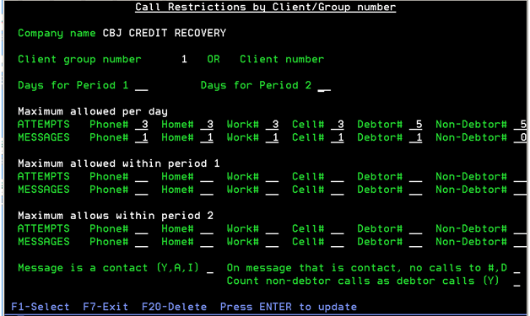

There are three fields at the bottom of the screen:

* **Message is a contact (Y, A, I):** Allows the user to restrict subsequent calls to a number if the first call resulted   
   in a contact

**Y** Any message is considered a contact

**A** Messages left by live agents are considered contacts

**I** Messages left by IVR agents are considered contacts

* **On message that is a contact, no calls to #, D**: If a call has been launched to a number and has resulted in a   
   message being left, the user has the option of prohibiting   
   subsequent calls to either that number or to any debtor number

**#** Prohibit subsequent calls to the number dialed

**D** Prohibit subsequent calls to any debtor number.

* **Count non-debtor calls as debtor calls (Y):** Allows you to count any call on an account to be considered a *debtor*   
   call

**Y** Limit the maximum number of calls on an account to the value specified in the Debtor# field; the value in the ‘Non-debtor#’ field will be ignored