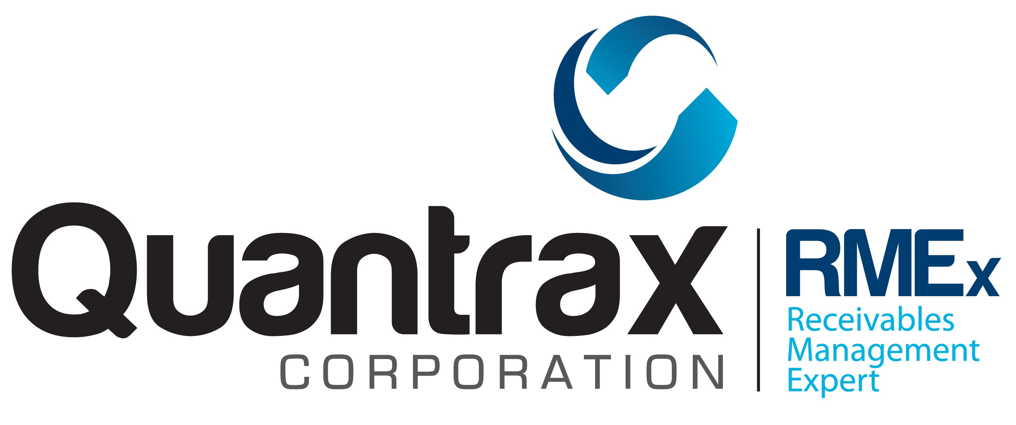

Following is a list of questions that will help us in understanding your system’s account information.

Account Information – General

How many accounts will you be converting?

Does your internal account number contain alphabetic characters?

How many characters is your internal account number?

How do you handle consumers that have multiple debts?

How many data bases do you have?

Other than 3rd party collections, what other products/services do you offer that should not be mixed with the 3rd party collections? (early out, pre collect, etc.)

Other than principal balance, what other Balance Types do you use? (court cost, bad check, etc.)

How will we determine that an account is in a letter series?

How do you handle accounts that have been forwarded to another agency or law firms?

How will we determine to which agency or law firm you forwarded the account to?

How will we determine what the Forwarded Agency’s commission rate is?

How will we determine the client commission rate at the account level?

How will we determine the promise date and promise amount on an account?

How do we differentiate between a follow up date and a promise date?

How will we determine that an account is closed? (Collection activity has been stopped)

How will we determine the date an account was closed?

How will we determine when an account was last worked?

How will we determine if the address on the account is bad?

How will we determine if letters should not be sent on the account?

How will we determine if external scores exist on an account?

Will you be converting purged accounts?

What types of codes do you use to indicate a special status or circumstance at the account level? (bankrupt, deceased, disputes, special account etc.)

Account Information - Collectors

What is the maximum number of characters your current collector code can contain?

How will we differentiate between a legal, pre legal and a regular collector?

How does your system maintain collector statistics?

What collector statistics does your system maintain?

Account Information – Notes

How will we determine the date the notes were entered in your system?

How will we determine the time the notes were entered in your system?

How will we determine the user id that entered the notes in your system?

Are your notes sequenced in numerical order?

Do you have accounts that have more than 999 lines of notes?

Account Information – Co-Signer

How will we determine co-signer (co-maker) information?

Do you have a separate account for the co-signer?

Account Information – Legal Accounts

How will we determine if accounts are in a legal status?

Do you segregate legal accounts by collectors?

Account Information – Collector Codes

Are your collector codes larger than 4 characters?

Account Information – Payment Arrangement

How will we determine payment arrangements?

Do you have one payment arrangement for multiple debts for the same debtor?

Account Information – Credit Cards

How will we determine if a credit card exists on an account?

Do you allow recurring credit card transactions?

Account Information – Direct Checks – Post Dated Checks

How will we determine a post dated check on an account?

How will we determine a direct check on an account?

Account Information – Consumer Attorney

How will we determine if the consumer is being represented by an attorney?

Account Information – Phone Numbers

How many phone numbers can you have on an account?

How will we determine the different types of phone numbers? (cell, home, work, relatives etc.)

Account Information – Skip Tracing

How will we determine any skip tracing information?

Account Information – Utilities Client

What information does your system store regarding utility accounts?

Account Information – Commercial Client

What information does your system store regarding commercial accounts?

Account Information – Retail Client

What information does your system store regarding retail accounts?

Account Information – Bad Check

What information does your system store regarding bad check accounts?

Account Information – Medical Client

What information does your system store regarding medical accounts?

Account Information – Other Client Type

What other account information does your system store that have NOT been mentioned above?

Following is the field level information for the account file used by RMEx. It can be used as a guideline for mapping the data from your existing system to RMEx.

Account File Layout

