**Submitting new accounts into your collection software**

* From the "Online Client Menu", select Account entry and press enter
* Type in your assigned Client Number (ex. 500001)
* Key in a Y next to the type of client you are then press enter
* You will now be on the "Account Entry" screen as seen below

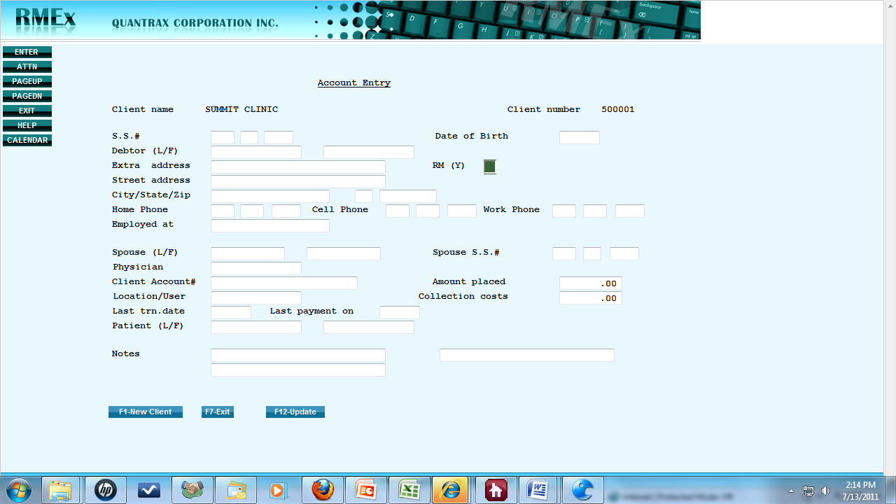

* If available, type in "Social Security Number" and "Date of Birth" (6 digits, i.e., 081275)
* Type in "Last Name", and then "First Name". If it's a company that owes you money type their company name straight across from left to right.
* "Street Address" and enter the most current address you have on file.
* "Extra Address" is used only for an Apartment number or Suite
* Next enter City/State/Zip
* Next enter "Home Phone", "Cell Phone" (if available) and “Work Phone" (if available). *Never duplicate the same phone numbers in more than 1 field* or an error message will appear when you attempt to submit the account.
* Enter "Employed at" (if available)
* Enter "Spouse Last Name", "First Name", and "Social Security" (if available)
* Enter the "Physician's Name" if you are a medical practice
* Enter your account number in the "Client Account #" field. We must have a client account number which is your internal account number on the consumer. If you do not have an account number leave the field “blank”. You will want to use the same approach for all consumers because this number will be used to report payments.
* If you have Multiple Locations (enter location), or Multiple System Users (enter name)
* You must enter a date in the "Last Trn. Date", i.e., (6 digits, i.e., 092212).
* The "Last Payment on" is not required but feel free to enter a date, (6 digits, i.e., 092212).
* If this is a Medical Account enter the "Patient" name only if the patient is a minor and not financially responsible for the debt.
* You may add short notes describing the debt.
* Next type in the "Amount Placed" in dollar and cents with no dollar sign. Then press the

"+ Key" just to the right of your keyboard number pad to justify to the right.

* In the "Collection Costs" box type your *Fixed Fee Per Account* as per your Service Agreement in dollar and cents with no dollar sign. Then press the "+ Key" just to the right of your keyboard number pad to justify to the right.
* After entering all consumer information click "F12-Update" at the bottom, or on your keyboard. Confirm the information, and press "F-12" again.
* A new "Account Entry" screen should appear and you can enter the next account. You may have to press enter a second time to get to the new "Account Entry" screen.
* Continue the process until all your accounts have been entered into the system.
* To back space at any time click "F7"
* When finished entering all accounts, backspace by clicking "F7" until you return to the "Main Menu".
* Type 90 in the box at the bottom, and click enter to Log Out

**Reporting Payments**

* From the "Online Client Menu", select Account entry and press enter
* You will now be on the "Payment Entry" screen as seen below

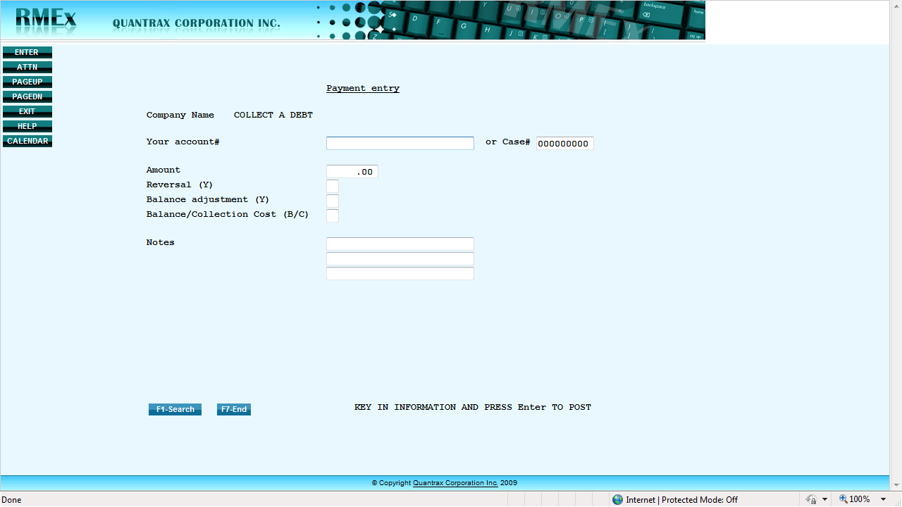

* Type in your internal account number on the consumer in the "Your account #" field
* To credit a payment to the consumers’ account:
  + Type in the "Amount" paid in dollars and cents with no dollar sign. Then press the

"+ Key" just to the right of your keyboard number pad.

* + Reversal (Y) - Leave this field blank
  + Balance adjustment (Y) - Leave this field blank
  + Balance/Collection Cost (B/C) - Leave this field blank
  + Click enter to post transaction
* To reverse a payment that may have been entered incorrectly to the consumers’ account:
  + Type in the "Amount" paid in dollars and cents with no dollar sign. Then press the "+ Key" just to the right of your keyboard number pad.
  + Reversal (Y) – Type a Y in this field
  + Balance adjustment (Y) - Leave this field blank
  + Balance/Collection Cost (B/C) - Leave this field blank
  + Click enter to post transaction
* To make a correction to the consumers’ balance (**lower** the account balance):
  + Type in the "Amount" paid in dollars and cents with no dollar sign. Then press the "+ Key" just to the right of your keyboard number pad to justify to the right.
  + Reversal (Y) - Leave this field blank
  + Balance adjustment (Y) – Type a Y in this field
  + Balance/Collection Cost (B/C) – Type a C to lower the Collection Costs or a B to lower the Primary Balance
  + Click enter to post transaction
* To make a correction to the consumers’ balance (**raise** the account balance):
  + Type in the "Amount" paid in dollars and cents with no dollar sign. Then press the "+ Key" just to the right of your keyboard number pad to justify to the right.
  + Reversal (Y) – Type a Y in this field
  + Balance adjustment (Y) – Type a Y in this field
  + Balance/Collection Cost (B/C) – Type a C to raise the Collection Costs or a B to raise the Primary Balance
  + Click enter to post transaction
* **IMPORTANT**: Transaction types must be entered as described above. **NEVER** correct a payment transaction using the Balance adjustment (Y) feature.
* You will be asked to confirm the payment so type a "Y" and click enter again
* To enter more payments click enter again until "Payment Entry" screen reappears
* To backspace at any time click "F7"
* When you are finished entering accounts backspace to the Main Menu screen
* Type 90 in the box at the bottom click enter to Log Out

**Searching accounts in order to view activity and change statuses**

* From the "Main Menu", type a 1 in the box at the bottom and press enter, or simply click on "Account Inquiry", top-left.
* The Account Inquiry Screen will appear as seen below

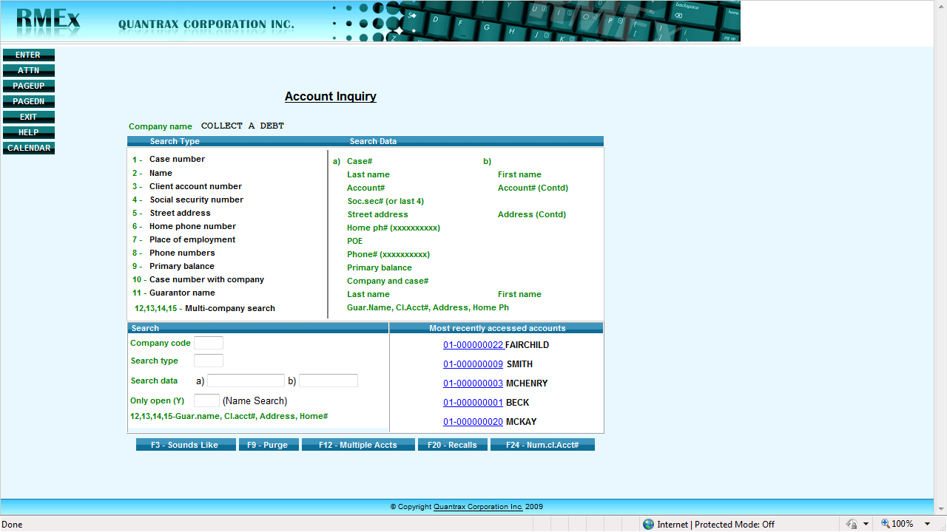

* You can search for your accounts using any of the criteria listed
* You can search by name by typing "02" in the Search Type box
* Then type the last name of the consumer in Search Data box a) , and then click enter
* You can search by account number by typing "03" in the Search Type box
* Then type the account number in the Search Data box a) , and then click enter
* You can also click the 5 most recently accessed accounts
* Your search will open up a window that looks like the following

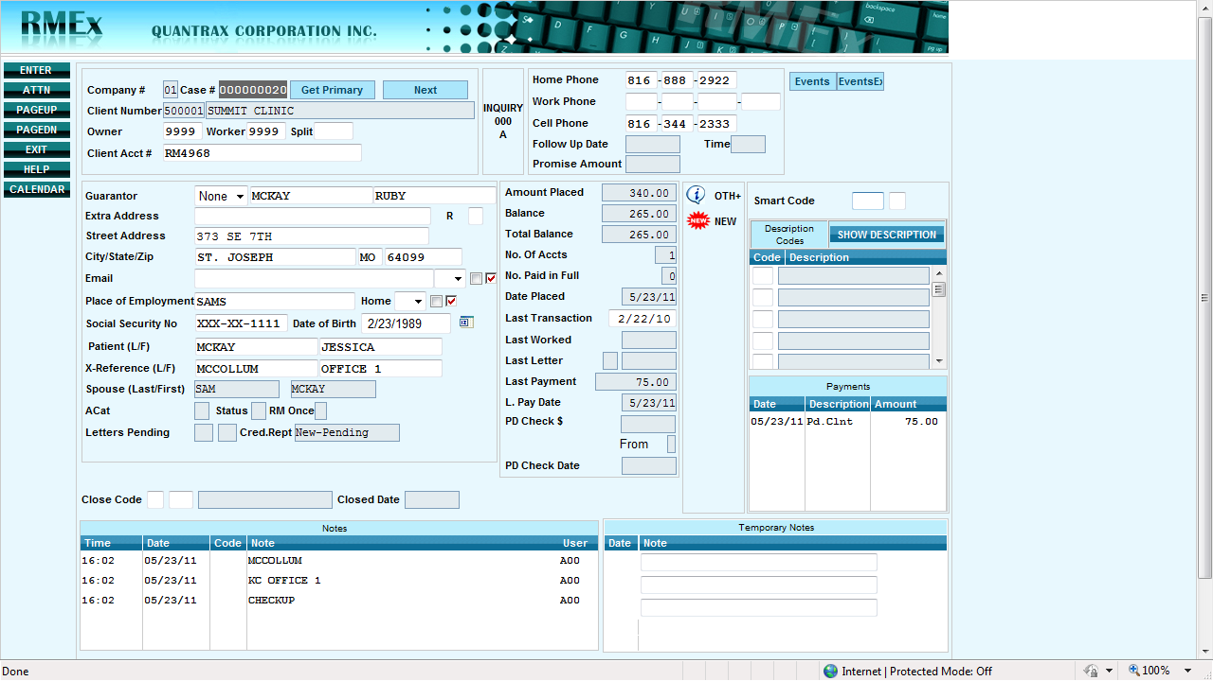

* You can now review all the consumer's information that was submitted on this screen, i.e., Name, Address, Phone Number's, Total Amount Placed, Total Balance, Payments Received, All Collection Activity and Notes
* You can click "F11" to expand the "Notes" section
* This is the screen where you Cancel an Account or Settle an Account in Full
* **IMPORTANT:** Be sure to **first report any payments received** using the instructions in the last section before Cancelling or Settling an Account
* To Cancel an Account that was accidently placed with the agency, scroll down to the Close Code section. In the first box type an "N" and click update at the bottom, or press the F-12 Key on your keyboard. This action will stop all collection actions and cause the account to become an inactive account.
* To Cancel an Account that you have set up on payment arrangements, once again scroll down to the Close Code section. In the first box type an "N" and click update at the bottom, or press the F-12 Key on your keyboard. This action will stop all collection actions and cause the account to become an inactive account.
* **IMPORTANT:** Be sure to report not only the first payment in a payment arrangement, but also all subsequent payments made as per payment reporting instructions above. The reason for this, if they break their arrangement and collection activities need to be reactivated the agency has record of all payments made to date.
* To Settle an Account in full after payment has been posted, once again scroll down to the Close Code section. In the first box this time type an "S" and click update at the bottom, or press the F-12 Key on your keyboard. This action will stop all collection actions and cause the account to become an inactive account.
* When finished backspace using "F7" to the Main Menu, type 90 and Log out