WebSphere Application Server (WAS) for GUI
Preliminary details to retrieve before implementing GUI
Please answer the questions in this document and return to support@quantrax.com if you are interested in moving forward with GUI.
- What IBM Operating System are you currently running? Need to be on V5R4M0 or higher.
- Are your PTF’s current on your iSeries? PTF’s may be needed if you need to upgrade some of the software.
- Have you loaded the latest Cumulative PTF from IBM Fix Central? (pls contact your IBM rep or IBM support for access to IBM Fix Central)
- Do you have the WebSphere Application Server /WebSphere Application Server Express running on your iSeries machine? It normally comes free with the iSeries machine. Note: WAS can also run on a PC. Let us know if this is the direction you would like to take. There will be added costs associated with this set up.
Sign on as QSECOFR and type “go licpgm” on the command line and hit enter as shown below:
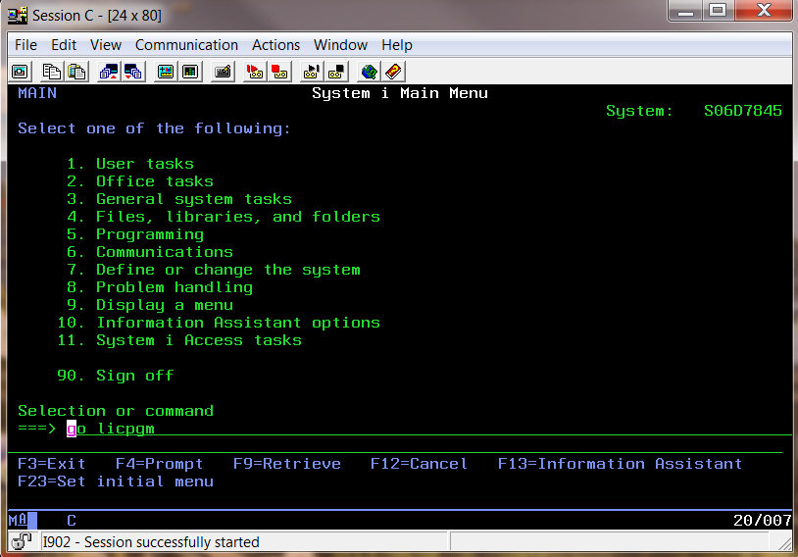
Now you will see the below screen
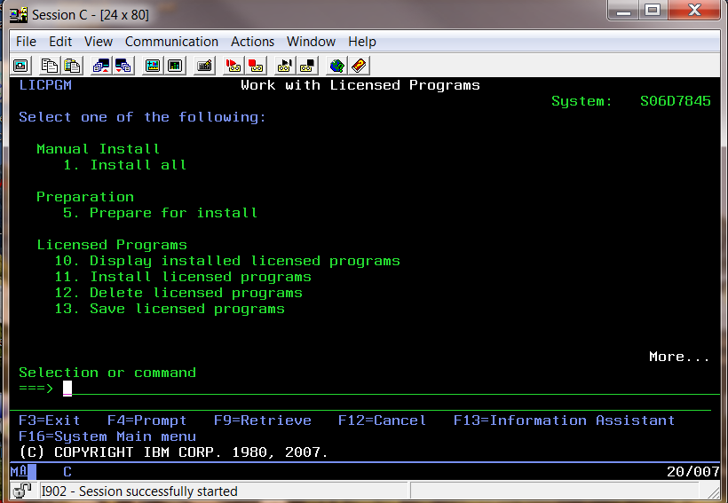Take option 10 from the above screen and then you will see the below screen
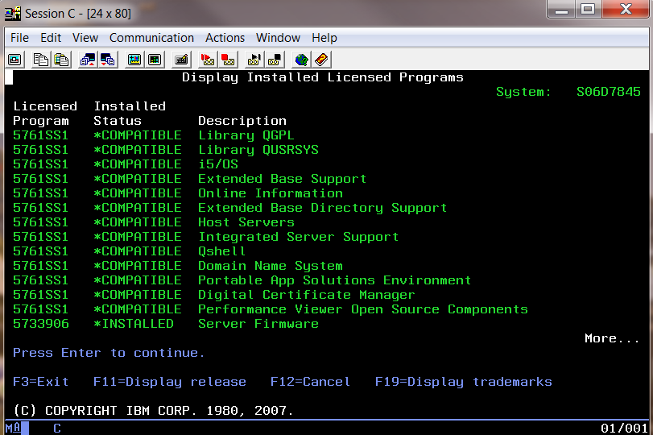
Roll down for WebSphere…
If the WAS is already installed in the iSeries, then you will see the status as Installed as shown below. (Page up/down to view the details)
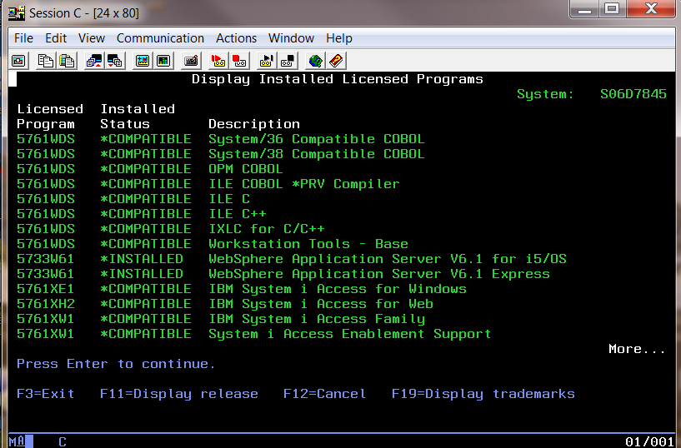
Remain on this screen for the next step

- What is your version of the WebSphere Application Server (WAS)?
Hit F11 (F11 – Display release) from the above screen.
Now you will see the below screen with the version details…
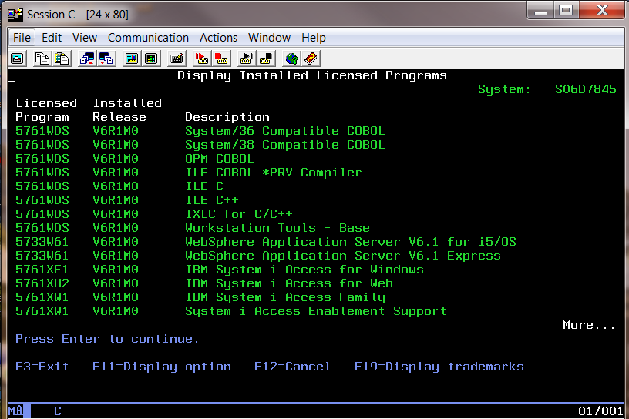
Our version shows “V6R1M0”. This is the version you will need to have installed.

- Please provide the Admin ID and password for WebSphere Application Server (WAS).
___________/_____________

- JAVA - JAVA Options 6, 7 & 8 needs installed as shown below:
(5722JV1-6 5722JV1-7 5722JV1-8)

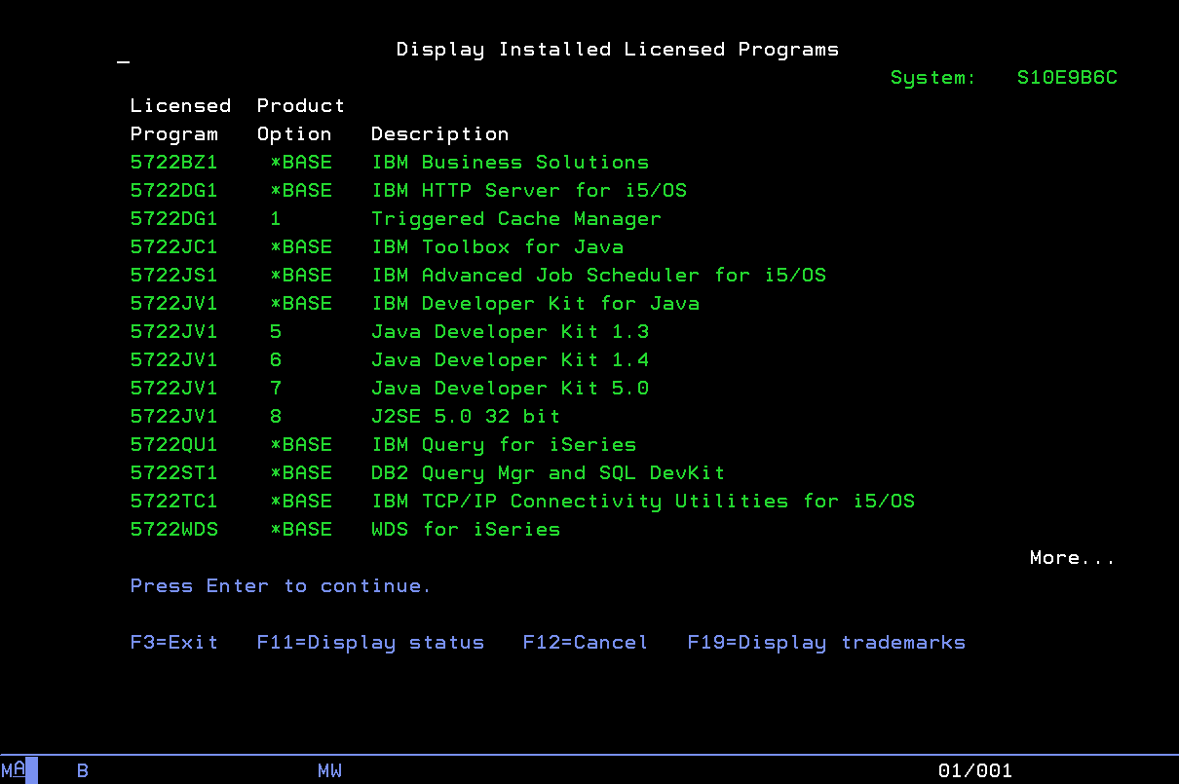

- What is your admin console IP address (the IP address of your iSeries)? That is the ip address of the machine where the WebSphere Application Server is installed? To retrieve this address:

Type “netstat” on a command line and enter. The following screen will be presented. (You need to use the ADMIN user id/password e.g., QSECOFR)
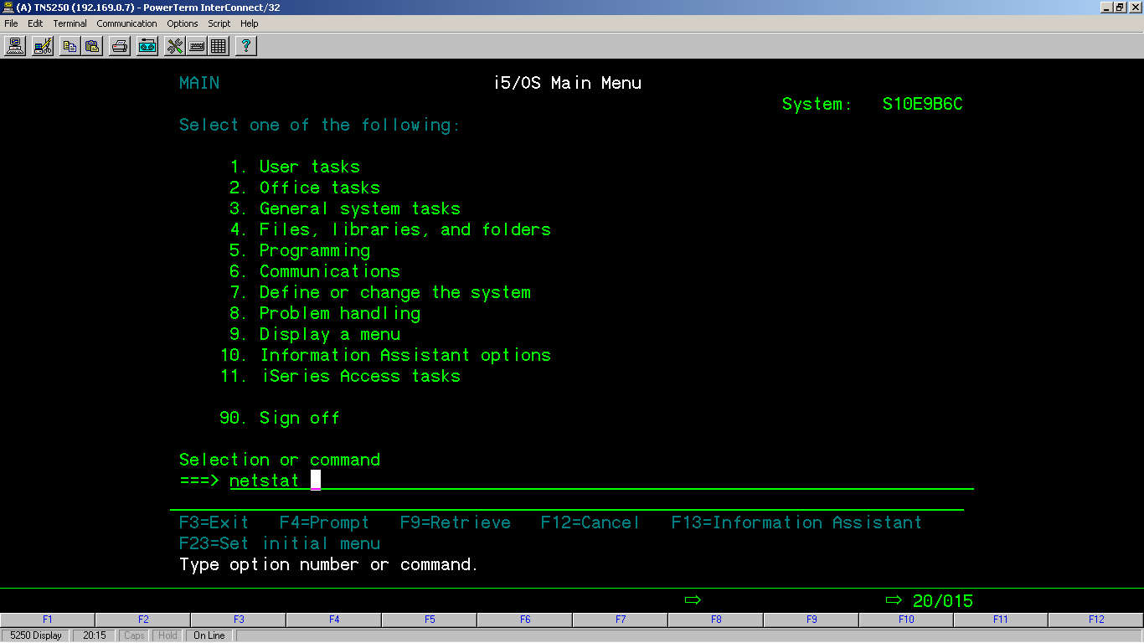
and the next screen will appear…take option 1. Work with TCP/IP interface status
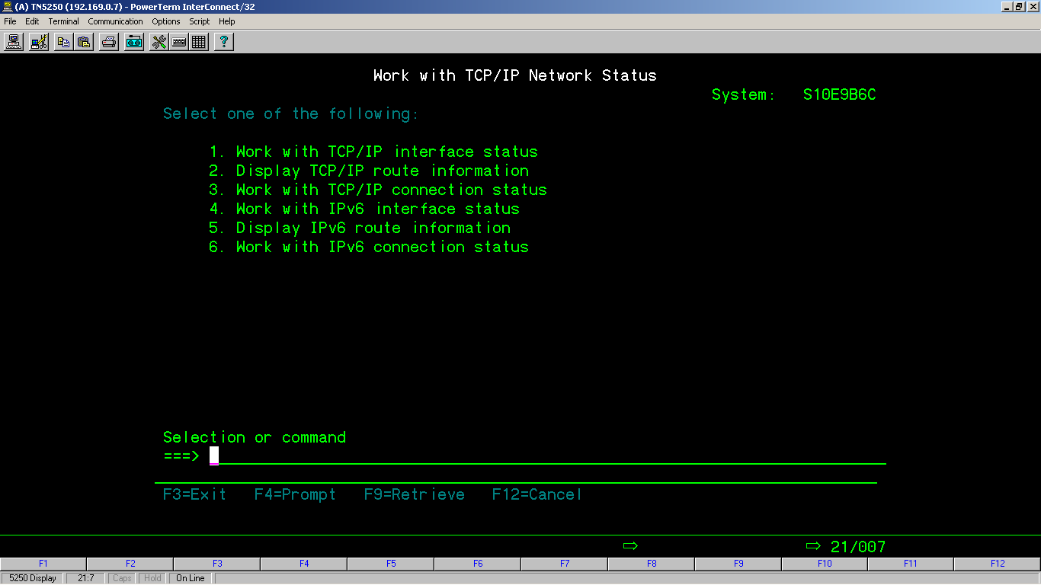
Now you will see the ip address of the iSeries where you installed the WAS. See the next screen shot.
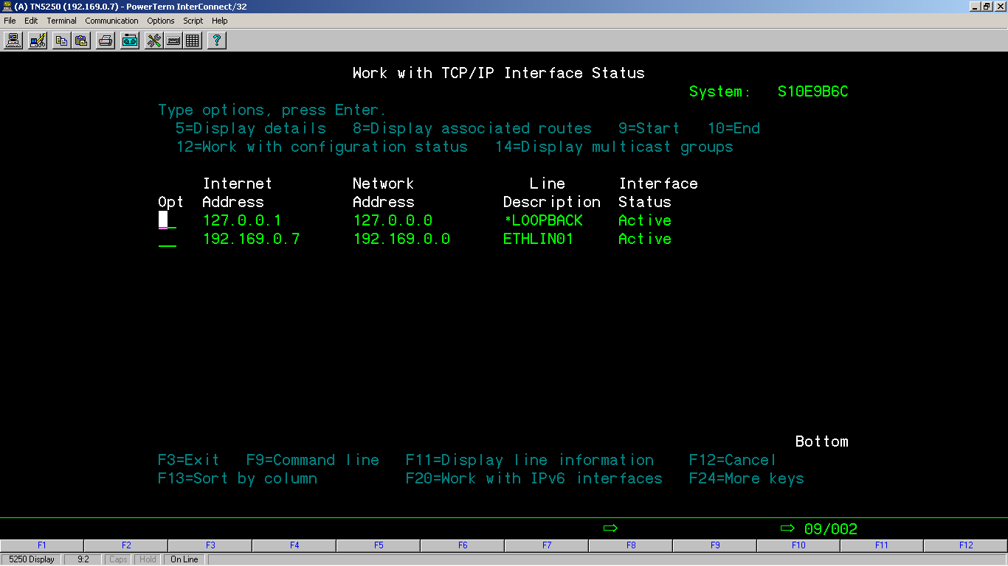

- If there is a User name and password required to access the admin console, please provide it. We need these details to upload the EAR file in the iSeries.

Please provide the password for QSECOFR.

_QSECOFR__/_____________

- Is your WebSphere Application Server (WAS) currently up and running? To verify follow below-
To verify that the HTTP server for WAS is running, type “WRKACTJOB” on a command line. See below.
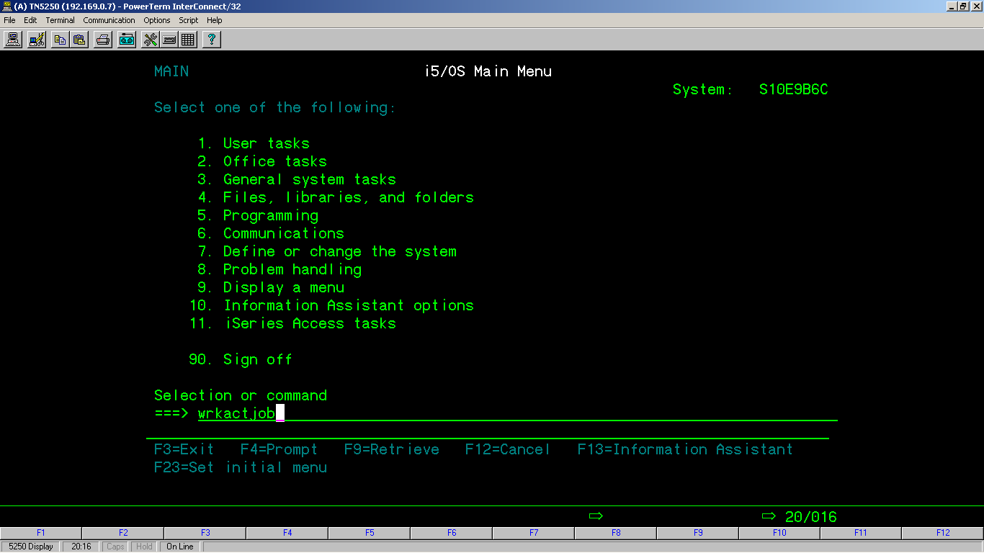
The status of the HTTP server under “QHTTPSVR” sub system will display as shown below if active.
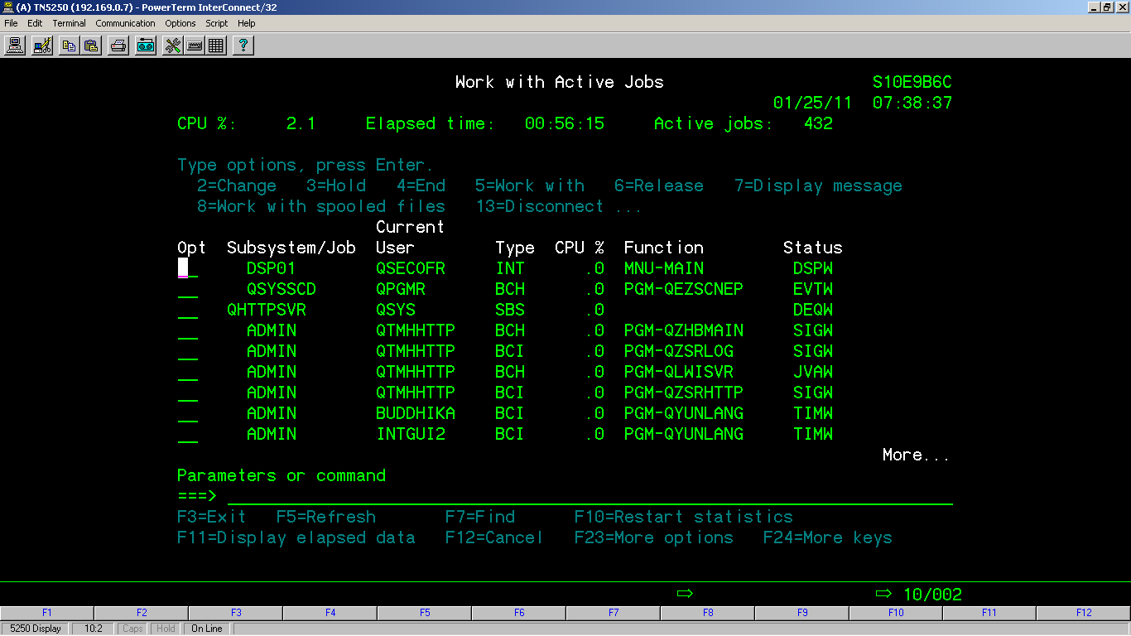
Once these steps are answered and or verified we can configure the WAS server and proceed.
- Please make sure that a PC (GUI server) is connected to the iSeries is up and running.
- If the GUI server is already up and running, please provide the IP address for this server.

- Please install the free version of Teamviewer on the GUI server. Send us the version of the Teamviewer installed on this PC. Once installed, double click on the icon on the desktop and provide the Session ID and Password to us. Please make sure the password is static so we can have access if the PC needs restarted.
We need to transfer the EAR file to the PC first and then we can start to deploy the EAR file on the iSeries...
(You may be purchasing a new PC (GUI server) to handle all of the RMEx components – please speak to us about this server)

- Also, a VPN connection for the iSeries will be needed. Or if you already have a TCPIP connection with us…just let us know.

