GUI/HTTP – Steps needed for GUI to RUN
- On the iSeries: make sure the HTTP server is running. To start the HTTP server—strtcpsvr server(*HTTP) server instance *admin then enter
- Type in the address below to make sure the WAS instance is running:
http://192.169.0.8:2001/HTTPAdmin (exactly as shown)
You should see the area below labeled ‘Manage Installed Apps’ green…
If they are red, click on the left start button.
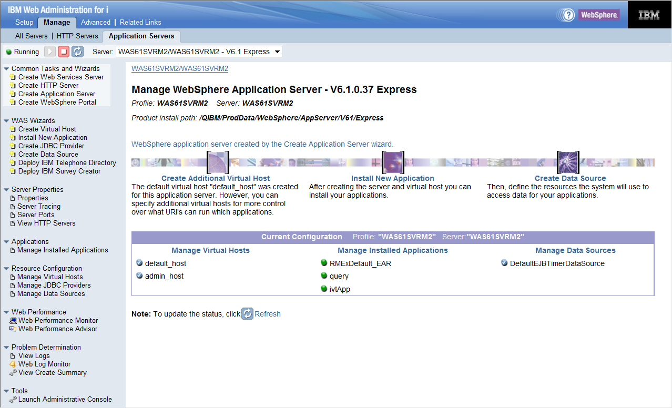

- The GUI server needs to be running – go to the IP address of the GUI (QServer). Make sure the server is up and running and
The following libraries need to be in this order…
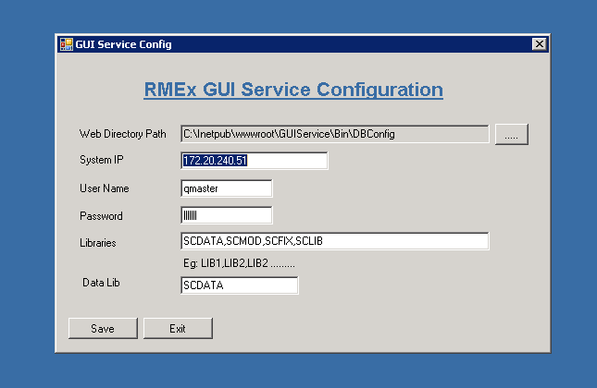

- If the agent receives a message that they need the server address added to Privacy-
Goto Tools → internet options → Privacy → select sites →enter the IP of the GUI server only and click allow, then ok. Sign back in and retry Events.
