QServer-Events

Administration Manual, Version 9.19

For Windows Web Server 2008



Prepared By:

Quantrax Corporation Inc.
4300 Montgomery Avenue. Suite 106.
Bethesda, MD. 20814
Phone: 301-657-2084
Fax: 301-657-4781
www.quantrax.com

- Introduction
Event processing works with the RMEx graphical user interface (GUI) to simplify and expedite the entry of data into the system. The collector will no longer need to remember to talk about each item: the key talking points will appear on the screen and ask the agent to click the appropriate box, such as ‘Is party a right party contact?’ or ‘Does the consumer have a source of income?’ The agent no longer needs to remember smart codes: just point and click! The system is totally customizable. The items on the screen and the smart codes applied by the system are all user controlled.

2.0 System & software requirements:
1. A properly installed Windows Web Server 2008 with .NET Framework 2.0 or greater
(.NET Framework can be selected at the time of installing Web Server machine.)

2. Latest IBM Client Access installed in the server

3. Memory, Disk space and processing power has to be varied depending on the Web-traffic

✴ Email Quantrax at support@quantrax.com for full Server Build specs and instructions

- Installing: ( STEP 3.1 to STEP 3.6 )
STEP 3.1: Unzip the RMEx Events file into any folder.
STEP 3.2: Select the Setup file and right click selecting ‘run as administrator’. Then continue with the wizard setup.
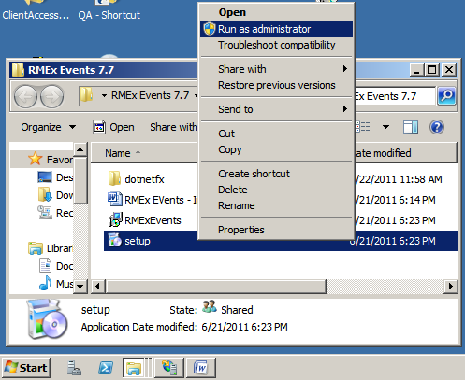

STEP 3.3: Select next
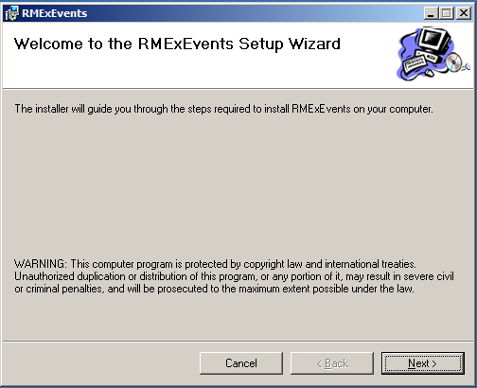

STEP 3.4: Change the name to Events as shown below:
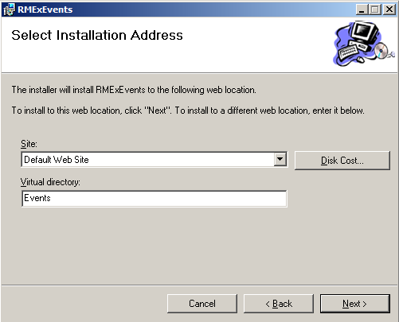

STEP 3.5: When complete, click close
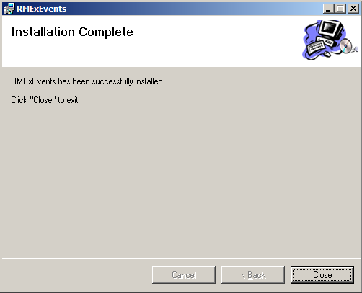

STEP 3.6: Go to the folder where you extracted the .zip file (step 1) and copy the text file:
- EventsErrorLog.txt

Save in to the C:\ drive (C:\ root folder). Please make sure it has all read, write or full control permission. (if file is not there, please create a blank EventsErrorLog.txt file and give full permission)
STEP 3.7: (Entering the Login & iSeries System details via IIS)

For the Windows Web server 2003:
Go to IIS (your web server) → Right click on “Events” site and get Properties → Select ASP.NET Tab →
Click on “Edit Configuration” button → Select the Key “Constr” and click on “Edit” button. →
Change the text according to your system (the following is an example):
Driver={Client Access ODBC Driver (32-bit)}; Connect Timeout=120; DBQ=SCDATA SCFIX SCRMX20; System=192.169.0.7; UID=INTGUI2; Password=INTGUI2;
→ Click on “Apply” → Ok
Re-start the IIS Server

For the Windows Web server 2008:
Go to IIS (your web server) → Double click on “Events” site → Select “Connection Strings Icon →
Add a new Custom type connection string (following is an example):
Driver={Client Access ODBC Driver (32-bit)}; Connect Timeout=120; DBQ=SCDATA SCFIX SCRMX20; System=192.169.0.7; UID=INTGUI2; Password=INTGUI2;
→ Name it Constr → Ok
Re-start the IIS Server

How to check your Installation:

Enter http://localhost (or the IP of this site)/events/start.htm and click the ‘Test’ button on the 1st page. Now, you should see a list of main Events. Do not go any further and close.
Next check if this new event site can be accessed from the Main Account Detail page of the RMEx-GUI site.
(FYI-http link of this Events site should be called when the user clicks on the “Events button” of the Main Account detail page of the RMEx-GUI site)

- Trouble shooting tips:
If the program fails while you start viewing the site, for example:
- If you get this kind of message “Access to the path C:\ EventsErrorLog.txt is denied. ”
Review the section above on setting up permissions for these files and make any corrections needed
  - EventsLogin.txt
  - EventsErrorLog.txt

- Check the URL for the new ‘Events’ site. Make sure it has been correctly mentioned in the RMEx-GUI main site. See the GUI install doc for more details
- Check whether the iSeries IP, Login ID, Password and Library List mentioned in the EventsLogin.txt file are correct (As mentioned above)
- Confirm that IBM Client Access ODBC is installed
- Check whether the Role service called "IIS-6 Metabase compatibility" has been added in the Web Server (IIS)
- If events is not working for one user, make sure they allow cookies in their Internet Explorer
- If any changes were made to the iSeries or the PC Server files, RESTART the IIS (or web server machine)
- If there are any errors on a web page, exit events, logout from GUI and retry

- Uninstalling:
1. Select Control panel -> Programs and Features
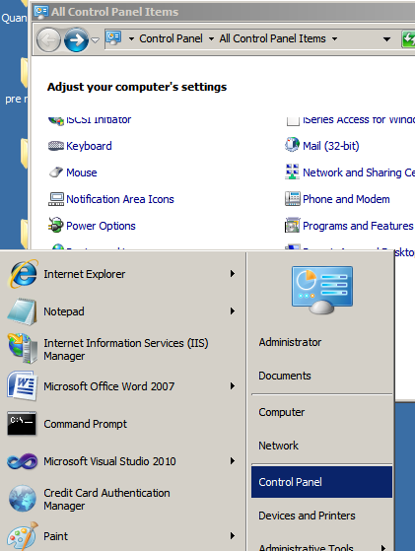

2. Select “RMExEvents” from “Programs and Features” and Uninstall…!
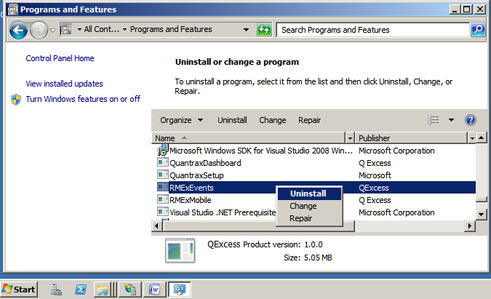

The End

