**QServer Build Document**

 RMEx Release 2.0 presented the opportunity to incorporate several component products that need a Windows server to operate. There are eight applications available:

1. RMEx GUI
2. Events processing (requires RMEx GUI)
3. RMEx Dashboard
4. E-Mailing Letters
5. EPP – Real-time payments
6. RMEx Mobile Reports
7. Collection Center Monitoring System (CCMS)
8. Web Reports

The *QServer* will generally be built by Quantrax. But, if you would like to take this task on yourself, we suggest taking all precautions necessary to insure maximum server stability such as using RAIDed hard drives, redundant power supplies, etc. If you are building or purchasing your own server, you should have a solid understanding of the hardware involved, Windows Server 2008 Operating System, and IIS (Internet Information Services).

For clients who have 50 users or less, a single Windows server will be able to run all of the applications listed. Clients with more than 50 users who are planning to use CCMS will need a separate server dedicated to this application.

**The minimum hardware configuration is as follows:**

1. Intel Xenon processor – 2.0 Ghz
2. Windows 2008 server – 64 bit
3. 6 Gb RAM
4. Raid 1
5. 2 x 1TB Hard Drives
6. Redundant power supply
7. 1 x 1 Gb Network card

***Prerequisites* for loading Quantrax Software:**

1. **Windows 2008**
2. **Windows updates installed**
3. **IIS must be installed**. IIS (Internet Information Services) Web Server comes standard with Windows 2008
4. **System i Access (formally Client Access), latest version for your iSeries**
   * Typical or Complete install to include everything needed. At a minimum **ODBC** *must* be installed.
   * Server 2008 requires System i Access V5R4 or higher (V5R4 requires service pack PTF SI25949 or later)
5. **.NET 3.5** found at <http://www.microsoft.com/net> . Click on the download or “Get the .NET Framework link”. (if you did the windows update, it may have already installed the .net 3.5 – this can be verified by checking the installed software)
6. **ASP.NET must be registered in the IIS Web Server.**

**(NOTE - Registering ASP.NET REQUIRES .NET to be loaded first!)**

* The Asp.net installs with the .net frame work. But it *must* be registered with IIS server. To register asp.net with IIS please follow the instructions below:
* Start the Windows Server manager (figure 1)

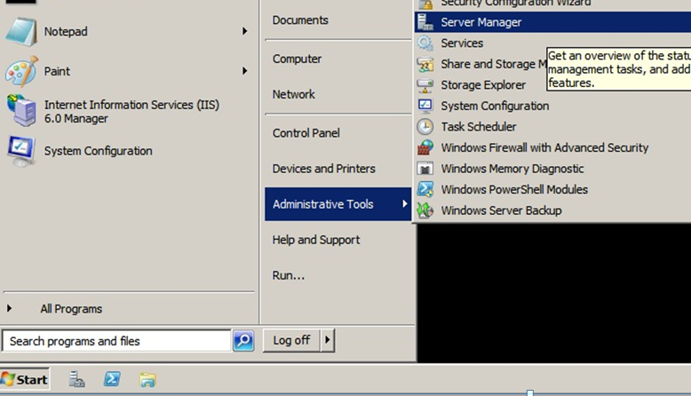

Figure 1 : Opening Server manager

* Then select “Roles” (figure 2)

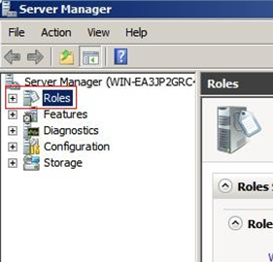

Figure 2 : Roles

* click “Add Role Service” (figure 3)

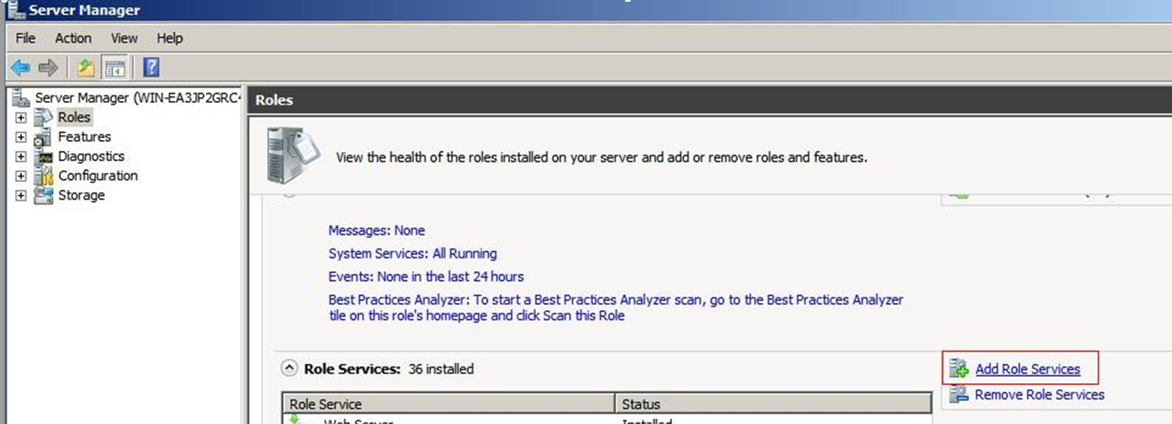

Figure 3: Add Role Service

* Then under “Application Development” Click the checkbox “ASP.NET”. (figure 4) Then click “Next” button. System will start installing the asp.net.

**NOTE:** *If ASP.NET is grayed out with the word “Installed” next to it, it is already installed and this step can be skipped.*



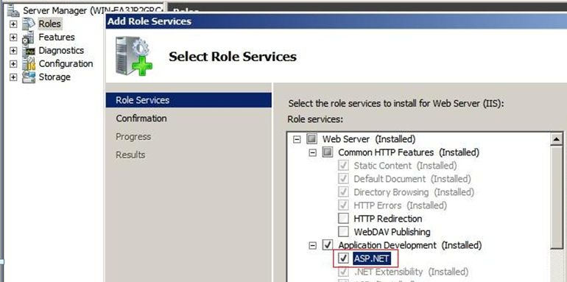

Figure 4: Select ASP.net

* If the installation is successful, the following screen will show:

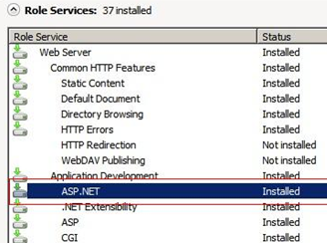  
Figure 5: Installation Success

* **NOW add the Role Services “IIS-6 Metabase compatibility”**
* Select “Add Role Services”

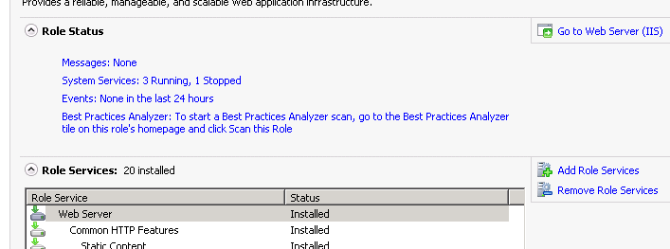

* **Expand** “IIS 6 Management Compatibility”
* Select **“IIS-6 Metabase compatibility”**

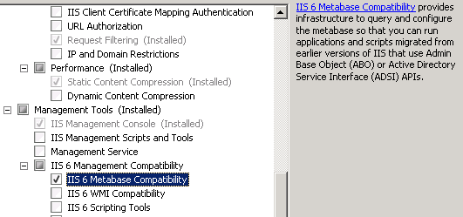

* **Click next and you are done**

**Now you are ready to proceed with any of the component products offered in RMEx 2.0!**