**Creating a WAS *instance***

1. Strart the TCP server on the iSeries (cannot create an instance if this is not running)
2. Go to the iSeries command line and type STRTCPSVR

(NOTE-to end the TCPIP type ENDTCPSVR)

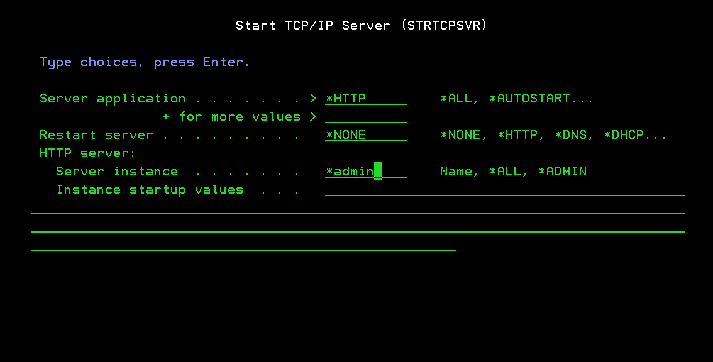

1. Open a browser session and bring up the WAS Admin console (i.e. [http://**192.169.0.8**:2001/HTTPAdmin](http://192.169.0.8:2001/HTTPAdmin), where the IP is the IP address for your iSeries)

* this may take several attempts…try ending HTTP on the iSeries and then restarting. Then try the WAS Admin console again

1. Then when the screen comes up as shown below…select ‘Create Application server’ on the left hand side

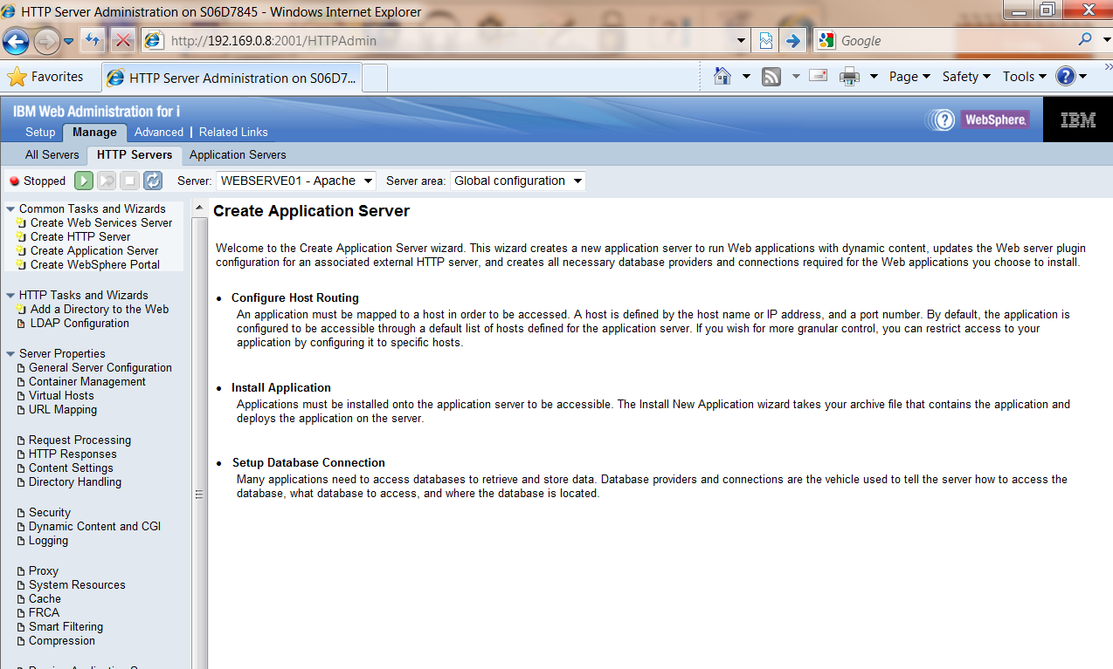

1. The Create Application Server screen is presented

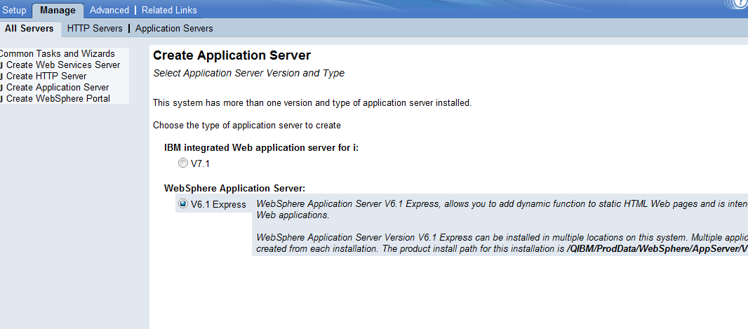

1. Select V6.1 express and click next
2. Now the system will ask for a specific name for the WAS instance…as shown below

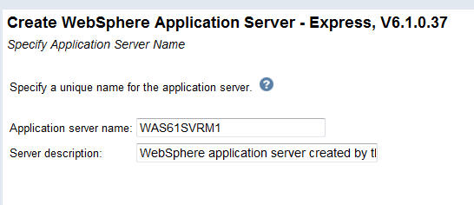

1. Type in the unique name
2. HTTP server type – select do not associate an external HTTP server with this application

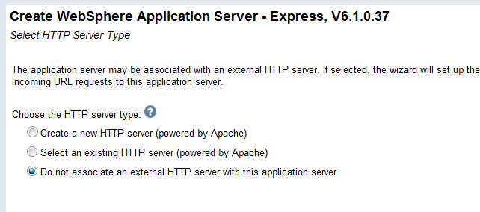

1. If this is the first instance you are creating take the default. If not, enter the first number for the beginning of the next range

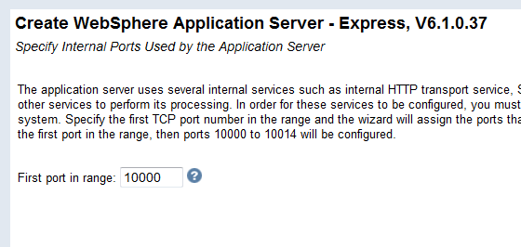

1. Uncheck default applications as shown below

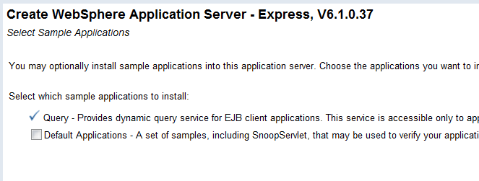

1. Do not configure identity tokens as shown on the next screen, so just click next

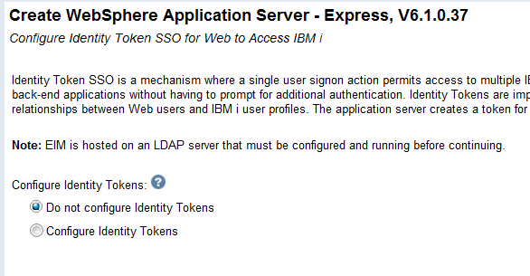

1. This is the final screen showing the details of the options you selected. Print this screen for your records. The internal port range is 10000-10014 for this instance, as shown below. Also, send us a copy of this screen so we can begin the GUI install

(If you need to create another instance the starting port number could be 10015)

