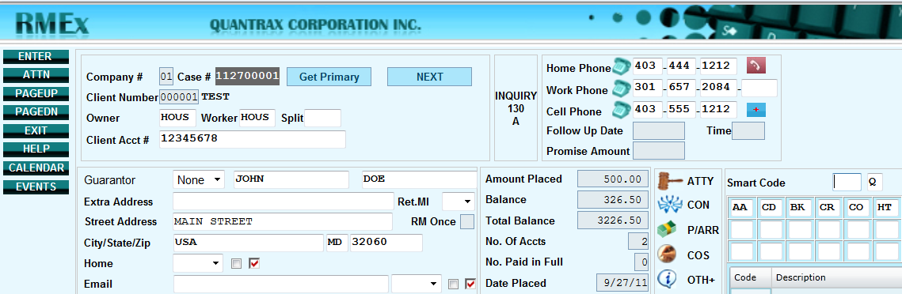

What is a phone number?

A phone number, in the literal sense, is a sequence of digits used to call from one telephone line to another in a public switched telephone network…

For us it’s simply a way of contacting, over the phone, anyone associated with an account in RMEx.

* Whether calling the Consumers residents, which we term the HOME number.
* The phone number where they’re employed, which in RMEx is designated as the WORK number,
* Or their mobile phone number which we call the CELL.

Another important aspect pertaining to phones is the fact that RMEx also has the ability to make decisions on an account based on the existence of phones using Smart Codes.

(Inquiry Screen)

First let’s see how we can easily find accounts based on a phone number. Within RMEx we use the Account Inquiry screen to bring up accounts. Within inquiry we can look for any phone number that is on an account… We can use option 6 to search for a valid Home number, or Option 8 to find any phone number on an account whether that number is consider good or bad… RMEx will look for good numbers first, and if no good numbers are matched, it searches bad. We will cover what constitutes a bad number later on.

(Account Detail screen)

When you first pull up a Consumers account in RMEx, right on the first screen you will be presented with the fields HOME, WORK and CELL, so you can immediately call an accounts.

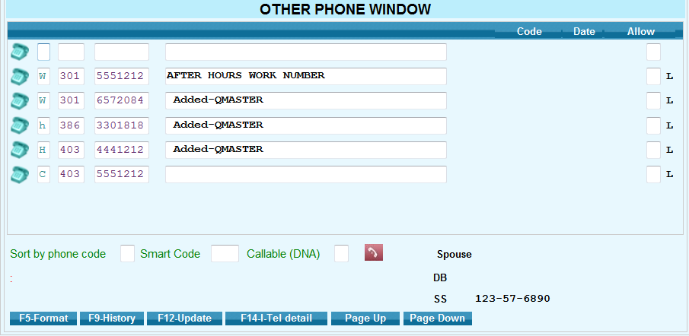

But what about other numbers that you might want to call to help you in collecting this debt such as family and relatives? Or what if there is more than one HOME, WORK or CELL. Within RMEx we not only store the HOME, WORK and CELL on the 1st detail screen, we also have an area to store almost an unlimited number of phones for this account. We call this area the TAB+ screens. We call it the Tab+ because, when an account is first presented, the cursor defaults to the “Smart Code” field. All you have to do is hit the TAB key on your keyboard, Then the Plus - or Equal key and hit enter, and you are presented not only with the phone numbers on the first detail screen but, you will also see any other phone numbers associated on an account. AND an area to ad free form notes about that phone number

In the Tab+ You’ll notice in front of each number there will be a letter, this letter is known as the “Phone code”. An H designates a number home, a W means work and a C is a CELL number. If letter is a capital letter we consider this number valid and can be called. If the number is lower case that number is BAD and should not be called.

Your management also has the ability to create other PHONE CODEs from the Phone Codes setup menu found both in the I-Tel Menu or the 3rd system control menu For example “R” could mean this number belongs to a relative, or N could mean nearby’s. The System Control setup is also where you can designate if a phone code is a Home Work or Cell. If you see any phone codes other then H W or C you will have to ask your management what they mean to you.

BREAK

* So how do numbers get removed or marked as bad?
  + Smart codes can remove phone numbers
  + A user can remove numbers manually from the first detail screen
  + A number can be marked as bad in the tab plus by…
  + Nightly can mark numbers as bad and remove them if there is a linked account with the same number marked as bad.

Once a number is removed from the the account details. It makes the number Lower case in the tab+ automatically.

* And what if a home or work number on the first detail screen is removed – If there is another good phone number in the Tab+ labeled as a home or work, RMEx will automatically move it to the first detail screen.
* Tab Plus and bad numbers and how links are managed.
  + If you mark a number as bad on one account – if that identical number is on linked accounts it will be marked as bad to
  + What if a number is bad on Tab+ and a new account is loaded with the same number in Tab+?
* What if you try to put back a number that was bad? Being an intelligent system if you try to put in a number that was in the account at one time, and marked as bad, we will notifiy the user that this New number was previously removed and forced the user to verify that they want to accept it as valid once again.
* Keep in mind that this is based on the phone number and not the phone type. If a Work number was made bad, and you later try to put that number in the home field, the system still acknowledges that that number was made bad regardless
* **(GUI SCREEN SHOT account 001881907).**

There are also times when a Consumer should not be called by a collector for compliance, or other reasons. RMEx has the ability to mask a Consumer phone numbers. The example here is based on a setting at the System Parameters that the management has chosen to employ. Notice that you do have the ability to see the last four digits of the phone number in case you need to confirm the number with a Consumer who has called in.

* It is also possible to mask phone numbers based on Maximum Calls and if accounts are in queues that are out of Time Zone

(Reference **http://support.quantrax.com/documentation/rmex3latest.pdf))**

**Break**

* Now when you’re looking at the TAB+ screen you’ll notice at the bottom there’s a function key F14 ITel Details… If you’re using the ITel Dialer, this option WILL show you important details about each phone number on an account. Everything from the number of attempts and contacts JUST FOR THIS ONE NUMBER, along with the last call date, answering machines, and more. All this information is kept in a file called SCPHONE making it easy to access important data about your Consumer’s accounts for more advance decision making and customization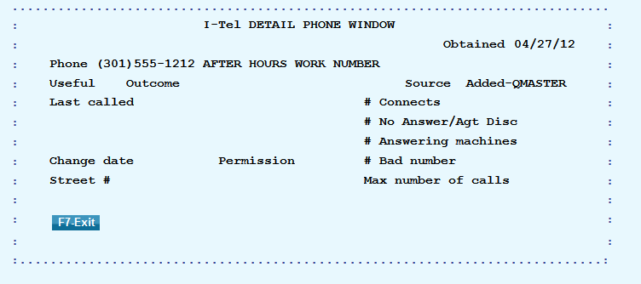

Break

* So’ - now that we have an understanding of how numbers are stored on accounts and how complex it can be managing linked accounts, let’s look at an option in RMEx to make it easier to find all the numbers for a Consumer on those linked accounts. On the Company Information Menu there’s an option to consolidated all the numbers from the linked accounts to the primary account. Making it easier to find all the phone numbers for a Consumer right there in one place.
* Also by using this option it will give you the ability to see ALL the phone numbers for a Consumer regardless of whether you looking at the primary Tab+ or a linked account’s tab+. We do this by dynamically presenting all the Consumers phone numbers in the tab+ window for linked accounts So when you access ANY of the accounts and go to Tab+, you will then see the same numbers, regardless of which account the number was on.
* And what happens if you change primaries? We can copy all of the information from the old primary to the new one using the Consolidate numbers option.
* You’ll also find on the Company Information screen we have an option to present the Tab+ when no phones are shown on the 1st detail screen of an account but there ARE phone numbers in the TAB+. This will automatically present the tab+ phone numbers every time an account is presented.

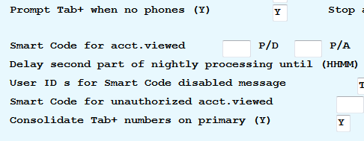

**NIGHTLY**

Next let’s take a look at how RMEx reviews each account every night to determine how accounts should be worked based on the phone numbers found on an account.

For example each nightly RMEx runs what’s called a “contact series”, where you can setup a series of letters to be sent on an account. Did you know that a Contact Series letter can be based on if there’s a phone number or not… Which means if there is NO phone on an account you may want to send a 1st and second notice, But if THERE IS a number on the account, you may only want to send only 1 letter and then send the account to collector to be called, saving you on the cost of a letter.

Also When account goes thought the Nightly process, RMEx, being an intelligent system, looks at the account to determine the most efficient way to present accounts to a collector, and sorts them in a manner that makes it easy to identify certain groups of accounts with something in common. We call these processing types.

For example, when a collector pulls up his work maps he’s presented with an opportunity to select all his accounts with a“Broken promises” or another processing type with the accounts that have a Follow-up dates, or maybe New Business.

We also want to make it easy to find accounts with a Work phone and may have a home phone, so we have a processing type for that called WORK PHONEs… What about accounts with no work but has a HOME PHONE? They will go to the HOME PHONE ONLY processing type.

RMEx also goes even further in helping collectors to identify accounts by creating subgroups under these processing types called System Generated qcats… For example we have QCAT 999

This QCat is used to identify any accounts that don’t even have any phone numbers for accounts that are in the processing types Broken Promises, Follow-up Dates and New Business.

CELL SCRUB

We have added features to allow you to manage calls to cell phones. There is a great deal of controversy about this subject, but we have given our clients the ability to manage this area and "stay within any applicable rules and laws". Provided you have an updated database of cell phone numbers, we have the programming to stop you from calling a cell phone using a dialer or even using manual dialing.

The key to the design is:

• Making sure that cell numbers do not get loaded into home or work phones which can be loaded into dialer campaigns or manually dialed.

And helping you to manage cell phones, in regards to whether the Consumer has given you permission to call the cell or not…

For example.. The ONLY time a cell should ever be put on the first detail screen is if you have permission to call that cell. Otherwise that cell should ONLY be placed in the Tab+, NOT on the first detail screen

The cell phone scrub requires you to purchase a Cell phone database which you will be required to run on a regular basis.

But we have provided all the base code already, and once you have an updated data base, rmx will then have the abilitiy to identify a Cell that is a Land line, OR a Land Line that’s a Cell, and change that number to the appropriate phone code.

It can even look at new accounts at the time of placement, where we give you an option that if the HOME is a Cell, MOVE the Home number to the 1st detail screen CELL field with the assumption on this new account the Consumer has given you permission to call this number.

If you are interested in using the cell phone scrub.. Please send an email to support and we will get you all the information you will need to get started..

And with that.. Thank you very much