COMPANY DASHBOARD

We started with client and collector dashboards. We now have new Company Dashboards as a new feature in RMEx 4.0. These new options allow the user to view a company’s overall performance at a glance. You can access this option through:
Management menu > 14. Dashboards (GUI tree view) > 2. Company analysis

The Dashboard contains following four Tabs;
- Home Tab
- Payment Options
- Placement Options
- Fees Options

By placing the mouse over a column chart, pie chart, line chart or tile view will display percentage and dollar value of the particular item.
The Dashboard Home tab contains the following options.

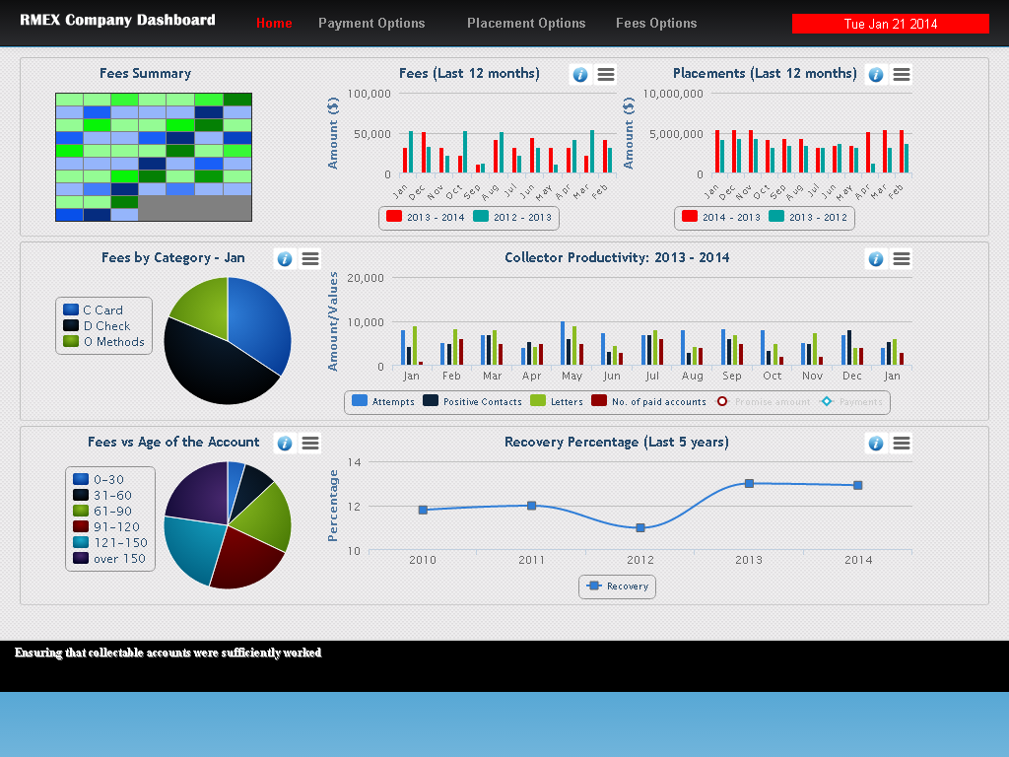
DASHBOARD HOME TAB

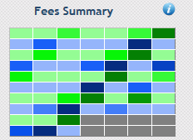
FEES SUMMARY (Tile view)
This option shows fees received comparing last month and the present month, in a tiled view using different color ranges. Depending on the amount a different color will be presented in a tile (a box) for the day of the month for the current month.

FEES (LAST 12 MONTHS) (Column Chart)
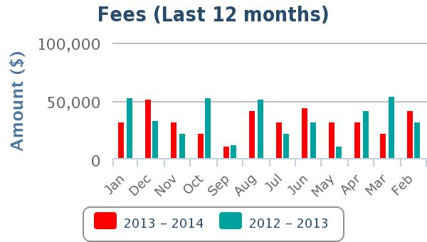
Shows fees received comparison of last 12 months and the same months of the previous year. For instance, the first 2 columns would be January 2014 and January 2013 whereas the last 2 columns would be February 2013 and February 2012 respectively.

PLACEMENTS (LAST 12 MONTHS) (Column Chart)

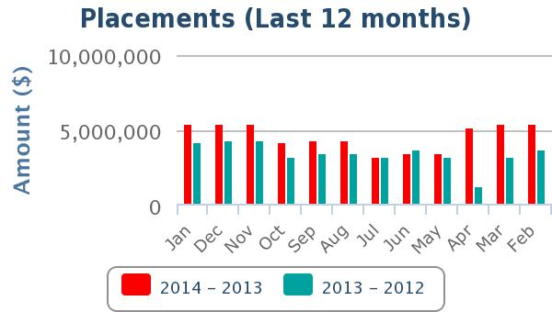
Shows placements made comparison of last 12 months and the same months of the previous year. For instance, the first 2 columns would be January 2014 and January 2013 whereas the last 2 columns would be February 2013 and February 2012 respectively.

FEES BY CATEGORY FOR CURRENT MONTH (Pie Chart)
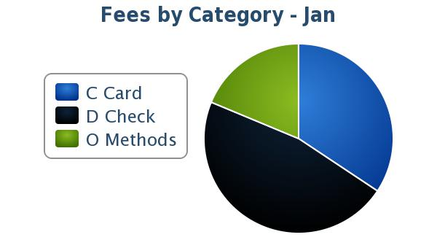
The graph shows the percentage and amounts of fee for the current month made through credit cards, direct checks and other payment methods.

COLLECTOR PRODUCTIVITY FOR LAST 13 MONTHS (Column and Line Chart)
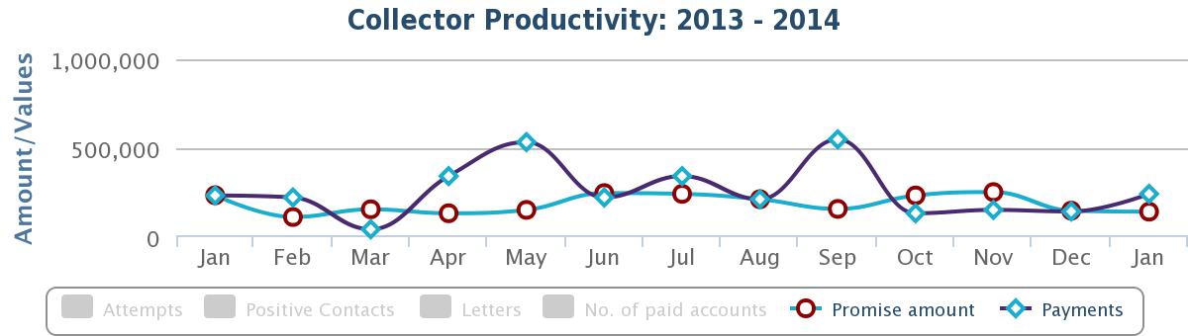
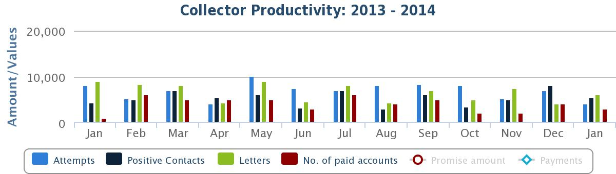
Column chart shows the number of attempts, positive contacts, letters and number of paid accounts made for last 13 months. On the same graph promise amount and payments are shown by line graph. For instance, the first column would be January 2013 whereas the last column would be January 2014.
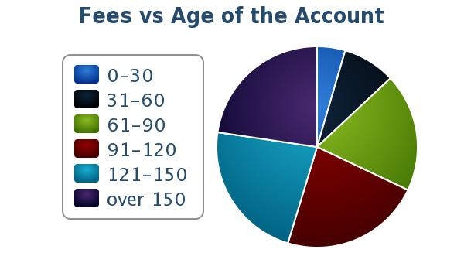
FEES VS AGE OF THE ACCOUNT FOR CURRENT MONTH (Pie chart)

This graph shows percentage and amounts of fees collected within each age category. For instance, fees we collected within 30 days of placement, 60 days of placement etc (0-30, 31-60, 61-90, 91-120, 121-150, 150>).

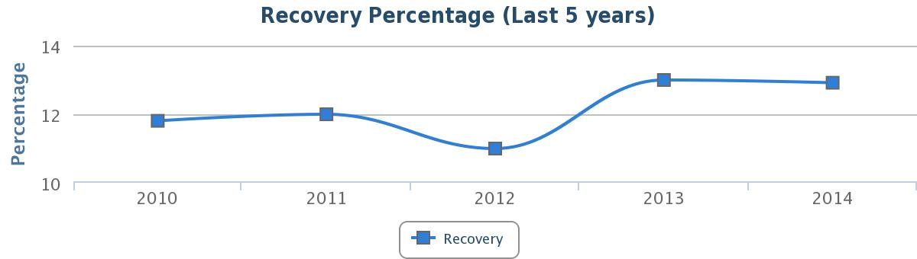
RECOVERY PERCENTAGE FOR LAST 5 YEARS (Line Graph)

This graph shows last 5 years recovery percentage from placements.

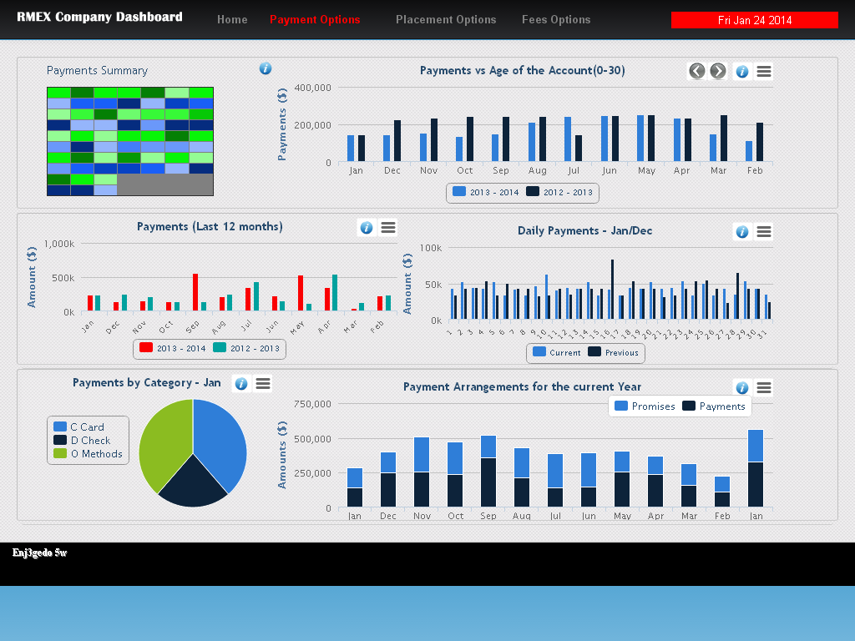
PAYMENT OPTIONS TAB

PAYMENTS SUMMARY (Tile view)
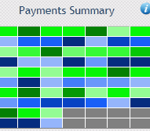
This option shows payments received comparing last month and the present month, in a tiled view using different color ranges. Depending on the amount a different color will be presented in a tile (a box) for the day of the month for the current month.

PAYMENTS VS AGE OF THE ACCOUNT (Column Chart)
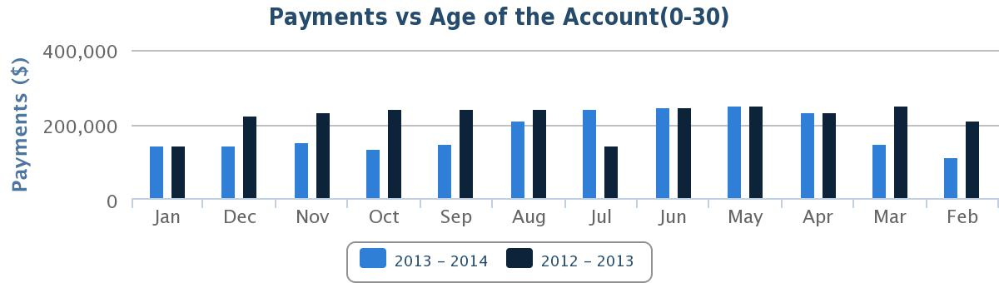
This graph shows payments collected within each age category. There are 6 graphs, one for each category (0-30, 31-60, 61-90, 91-120, 121-150, 150>). It shows details for the last 12 months and the same months of the previous year. You can view graphs individually by using the sliders (< >) on the top right hand corner.

PAYMENTS (LAST 12 MONTHS) (Column Chart)
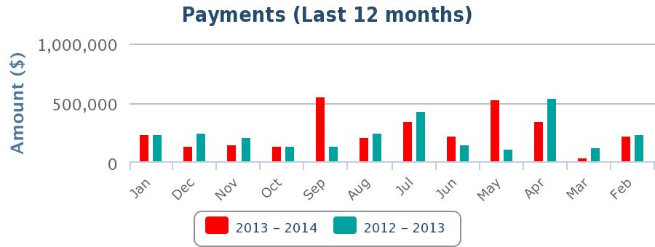
Payments received in last 12 months compared to the previous year. For instance, the first 2 columns would be January 2014 and January 2013 whereas the last 2 columns would be February 2013 and February 2012 respectively.

DAILY PAYMENTS (JAN/DEC) (Column Chart)
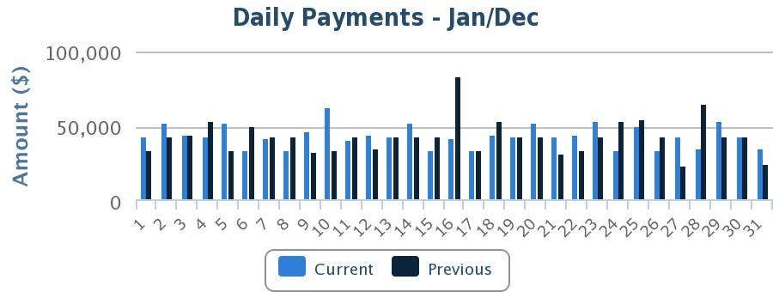
Payment amounts received on daily basis; comparison of 2 months - each same day of current month with the previous month.

PAYMENTS BY CATEGORY (Pie Chart)
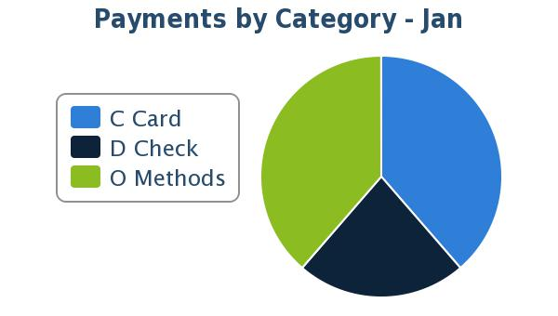
The chart shows the percentage and payments received for the current month made through credit cards, direct checks and other payment methods.

PAYMENT ARRANGEMENTS FOR THE CURRENT YEAR (Column Chart)
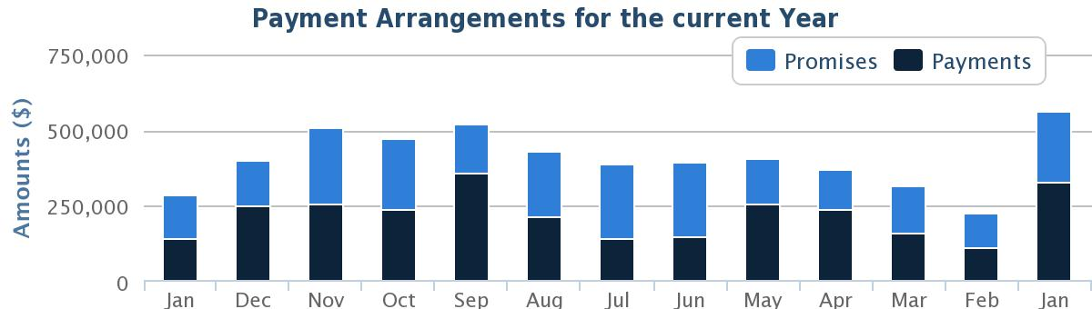
The graph shows all the payments that we have scheduled for the last 13 months e.g. Payment arrangements and promises etc. The payments received are displayed with the promises in a lighter shade above the actual payments posted each month.

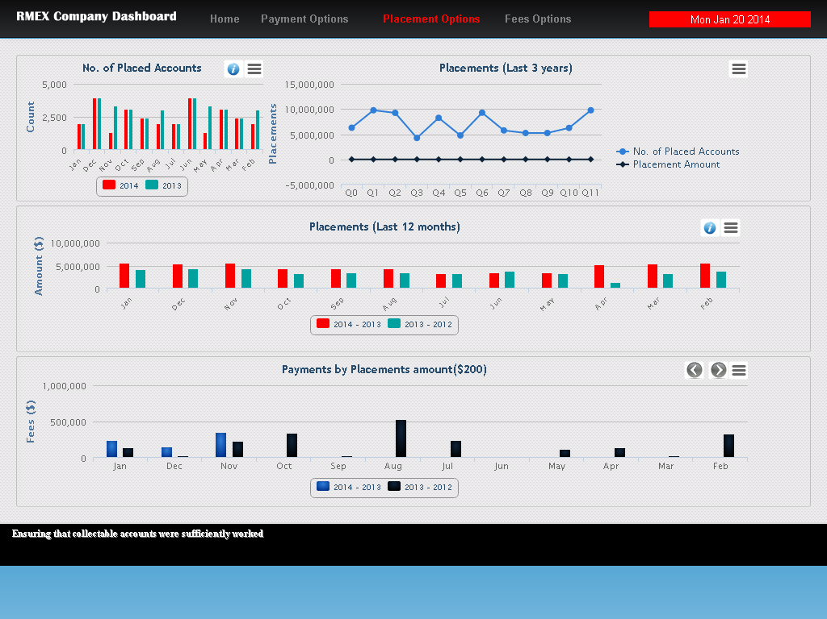
PLACEMENT OPTIONS TAB

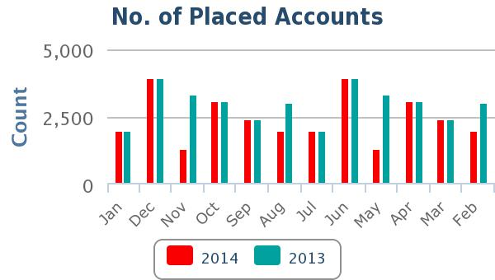
NO. OF PLACED ACCOUNTS (Column Chart)
The graph shows a comparison of last 12 months and the same months of the previous year by number of placements. For instance, the first 2 columns of the graph would be January 2014 and January 2013 whereas the last 2 columns would be February 2013 and February 2012 respectively.

PLACEMENTS (LAST 3 YEARS) (Line Graph)
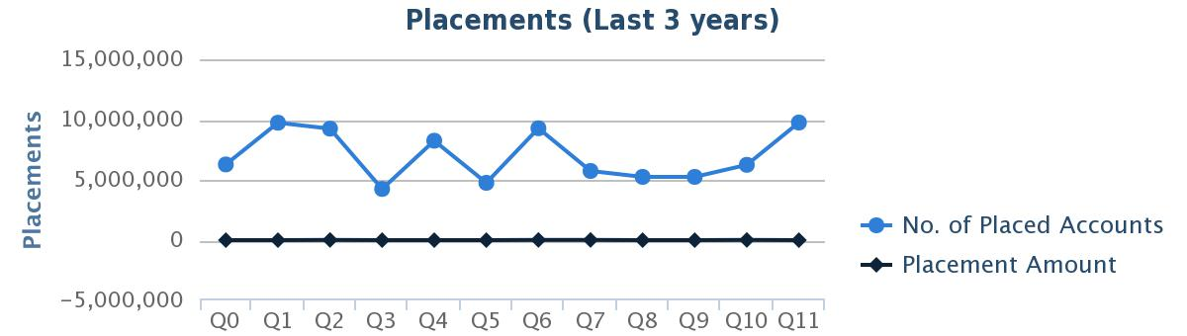
This graph shows number of placed accounts and placed amounts for last 3 years.

PLACEMENTS (LAST 12 MONTHS) (Column Chart)
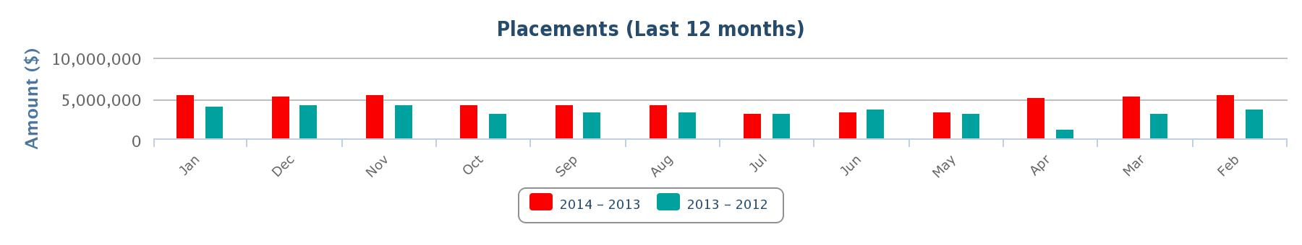
This chart shows a comparison of last 12 months and the same months of the previous year by placement amounts. For instance, the first 2 columns of the graph would be January 2014 and January 2013 whereas the last 2 columns would be February 2013 and February 2012 respectively.

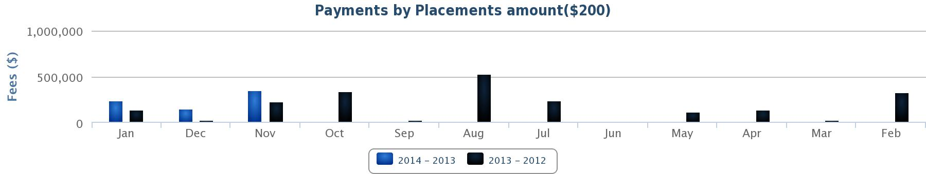
PAYMENTS BY PLACEMENT AMOUNTS (Column Chart)
This chart represents payments received on placements in comparison of last 12 months and the same months of the previous year. There are 4 graphs, one for each category ($200, $400, $1000, over $1000). You can view the graphs individually by using the sliders (< >) on the right hand corner.

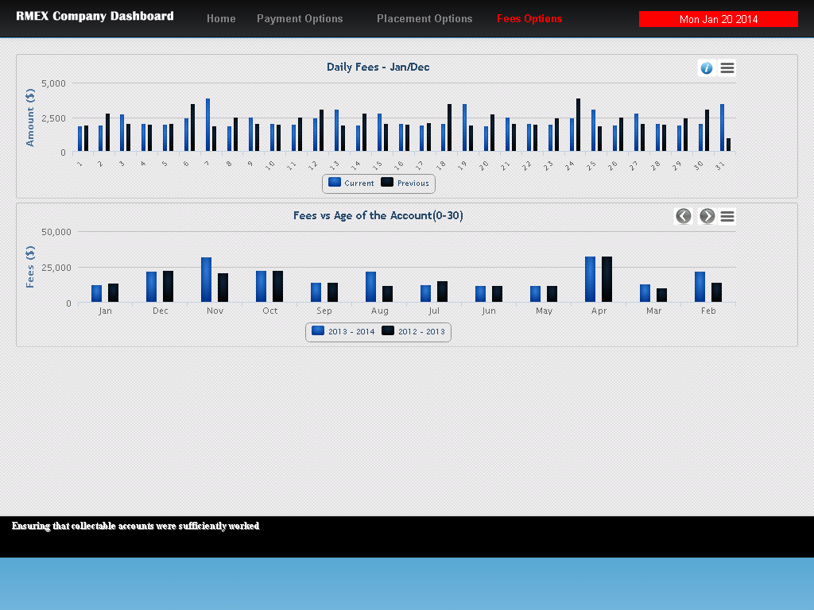
FEES OPTIONS TAB

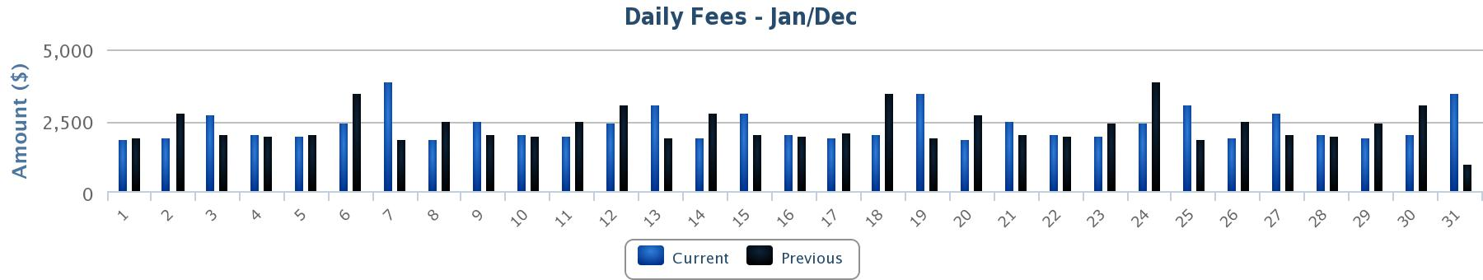
DAILY FEES (JAN/DEC) (Column Chart)
Fee amounts received on daily basis; comparison of 2 months - each same day of current month with the previous month.

FEES VS AGE OF THE ACCOUNT (Column Chart)
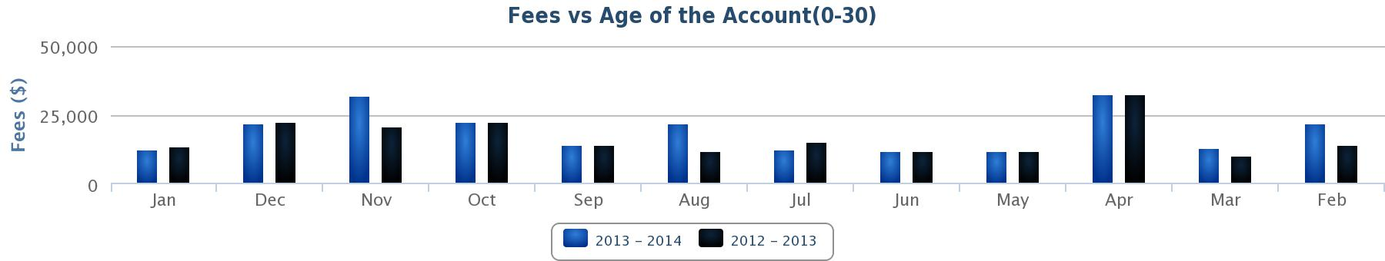
This graph shows fees collected within each age category. There are 6 graphs, one for each category (0-30, 31-60, 61-90, 91-120, 121-150, 150>). It shows details for the last 12 months and the same months of the previous year. You can view the graphs individually by using the sliders (< >) on the right hand corner.

