|  |
| --- |
| **Using FTP To  Move Files To And From ISeries** |
|  |

**Table of Contents**

**Overview** 3

**Using FTP With The Windows DOS Prompt** 3

**Transferring Files Using FTP From The ISeries To An FTP Server** 5

**Using The RMEX FTP Module** 8

**Daily FTP Process Control Menu – Glossary Of Fields** 9

**F10-Process Immediately** 12

**F8-Log** 13

**Troubleshooting:** 13

**Turn Your PC in An FTP Server: For Transferring Files FROM The ISeries To A PC** 14

**Logging into your new server:** 20

# 

# **Overview**

This document will show you several methods for transferring files to and from the iSeries using FTP (File Transfer Protocol).

In this document you find sections on:

* Using the Windows DOS prompt
* Transferring files using FTP from the iSeries to an FTP Server
* Using the RMEX FTP Module

And as an added bonus:

* Turn your PC in an FTP Server: For transferring files FROM the iSeries to a PC

# **Using FTP With The Windows DOS Prompt**

In this example we will create a folder in the c:\ drive called files (c:\files). This is where you will move the files to and from the iSeries.

**TIP**: When transferring files to the iSeries, If a program requires a file to be named a certain way, it is a good idea and easier to change the file name on the PC and then transfer the file.

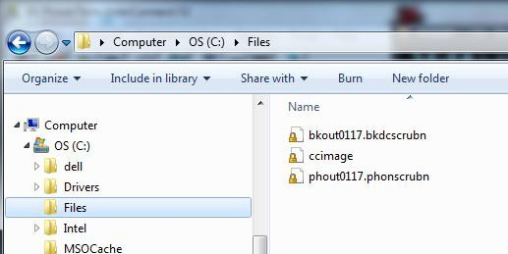

Using a command (DOS) box start an FTP session to your iSeries (Example here is 192.169.0.8).

1. To access to the c*ommand box* from Windows, click on the **Start button > Run >CMD and press ENTER**
2. In the *command box* type, **ftp 192.169.0.8** and press **ENTER**

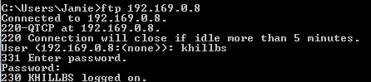

1. Sign into the FTP site using *your RMEx User Name* and *Password*
2. Use “lcd c:\files” to change the local folder on your C: drive where you want to put the files. LCD means Change Local Directory as in changing to whatever directory on your PC you will be working from



**NOTE:** If you are transferring a PROGRAM to your iSeries, type ‘**BIN’** here and press **ENTER**. Enter. DO NOT do this if you are transferring data files such as .txt or.CSV files.

* ‘GET SCDATA/FILENAME’ (Without the quotes) or as in this case “get scdatabs/phout0117.phonscrubn”. The PUT command will take a file from your c:\folder and place it ON the iSeries
* ‘PUT FILENAME SCDATA/FILENAME’

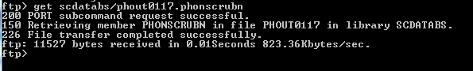

# **Transferring Files Using FTP From The ISeries To An FTP Server**

**NOTE:** Only users authorized to go the iSeries command line can use this method. Hosted clients are not able to get to the iSeries command line.

Most companies have an FTP server. This will allow you to send a file to the FTP Server so you may retrieve that file for processing. You will need to know the IP Address, user name, and password of your FTP Server before we start.

1. Go to the iSeries command prompt (you can get there in RMEX either by going to **Quantrax remote support menu** off the menu tree ***OR*** from the **Ready for option** by putting **DA** then press **ENTER**.

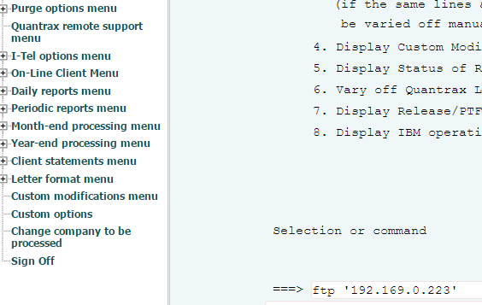

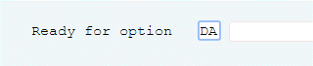

1. On the command line type ***FTP*** and the ***IP Address of your FTP Server*** and press **ENTER**.   
     
   In the example below it is typed as: FTP ‘192.169.0.223’

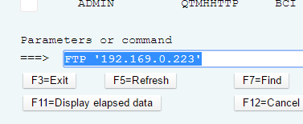

1. Next you will be asked for your ***FTP user name*** and press **ENTER**.

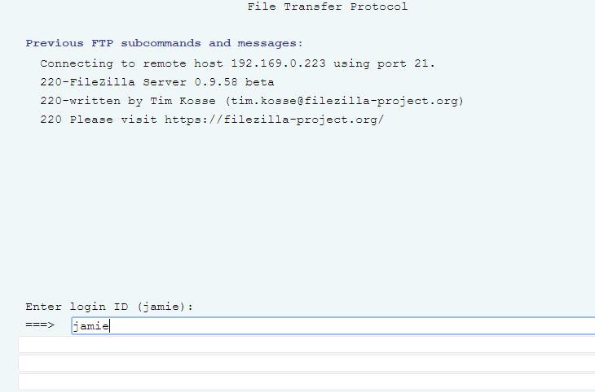

1. Next your ***password*** and press **ENTER**.

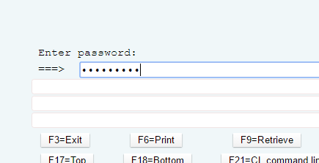

1. Next use the **PUT** command to move the file from your iSeries to the FTP Server.

* You will need to tell the software what ***Library*** the file is in on your iSeries. In this case the file is in Library “XXJAMIE”
* You will also need to know the ***file name*** you are transferring from the iSeries. In this case “JAMIE”

So in the example below, we use the command:

***PUT XXJAMIE/JAMIE*** Or in other words: **PUT LIBRARY/FILENAME**

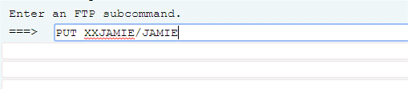

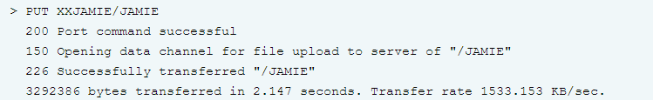

**NOTE:** The message says “*Successfully transferred “/JAMIE*” “. After you press **ENTER**, you will get message that either the transfer was successful, or it will let you know if there was a problem.

Now this file will be available for you on your FTP Server.

# **Using The RMEX FTP Module**

The FTP Job processing module allows you to schedule the transferring of files between the AS400 and your FTP site automatically. Once set up, the processing will occur on the date and time entered.

**Note:** If you power down your system, run an IPL, loose power, etc. you will need to reactivate the schedules (see bottom of doc for instructions)

1. Before creating your first FTP job, Quantrax will need to activate the FTP Module. If you get an error please contact Quantrax.
2. From **System Control menu 4** > **1-FTP Job Processing**, you can:

* Press **F6** - **Create a new job**
* Type **2** - **Change an existing job**
* Type **3** - **Copy an existing Job**
* Type **4** - **Delete an existing Job**

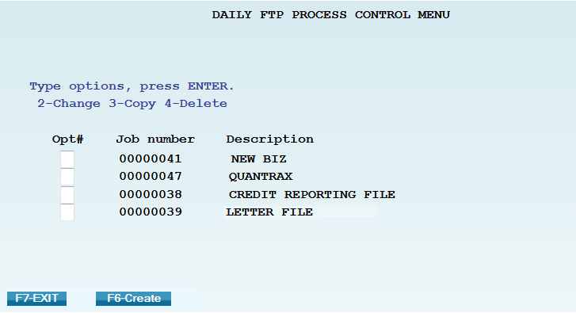

**NOTE:** Once you have Jobs created it is more efficient to just copy an existing one and make the needed changes rather than creating a new one each time.

## **Daily FTP Process Control Menu – Glossary Of Fields**

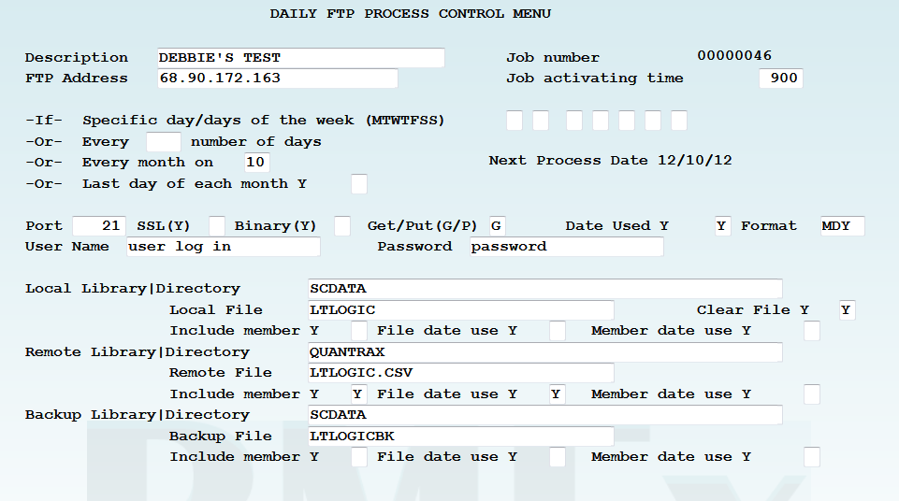

* **Description** – Name of the job
* **Job number** – Assigned by RMEx
* **FTP address** – The FTP address associated with your FTP site
* **Job activating time** – Time of day the job should run (military time)
* **-If- Specific day/days of the week (MTWTFSS)** – Enter a “Y” in the associated day of the week field
  + **-Or- Every __ number of days** – every “x” number of days (ex. Run every 10 days)
  + **-Or- Every month on __** - A specific day of the month (ex. Run on the 10th of each month)
  + **-Or- Last day of each month Y _** - “Y” if you want it to run on the last day of the month
* **Port** – The port used to connect to the FTP site (default is 21 as that is the most commonly used)
* **SSL** - Secure Socket Layer (currently not available)
* **Binary** – If the file needs to be transmitted as binary (mainly used for transmitting programs), enter a “Y”
* **Get/Put** – If you are moving a file from the FTP site to the AS400, enter “G” = get. If you are moving a file from the AS400 to the FTP site, enter “P” = put
* **Date Used** – If you are going to be using a date within the naming convention, enter a “Y”
* **Format** - If you are going to be using a date within the naming convention, enter the format to be used. Ex. MDCY, MDY, YMD, etc.
* **User name** – Enter the User name to log into the FTP site
* **Password** – Enter the Password for the User name

**NOTES:** Job activating time and a day/date schedule are required. If you are going to be manually processing every day, to prevent auto processing you can enter 999 in the field **-Or- Every __ number of days**

* **Local = AS400 (RMEx)**
  + **Local Library|Directory** – Enter the library name on the AS400 where the file should either be put to or gotten from (example below = SCDATA)
  + **Local File** – Enter the valid file name that should exist on the AS400 (example below = LTLOGIC)
  + **Clear file** – Enter a “Y” if you want to clear the existing AS400 file once transmission is complete
  + **Include member** – Enter a “Y” ONLY if the AS400 member name is different from the file name
  + **File date use** – Enter a “Y” if the FTP module should associate a date within the name of the AS400 file
  + **Member date use** – See File date use above. This field is rarely used, it is only used if there is a date associated with the member name

* **Remote = FTP site**
  + **Remote Library|Directory** - Enter the directory (folder) name on the FTP site where the file should either be put to or gotten from (example below = QUANTRAX)
  + **Remote File** - Enter the valid file name that should exist on the FTP site (example below = LTLOGIC.CSV)
  + **Include member** – Always enter a “Y” as this associates the file extension (.txt, .csv, etc.)
  + **File date use** – Enter a “Y” if the FTP module should associate a date within the name of the FTP file (date appears before the extension)
  + **Member date use** – This field is rarely used. Enter a “Y” if the FTP module should associate a date within the name of the FTP file (date appears after the extension)
* **Backup = AS400 (RMEx)**
  + **Backup Library|Directory – The library name on the AS400 where the backup file should be created (example below = SCDATA)**
  + **Backup File - Enter the valid backup file name that should be created on the AS400 (example below = LTLOGICBK)**
  + **Include member – Enter a “Y” ONLY if the AS400 member name is different from the file name**
  + **File date use – Enter a “Y” if the FTP module should associate a date within the name of the AS400 file**
  + **Member date use – See File date use above. This field is rarely used, it is only used if there is a date associated with the member name**

**NOTE:** All file names MUST follow standard file naming conventions to be considered valid.

Ex. AS400 file names can only be a max of 10 characters and cannot begin with a Q, keyboard character or number. FTP site file names cannot have certain keyboard characters in them.

**NOTE:** When a date is used in the file name – the date in the file name must be the exact date as the file that is being transmitted.

**NOTE:** Files are only transferred between the iSeries and your main FTP directory. FTP Sub folders cannot be used at this time.

**F10-Process Immediately** = Runs the process immediately instead of at a scheduled time.

* Can be used to process 1 time files or files where the name changes from time to time.
* If there is a date extension associated with either file, you will be presented with this additional screen:

**NOTE**: You must manually enter the local and remote file names, including any date and member/extension associated.

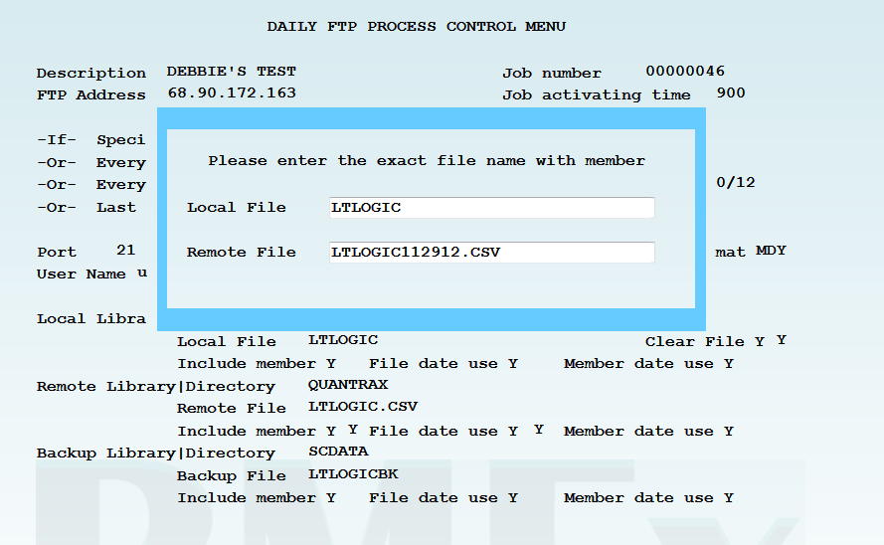

**NOTE:** If there is no date extension associated with either file, you will not be prompted to re-enter the file names.

**NOTE:** If setting up a Process Immediately for the first time you must F12-Update before using the F10-Process Immediately feature.

**F8-Log** = Specifics regarding the success or failure of the last time this job was processed

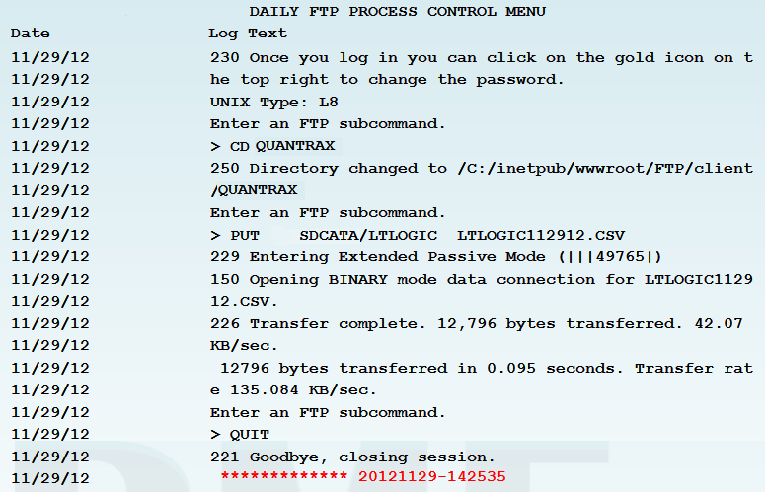

## **Troubleshooting:**

If your AS400 takes a power hit the FTP Job processes will need to be reset.

Go into each job:

1. Use **2-change**
2. Confirm day and time
3. Press **F12**
4. This will reset the schedule for that FTP job

**NOTE:** Most FTP sites have security settings that prevent hackers from accessing the site. One of these features blocks any IP address that is perceived to be attacking it. To help prevent this blocking, we have done the following fail safes:

When multiple jobs are scheduled for the same date and time the system will add a 2 second delay when submitting each job.

The system is designed to check the active jobs before submitting the next job. It will check up to 10 times before submitting the next job. If other jobs are still running after 10 checks, you will need to review the scheduled jobs and make changes. You can change the job processing time on each job to be 5 minutes apart.

# **Turn Your PC in An FTP Server: For Transferring Files FROM The ISeries To A PC**

If you have an FTP Server in your office that you can access FROM your iSeries you have the ability to use either the FTP module OR a command line from the iSeries to move files back and forth. Your company may already be doing this with a dedicated Internet FTP server. But what about transferring a file from the iSeries to your PC. How can you do this? By turning your PC into an FTP Server.

Below is a demonstration of how to use a program running on my PC called “FileZilla Server”, an Open Source and free server. Keep in mind this is the FileZilla SERVER software, NOT the popular FileZilla FTP client software.

**NOTE**: We DO NOT support nor answer questions about FileZilla. This is for demonstration ONLY, there are many fine FTP Server programs to choose from.

1. For this demonstration I will be creating a folder off my C:\ drive called FTP. When I am done the example files will be in C:\FTP.

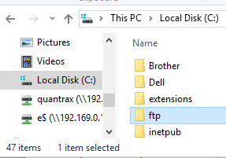

1. Now you will need to download your FTP Server software and install it. In this case from <https://filezilla-project.org>
2. Note once again we are downloading the Server NOT the client software. I choose to install FileZilla just using the Defaults.

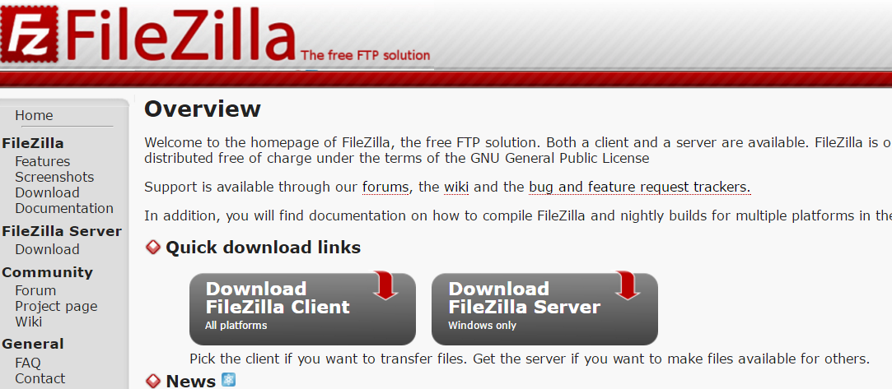

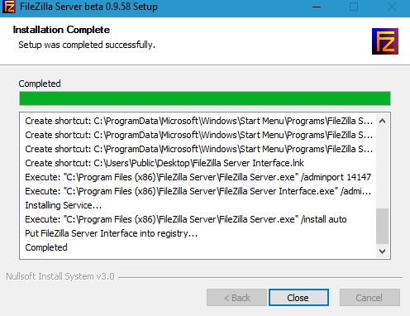

1. At this point I added a *Password* so not just anyone can control my FTP Server. Otherwise I left everything as default and clicked **Connect**.

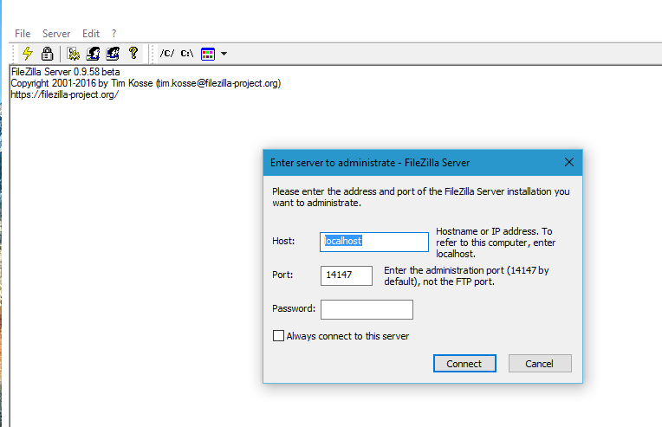

1. Since I am running this server in my office I ignore the TLS warning.

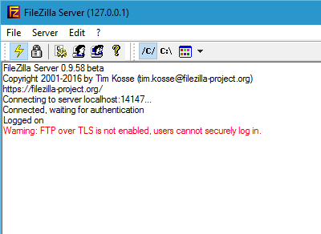

1. Next I click **Edit** > **Users**

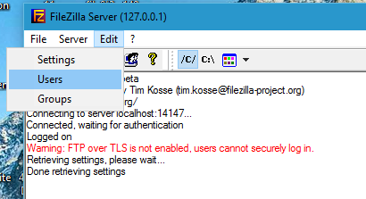

1. Next, click **Add**, insert a *user name* then click **OK**.

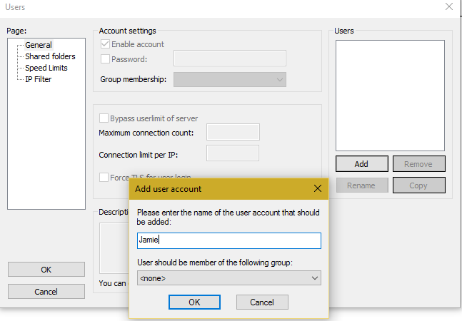

1. Then give the *user a password*.

**NOTE:** This user name and password will be used by your FTP client, so please make a note of it.

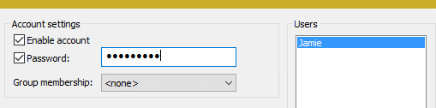

1. Next click “**Share folders**” and then click **Add**.

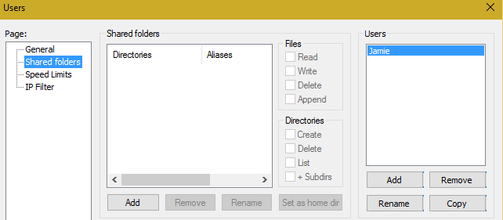

1. For this example will use the folder off my C: drive called FTP (That I just created) and click **OK.**

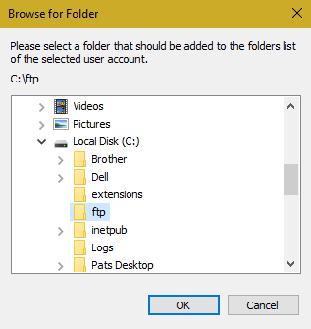

1. Next give this user authority to. . . .

* **Read**, **Write**, **Delete**, and **Append**.
* Then, click the button “**Set as home dir**”.
* Then, click **OK.**

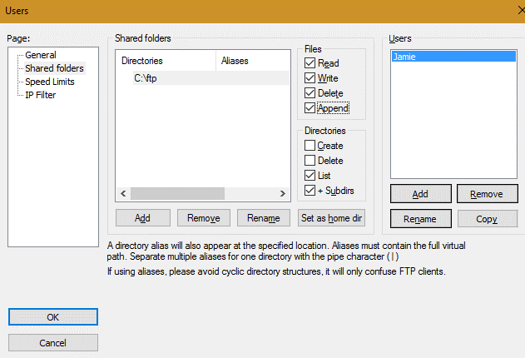

1. You now have an FTP Server running on this PC. When you login using your FTP client software all the files will be *moved* to and from C:\FTP.

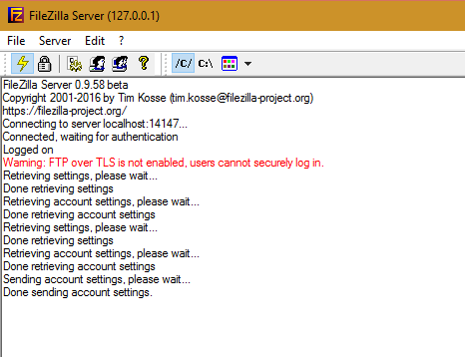

## **Logging into your new server:**

Do you know your IP Address for the PC you have the FTP Server software running on? **This will be required.**

1. Access this info by a *command box*

* ***Windows 8 or above***: **Start button** > **CMD**
* ***Windows 7 or below***: **Start**  > **Run** > **CMD**

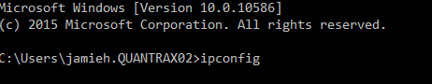

1. Type ‘**ipconfig’** and press ENTER..

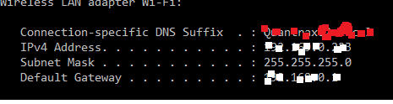

1. Now look for the ***IPv4 Address***

**NOTE:** The software you use to access your personal FTP server will require the user name user and password you created. As well as the IPv4 Address you just retrieved.

Example:

Login: Jamie

Password: XXXXXXXXX

IP Address: 10.0.0.215