**C:\Users\su2\Dropbox\Support\KB\RMEx logo.jpg**

***E-mailing consumer letters***

We have added the ability to email letters to consumers.

* Once you have obtained a consumer’s email address, Selected and Contact Series Letters can be emailed.
* You will save on postage, save letter printing costs, save time and costs on setting up new letters, save on returned mail costs, and save time on delivery.
* You can set up new ‘letters’ either as letters that will be mailed out as usual, or emails that will be sent to consumers electronically, or both.
* Letter ‘X1’ can be set up to be mailed and a different letter format ‘XE’ can be set-up if that same letter is to be emailed. Same letter content – different format.

(Company requirements may exist for new letters)

* If a consumer has an email address on file and you choose to send a ‘letter’ that is designated as an email, then the system will generate an email instead of a letter.
* The consumer’s email address is stored in the “Special Address” from the Tab Q window.
* Agents can also send emails instead of letters. They have the option to enter an email address and specify whether the letter is to be sent by regular mail, email, or both. Notes are added to the account to provide an audit trail of what was done.
* E-mailed letter are sent using option 11. Email letters under the Letter format menu.

**Note**: If ONLY an email is sent, it will be notated in the notes on the account. We are only tracking the original letter being sent. You can track emails that have been sent by applying a Smart Code or adding a Description Code from the Letter Code set-up screen.

Below is a screen shot of a standard letter:



To send the original letter and email the same letter, enter a Y in the ‘Email’ field. An *S will also need to be entered in to the field ‘Email code’.

The display below shows another standard letter with a different emailing option.



If a different letter should be emailed when the standard letter Z1 is selected, leave ‘Email’ blank and enter the letter code to be emailed in the ‘Email code’ field. This set-up also gives you the opportunity to keep the same format for the letter or create something different.

Note: If a new format is chosen, please take into consideration company requirements for new letters.

To complete the set-up for this action the Z4 letter needs set up.

Below is a screen shot for the Z4 letter.



Notice the ‘Email’ field has a ‘Y’ entered but the ‘Email code’ is blank.

**The agent can expect to see a new option:**

Following is a screen shot of the main detail screen and a smart code window has been presented.

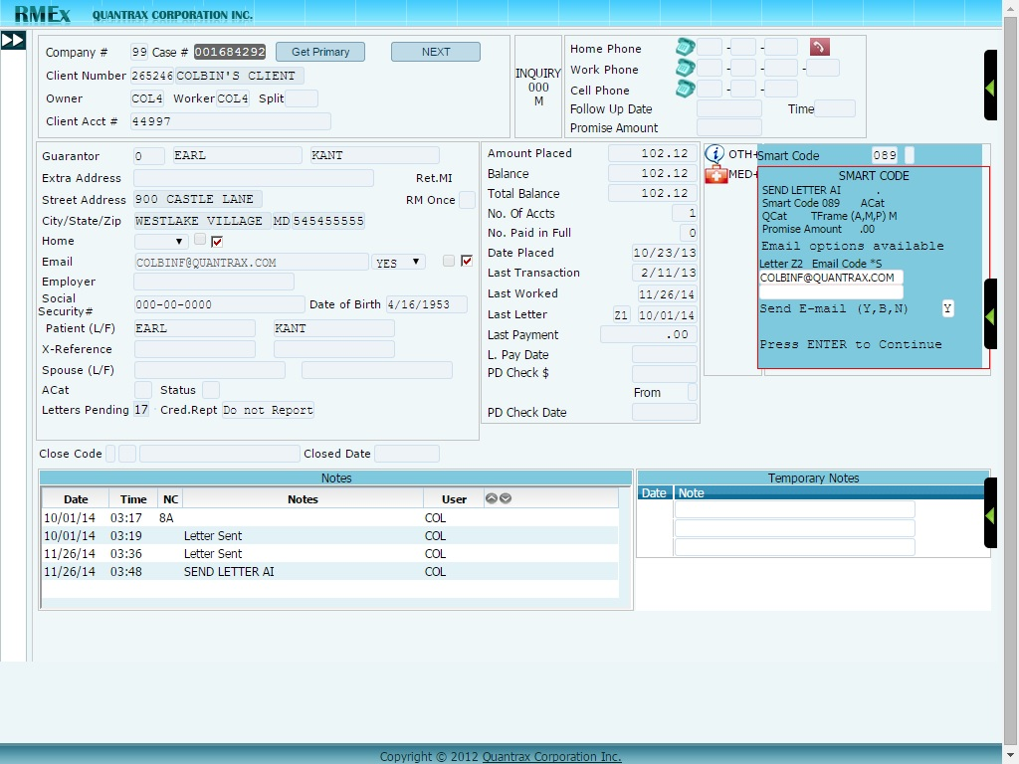

The agent has entered a Smart Code and then entered the letter code Z2. If the letter code allows for the letter to be emailed, an email field is then presented. A message will also be shown, “email options available”. The email field may include the consumer’s email address already on file. This email address is stored at the account level in the Tab Q, option 6. If a new email address is required, the agent can type over the existing address in the smart code window, replacing the stored address and sending the letter to the new email address.

When an email address has not already been secured, the agent will be presented with a message, “emailing is not set up”. The agent can then enter the email address and the Tab Q field will automatically be updated for future use.

**Note:** The user must request the original letter. A user cannot request the letter that is set-up for emailing only. (Similar to Letter Translation)

Another option will need a response by the agent, ‘Send letter by email’.

Y – Email only

B – Email letter and mail letter

N – Do not email the letter

Once the user has requested the selected letter to be e-mailed the e-mail letters can be sent right away by taking option 11 (Email letters) from the letter format menu.

**Note:** We do not process e-mail letters through nightly.

Emailing letters will require additional software, *‘Emailing letters RMEx 2.0 for server’,* to be loaded on a separate server.

Also we have allowed users to use KeyesMail for sending consumer letters. Within letter codes system control file (Option 11 from the first system control menu), there is an option called “Letter control specifications”. The new option to specify that KeyesMail should be used is on this screen.

**Note:** If you choose to use this feature, we will need to make changes if your letter printing is modified and you use the modifications in your e-mailed letters. There will be a nominal charge for this. Please contact the programming team.