USING DIRECT DROP CELL NUMBER INTERFACE WITH RMEx - Video Script

Outline (Partial Script) | Slide
Cover slide 1: Using DIRECT DROP CELL NUMBER INTERFACE with RMEx - this video is an overview of the Direct Drop process from the RMEx perspective. You will need 3rd party software, VoApps and follow the instructions for that product to complete the process. | 
NOTE: Using script for slide 2 for Audio Only - overview  Slide 2: What does it do?  Direct Drop gives you the ability to place a pre-recorded voicemail to any mobile phone without calling it.  Quantrax does not provide this service however we have screens that interface with the Voapps product which does this process. You to contact VOAPPS and get a contract with them.  The way it works is Quantrax’s RMEx sends a file to VOAPPS, they drop the messages, we get a file back, with the results, and smart codes can be applied based on status.  Direct Drop allows you to:  -Contact consumers without calling their mobile phone without an agent while  -You can communicate to the consumer how they can contact your office - via your website, phone number, or maybe both. This allows consumer to contact your office and handle their account at their convenience.  -Setup different messages and scripts based on different scenarios - For example, have a tailored message for old accounts asking them to contact your office and let them know that they may be eligible for a settlement. | 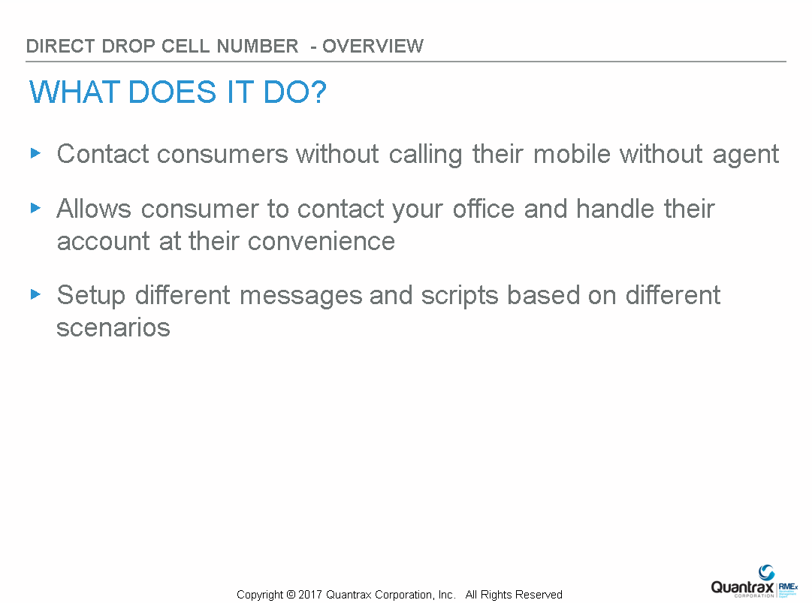
Slide 3 : Step 1 - Pick or Select your accounts with the queue consolidation  Specifically which of your accounts with cell numbers that you wish to send to VoApps. You will use the queue consolidation to pick cell phone numbers | 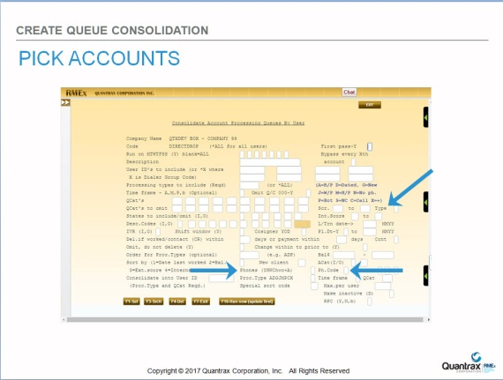
Slide 4 : Step 2 - Setup the basics to Create I-Tel Campaign
Next you will need to create a Predictive campaign.

Slide 5: Step 4 - Create Smart Codes for notating accounts and taking actions when using Direct Drop  You will need to create several Smart codes that will be used when creating the Direct Drop file and to be applied after the calls are made, and you get a file back with the call results. | 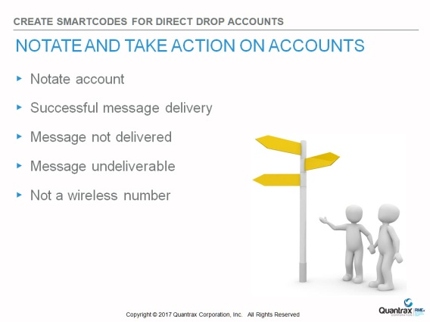
Slide 6: Step 5 - Running the Direct Drop Process  Run the consolidation to select accounts. This can be done during nightly processing or immediately. The Direct Drop file, this is the download process.  When creating the Direct Drop files. You will also be able to setup  Caller ID Name and Number, basically what you want presented on the consumer’s cell phone caller and apply a smart code to accounts that were selected to be called. | 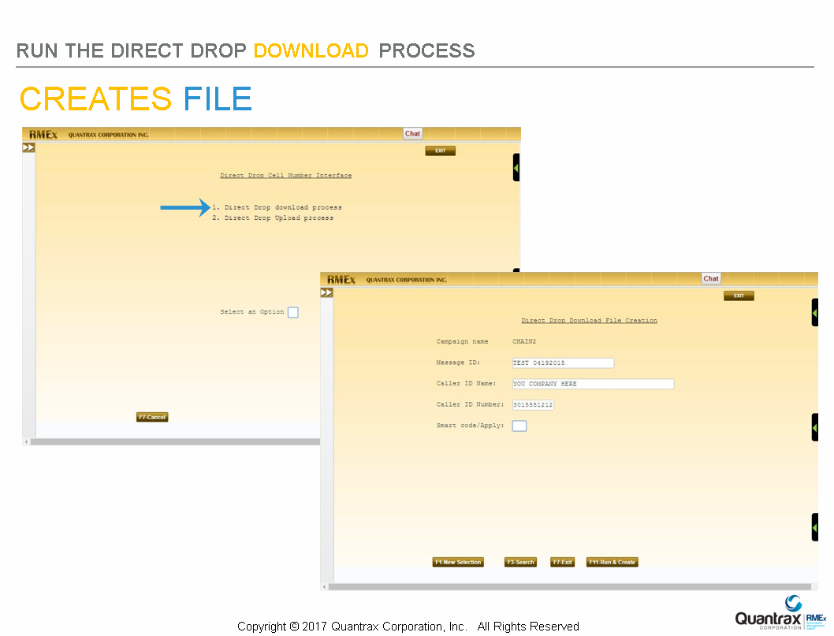
Slide 7: Retrieve the Outcome file  After running Direct Drop you will be sent a .CSV file that you will upload into RMEx. The upload process applies smart codes to take actions, and notate accounts based on the results of the phone calls made. | 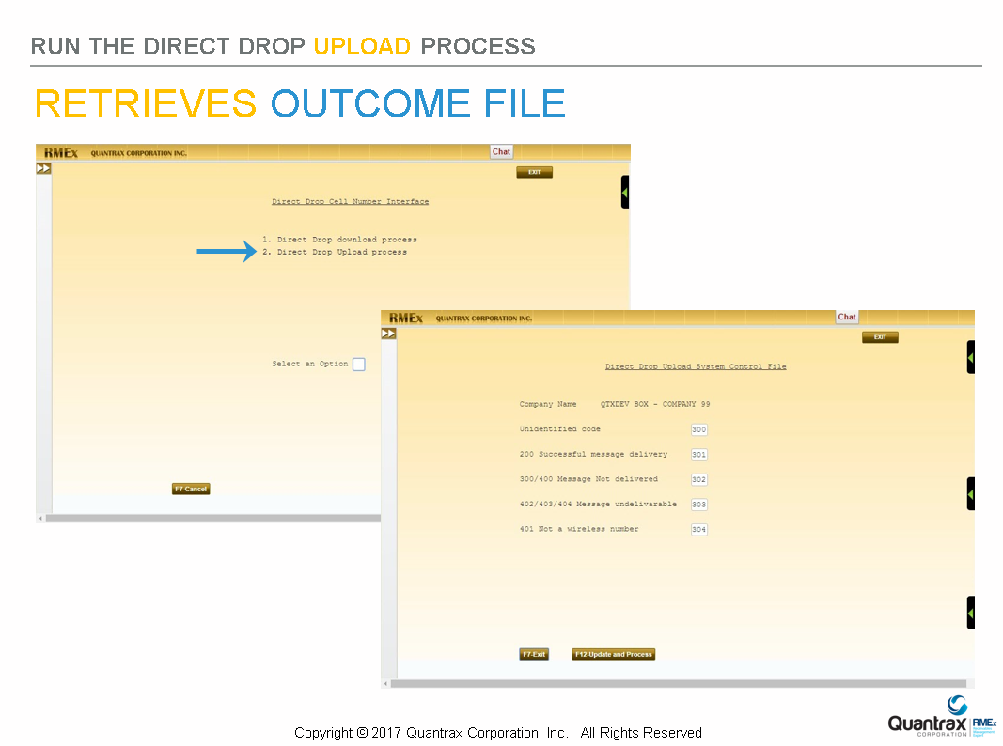
Slide 8:  This concludes our session on Using DIRECT DROP CELL NUMBER INTERFACE with RMEx - Overview. | 

