**Creating Client Videos - 2017**

1. **Setting Up Your Software**
2. In Camtasia go to, Tools > Options >PowerPoint tab and select the following options:

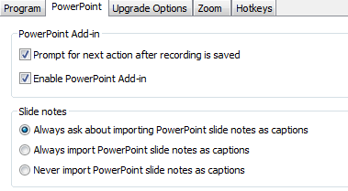

1. In PowerPoint check to make sure you have the Camtasia Add-In.   
   1. Click Add-In tab, you should see Recording icons

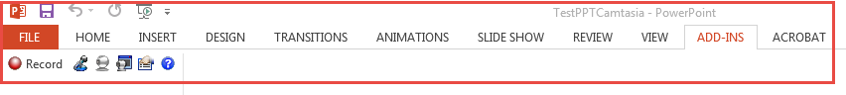

* 1. To add Camtasia add in to your PowerPoint and go to, Insert > My Apps/ My AddIns  
       
     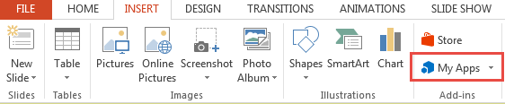

1. **Make sure directory for files have been created on FTP site:**
   1. Login ID FTP Site: **Knowledgebase**
   2. In the directory (Management_Training/2017/YourTopic)
      1. DO NOT use spaces in creating your directory or files use and underscore (Mgmt_training) or initial caps (MgmtTraining)
      2. Create your subdirectories under each topic directory as listed below  
           
         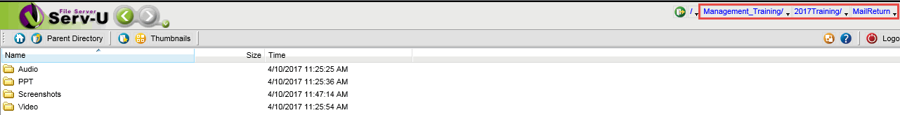  
         1. ***PPT*** (for the .PPT slide presentation)
         2. ***Audio*** (for the individual audio slides numbered by the slide they are for – they should be named 01_topic or 01Topic (01MailEntry or 01_Mail_Entry)
         3. ***Screenshots*** (for screenshots to be put in the .PPT)
         4. ***Video*** (for the Camtasia files created)
2. **Create .PPT Slide Deck**
   1. Save in FTP directory (Management_Training/**2017**/YourTopicName/***PPT*** )
3. **Record Audio For Each Slide**
   1. In PowerPoint, click Add-Ins > Record
   2. Bring up slide (in Slideshow mode)
   3. Click Record and record audio for that single slide
   4. Save recording (Camtasia project) in FTP directory (Management_Training /**2017**/YourTopicName/***Video***)
   5. A new Camtasia project will open up and slide will be added into it
   6. Save this project
   7. Repeat steps C1 – C4 and save your project regularly. Each slide will be added into the project.
   8. Save audio file for each slide in FTP directory (Management_Training/**2017**/YourTopicName/***Audio***)
      1. Click on frame Audio1-specific slide
      2. From menu select, File > Produce special > Export Audio As
      3. Name audio file 01TopicSubject and save as .mp3 file (*ManagePhone.mp3*)
4. Produce Video (save as .)
   1. Click Produce and share as .html file type. In FTP directory (Management_Training/**2017**/YourTopicName/***Video***

**Web Training production – Select to Produce from Camtasia and you will be presented with these options:**

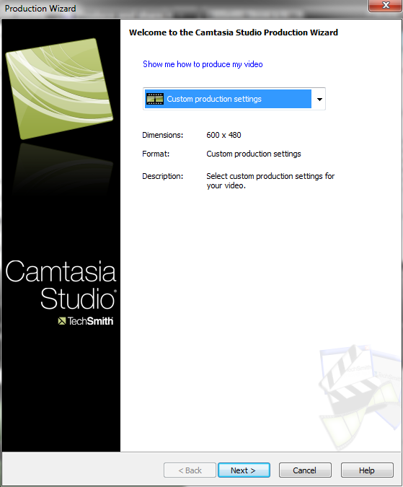

* **Select Custom, Then Next**

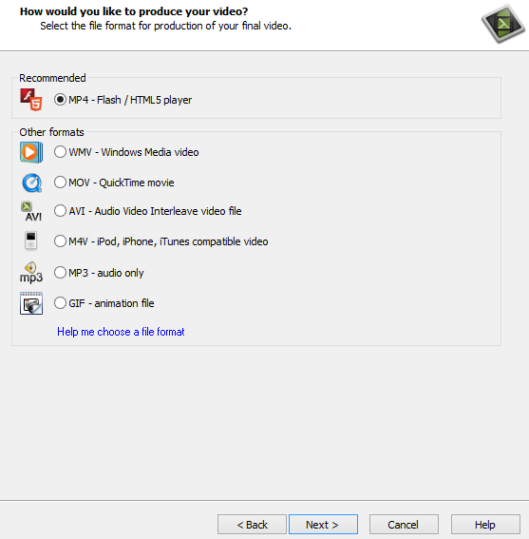

* **Select “Flash”, Then Next**

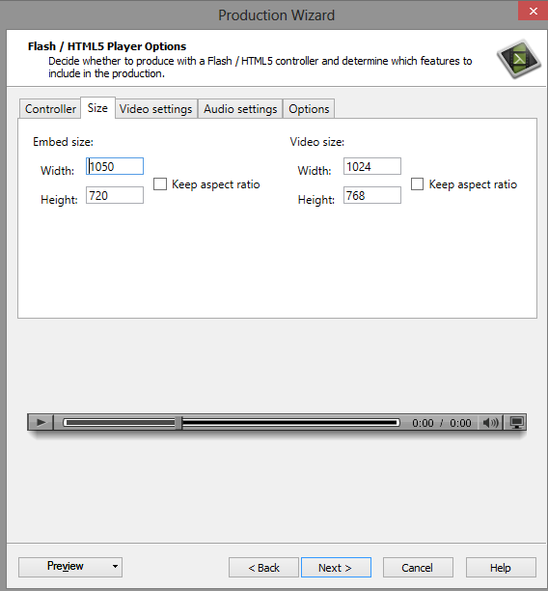

* **Embeded size 1050 x 720**
* **Video size 1024 x 768**

Click Next until you get to “Produce Video”

**Give your video a meaningful name and try not to use spaces.**

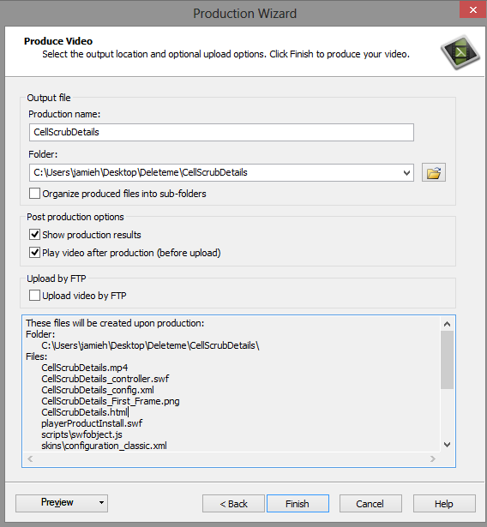

* and click **Finish**.

**Video Production**

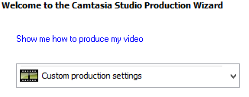

Then

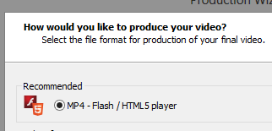

Then

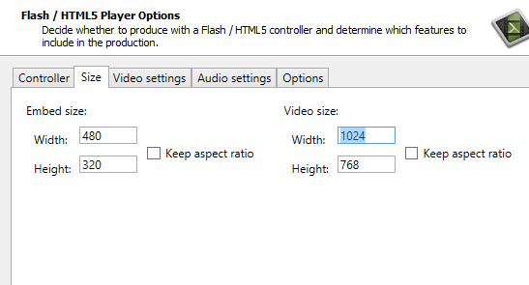

* **Embedded size 480 X 320 Video size 1024 x 768**
* **Continue hitting next till you click “Finish**”

**Creating Your Link: (for distribution – used in Knowledgebase, distribute to client, etc.)**

**How the links will look:**

* Web Training – COPY all your files that are produced from Camtasia into the FTP site directory  
  Management_Training/**2017**/YourTopicName/***Audio***

**How to find the web links: (Need to verify below with Jamie)  
How the links will look:**

Web Training:

<http://www.quantrax.com/KB/Management_Training/Management_Training_Acats/Management_Training_Acats.html>

**NOTE: Our videos for 2017 would be:** <http://www.quantrax.com/KB/Management_Training>/**2017/*YourTopic*Directory/Audio/*YourTopic*video.html**

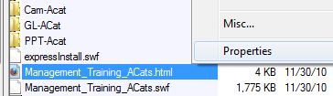

**How to find the web links:**

1. All web links for the Knowledgebase start with

<http://www.quantrax.com/kb>

1. To get the rest of the link, using CoreFTP, login and go to the directory with

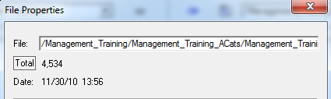

the file or video that you want to present to the user.

1. Right click on the file and go to its properties.

The field **“File”** in Prosperities has the rest of your link

**“/Management_Training/Management_Training_ACats/Management_Training_ACats.html”**

Adding the with the info above you get:

[**http://www.quantrax.com/kb**/Management_Training/Management_Training_ACats/Management_Training_ACats.html](http://www.quantrax.com/kb/Management_Training/Management_Training_ACats/Management_Training_ACats.html)

**NOTE: Our videos for 2017 would be:** <http://www.quantrax.com/KB/Management_Training>/**2017/*YourTopic*Directory/Audio/*YourTopic*video.html**

**The above is the link used in Kbase article, sent to clients (test it).**