If you have names for the Guarantor, Spouse, Patient and Co-signer 1, 2 or 3 (last name or first name) that are longer than the standard name fields, you can store these names in a new screen - **NB LOAD-LONG NAMES**. This screen can ONLY be updated at the time of placement by a custom program or I-Load.

To turn on this option you need to make sure that there is a ‘**Y**’ in field ***OPF050*** in file **SCSYSOP2** for each company. Once the flag is set:

* **I-Load** - the system will check the name fields in the file and if they are longer than the standard fields, it will automatically write the long name to the ***SCATRNFG*** transaction file.
* **Custom NB programs** – you must have this logic added to each of your custom programs. In the specs you need to tell the programmer to check if the file field names are longer than the standard fields and if so, to write the names to the ***SCATRNFG*** transaction file.

**NOTE:** The file that is used to store these names is ***SCNAMELG***.

To access this screen, go to **Tab-Q** > **ADD CHANGES/LONG NAMES** then press **F7-Exit**. The screen will only appear if long name exists for the account. Below is an example of a populated screen.

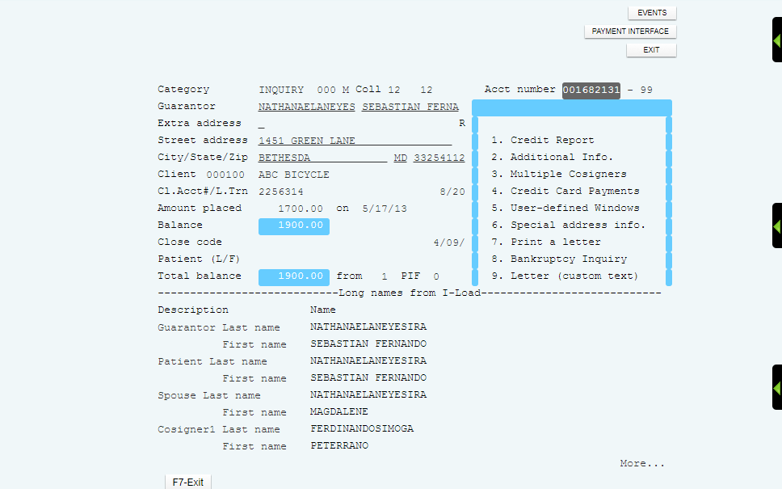

**NOTE:** Please be aware of the following:

* **Merge Codes:** You will have to use different merge codes if you need to print the long names in your letter. Merge codes **NNA-NNL** have been created to check the long name fields first and if they do not exist the standard name fields will be used. **YOU MUST HAVE THESE NEW MERGE CODES ADDED TO YOUR LETTER PRINT PROGRAM.**
* **Credit Reporting v5.2 only**: The system will first check for the long name and if it exists it will be used for the METRO2 file. If it does NOT exist, it will use the standard fields.