**Legal Screen Enhancements**

New options have been added to the **Update Legal Master Files** menu, **Full Legal Screen** and the addition of new fields within some of the screens. The enhancements are as follows:

* Additional fields in Defendant Attorney Codes
* Additional fields in Court Codes
* Additional fields in County Codes
* New options on Legal Master Files Menu
  + Judge Codes
  + Covering Attorney Codes
* Additional screens in Full Legal Screen
  + New Garnishment screen
  + New Suit Detail screen
  + New Full Detail screen by Defendant
  + New Caption screen

**Defendant Attorney Codes**

The following new fields have been added to the Defendant Attorney Codes screen:

|  |  |
| --- | --- |
| * Additional name | * Secretary name |
| * Phone | * Remarks |
| * E-Mail address |  |

**To access the Defendant Attorney Codes screen:**

1. From *Main Menu* select **Management menu** then select **Legal Files and Reports**
2. From *Legal Files and Reports*, select **Defendant Attorney Codes**
3. Type in information and press **ENTER** to save   
    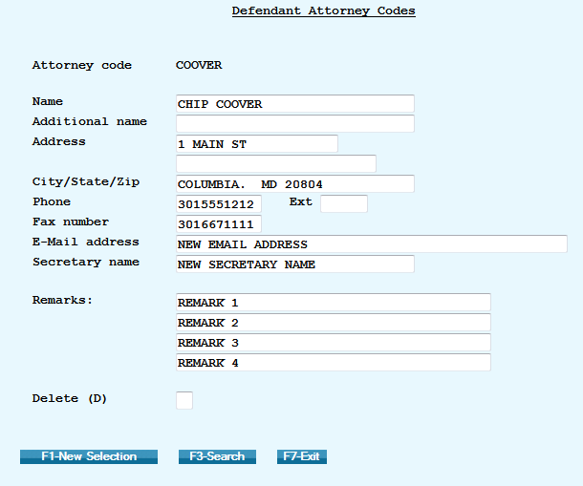

**Court Codes**

The following new fields have been added to the Defendant Attorney Codes screen:

|  |
| --- |
| * Description (longer length) |
| * Courthouse Name |
| * Phone |
| * Extension |

**To access the Court Codes screen:**

1. From *Main Menu* select **Management menu** then select **Legal Files and Reports**
2. From *Legal Files and Reports*, select **Court Codes**
3. Type in information and press **ENTER** to save

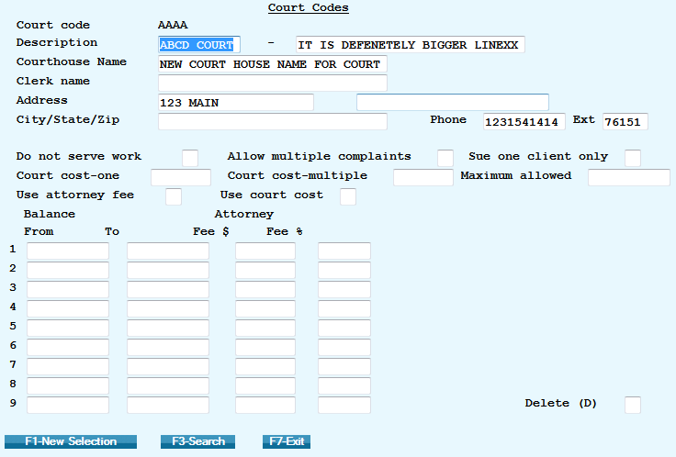

**County Codes**

The following new fields have been added to the Defendant Attorney Codes screen:

|  |
| --- |
| * Second person |
| * Phone |
| * Fax |

**To access the County Codes screen:**

1. From *Main Menu* select **Management menu** then select **Legal Files and Reports**
2. From *Legal Files and Reports*, select **County Codes**
3. Type in information and press **ENTER** to save

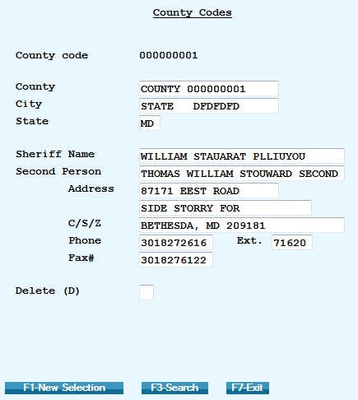

**Judge Codes**

A new option is available on the **Legal Master Files Menu** called **Judge Codes**. Use the Judge **Codes** screen to enter detailed information about the judge.

**To access the Judge Codes screen:**

1. From *Main Menu* select **Management menu** then select **Legal Files and Reports**
2. From *Legal Files and Reports*, select **Judge Codes**
3. Type in information and press **ENTER** to save

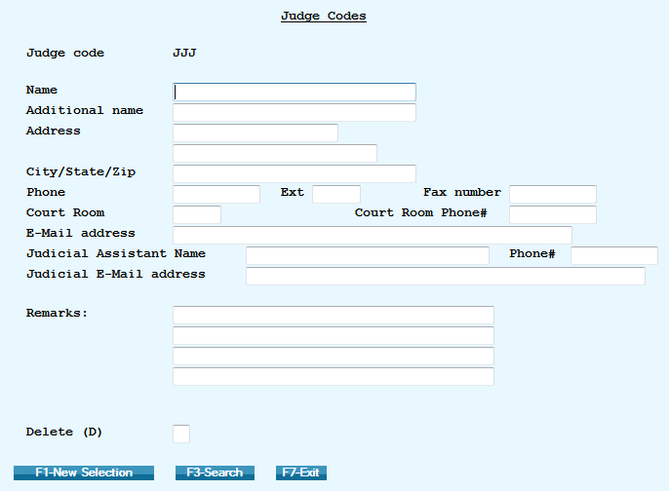

**Covering Attorney Codes**

A new option is available on the Legal Master Files Menu called **Covering Attorney Codes**. Use the Covering Attorney Codes screen to enter detailed information about the covering attorney.

**To access the Covering Attorney Codes screen:**

1. From *Main Menu* select **Management menu** then select **Legal Files and Reports**
2. From *Legal Files and Reports*, select **Covering Attorney Codes**
3. Type in information and press **ENTER** to save

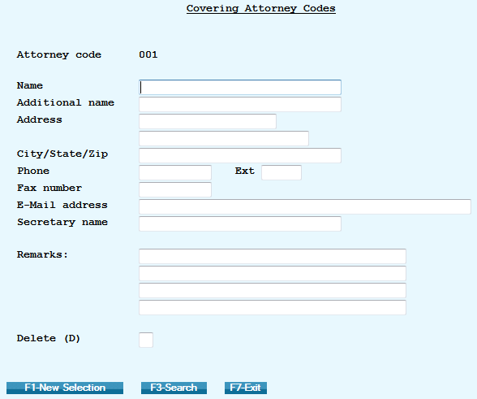

**Full Legal Screen Enhancements**

Additional legal screens are available from the **Full Legal Screen** via the **Account Detail** screen. The new screens are:

* Caption Screen
* Suit Details Screen (by defendant)
* Garnishment Screen  
  **NOTE**: Only three defendants can be entered (Def1, Def2 and Def3)

There are 2 new files (one for Garnishments and for a second legal screen) stored at the defendant level (DEF1, DEF2 and DEF3)

For letters, there are a set of merge codes for data in each screen. For the Caption and Garnish screens, there are merge codes to indicate these items are for which defendant.   
Click on the icon to view the list of merge codes for the **Full** **Legal** screen enhancements [](http://www.quantrax.com/kb/Legal_Screen_Enhancements/DOC_LegalScreen/NewScreenMergeCodes.pdf)

To view the merge codes used for letters:

1. From *Main Menu* select **Letter Format menu** then select **Merge Codes**

**Caption Screen**

Use the **Caption Screen** to notate the heading of a motion or other document filed with a court. It typically contains the names of the plaintiff(s) and the defendant(s), the name of the court, the assigned judge, and the case number.

**To access the Caption Screen:**

1. From *Main Menu* select **Inquiry menu** then select **Account Inquiry** and bring up an account **NOTE:** You can also access **Account processing****menu** then select **Account inquiry**
2. From the **Account Detail Screen** press **F6** for the **Full Legal** screen, then **F2** for the **Caption** screen
3. Type in information and press **F12** to update

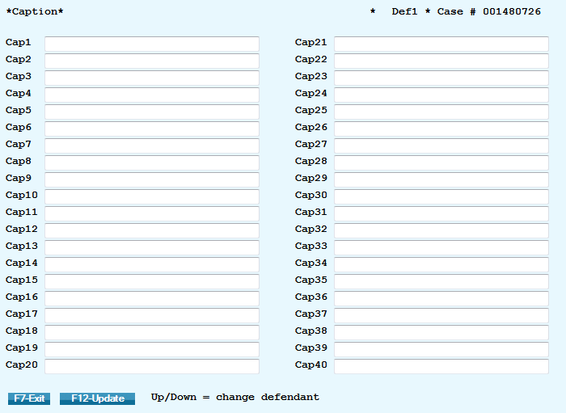

**Suit Detail Screen**

Use the **Suit Detail Screen** to enter detailed information about the law suit.

**To access the Suit Detail Screen:**

1. From *Main Menu* select **Inquiry menu** then select **Account Inquiry** and bring up an account **NOTE:** You can also access **Account processing****menu** then select **Account inquiry**
2. From the **Account Detail Screen** press **F6** for **Full** **Legal** screen then **F8** for the **Suit Detail** screen
3. Type in information and press **F12** to update /or go to view info for next defendant

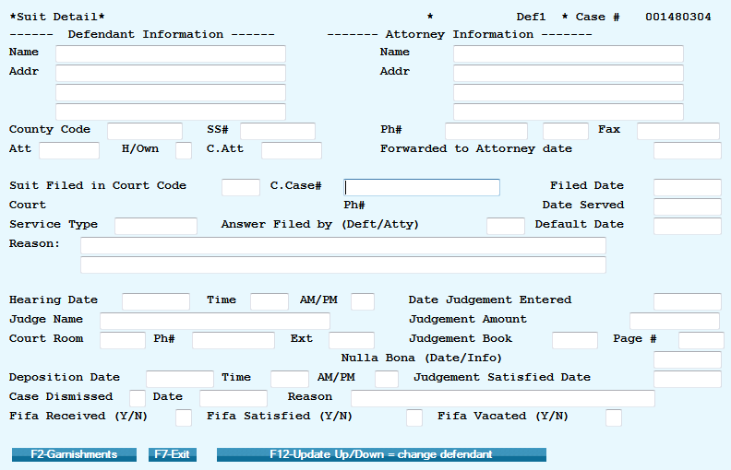

**Garnishment Screen**

Use the **Garnishment Screen** to enter up to 5 garnishments for each defendant.

**To access the Garnishment Screen:**

1. From *Main Menu* select **Inquiry menu** then select **Account Inquiry** and bring up an account **NOTE:** You can also access **Account processing****menu** then select **Account inquiry**
2. From the **Account Detail Screen** press **F6** for **Full** **Legal** screen, **F8** for the **Suit Detail** screen then press **F2** for **Garnishment** screen
3. Type in information and press **F12** to update and/or go to view info for next defendant

