**DRAFT- How to Search the Quantrax Knowledgebase**

To access the Knowledgebase, in Internet Explorer type [**http://www.quantrax.com/helpdesk**](http://www.quantrax.com/helpdesk)

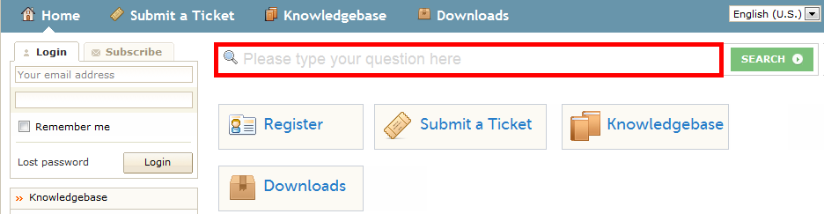

**TIPS for Better Search Results -** Use the following *logic* :

|  |  |
| --- | --- |
| **Value** | **Description** |
| Quotes (**“** **“**) | **EXACT** **PHRASE**, put quotes around multi-word items or phrases it:  **”**smart code**”** (*Finds articles with this phrase)* |
| Plus Sign (**+**) | **AND** , use plus sign in front of word that must be included in article:  **+**”smart code” **+**letters *(Finds articles must have both the phrase smart code and letters)*  **“**smart code**” +**letters *(Finds articles that may have the phrase smart code but must have the word letters)* |
| Minus Sign(**-**) | **NOT**, use minus sign in front of word that must **not** be included :  **“**smart code**”** **–** letters (*Finds articles that may have the phrase smart code but cannot have the word letters)*  +“smart code” – letters *(Finds articles that must have the phrase smart code but cannot have the word letters)* |

|  |  |  |
| --- | --- | --- |
| **What You Want To Find** | **What To Type In Knowledgebase Search Box** | **Results For This Example** |
| How do you stop sending letters from going to a certain states? | **Weak:** Stop sending letters from going to a certain states  **Strong:** +stop +sent +letters +states | -many articles in result because system searched on *every* word that was type in search  - 2 articles in results discussing the exact topic |
| How do I create a smart code? | **Weak**: Create a “smart code”  **Strong**: “smart code” training  **Strong**: “smart code” training audio | -many articles in result because system search on the words *create* and *a*  -results in all articles with links to training  -results in articles with links to audio-only training  NOTE: Use *audio*, *video (web-based)*  or *text*  .PDF ( documents) to search for links to types of training |