**Printing using the Hosting Menu**

Based on how your office is setup, when you run a report, letters, statements or other options that print in RMEx, they may not print automatically. The purpose of this document is to show you how to access these documents, and if needed print them from our Hosted Menu option.

To print you will need to know the name of your printer this was given to you at the time your printer and VPN were setup. It generally called something like this: XXPRT01

To access the “Hosted Menu” from the Main Menu, in the “Ready for option” put “M1” to be presented with the “Hosted Menu”.

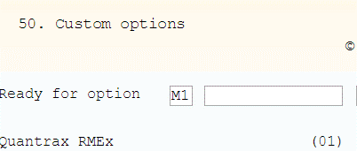

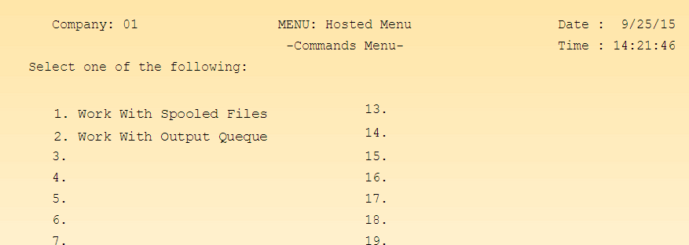

**From this menu you can take these options:**

Option 1 “Work With Spooled Files”. Shows only documents that are available with YOUR User ID only

Option 2 “Work With Output Queues”. Shows documents that are available for ALL User IDs, and where, for example, you find the nightly reports.

**How to Print**

For this example we will use Option 1 “Work With Spooled Files” (This works for option 2 also), and lets print the bottom “LINKING” report.

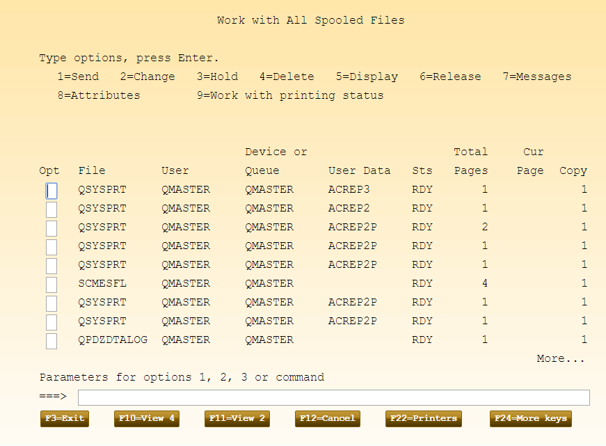

At the top you see the “Type options”. There are different options you can use as you start to understand more about printing.

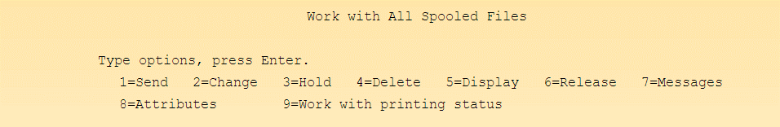

Lets use option “2=change”, so next to the report to be printed place a “2” and press enter

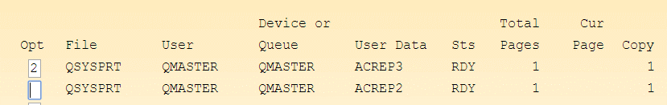

Which taks you to the option called “ Change Spooled File Attributes”

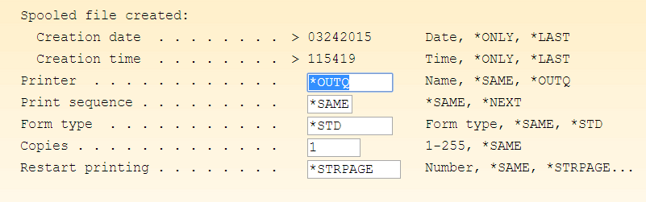

Where you see “Printer” change this to the working printer in your office which is WAPRT02 and hit ENTER



After this the report will print.

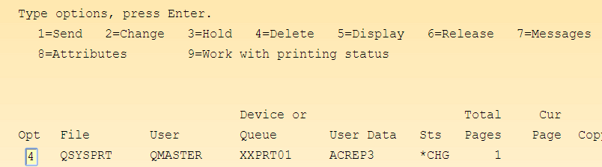

From here you can take option 4 to delete it.