**Roadmap to Quantrax and RMEx Hosting**

The purpose of this document is to help guide you through the setup of hosting for RMEx, showing your responsibilities along with Quantraxs and the hosting company Manage Inc.

So what is “Hosting”? Hosting gives the ability for our clients to run the RMEx software remotely and securely, without the expense and worry of maintaining the hardware required.

Here is a quick overview showing only a few of the major benefits of hosting with Quantrax:

* The hosting is located in the SAME room with Time-Warner Telecom’s redundant dual internet backbone, for superior internet uptime and accessibility.
* There is now a large diesel back up in case of power failure.
* Physical security - Entry to facility requires identification validation at three different checkpoints:
  1. Building entry
  2. Hosting facility entry
  3. Rack area entry
* RMEx will be running on an IBM System iPower7 and x blade technology, running at the latest releases. Maintenance will be done for you.
* With System iPower7 you will get the superior level of service you have always expected from IBM, including the built in redundancies of key areas. This means there would have to be multiple hardware failures to bring a system down, and this is extremely rare. If a disk fails, we are notified immediately and it can be repaired while you work. We have system and alert monitoring 24 hours day, and our maintenance plans for IBM support are 24x7x365.
* Daily Backups will be maintained for you. There are also additional options that offer a large choice of optional High Availability and Disaster Recovery Options, from tape restore to mirrored systems, and all choices in-between.
* We use the Powerful IBM LTO automated tape library backups which are stored off-site.
* Scalability: Pay for what you need. When your company grows, you just add new license. Leave the Hardware expansion to us
* Now able to offer a fully integrated dialer solution to our hosting client.
* Latest Technology: Keep ahead of the technology curve. You won't have to worry about replacing out dated technology, iSeries upgrades and maintenance are included in the price.
* Quantrax maintains your Hosted iSeries reducing the need for specialized technicians. This frees up staff to focus on strategic business objectives instead of server replacement, maintenance, operating system upgrades, application fixes, and daily management tasks.
* Quantrax Maintains your RMEx releases, and updates.

**What Hosting Looks Like.**

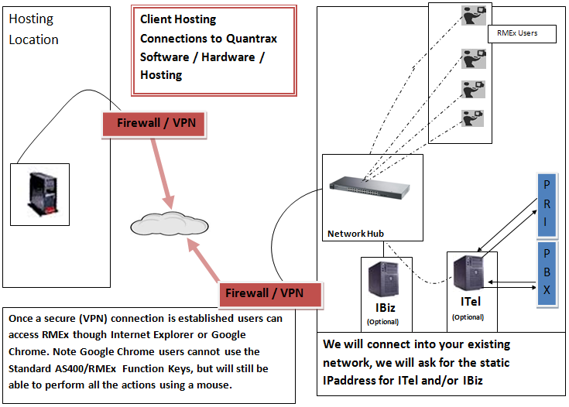

**Migration to the Hosting site:**

**Before the Hosting Migration**

This section will give a high level overview of what all persons involved in the hosting migration can expect, listing what is required before the hosting migration, during the migration, and what is required after the migration is completed.

* **Clients Responsibilities:** The Hosting Form filled out and sent back to Quantrax

Link: <http://support.quantrax.com/kb/HostingClientsInfo/HostingFirstDocs/HostingForm.docx>

This is information that Manage Inc. will require, such as:

* + Client demographics (Name, addresses, etc)
  + VPN setup information – **MUST BE SETUP ASAP. Cannot give a FIRM migration date without this.**
  + Printer Setup information – **MUST BE SETUP ASAP. Cannot give a FIRM migration date without this.**
  + User ID’s (Created by Manage Inc)
    - If new client, new User IDs will be created, and the names of the person using them.
    - If existing Hosting client, currently used User IDs and the names of the person using them.
    - Once you have the new User ID’s, you will need to set it up in System Security (Main Menu-> System control menu-> System security-> System security)
  + A list of client modifications or processes that could be affected by hosting at Manage Inc.
* **Quantrax Responsibilities:**
  + “Hosting Form” sent to Manage Inc
  + Setting up the Hosting environment.
  + Clients Nightly User ID is created
  + Nightly setup and tested
  + Test data migrated for client
  + User IDs: Manage Inc will create the User IDs. Test one before asking the client to log in to confirm there are no issues. If there is an issue contact Nelson
  + GUI: Along with the User IDs sent the client the GUI information needed for logging in.
* **Manage Inc Responsibility:**
  + VPN established between Manage Inc and Client
  + Printer is tested - Required prior to giving a FIRM migration date.
  + User IDs created and sent to clients. Note, the User IDs MUST be setup using the correct libraries and user groups.
  + Create printer Out queues

**Migration Responsibilities:** The migration to hosting will require actions to take place by the various parties involved. Here is a high level overview of what you can expect.

* **Quantrax Responsibility** 
  + Quantrax sets up System Security Menu access for the Client ( Note: Documented in the KB). Quantrax has a System Security Menu that allows clients to change their own User ID’s as far as to what areas and information a person can access. We will need to do an initial set for this.
* **Clients Responsibility.** 
  + Test GUI links using Internet Explorer.
  + Test User ID’s
  + Test Smart Codes on accounts
  + Review collectors work queues
  + Review accounts for things like:
    - Social Security Numbers
    - Balances
    - Payments
    - Etc.
  + Run test and live statements (Running live statements is fine in the testing environment)
    - Do they print automatically or go to an out queue correctly? Remember the client can decide how they want their queues setup
    - Print a Statement – Does it line up correctly
  + Run reports
    - Do they print automatically or go to an out queue correctly? Remember the client can decide how they want their queues setup
    - Print the report – Does it line up correctly
  + Test any mod’s or procedures that might be affected by migration

**After Migration:** For existing RMEx the Migration will take place over the weekend. For new clients you will receive other responsibilities involving the conversion.

* **Clients Responsibilities:** 
  + Access RMEx
  + Review collectors work queues, are their accounts?
  + Run test statements
    - Do they print automatically or go to an out queue correctly? Remember the client can decide how they want their queues setup
    - Print a Statement – Does it line up correctly

Contents

**No table of contents entries found.**

* **Quantrax Responsibilities:**
  + Confirm Nightly is setup correctly

**Hosting and how you will connect:**

You can access RMEx Hosting by using the GUI or IBM Client Access. New clients will want to use the GUI. Older clients with experience with the IBM iSeries may want to use Client Access and the GUI before going to the GUI exclusively. They both can run simultaneously in your office, they are two separate products, and one does not exclude the other.

**The GUI Quick Start Guide.**

Link: <http://support.quantrax.com/kb/GUI_Installs/DOC_GUI_Install/GUI%20Collector%20Quick%20Start1b.pdf>

**Link to access the GUI (Requires a VPN):**

With VPN: <http://quantraxhost.com:10046/RMExDefault/templates/index.jsp>

**Link to access the GUI WITHOUT a VPN:**

There is a method of accessing RMEx remotely that is encrypted and can be used WITHOUT the Site to Site VPN using “HTTPS”. Before considering using this other link outside your office make sure you plan for this and review the security risks of allowing users to access your data from outside your office. Contact Quantrax if you are interested.

**FTP: Accessing your Data Library**

You can FTP to your data library by going using the address: **quantraxhost.com**

You login will be your User ID.

Your data library will be the same two characters as your User ID followed by “scdata” (Ex. XXSCDATA) unless otherwise noted.

**Hosting Support**

Quantrax is your one stop shop for support, but for curtain areas you will find faster support for the hosting issues/setups below. If you have any questions or not sure to contact, please feel free to always contact Quantrax first for guidance.

**New User ID’s and Printer support**

Contact: Jim Davidson at

Email: [jdavidson@manageinc.com](mailto:jdavidson@manageinc.com)

Phone: 512-535-0333

You must send him the users first and last name and the company they represent.

Once you have the new User ID’s, you will need to set it up in System Security (Main Menu-> System control menu-> System security-> System security)

**VPN Issues:**

Contact: Dan Baldwin

Email: [db@manageinc.com](mailto:db@manageinc.com)

Phone: 206-682-9302

**Hosting Emergency Number**: 206-682-9302 and take option for the “Helpdesk”

**Tape backup and restore:** If you need to access a backup contact Quantrax, from there we will put you contact with:

Dave Martin

Phone: 206-682-9302 ext: 105

Email: [davem@manageinc.com](mailto:davem@manageinc.com)

OR

Kirk Goins

Phone: 503-674-2985

Phone: 206-682-9302

**RMEx Issues**

All RMEx issues will be handled by Quantrax, full contact info can be found at Quantrax.com in the “For our clients”, “Contact us” section.