|  |
| --- |
|  |
| **RMEx®**  **GUI Payment Interface – Fees And Other Changes** |

**Table of Contents**

**Fees For Credit Card Payments** 3

**Other Changes** 4

# **Fees For Credit Card Payments**

RMEx® GUI payment interface now supports fees for Credit card transactions. When a fee is defined and an account is eligible for a fee to be added, the following screen displays when an agent attempts a credit card authorization.

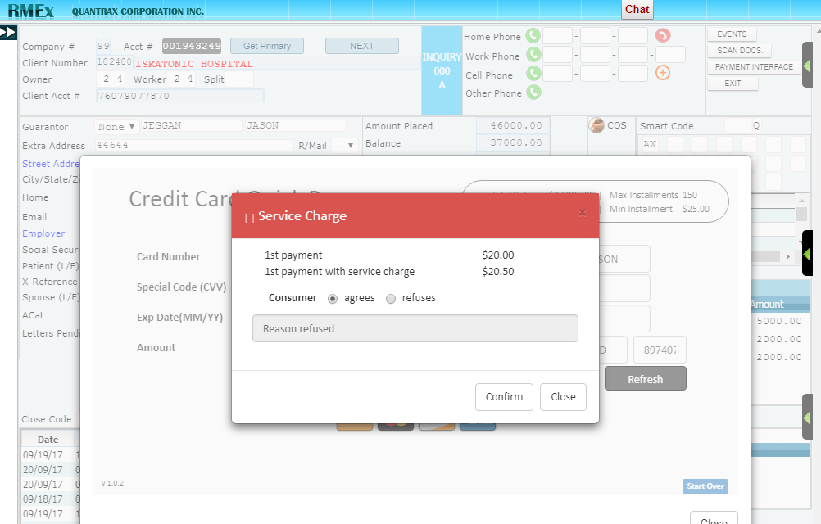

Whether the consumer is agreeing or refusing to pay the fee, actions will be taken on the account based on settings in the following screen:

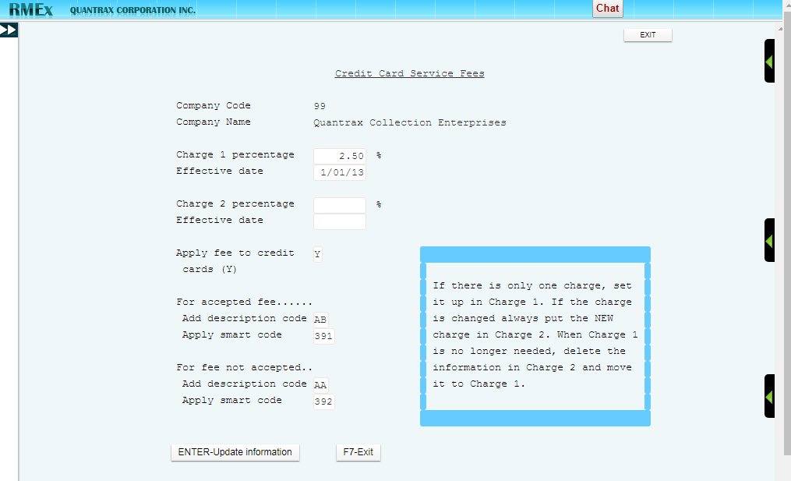

# **Other Changes**

* When an agent has authorized a payment for today, any payment for the same account for ‘today’ will be blocked. The system will only allow future payments to be stored.

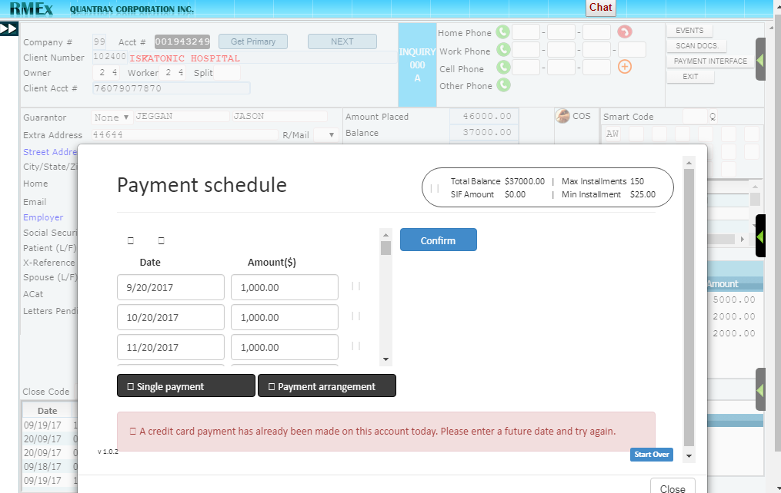

* If an account already has an authorized payment for today, if an agent tries to access the payment interface again, they will be presented with the following warning screen which warns them of the transaction made on the account.

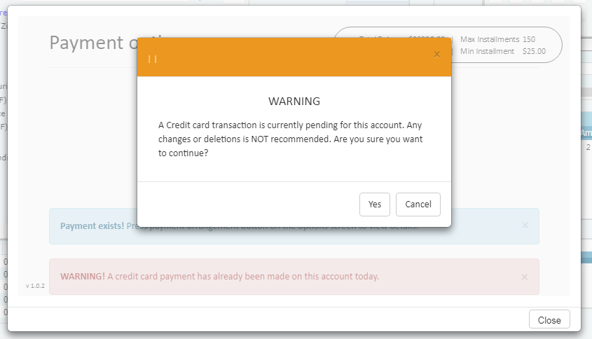

NOTE: Selecting ‘Yes’ allows the agent into the interface and still displays a warning sign to keep the agent aware of the previous payment.

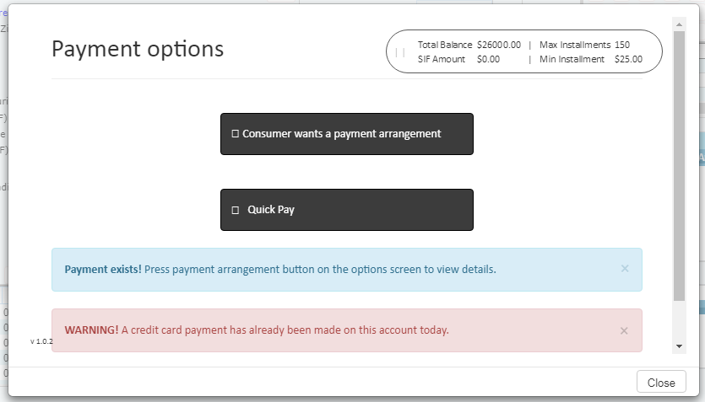

* If an account already has a credit card payment arrangement, Quick Pay will only allow check payments and visa-versa.

