**IMPLEMENTING THE RMEx GUI**

**This document discusses the system requirements to prepare for the RMEx GUI.**

QUANTRAX CORPORATION INC.

QUANTRAX CORPORATION INC.

**TABLE OF CONTENTS**

Troubleshooting 15

## Introduction

RMEx GUI, our *Graphical User Interface* is an innovative product for our Quantrax clients, providing a new and unique web-based environment for the user. User navigation is reduced, allowing the user to work more efficiently. The RMEx GUI product will change the way you work, letting experienced agents work faster and reducing the learning curve and training time for new hires.

### The RMEx GUI System Configuration

The installation of the GUI requires WebSphere Application Server Version 8 (WASE 8), or higher on the ISeries. Additionally, a separate Windows PC server is needed for the GUI delivery, which we will call the QServer.

**NOTE**: WASE can also run on a PC. Notify Quantrax if this is the direction you would like to take. There will be added costs associated with this set up.

The key configurations that will be needed for the GUI are as follows:

* Setting up VPN access with Quantrax
* Installing the WebSphere Application Server and related required software on the ISeries
* Installing and configuring QServer
* Installing RMEx GUI

The implementation will take approximately 2 – 3 weeks from the time you order your QServer. Please use the checklist on the next page to guide you through the tasks that need to be completed before the RMEx GUI installed.

Throughout this document you will be asked to verify and send Quantrax information about your systems.

**IMPORTANT:** As you read each section of this document **fill-out** and **print** the *GUI Implementation Client* Info form to notate the information requested. On the last page is a *GUI Implementation Checklist* for you to confirm all the tasks you need to complete prior to the GUI being installed.

Quantrax must have this document before we can install the RMEx GUI.

**NOTE**: Directions/AS400 commands are listed in the following pages.

***Click*** to open the *GUI Implementation – Client Info* form [](http://support.quantrax.com/kb/GUI_Installs/DOC_GUI_Install/GUIClientInfo.docx)

### Pricing Information

### Graphical User Interface (GUI) Pricing

|  |  |
| --- | --- |
| **License** | **Cost** |
| Up to 10 Users | $2,000 |
| Up to 25 Users | $3,000 |
| Up to 50 Users | $5,000 |
| Up to 75 Users | $6,000 |
| Up to 100 Users | $7,500 |
| Over 100 Users (per user) | $80 |
| Enterprise License | $50,000 |

### QServer Pricing

If Quantrax builds the Windows Server, we will load and configure all applications ordered by clients prior to delivery for a total cost of $1,500. Applications loaded after delivery will incur a fee of $500 per application.

The Windows server can be purchased from **Velocite**. The cost for this server is $2,790.00. We can order the server from Velocite, even if you would like to install the products.

**NOTE**: For clients who have 50 users or less, a single Windows server will be able to run all of the applications listed.

## VPN Access with Quantrax

Clients are asked to set up a Site-to-Site, SES-256-bit encrypted VPN link between your iSeries and our own systems. This is for the purpose of transmitting modifications or PTF’s and to analyze a problem remotely, if required.

Using other client VPN Software such as Cisco, SonicWALL, WatchGuard, etc., running from remote PC's, instead of a Site-to-Site connection VPN, has caused PC and connection issues in the past, resulting in unwanted delays. Direct access has been the most reliable and efficient method, allowing us to avoid unnecessary delays regarding customer support, which we would like to always avoid if possible.

Information needed to establish a Site-to-Site VPN Connection:

|  |  |
| --- | --- |
| **VPN Client information (*send to Quantrax*):**   * Firewall Type * Remote IP Address * Your LAN IP Address * Your LAN Subnet * iSeries address * I-Tel address (if used) | **VPN Quantrax Information (Keep for your setup):**   * *Firewall Type*: SonicWALL NSA 2400 * *Our Remote FQDN*: vpn.quantrax.com (If you cannot use a domain name the IP address is 67.90.175.166) * *Encryption*: AES-256 * *Authentication*: SHA1 * *Key Lifetime*: 86400 * *Shared Secret*: (We will exchange this at a later date) * *Our LAN*: 192.169.0.0 * *Our Subnet*: 255.255.255.0 |

## System Requirments for End User PCs

The minimum requirements for end user PCs to run with RMEx GUI:

* The RMEx GUI uses Microsoft’s Internet Explorer, and is capable of running on older PC’s such as a Pentium 4 with 512mb of RAM. But, we have found that on older PC’s the GUI will be sluggish, the same way many of the newer programs would be on that same PC. So we suggest whenever possible a newer Dual or Quad Core Pentium, or AMD CPU, with 2 gigs of RAM for the best performance.

## Setting Up the QServer (Windows Server) for RMEx GUI

The minimum configuration for the QServer is as follows:

* Intel Xenon processor – 2.0 Ghz
* Windows 2008 server – 64 bit
* 8 GB RAM
* Raid 1
* 2 x 1TB Hard Drives
* Redundant power supply
* 1 x 1 GB Network card
* Minimum of Windows 2008
* Windows updates installed
* Internet Information Services (IIS)

**NOTE**: IIS comes with Windows 2008

* **System access (Formally Client Access). This will install the required ODBC Drivers**
* .NET 3.5
* ASP.NET (in IIS Web Server)

### How to Find: Verify if iAccess (ODBC drivers) installed on the QServer?

|  |  |
| --- | --- |
| 1. **On Server from the Desktop, click *Start*** | 1. **Click *All Programs*** |
| 1. **Click IBM System iAccess for Windows**   C:\Users\dawnab\AppData\Local\Temp\SNAGHTML146c400.PNG | 1. **ODBC Administration items will display if it is installed**   C:\Users\dawnab\AppData\Local\Temp\SNAGHTML14bc029.PNG |

### QServer Installation

If Quantrax does not build your QServer, you must configure the server with the specifications provided by Quantrax. Please contact Quantrax for information regarding:

* Installing System iAccess (formerly called Client Access)
* Installing .NET 3.(in Server Manager)
* Registering ASP.NET in the IIS Web Server

## WebSphere Application Server (WASE) for RMEx GUI

Verify that the minimum configuration for the WASE 8 (Or above) is as follows:

**NOTE**: AS400 should have IBM Operating System Version 6.1

* WebSphere Application Server (WASE)

**NOTE**: Free product from IBM (may already be installed)

* + WebSphere Application Server V8 for i5/OS
  + WebSphere Application Server V8 Express
* HTTP Admin or 5722DG1 IBM HTTP Server for i5/OS*
* JAVA
  + JAVA5722JV1 option 6 Java Developer Kit 1.4 (5722JV1-6)
  + JAVA 5722JV1 option 7 Java Developer Kit 5.0 (5722JV1-7)
  + JAVA 5722JV1 option 8 J2SE 5.0 32 bit (5722JV1-8)
* iSeries PTF's are current [](http://www.quantrax.com/kb/GUI_Installs/DOC_GUI_Install/PTFs%20needed%20for%20GUI.pdf) (click for list of PTFs)
* RMEx is the latest version
* IBM HTTP Server is installed

Below are instructions to help you find the information needed to send to Quantrax prior to GUI implementation.

### How to Find: What version of WebSphere Application Server (WASE) running on your iSeries machine?

|  |  |
| --- | --- |
| 1. **Sign on as QSECOFR and type, *go licpgm* on the command line to see *Licensed Programs*:** | 1. **Take *option 10* from the Work with Licensed Programs screen.** |
| 1. **Roll down to see if WebSphere was installed. Remain on this screen for the next step.** | 1. **Press *F11* (Display Release) to see version details. Our version shows *V6R1M0*. This is the minimum version you will need to have installed.**   **Remain on this screen for next section (use for JAVA options).** |

### How to Find: JAVA Product Options 6, 7 & 8 needs to be installed as shown below (5722JV1-6 5722JV1-7 5722JV1-8)

|  |
| --- |
| 1. **From *Licensed Programs* PG-UP to see if JAVA is installed:** |

### How to Find: What is your admin console IP address (the IP address of your iSeries – machine where WASE is installed)?

|  |  |
| --- | --- |
| 1. **Type *netstat* on a command line and enter. The following screen will be presented. (You need to use the ADMIN user id/password e.g., QSECOFR)** | **2. Select *option #1* Work with TCP/IP interface status.** |

|  |
| --- |
| **3. Now you will see the IP address of the iSeries where you installed the WASE.** |

### How to Find: Verify that the HTTP server for WASE is running

|  |  |
| --- | --- |
| 1. **Type *WRKACTJOB* on command line.** | **2. The status of the HTTP server under *QHTTPSVR* sub system will display as shown below if active. Once these steps are answered/verified we can configure the WASE server and proceed.** |

### How to Find: Verify that the current PTFs are installed on AS400

|  |  |
| --- | --- |
| 1. **On Command Line type *go licpgm*** | 1. ***Page Down* to Related Commands menu and select *option 71*-Program temporary fix commands** |
| 1. **Select option 13-Display Program Temporary Fix** | 1. **Press *Enter* key to see all PTF’s** |

## Creating a WASE Instance

**NOTE:** We also recommend that clients use Internet Explorer to open a GUI session. We currently require Internet Explorer 6.0 with SP1 or later to run the RMEx GUI.

1. Select **Create Application server** on the left hand side

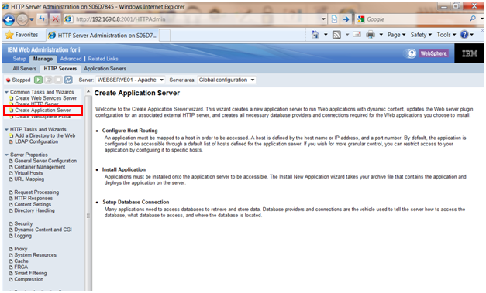

1. Select **V8 Express** and click next

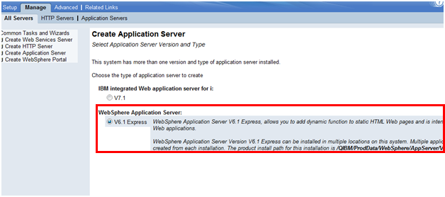

1. Type in the **unique name**

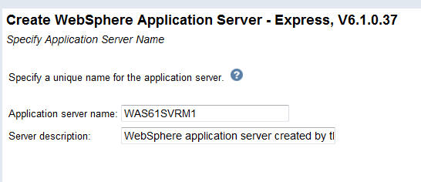

1. For *HTTP server type*, select **Do not associate an external HTTP server with this application**

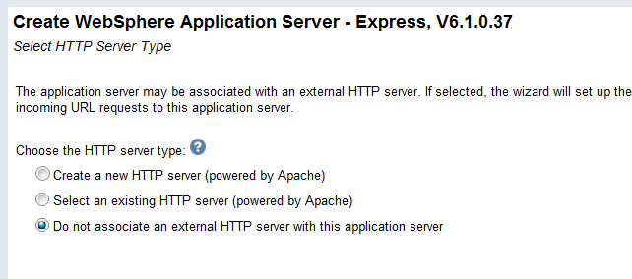

1. For the *Create WebSphere Application Server* *port range*:
   1. If this is the first instance you are creating take the default
   2. If this is **not** the first instance, enter the first number for the beginning of the next range

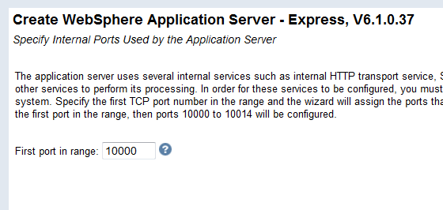

1. Uncheck **Default** **Applications** as shown below

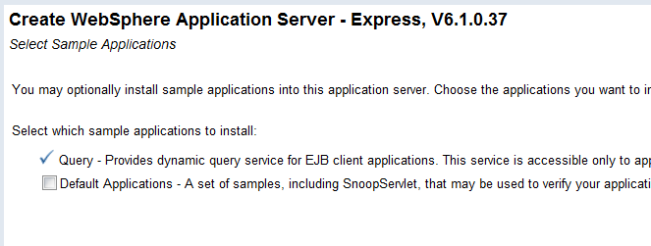

1. Do not configure identity tokens, click next to move ahead

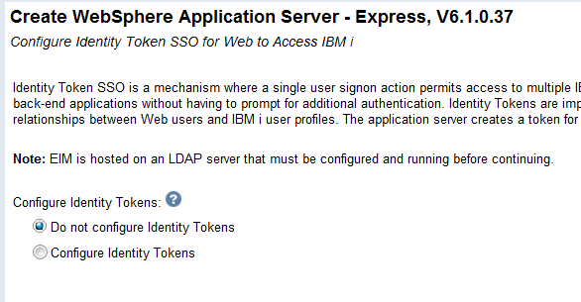

1. This is the final screen showing the details of the options you selected. **Print this screen for your records and send Quantrax a copy** of this screen so we can begin the GUI install. This is the **WASE Instance Information Sheet.**

(**NOTE**: Based on the screen below if another instance needed to be created the starting port number could be 10015)

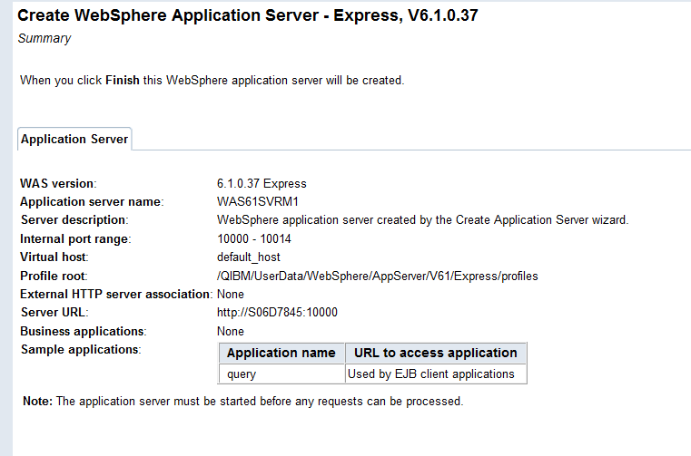f

## Installing RMEx GUI

Quantrax will install the RMEx GUI once all the tasks on the RMEx GUI Checklist has been completed.

##### Troubleshooting

Each desktop must have the ability to reach the AS400 and QServer.

* After installing the GUI if you cannot see it on the PC, *ping* the AS400 server
* After installing the GUI if you cannot see the *Notes* section in *Account Detail* screen, ping the QServer

To *ping* the AS400 or the PC Server to make sure the PC can reach them:

**NOTE**: You need the IPadress for the server you want to reach. In this example we will use the IP address of **192.169.0.8**

|  |  |
| --- | --- |
| 1. In Windows, click on the **START** button and in the dialog box type **CMD** and press **Enter**   C:\Users\dawnab\AppData\Local\Temp\SNAGHTML5c645f.PNG | 1. At DOS prompt type, **PING 192.169.0.8** and press **Enter**   cid:image001.png@01CD3436.8A41D160  After you hit **Enter** a "*Reply from*" message means you can reach that server.  If you get a message that states "*Request timed out*", they you are *not* able to reach that server |