Getting Started with RMEx GUI
- Silverlight: The first time users logon to GUI, they will be prompted to install Silverlight. Each desktop needs the ability to reach the AS400 and QServer.  - After installing the GUI if you cannot see it on the PC, ping the AS400 server  - After installing the GUI if you cannot see the Notes section in Account Detail screen, ping the QServer | 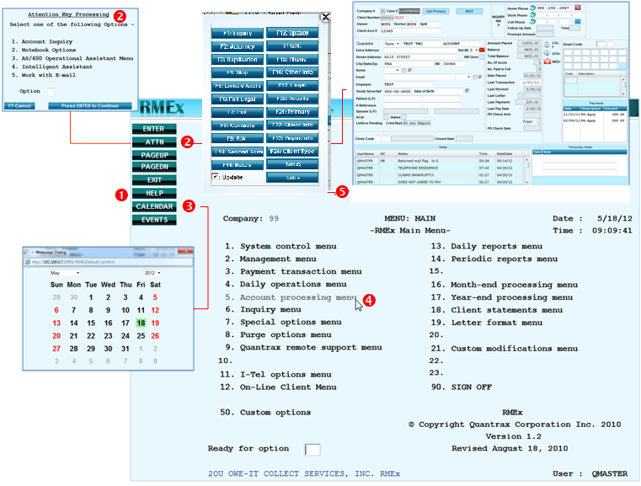  ❶ View field level HELP in any screen – place cursor in field then click HELP  ❷ Use the Up Arrow key on your keyboard to access these options. Ex. Click ATTN to get to new, separate account Inquiry screen, switching between account Inquiry and your workmap account.  ❸ Click the (Double Arrows) to expand and contract the RMEx menu  ❹ Use mouse to select and open menu  ❺ Click on Function key buttons to access screen. This is accessed by hitting Alt and the F1 function key. (Alt + F1 – The old Client Access help key)
- In Windows, click on the START button and in the dialog box type CMD and press Enter
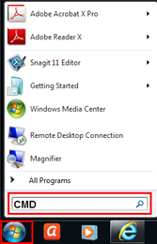
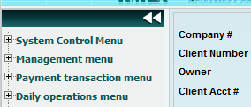
- At DOS prompt type, PING 192.169.0.8 and press Enter
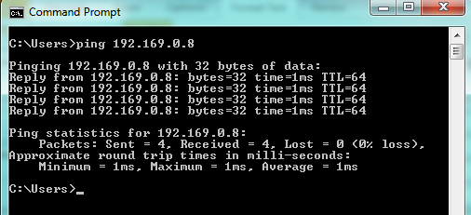
"Reply from" message means you can reach that server
"Request timed out" message means you are not able to reach that server

