Getting Started with RMEx GUI
- Silverlight: The first time users logon to GUI, they will be prompted to install Silverlight. Each desktop needs the ability to reach the AS400 and QServer.  - After installing the GUI if you cannot see it on the PC, ping the AS400 server  - After installing the GUI if you cannot see the Notes section in Account Detail screen, ping the QServer | 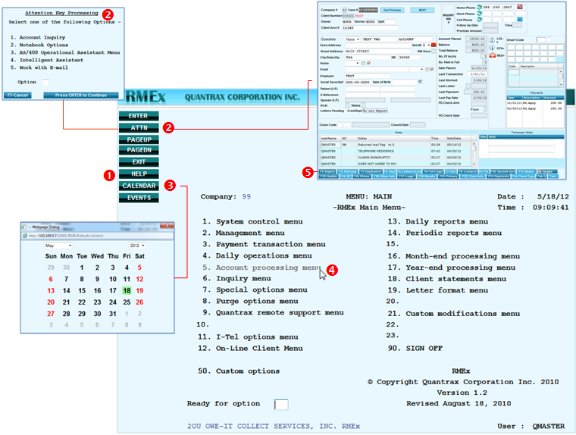  ❶ View field level HELP in any screen – place cursor in field then click HELP  ❷ Click ATTN to go back to the last account you opened (Account Detail Screen) or Attention Key Inquiry screen if no account was accessed  ❸ Opens pop-up CALENDAR  ❹ Use mouse to select and open menu  ❺ Click on Function key buttons to access screen
- In Windows, click on the START button and in the dialog box type CMD and press Enter
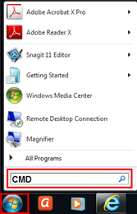
- At DOS prompt type, PING 192.169.0.8 and press Enter
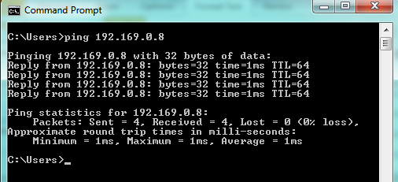
"Reply from" message means you can reach that server
"Request timed out" message means you are not able to reach that server

