Account Processing Quick Start
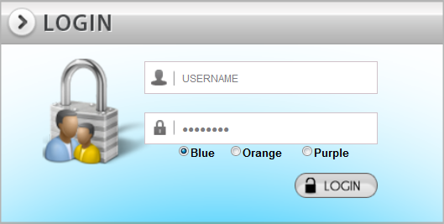 |  | 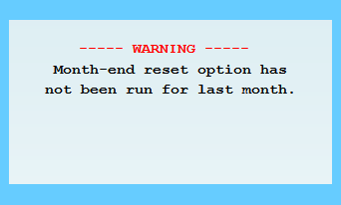
Sign on with your UserID pressing “Enter” for each message, unless a message tells you otherwise.
NOTE: If you cannot get past the login try clicking Internet Explorer Compatibility Mode. CLICK HERE
(If you do not see the blue torn sheet, hit the ‘ALT’ key, then Tools, then ‘Compatibility Mode’)

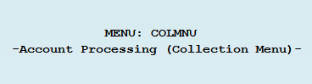 | 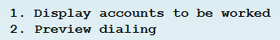  (Tip: Left mouse click option 1) | 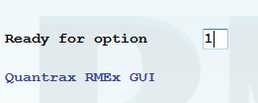
Collectors generally start at the “Account processing menu” so from there, in the “Ready for option” put a “1” to “Display accounts to be worked” and hit “Enter”. NOTE: you can also left mouse click on the menu option “"1. Display accounts to be worked"
TIP: Lost after taking an option? F7 from will bring you back to a Menu (As long as a message is not telling you otherwise)

Presenting Accounts to Work from within “Account Processing”:
1) Hit F2 to see where accounts are located. 2) Fill in the “Type of processing”, “Qcat”, and “Time frame” fields. 3) Hit “Enter” to see first account
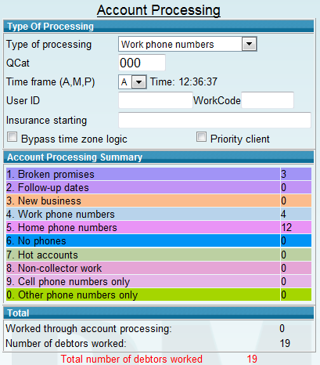  First Hit F2 To see accounts to be worked -->  Tip: F2 Then F10: More information about Work maps, number worked, and current status. | Processing Types: Main Buckets where similar accounts are grouped, such as New Business, Broken Promises, etc  Qcat: Processing types are broken down into sub-queues to make it easier to find accounts  Time Frame: Accounts can be presented by time of day. Select accounts in AM, Mid-day or PM.  USERID/WorkCode: Only use if working someone else’s accounts  Bypass time zone logic: Present accounts not yet eligible to be worked due to time zones  F2 Screen:  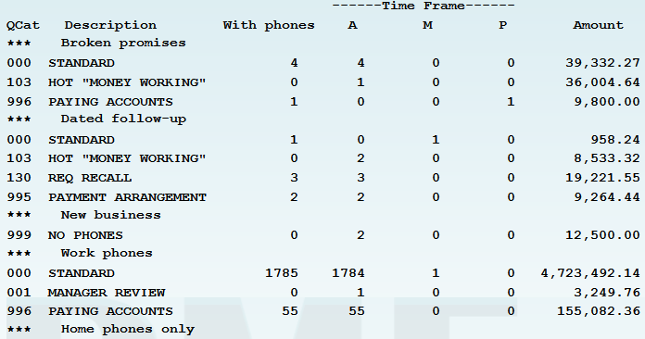  Number of accounts to be worked in each “Time frame” (A M P)  QCats  Processing types

Function Keys and accessing information: REMEMBER: Function key F12 saves (Updates) any new information you enter on the account. You will lose what you typed if you do not hit F12
Escape Key OR on top right: Displays other areas of the account.  Tip: Clickable Icons will be presented. You can also use the Function keys on your keyboard to go to that location if function keys are listed. | 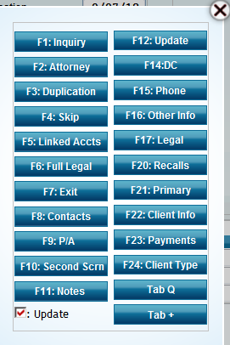 | Up Arrow Key Or on bottom right : To access Help and other features  Tip:  ATTN accesses an account Inquiry screen  HELP button: Make sure the cursors in the field or area in question | 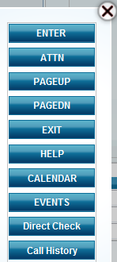
Account Detail at a Glance
-Case Number  -Client  -Owner/Worker  ---------------------  -Debtors name and address  --------------------  -Placed Amount  -Balance Owed  -Date Placed  -Post Date Chks  -etc  --------------------  -Close Code  -Last 5 notes on an account | 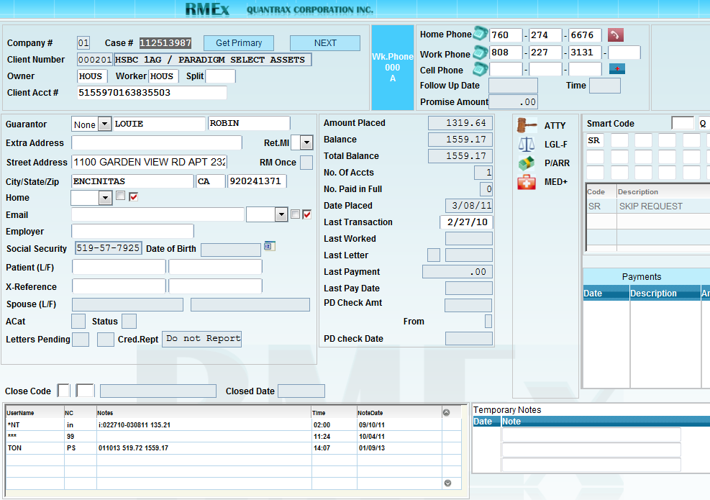  Clickable Indicators showing Information found in other areas of account | -Home #  -Work #  -Cell #  -------------------  -SMARTCODE  -Other Phones  --------------------  -Description Codes  --------------------  -Payments  --------------------  -Temp Notes
Full Notes (F11 Function key) Hit Alt+F1 to see other function keys for things like Letter history, a summary of notes from linked accounts, etc
F11 Function Key | 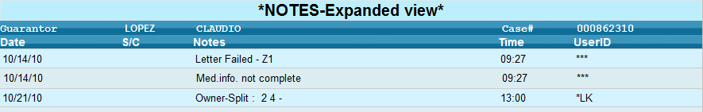
F9 from F11 | 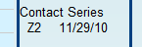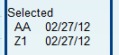 | Shows the First 3 contact series letters, and the first 6 Selected letters (Sent by Smart Code) on an account
F5 Linked Account Summery
F5 for Linked accounts  F24 to see other linked info | 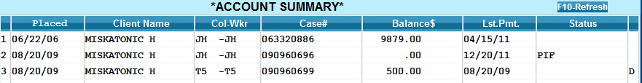  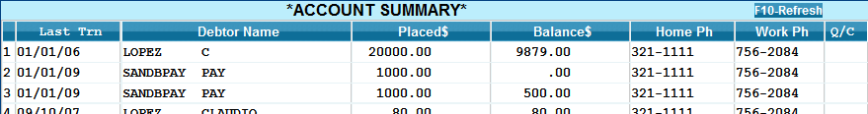

Second Account Detail Screen (F10)
Balance types with the total due below. | 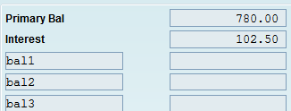  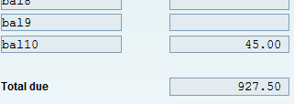 | -Interest Rate  -Credit reporting info  -Number of attempt and contacts. | 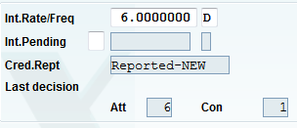
Contact Series &  Smart Code Series  Tip: Sequence 9 means its done | 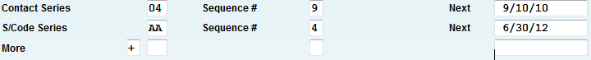  + next to “More” to see additional Smart Code Series.
TabQ and the Other Phone Window
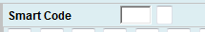
The field the field NEXT to the smart code field is used to access additional areas of an account. Start with the Cursor in the Smart code window, then hit your TAB key
Tab then Q  Called the “TabQ window”  -Credit cards  -Co-signers  -Bankruptcy  etc | 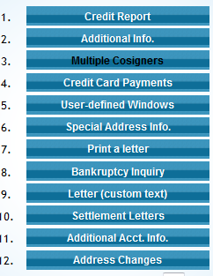 | Tab then + takes you to the “Other Phones  Window”.  Tips: Tab then = will also bring you here.  Hit Alt+F1 for additional phone options | 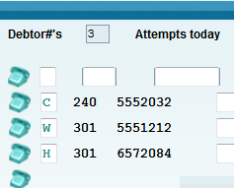
Using Events and Smart codes: So all you need to do is work the account and report the outcome. Seems too simple doesn’t it?
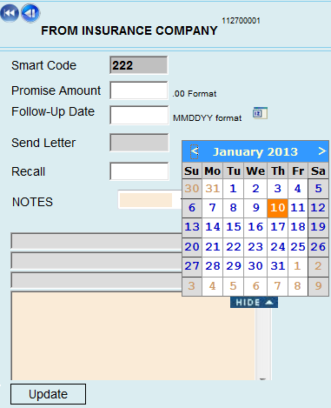
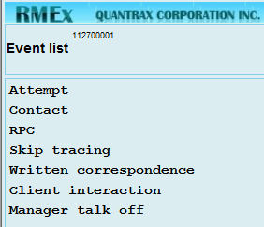 Events are used to guide you when defining what has happened on an account.
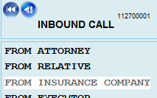
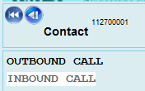

Smart Codes
Smart Codes are an action taken on an account and can be manually applied from the “Smart code” field. They also have the ability, based on how they are setup, to advance you to the next account. Notice, the last window on the Events above looks like a Smart Code window. That’s because Events can also apply Smart Codes
Tips from the Smart code windows online Help:
-Transfer to: Sends account immediately to anyone working in Account Processing
- Recall: Uses military time (5:30pm=1730). Also, to see account in one hour and fifteen minutes enter “115” <field exit>, (can be used for up to 3 hours this way).
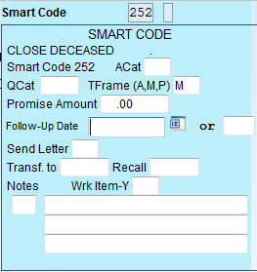
-Existing Follow-up dates and/or promises can be removed using all nines (999999) in the field

Payment Arrangements (F9 Function key)
Minimum setup:  -“Frequency” (Month, Bi-Monthly, Daily)  -“Start Date”  -“Installment amount OR #Installments”  WORKS LIKE A CALCULATOR: With Frequency and Start date filled in (Ex) a “12” in #Installments, Hit “Enter” and it will calculate the installment amount. Instead of Installments you can put the Amount and it will calculate the number of Installments. | 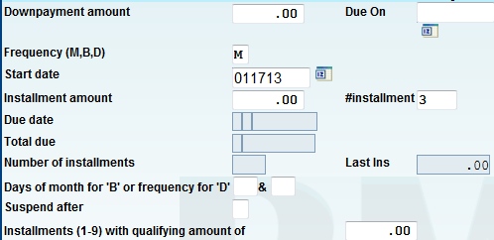

Direct Check (found off the payment arrangement screen F9 then F14)
Requires:  -Account Number  -Routing number  -Date for Payment  -Check Number  -Amount | 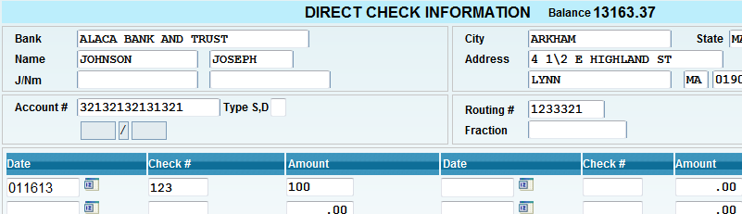

Credit Card (CC from the Smart code field)
-Fill in the “Card #”  -“Name”  -“Exp. Date”  -“We Process” if your company processes CC’s  -“Retain Info” if you want to store CC info on this screen for later use  -Hit “F12” for next options | 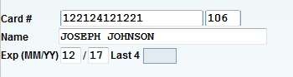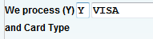 | 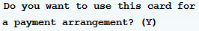  -Payment Arrangement? If “Yes” You will be take to the P/A Screen.  If not for P/A Enter amount and hit “Update” and to make Payment