C:\Users\su2\Dropbox\Support\KB\RMEx logo.jpg

**How to open MULTIPLE SESSIONS in Internet Explorer**

**Open Internet Explorer**

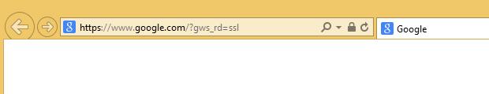

**Click on the “ALT” key on your Keyboard if you do not see the tool bar as shown below. This will present the Tool Bar.**

**Click on File, then “New session”.**

