C:\Users\su2\Dropbox\Support\KB\RMEx logo.jpg

**How to open MULTIPLE SESSIONS in GOOGLE CHROME**

Note: Chome gives you an option on the first page to “Sign in”. You are not required to do a Google Chrome sign on.

1. Open up a **GOOGLE CHROME** browser > Click on the icon (top right hand corner…) as I shown Below   
     
   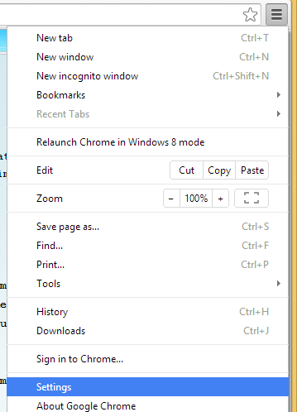
2. Then click on “**Settings**” > A new Tab will be opened…
3. Click on “Add new user…” button as shown below…  
   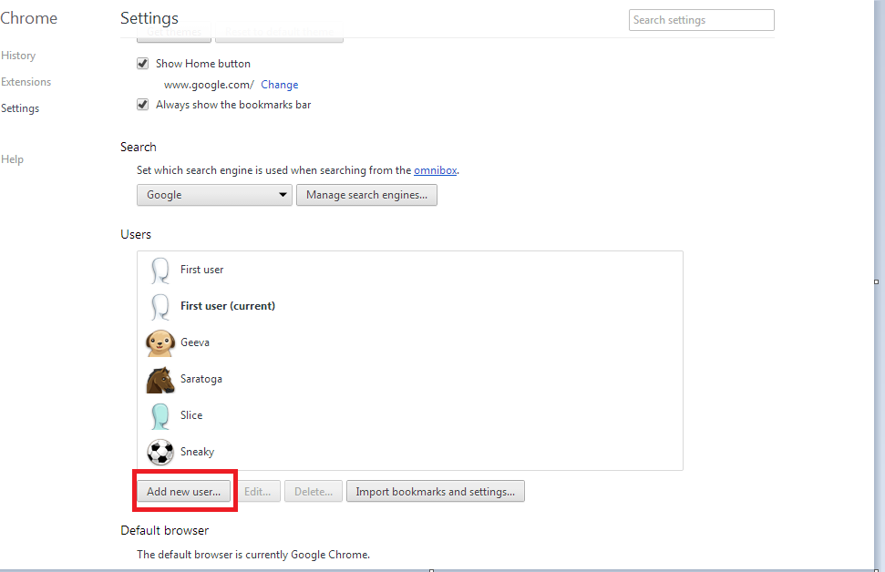
4. Now, you will see a pop up window as shown below…  
     
   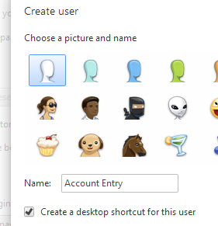
5. Click on “Create” button…
6. You should be able to create as many users by following the above steps…
7. Now you can see an icon at the top left hand corner. You should be able to access all the new sessions by clicking that icon as shown in below image…  
     
   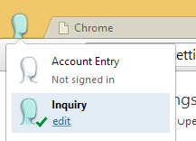
8. Just open up another session of Chrome, and click on the icon for a separate session