Downloading from the AS400 to your PC
- Create a folder in the c:\ drive called files (c:\files)
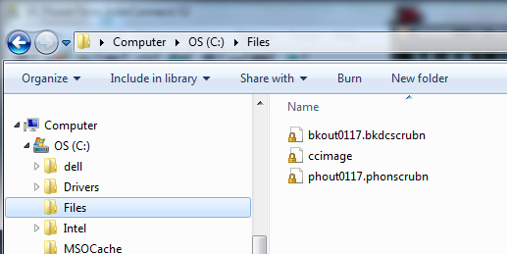

- Using a command (DOS) box start an ftp session to your iSeries (Example here is 192.169.0.8).
- To get to the Command box From Windows click on the Start button-> Run->CMD and hit ENTER
- In the command box Type: ‘ftp 192.169.0.8’ and hit ‘Enter’

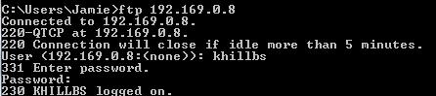

- Then sign in to the ftp site using your RMEx User Name and Password
- Use “lcd c:\files” to change the local folder on your C: drive where you want to put the files
NOTE: If this is a PROGRAM file you MUST type ‘binary’ and hit enter 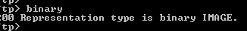

- Using the ‘GET’ command you will download the files. You will need to specify the LIBRARY on the as400 and the file name and sometimes the member name
  - ‘GET SCDATA/FILENAME’ or GET ‘ SCDATA/FILENAME.MEMBER’ (Without the quotes)

