|  |
| --- |
|  |
| **FTP Job Processing** |

Contents

**FTP Job Processing Module** 3

F10-Process Immediately 7

F8 –Log 8

Trouble shooting 9

# **FTP Job Processing Module**

The FTP Job processing module allows you to schedule the transferring of files between the AS400 and any non-secure FTP site automatically. Once set up, the processing will occur on the date and time entered.

**Note:** If you power down your system, run an IPL, loose power, etc. you will need to reactivate the schedules (see bottom of doc for instructions)

Before creating your first FTP job, Quantrax will need to activate the FTP Module. If you get an error please contact Quantrax.

From System Control menu 4 – Option 1. FTP Job Processing

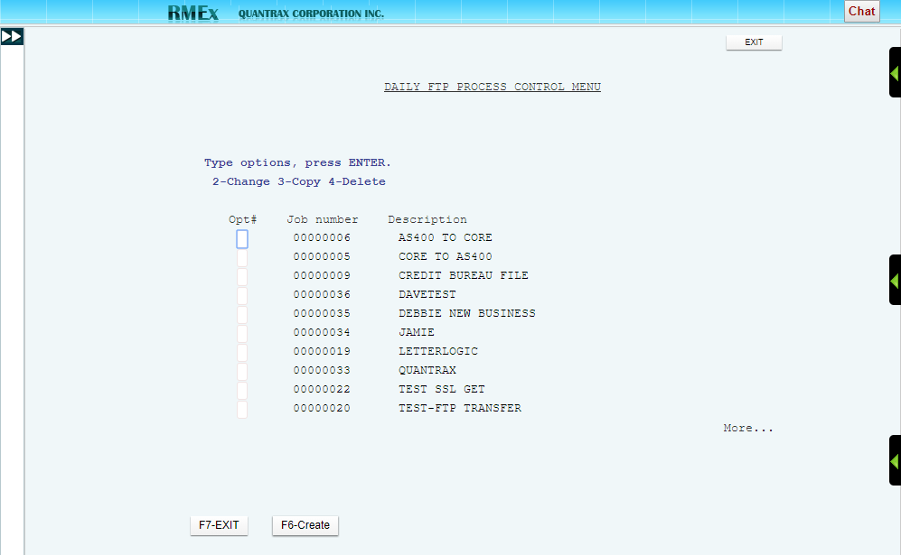

You can:

F6 - Create a new job

2 - Change an existing Job

3 - Copy an existing Job

4 - Delete an existing Job

**NOTE:** Once you have Jobs created it is more efficient to just copy an existing one and make the needed changes rather than creating a new one each time.

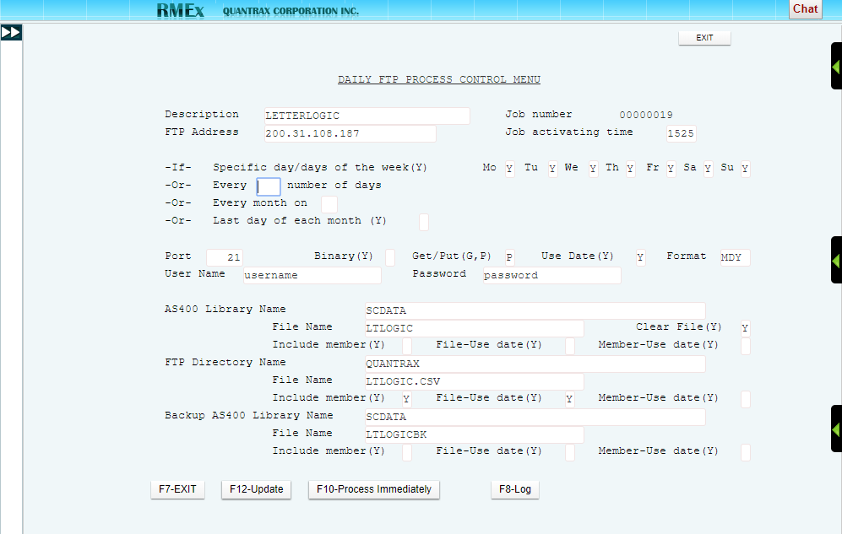

**Description** – Name of the job

**Job number** – Assigned by RMEx

**FTP address** – The FTP address associated with the FTP site

**Job activating time** – Time of day the job should run (military time)

**-If- Specific day/days of the week(Y)** – Enter a “Y” in the associated day of the week field

**-Or- Every __ number of days** – every “x” number of days (ex. Run every 10 days)

**-Or- Every month on __** - A specific day of the month (ex. Run on the 10th of each month)

**-Or- Last day of each month (Y) _** - “Y” if you want it to run on the last day of the month

**Port** – The port used to connect to the FTP site (default is 21 as that is the most commonly used)

**Binary(Y)** – If the file needs to be transmitted as binary (mainly used for transmitting programs), enter a “Y”

**Get/Put (G,P)** – If you are moving a file from the FTP site to the AS400, enter “G” = get. If you are moving a file from the AS400 to the FTP site, enter “P” = put

**Use Date(Y)** – If you are going to be using a date within the naming convention, enter a “Y”

**Format** - If you are going to be using a date within the naming convention, enter the format to be used. Ex. MDCY, MDY, YMD, etc

**User name** – Enter the User name to log into the FTP site

**Password** – Enter the Password for the User name

**NOTES:** Job activating time and a day/date schedule are required. If you are going to be manually processing every day, to prevent auto processing you can enter 999 in the field ***-Or- Every __ number of days***

**AS400 Library Name**– Enter the AS400 library name where the file should exist (example below = SCDATA)

**File Name** – Enter a valid file name that should exist on the AS400 (example below = LTLOGIC)

**Clear file(Y)** – Enter a “Y” if you want to clear the existing AS400 file once transmission is complete

**Include member(Y)** – Enter a “Y” ONLY if the AS400 member name is different from the file name

**File-Use date(Y)** – Enter a “Y” if a date exists within the name of the AS400 file

**Member-Use date(Y)** – See File-Use date above. This field is only used if there is a date associated with the member name

**FTP Directory Name** - Enter the directory (folder) name on the FTP site where the file should exist (example below = QUANTRAX)

**File Name** - Enter a valid file name that should exist on the FTP site (example below = LTLOGIC.CSV)

**Include member(Y)** – Always enter a “Y” as this associates the file extension (.txt, .csv, etc)

**File-Use date(Y)** – Enter a “Y” if the FTP module should associate a date within the name of the FTP file (date appears before the extension)

**Member-Use date(Y)** – This field is rarely used. Enter a “Y” if the FTP module should associate a date within the name of the FTP file (date appears after the extension)

**Backup AS400 Library Name** – Enter the AS400 library name where the backup file should be created (example below = SCDATA)

**File Name** - Enter a valid backup file name that should be created on the AS400 (example below = LTLOGICBK)

**Include member(Y)** – Enter a “Y” ONLY if the AS400 member name should be different from the file name

**File-Use date(Y)** – Enter a “Y” if a date exists within the name of the AS400 file

**Member-Use date(Y)** – See File-Use date above. This field is only used if there is a date associated with the member name

**NOTE:** All file names MUST follow standard file naming conventions to be considered valid.

Ex. AS400 file names can only be a max of 10 characters and cannot begin with a Q, keyboard character or number. FTP site file names cannot have certain keyboard characters in them.

**NOTE:** When a date is used in the file name – the date in the file name must be the exact date as the file that is being transmitted.

**NOTE:** Files are only transferred between the iSeries and your main FTP directory. FTP Sub folders cannot be used at this time.

## 

## F10-Process Immediately

Runs the process immediately instead of at a scheduled time.

Can be used to process 1 time files or files where the name changes from time to time.

If there is a date extension associated with either file, you will be presented with this additional screen:

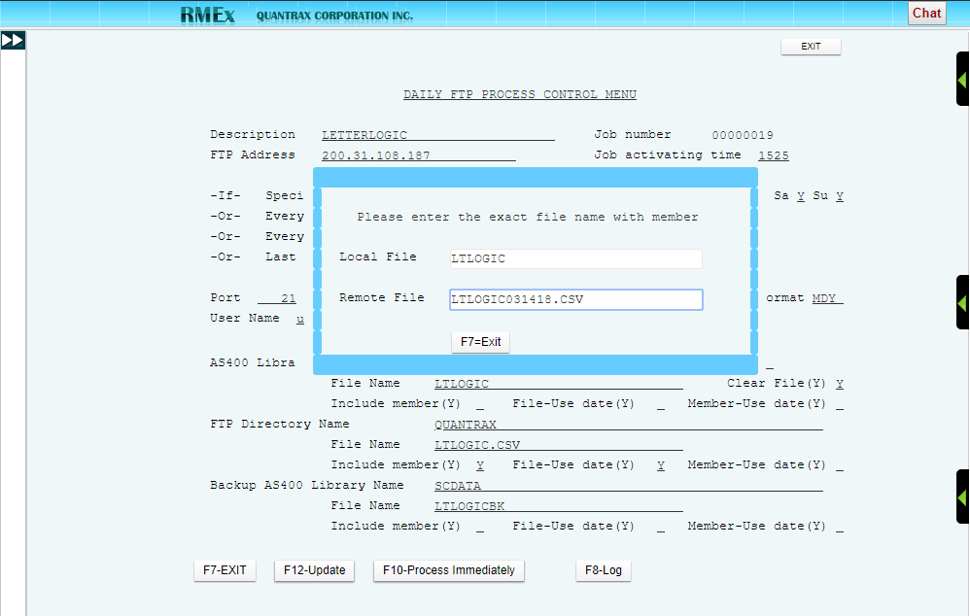

You must manually enter the local and remote file names, including any date and member/extension associated.

**NOTE:** If there is no date extension associated with either file, you will not be prompted to re-enter the file names.

**NOTE:** If setting up a Process Immediately for the first time you must F12-Update before using the F10-Process Immediately feature.

## F8 –Log

Specifics regarding the success or failure of the last time this job was processed

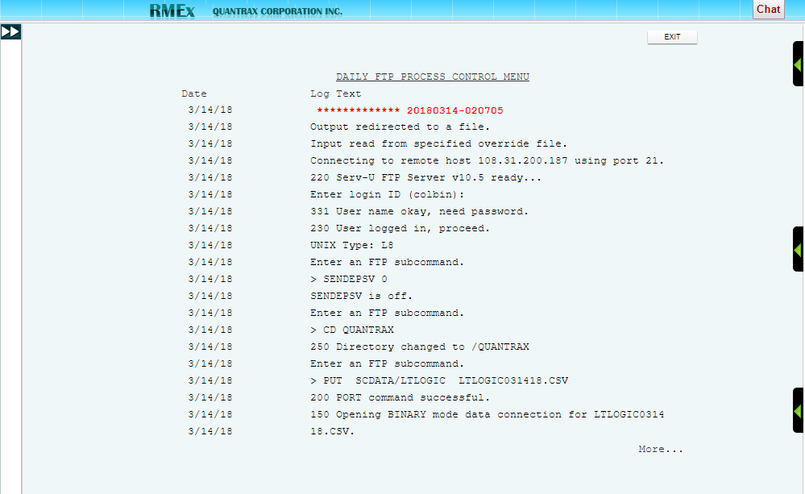

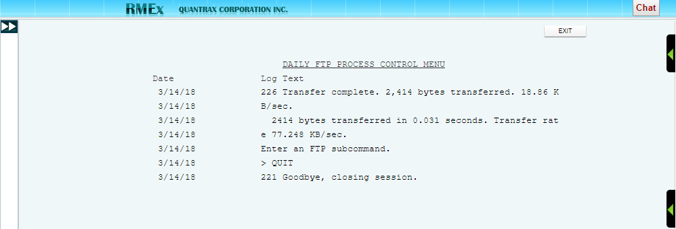

## Trouble shooting

If your AS400 takes a power hit the FTP Job processes will need to be reset.

Go into each job:

Use 2-change

Confirm day and time

Hit F12

This will reset the schedule for that FTP job

**NOTE:** Most FTP sites have security settings that prevent hackers from accessing the site. One of these features blocks any IP address that is perceived to be attacking it. To help prevent this blocking, we have done the following fail safes:

When multiple jobs are scheduled for the same date and time the system will add a 2 second delay when submitting each job.

The system is designed to check the active jobs before submitting the next job. It will check up to 10 times before submitting the next job. If other jobs are still running after 10 checks, you will need to review the scheduled jobs and make changes. You can change the job processing time on each job to be 5 minutes apart.