This is the best practice for adding sound to Adobe .PDFs; you cannot add .WAV files to Adobe. When recording save it as .**MP3 not .WAV.** This is helpful because:

* Sound files are very large, especially .WAV
* Adding sound into .PDF (are preferred way of sending client documents), opens the recording in a small window on the page with document. Before it would open in a large window in Internet Explorer

**NOTE**: Do not have spaces in filename *(AnalyzingAcctProcessing* or *Analyzing_Acct_Process*)

1. After you have completed the work document and added the icon for sound, **open Adobe Acrobat Pro** then select **Create PDF** and select the ***Word document (.DOC)*** to convert to .PDF  
   **NOTE:** If you do not have it speak with Jamie for installation instructions and key#
2. Select **Tools** > **Multimedia** > **Sound**, then use cursor to ***draw box*** around headphones icon

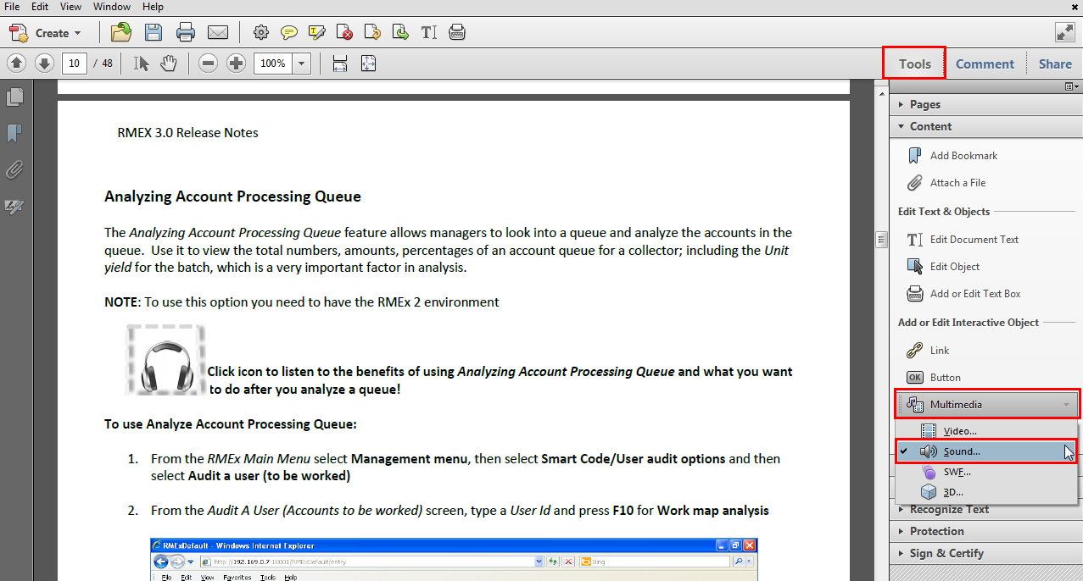

1. In *Sound* window select Advance Options check box then populate as seen below:

