**Web Training, Glossary, and PDF creation**

Create the folders that will ultimately store the files on the web server

**Main folder is: “Management_Training_topic” (i.e; Management_Training_Close_Codes):** This Folder will store the Web Training Files

**Within this folder create folders called**

**“CAM-topic”**: ALL of the camtasia work files (*,camrec, *.PNG, *.wav etc). If we download this folder we can re-produce/edit any video

**“GL-topic”**: This is the Glossary web presentation / Produced vid

**“PPT-topic”:** This is the PowerPoint and the PDF created from that PowerPoint

**How it looks on the web site:**

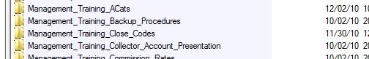

**How the inside of the folders will look:**

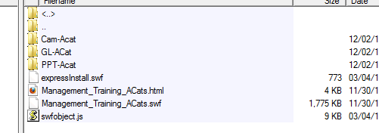

**How the links will look:**

Web Training

<http://www.quantrax.com/KB/Management_Training/Management_Training_Acats/Management_Training_Acats.html>

Glossary

<http://www.quantrax.com/kb/Management_Training/Management_Training_ACats/GL-ACat/GL-ACat.html>

PDF

<http://www.quantrax.com/kb/Management_Training/Management_Training_ACats/PPT-Acat/ACats.pdf>

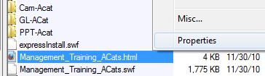

**How to find the web links:**

All web links for the Knowledgebase start with

<http://www.quantrax.com/kb>

To get the rest of the link, using CoreFTP, login and go to the directory with

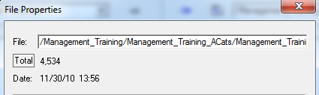

the file or video that you want to present to the user.

Right click on the file and go to its properties.

The field **“File”** in Prosperities has the rest of your link

**“/Management_Training/Management_Training_ACats/Management_Training_ACats.html”**

Adding the with the info above you get:

**http://www.quantrax.com/kb**/Management_Training/Management_Training_ACats/Management_Training_ACats.html**Web Training production – Select to Produce from Camtasia and you will be presented with these options:**

* **Select Custom, Then Next**

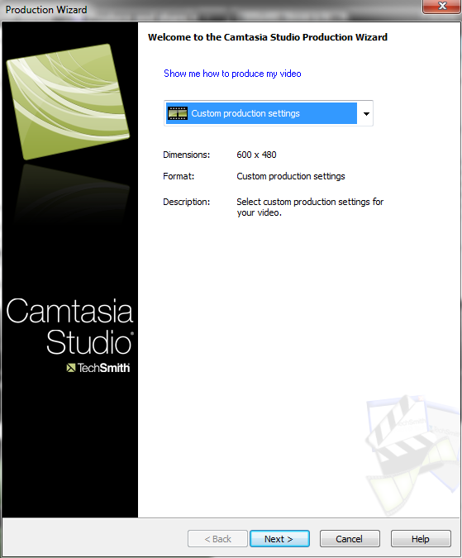

* **Select “Flash”, Then Next**

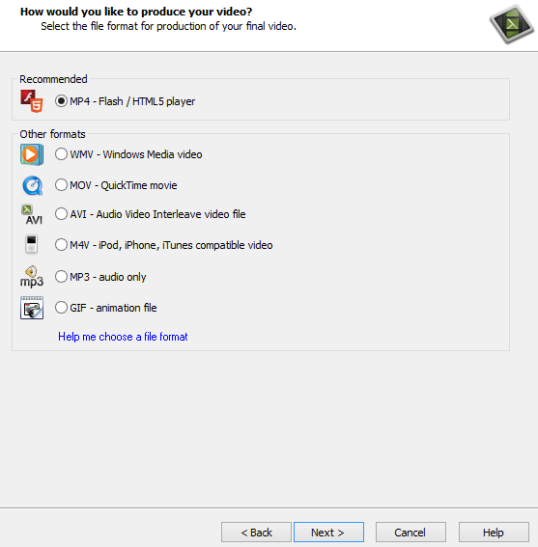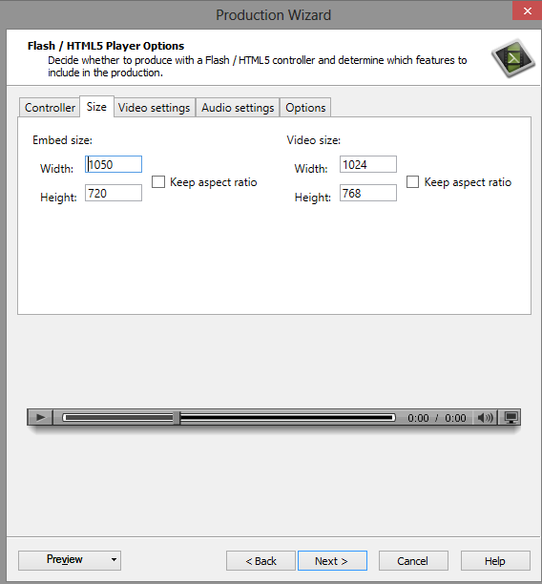

* **Embeded size 1050 x 720**
* **Video size 1024 x 768**

Click Next until you get to “Produce Video”

Give your video a meaningful name and try not to use spaces.

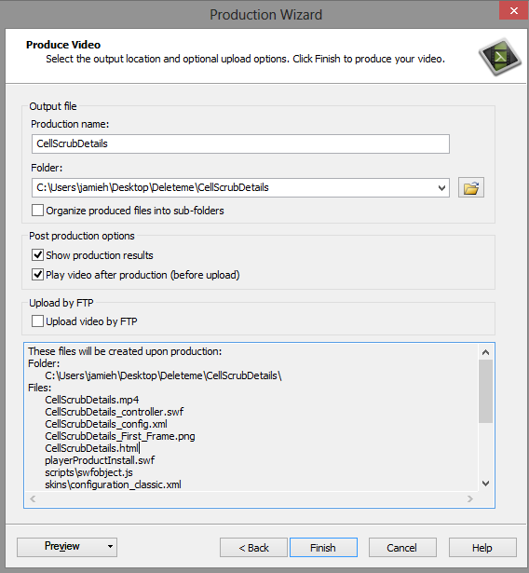

and click finish

Sound Only Production



Photo used for Voice Production

* Once you have created your sound recording it will appear in Camtasia
* Delete the “Screen” track

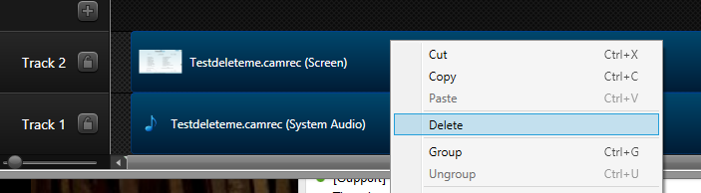

* Add the SoundOnlySlide

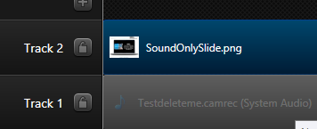

* Produce your Video.

**Video Production**

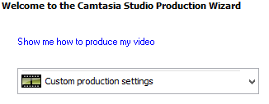

Then

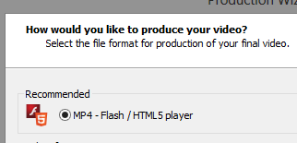

Then

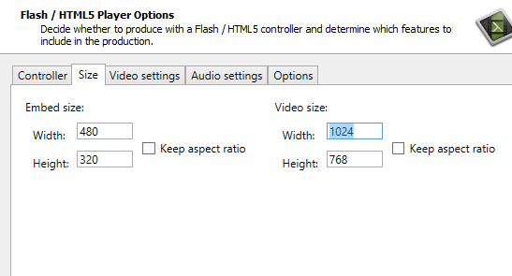

Embedded size 480 X 320 Video size 1024 x 768

**Continue hitting next till you click “Finish**”

**Converting WebEx to Camtasia videos…**

You will need to download your WebEx training session.

You will also have to install the “ARF Player” software, which will do the actual converting of your WebEx presentation.

<https://welcome.webex.com/client/wbxclient/nbr2player.msi>

After you have installed the ARF Player, you can go here for the instructions for saving the WebEx session to a WMV file. The WMV file format can then be used in Camtasia.

<http://support.webex.com/support/documentation/help/index.htm#9402.htm>

Once you have converted the file to a WMV you use our normal process for creating and publishing videos.

**WebEx to Camtasia for publishing after saving as a WMA file.**

The WebEx video may have parts of your desktop that you will not want in the finished product.

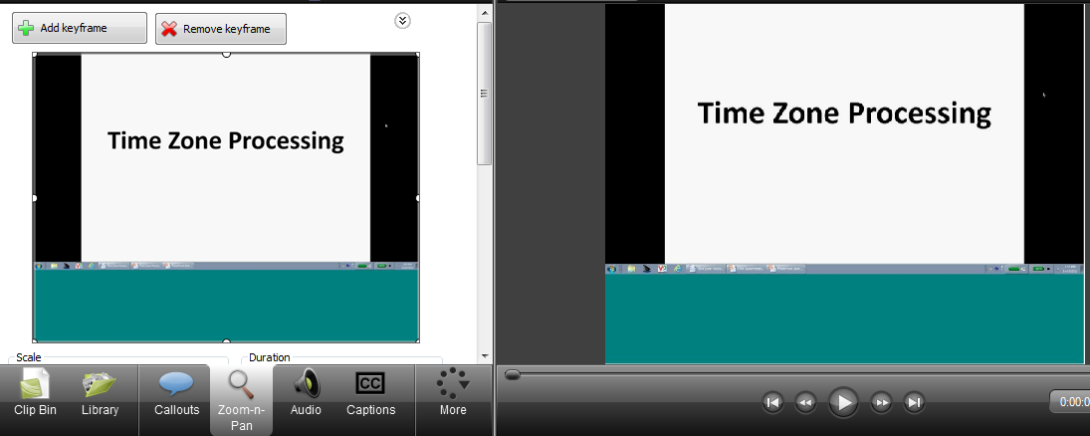

Within Camtasia there is a tab called "Zoom-N-Pan

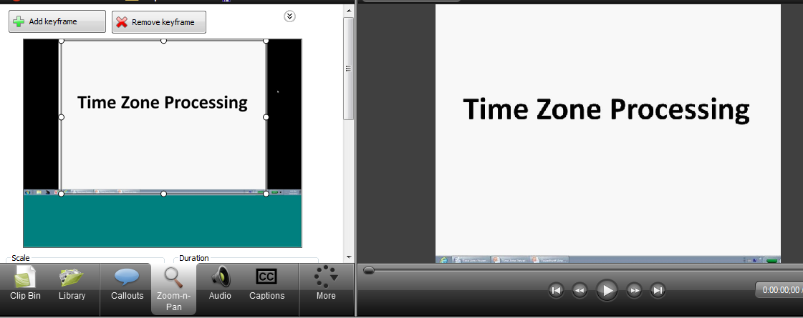

This tab will give you the ability to draw a box around your video, in essence zoom in, on the are that you want to present excluding anything outside that box.