**Interactive Data Interface**

We have created an interface for Interactive Data’s Bankruptcy and Deceased scrub.

You can select accounts to send to Interactive Data for a Bankruptcy scrub and/or a Deceased scrub.

You can also “Warehouse” accounts on their database. Warehousing means that you send them the accounts once and they keep them. If the debtor appears in their database anytime in the future, they will notify you via the return file.

The scrub is set up and run from the Special Options Menu and from there you have two options.

**Option 1** is used for selecting the accounts and creating the file.

**Option 2** is used for processing the return file from Interactive Data.

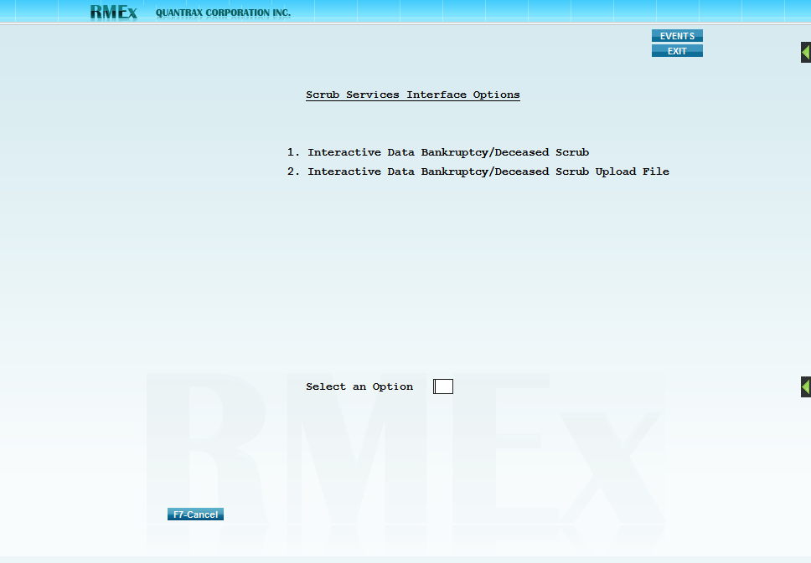

**Option 1** – Selecting the accounts and creating the file

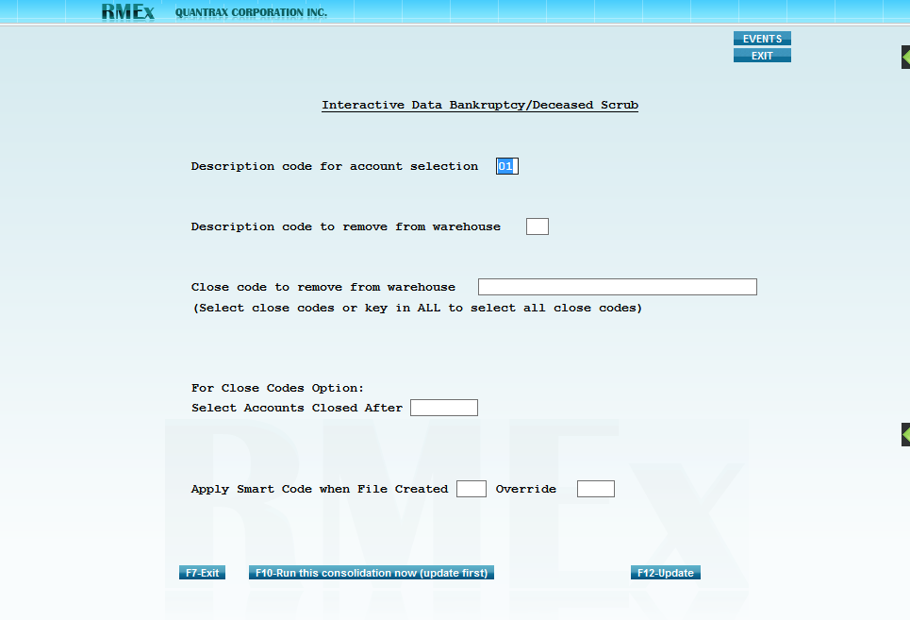

You need to have a Description Code on the accounts you want to select for the scrub file.

If you are using the Warehousing Service and want to remove accounts:

You can indicate a description code to remove accounts from the Warehouse and/or you can specify specific Close Codes to remove accounts from the Warehouse. You will need to specify a date for the close code option.

You can apply a Smart Code to all the accounts selected for the file.

**Ex. Of the Smart Code usage**:

Remove the selection criteria Description Code, add a Description Code to stop the accounts from being selected in the future or move the accounts to a new owner.

**Option 2** – Processing the return file.

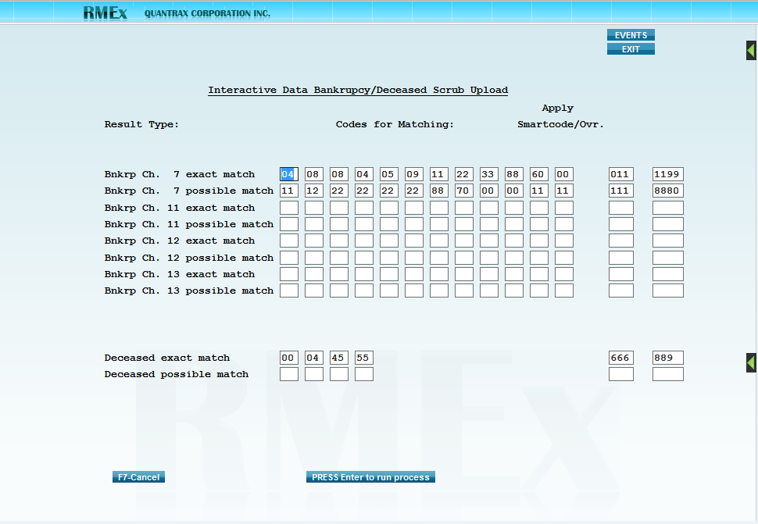

You and Interactive Date will agree on the codes that they are sending back (Matching Codes) and what those codes mean for each type of result.

Based on each type of result, you can apply a Smart Code (and include the override) for each of the results.